This is a ______________. MC900295755[1]

The student needs to go to _______________. 

The student does not have a ____________. 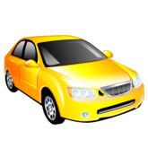

The student must ride the bus. 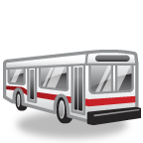

The student must read the bus ________.

The bus schedule says Bus 29 will come at 8:30 a.m.

The student walks to the _____________. MC900089286[1]

The student waits at the bus stop for Bus 29.

Bus 29 stops at the bus stop.

The ____________ opens the door. MC900212091[1]

The student gets on the bus. The student is now a ________________. 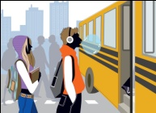

The student says, “How much is the fare?”

The bus driver says, “The fare is $1.75.”

The student pays $1.75.

The student finds a _____________ and sits down. 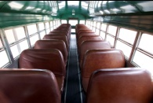

The bus driver drives the bus.

The student looks out the _____________. .

The student sees the ____________. 

The student pushes the __________________. 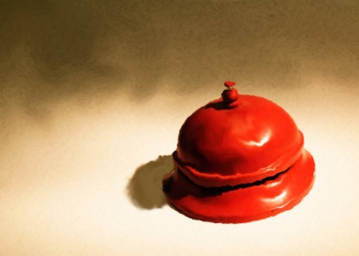

The bell goes “ding.”

The bus driver stops the bus.

The student gets off the bus.

The student rode the bus to school.

The _________ on the _______ go round and round

_________ and round

Round and ­­­­________

The wheels on the bus go round and round

All ________ long

The _____ on the bus goes beep, beep, beep

Beep, beep, beep

Beep, _______, beep

The horn on the _______ goes beep, beep, beep

All day _______

The ______ on the bus _______ swish, swish, swish

swish, swish, swish

swish, swish, _______

The wipers _______ the bus go swish, swish, swish

_______ day long

The _______ on the bus goes waa, waa, waa

________, waa, waa

waa, waa, waa

The baby on ________ bus goes waa, waa, waa

All day long

The ________ on the bus goes ding, ________, ding

ding, ding, ding

ding, ding, ding

________ bell on the bus goes ding, ding, ding

All day long

The _______ on the bus go round and round

Round _______ round

Round and round

The wheels on the bus go round and round

______ day long

All ______ long

All day _______

The wheels on the bus go round and round

Round and round

Round and round

The wheels on the bus go round and round

All day long

The horn on the bus goes beep, beep, beep

Beep, beep, beep

Beep, beep, beep

The horn on the bus goes beep, beep, beep

All day long

The wipers on the bus go swish, swish, swish

swish, swish, swish

swish, swish, swish

The wipers on the bus go swish, swish, swish

All day long

The baby on the bus goes waa, waa, waa

waa, waa, waa

waa, waa, waa

The baby on the bus goes waa, waa, waa

All day long

The bell on the bus goes ding, ding, ding

ding, ding, ding

ding, ding, ding

The bell on the bus goes ding, ding, ding

All day long

The wheels on the bus go round and round

Round and round

Round and round

The wheels on the bus go round and round

All day long

All day long

All day long

Bus Verbs to Practice

**Look** for the bus number

**Wait** for the bus

**Get on** the bus

**Pay** the bus driver

**Find** a seat

**Sit** down

**Look** for the stop

**Pull** the cord

**Wait** for the bus to stop

**Stand** up

**Walk** to the door

**Get** off the bus

Images for Retail Dictionary

MC900089286[1]MC900212091[1]MC900319436[1] 