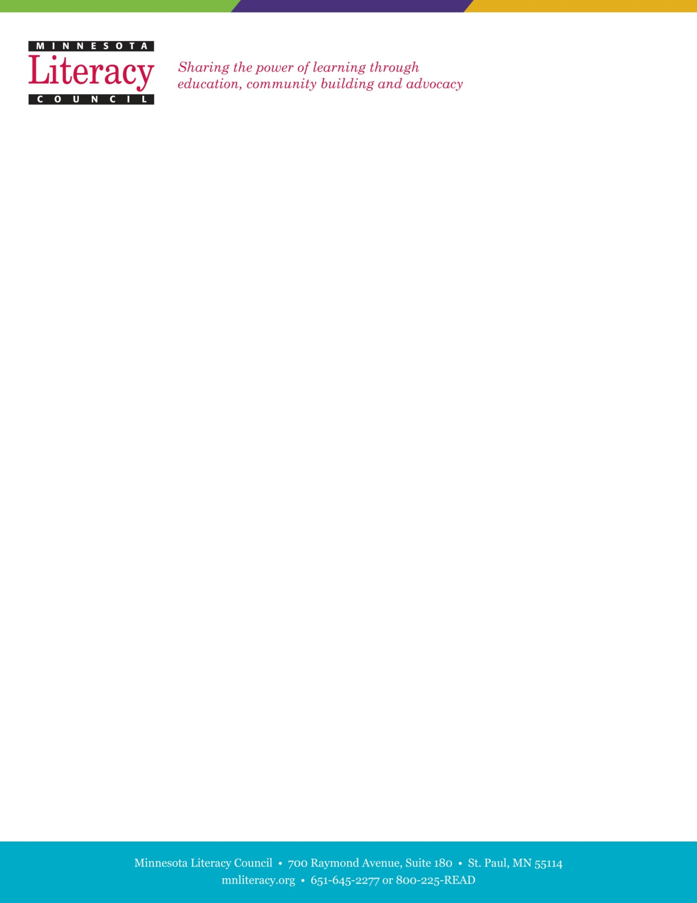

**Student Literary Journal**

**Managing Editor Internship**

The Minnesota Literacy Council is a nonprofit organization dedicated to improving literacy throughout our state. We offer literacy services for adults and at-risk children, native-born citizens and recent immigrants, and urban and rural residents.

**Journeys**is a student literary journal featuring the writings and artwork of adult learners across Minnesota. The purpose of the journal is to empower adult learners to share their voices and unique perspectives with the larger Minnesota community. The journal receives over 500 submissions annually. Please visit the following website for more information on the journal: [www.mnliteracy.org/journeys](http://www.mnliteracy.org/journeys)

**Purpose of Position:**

We are seeking a Managing Editor to supervise a team of two copyeditors and one graphic designer and oversee all aspects of the production of the 2018 edition of *Journeys*. The internship will include organizing submissions, communicating with copyeditors and literacy council staff, using desktop publishing software and working with formatting and layouts. A stipend of $500 will provided upon completion of internship in May.

**Qualifications:**

1. Experience with Adobe InDesign, Photoshop and MS Office including Word and Excel.
2. Supervision experience preferred. Good judgment and follow-through required.
3. Excellent understanding of the English language including English grammar.
4. Demonstrated ability to meet deadlines and work collaboratively to complete a project.
5. Preference will be given to those who are enrolled students at a post-secondary institution.
6. Comfort with email and online platforms for working collaboratively.
7. High level of responsibility, initiative and punctuality.
8. Open to new viewpoints and respectful of diversity.
9. Encouraging, creative, flexible, and friendly.

**Time Commitment**:

The time commitment is an average of twelve hours per week between January and May, 2018. Some of the editing work can easily be accomplished from off-site locations, such as home or school. Flexible working hours are available.





**Responsibilities:**

1. Work collaboratively as the production leader. Communicate effectively with editorial team members and literacy council staff about deadlines, tasks and design choices.
2. Edit entries as Word documents.
3. Editing for typos, and grammatical errors affecting understanding.
4. Review content to eliminate inappropriate or offensive entries
5. Proofread all entries

* Use standard proofing techniques to eliminate errors and improve understandability.
* Classify entries by theme and/or reading level (or other criteria) for division of the book into sections or chapters.

4. Lay out document in Adobe InDesign.

* Oversee cover, spine, title, introductory, and informative pages.
* Select artwork for the title pages and the section/chapter intro pages.
* Determine section/theme order.
* Oversee the format for title, author and text within each written entry.

1. Final proofreading of all aspects of book.
2. Ensure accuracy of the index of authors.
3. Review the printer's proof and make necessary changes.
4. Oversee web version.

**Benefits:**

* Management, publishing and editing experience in a non-profit environment.
* Knowledge of Adult Basic Education and literacy programs in Minnesota.
* Upon successful and timely completion of the book, a $500 stipend will be awarded.

**To apply:**

Please email cover letter and resume by November 27th, 2018 (for priority consideration) to:

Liam Shramko, Distance Learning and Database Specialist

[lshramko@mnliteracy.org](mailto:dbackman@mnliteracy.org)

700 Raymond Ave., Ste. 180, St. Paul, MN 55114