The Minnesota Literacy Council created this curriculum with funding from the MN Department of Education. We invite you to adapt it for your own classrooms.

Intermediate Level

Letter Writing with Pen Pals: Week 1 of 1

Unit Overview
This is a 2 day unit in which students learn about the Pen Pal project and write introductory letters to pen pals.

Focus of Week 1
- Reading about the Pen Pal Project
- Writing introductory pen pal letters based off of sample letters and templates

Letter Writing with Pen Pals: Day 1

Objectives Learners will be able to… | Materials
Life Skill: describe the Pen Pal Project  Speaking: list reasons for writing to a pen pal  Reading and Writing: identify the parts of a friendly letter | Make Student Copies  - Handout: Fill in the Blanks Letter #1  - Handout: Sample Letter #2  Make Single Copies or Reference  - Sample Letter #1  - Fill in the Blanks Answer Key  Props, Technology, or Other Resources  - Sample pen pal letters with envelopes, or other letters received in the mail with envelopes  - projector  - highlighters
Lesson Plan
Activity 1: Introducing Letters
Description: Show students letters and teach vocabulary
Materials/Prep: sample pen pal letters with envelopes, or other letters received in the mail, projector

Activity 2: Introducing the Pen Pal Project
Description: dictation activity with a sample letter and closely reading the letter to learn more about the project
Materials/Prep: one copy of Sample Letter #1 for teacher reference, class copies of Fill in the Blanks Letter #1, one copy of Fill in the Blanks Answer Key, and highlighters

Activity 3: Reasons for Writing to Pen Pals
Description: think, write, pair share activity in which students list reasons for participating in the Pen Pal Project
Materials/Prep: None

Activity 4: The Parts of a Letter
Description: students label the parts of a letter
Materials/Prep: class copies of Sample Letter #2, teacher reference copy of Sample Letter #1

Teacher Directions: Activity 1: Introducing Letters
Step 1: Prep
If possible, collect copies of pen pal letters, including the envelopes, that students and pen pals have written in the past. If not, collect examples of letters from the mail.

Step 2: Share Examples and Experiences
Use a projector to show students example letters and then pass them around the room. Elicit from students what they are and where they are from. As students use these key words, write them on the board: letter, mail. Ask students to raise their hands if they’ve ever written a letter. Call on students and ask who they wrote to and why.

Step 3: Introduce Pen Pals
Add the word pen pal to the word list on the board. Say the definitions of the key words (don’t write the definitions because it isn’t the best use of class time for students to copy them).
Letter: a paper someone writes to you and then sends to you in an envelope.
Mail: send a letter to someone
Pen Pal: a person you write letters to; you’ve never met this person

Tell students that today we’re going to learn how to write letters to pen pals.
Teacher Directions: Activity 2: Introducing the Pen Pal Project
Step 1: Prep
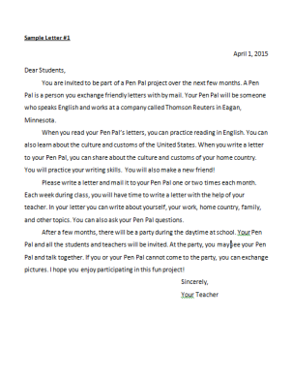
Make one teacher reference copy of Sample Letter #1, one teacher reference copy of Fill in the Blanks Answer Key and copies for the class of Fill in the Blanks Letter #1. If possible, get a class set of highlighters.

Step 2: Read Out Loud
Read Sample Letter #1 out loud as the class listens.

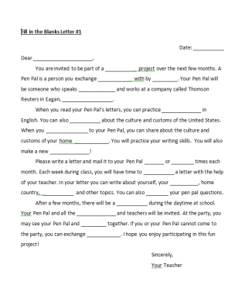
Step 3: Fill in the Blanks
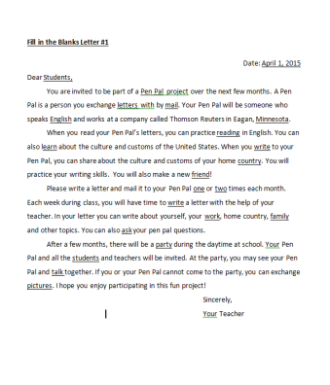
Provide students with copies of Fill in the Blanks Letter #1. Read Sample Letter #1 aloud at a slightly slower than normal rate and students listen and fill in the blanks. Then read the letter a second time for students to fill in any answers they missed. Read one more time at a normal rate for students to check their answers.

Use a projector to show students Fill in the Blanks Answer Key and allow students time to correct their own answers.

Step 4: Check for Understanding
Leave the Answer Key on the projector. Tell students that you want to find five important things to remember in the letter. Demonstrate students how to highlight one important item by highlighting “invited to be part of a Pen Pal project over the next few months.” Ask students what else they need to remember from the letter and highlight that item.

Give students highlighters and they highlight three more important things to remember. As the finish highlighting, they can compare their answers with partners. Call on a couple students to share their answers.

Teacher Directions: Activity 3: Reasons for Writing to Pen Pals
Step 1: Students Think
Invite students to think about reasons to write to pen pals. What will they practice? What will they learn? What will they teach? Students write their thoughts and ideas.
Step 2: Students work in Pairs
Students turn to a neighbor and share their ideas.
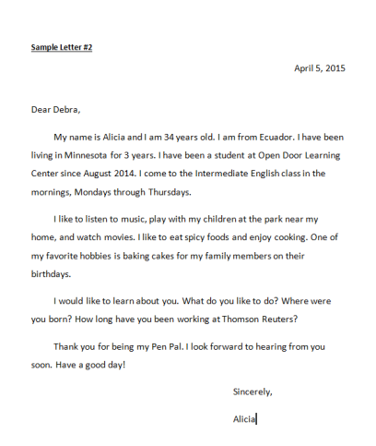
Step 3: Students Share
Call on a few students to share their ideas.
Teacher Directions: Activity 4: The Parts of a Letter
Step 1: Prep
Make copies for the class of Sample Letter #2.
Step 2: Introduce Sample Letter #2
Read Sample Letter #2 aloud as the class just listens. Ask students to turn to neighbor and share three things they remember from the letter and then raise their hands when they are done. Call on a few students to see what they remember.
Step 3: Introduce the parts of a letter
Show Sample Letter #1 on the projector. Elicit from students where the date is and highlight it. Highlight the following parts of the letter, one at a time, and label each part while saying its name: date, greeting, body, closing, signature. Point to each part and ask the class what it is.
Write the parts of a letter on the board. Give students copies of Sample Letter #2. Students highlight and label its parts. As students finish, check one student’s answers and have that student check others, check another student and have that student also check others, and so on.
Optional Extension
Draw a rectangle on the board to represent a piece of paper. Draw lines to represent the parts of a letter. Invite students to the board to fill in the date, greeting, closing and signature. Invite other students to label the parts.

Sample Letter #1
April 1, 2015
Dear Students,
You are invited to be part of a Pen Pal project over the next few months. A Pen Pal is a person you exchange friendly letters with by mail. Your Pen Pal will be someone who speaks English and works at a company called Thomson Reuters in Eagan, Minnesota.
When you read your Pen Pal’s letters, you can practice reading in English. You can also learn about the culture and customs of the United States. When you write a letter to your Pen Pal, you can share about the culture and customs of your home country. You will practice your writing skills. You will also make a new friend!
Please write a letter and mail it to your Pen Pal one or two times each month. Each week during class, you will have time to write a letter with the help of your teacher. In your letter you can write about yourself, your work, home country, family, and other topics. You can also ask your Pen Pal questions.
After a few months, there will be a party during the daytime at school. Your Pen Pal and all the students and teachers will be invited. At the party, you may see your Pen Pal and talk together. If you or your Pen Pal cannot come to the party, you can exchange pictures. I hope you enjoy participating in this fun project!
Sincerely,
Your Teacher

Fill in the Blanks Letter #1
Date: ___________
Dear _____________________,
You are invited to be part of a ___________ project over the next few months. A Pen Pal is a person you exchange ____________ with by _________. Your Pen Pal will be someone who speaks _____________ and works at a company called Thomson Reuters in Eagan, __________________.
When you read your Pen Pal’s letters, you can practice ______________ in English. You can also ___________ about the culture and customs of the United States. When you _______________ to your Pen Pal, you can share about the culture and customs of your home ____________. You will practice your writing skills. You will also make a new ______________!
Please write a letter and mail it to your Pen Pal _______ or ________ times each month. Each week during class, you will have time to ___________ a letter with the help of your teacher. In your letter you can write about yourself, your __________, home country, ___________ and other topics. You can also ________ your pen pal questions.
After a few months, there will be a ___________ during the daytime at school. Your Pen Pal and all the ______________ and teachers will be invited. At the party, you may see your Pen Pal and _________ together. If you or your Pen Pal cannot come to the party, you can exchange ____________. I hope you enjoy participating in this fun project!
Sincerely,
Your Teacher

Fill in the Blanks Answer Key
Date: April 1, 2015
Dear Students,
You are invited to be part of a Pen Pal project over the next few months. A Pen Pal is a person you exchange letters with by mail. Your Pen Pal will be someone who speaks English and works at a company called Thomson Reuters in Eagan, Minnesota.
When you read your Pen Pal’s letters, you can practice reading in English. You can also learn about the culture and customs of the United States. When you write to your Pen Pal, you can share about the culture and customs of your home country. You will practice your writing skills. You will also make a new friend!
Please write a letter and mail it to your Pen Pal one or two times each month. Each week during class, you will have time to write a letter with the help of your teacher. In your letter you can write about yourself, your work, home country, family and other topics. You can also ask your pen pal questions.
After a few months, there will be a party during the daytime at school. Your Pen Pal and all the students and teachers will be invited. At the party, you may see your Pen Pal and talk together. If you or your Pen Pal cannot come to the party, you can exchange pictures. I hope you enjoy participating in this fun project!
Sincerely,
Your Teacher

Sample Letter #2

April 5, 2015

Dear Debra,

My name is Alicia and I am 34 years old. I am from Ecuador. I have been living in Minnesota for 3 years. I have been a student at Open Door Learning Center since August 2014. I come to the Intermediate English class in the mornings, Mondays through Thursdays.

I like to listen to music, play with my children at the park near my home, and watch movies. I like to eat spicy foods and enjoy cooking. One of my favorite hobbies is baking cakes for my family members on their birthdays.

I would like to learn about you. What do you like to do? Where were you born? How long have you been working at Thomson Reuters?

Thank you for being my Pen Pal. I look forward to hearing from you soon. Have a good day!

Sincerely,

Alicia

Letter Writing with Pen Pals: Day 2

Objectives Learners will be able to… | Materials
Speaking: Share introductory information about themselves  Life Skills: Review the parts of a letter  Writing: Introduce themselves in a letter to a pen pal | Make Student Copies  - Handout: Ideas for a Pen Pal Letter  - Handout: Introduction Letter Template  - Handout: Introduction Letter Template V2 (for a few lower level students)  Make Single Copies or Reference  - Introduction Letter Template—fill it out as a model during class and refer to it again later  Props, Technology, or Other Resources  - projector  - clean paper for letter writing
Lesson Plan
Warm up for today’s Lesson
Description: Students each share 5 things about themselves
Materials/Prep: none

Activity 1: Review
Description: Call on students to review vocabulary and parts of a letter from yesterday’s lesson
Materials/Prep: one teacher reference copy of Introduction Letter Template

Activity 2: Brainstorming
Description: Students fill in ideas for their first pen pal letter on a brainstorming worksheet
Materials/Prep: copies for the class of Ideas for a Pen Pal Letter worksheet

Activity 4: Drafting
Description: Students use a template to write their first letter to a pen pal
Materials/Prep: copies for the class of Introduction Letter Template and a few copies of Introduction Letter Template V2 for lower level students, if needed; filled out example copy of Introduction Letter Template that was completed during Activity 2

Activity 5: Revising
Description: Students use their templates to write final drafts of their letters
Materials/Prep: filled out copies of Introduction Letter Template, clean paper

Teacher Directions: Warm Up: Five Things
Step 1: Model It
Tell students they will say five things about themselves. Start by sharing five things about yourself. You might share your name, where you live, something about your family, something you like, and something you don’t like.

Step 2: Students Share
Go around the room listening as students each share five things about themselves. Provide sentence starters if needed (I like…I have… etc.). If the class is large, divide up into two groups for the activity.

Step 3: Wrap Up
Tell students that the things they just said are good ideas to write about when they write letters to pen pals.

Teacher Directions: Activity 1: Review
Step 1: Review Pen Pals
Call on students to explain/review for students who were absent on day 1. What is a pen pal? What are reasons to write to a pen pal?
Step 2: Review Parts of a Letter
Show students Introduction Letter Template using a projector. Invite students to point to and name the parts of the letter.
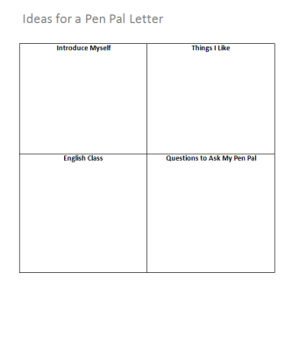
Teacher Directions: Activity 2: Brainstorming
Step 1: Prep
Make copies of Ideas for a Pen Pal Letter for the class.
Step 2: Modeling
Show students a copy of Ideas for a Pen Pal Letter using a projector. Model for students how to write ideas in the boxes by thinking aloud and writing one idea in each box. Elicit another idea for each box.
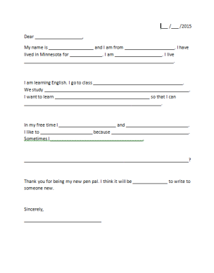
Step 3: Brainstorming
Give students copies of the handout for them to fill out. Circulate and make suggestions as needed. Ideas do not need to be complete sentences at this point.
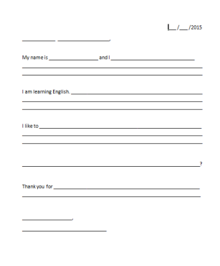
Teacher Directions: Activity 3: Drafting
Step 1: Prep
Make copies of Introduction Letter Template for the class. If there are few lower level students in class, make a few copies of Introduction Letter Template V2.
Step 2: Modeling
Show students both your filled in copy of Ideas for a Pen Pal Letter and Introduction Letter Template. Ask students where you should write the different categories of ideas (Introduce Myself, Things I Like, etc.) on the template. Think aloud as you choose one idea and then write a sentence about it on the template. Continue with several more ideas.
Show students your ideas page again and elicit from the class which idea you might write next on the template. Ask students what you should write and where you should write it. Repeat with one or two more ideas.
Step 3: Writing
Give students copies of Introduction Letter Template. If necessary, give a few students Introduction Letter Template V2. Students draft their ideas on the template. You may need to remind students to use the ideas they wrote in Ideas for a Pen Pal Letter. If necessary, have some students read Sample Letter #2 from Day 1 for more ideas about how to write a letter.
Teacher Directions: Activity 4: Revising
Step 1: Reading Out Loud
As students finish filling in their templates, pair them up with others who are finished. Ask them to trade papers and read out loud to each other. Encourage them to ask each other questions and give each other some help with revising. This will probably naturally happen as the read out loud.
Step 2:
As students are ready, give them clean, blank paper to copy their final drafts onto. You may also wish to provide students with laptops so they can type their letters, if time and resources allow.
If some students don’t have time to complete a final draft on clean paper, the pen pal program can use their templates instead.
Need a Challenge?
If some students finish writing their letters quickly encourage them to add more details to their writing and to add another question or two.

Ideas for a Pen Pal Letter

Introduce Myself | Things I Like
English Class | Questions to Ask My Pen Pal

Introduction Letter Template
___ /___ /2015
____________ ___________________,
My name is __________________ and I _______________________________
______________________________________________________________________________________________________________________________________
I am learning English. _________________________________________________
______________________________________________________________________________________________________________________________________
I like to ____________________________________________________________
______________________________________________________________________________________________________________________________________

__________________________________________________________________?

Thank you for ______________________________________________________
__________________________________________________________________

__________________,
_______________________________

Introduction Letter Template V2

___ /___ /2015
Dear ___________________,
My name is __________________ and I am from ____________________. I have lived in Minnesota for _____________. I am ___________________. I live ____________________________________________________________.

I am learning English. I go to class ____________________________________. We study __________________________________________________________. I want to learn ______________________________________ so that I can _______________________________________________________.

In my free time I _______________________ and _________________________. I like to _____________________ because _______________________________. Sometimes I _____________________________________.

__________________________________________________________________?

Thank you for being my new pen pal. I think it will be ______________ to write to someone new.

Sincerely,
_______________________________

Sample Letter #2

April 5, 2015

Dear Debra,

My name is Alicia and I am 34 years old. I am from Ecuador. I have been living in Minnesota for 3 years. I have been a student at Open Door Learning Center since August 2014. I come to the Intermediate English class in the mornings, Mondays through Thursdays.

I like to listen to music, play with my children at the park near my home, and watch movies. I like to eat spicy foods and enjoy cooking. One of my favorite hobbies is baking cakes for my family members on their birthdays.

I would like to learn about you. What do you like to do? Where were you born? How long have you been working at Thomson Reuters?

Thank you for being my Pen Pal. I look forward to hearing from you soon. Have a good day!

Sincerely,

Alicia

