Keyboarding and Computer Basics

Created for Adult Basic Education use. Contact Adult Basic Education Coordinator Cambridge-Isanti School District #911 625 Main Street North Cambridge, MN 55008. Phone: (763) 689-6228 Fax: (763) 689-6239 E-mail: vicki_ostrom@cambridge.k12.mn.us
Table of Contents
Welcome! 2
Keyboarding Basics 4
Free online Web site for help with keyboarding and computer basics. 6
Hardware 7
Basic parts of a desktop computer 9
How to use a mouse 10
Mouse Practice 13
Operating System 14
Start, shutdown, restart, log on and off 14
Start 14
Shut down (or turn off) 15
Switch user 15
Lock, restart, sleep and hibernate 18
Connecting Devices to Your Computer 21

Welcome!

Welcome! This class covers keyboarding and computer basics and will provide you with skills for some of the most common uses for computers.
Nearly everything we do these days requires the use of a computer, whether it is applying for a job, training for a job, or going to college. Even cell phones are small computers! You will be learning new skills, so go easy on yourself and take it one step at a time. Practicing your new skills as often as you can will help ensure that you remember what you’ve learned.
First, let’s make sure you’re comfortable. Most office chairs have many adjustments. Have your teacher demonstrate chair adjustments and check your posture. 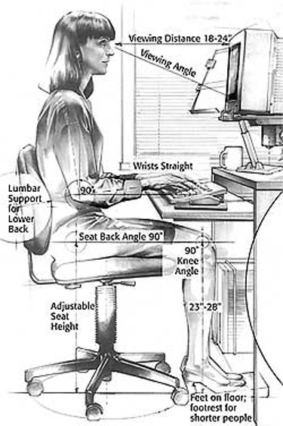
TIP: Posture
If your chair has adjustable arm rests, raise them to support your forearms so your shoulders can relax. Take frequent breaks to stand, stretch, and relax!

http://www.lbl.gov/ehs/pub811/hazards/ergonomics.html Ergonmics], Integrated Safety Management, Berkeley Lab. |Date=Image retrieved 9 July 2008 |Author=Berkeley Lab |Permission= |other_ve

Basic computer skills covered here include:
- Basic keyboarding
- Identify types of computers: desktop (stationary), laptop (portable)
- Turn computer and monitor on and off
- Log on and log off of a computer
- Shutdown and restart computer
- Identify specific computer hardware: CPU, monitor, printer, keyboard, mouse or touchpad, USB port
- Find and know function of keys: enter, shift, control, backspace, delete, arrow keys, tab, caps lock, number lock
- Identify mouse, touchpad, touch screen
- Hold a mouse
- Use and know functions of mouse buttons: left button, right button, single click, double click
- Know that mice can be customized for left-handed people and that the speed of clicking can also be customized
- Recognize cursor shapes: typing, arrow, hand pointer, I-beam
- Single click, double click, and right click
- Click and drag
- Use mouse to select check boxes, use drop-down menus and scroll

Keyboarding Basics
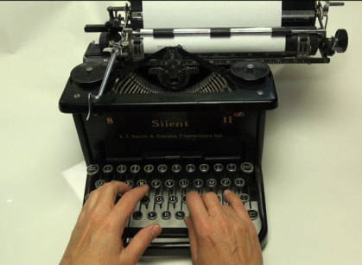  Typing | The word typing just means that you are using a machine to write. Many people still use this word when they talk about writing on a computer, but it is also called keyboarding.
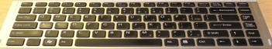  Keyboarding | Keyboarding is to teach your fingers to press the correct keys on a computer keyboard.
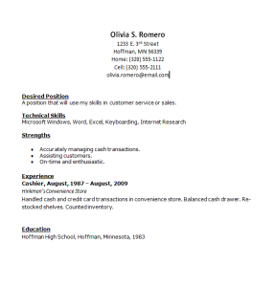  Word Processing | Word Processing is to create a document using a computer and word processing software. Documents can include letters, a job search resume, a class assignment, or any other typed material.
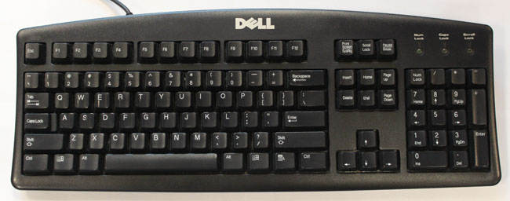  Alphabet Character Keys | The alphabet character keys on a keyboard are found in the center of the keyboard.
B  A  Numeric Character Keys | The numeric characters 0 to 9 are found on the row that is second from the top of the keyboard.  If you are using an extended keyboard, you will also have a numeric keypad on the right side of the keyboard that can be used by pressing the Num Lock key in the top left corner of the keypad.
B  A  Special Character Keys | Special character keys are found in two places on the keyboard. Some of them are found on top of the numeric keys. You can type one of these by pressing the Shift key while you press a number key.  Other special character keys are found on the right side of the alphabet keys. Press the shift key to type the special character on the top of the key.
Function Keys | Function keys are found across the top row of keys. They are used to make a certain task happen – like display a help screen, or to make your computer display on a projector screen.
Special Keys  TIP: Caps Lock and Num Lock  If you want to type everything in capital letters, press the Caps Lock key. When you’re done, press it again to turn Caps Lock off.  To use the number key pad, press Num Lock. You might want to leave it on all the time! | There are special keys on your keyboard that control things, but do not type a character by themselves.  Backspace deletes to the left, Delete key deletes text to the right of the cursor.  The Tab key will move to the next tab stop in word processing programs and move to the next text entry field in other programs (i.e. a web browser).  These special keys change what happens when you press it along with another key. Some examples are:  Shift and a letter key types an upper case letter  Ctrl and another key tells the computer to do something else (not type a letter). Ffor example:  - Ctrl+S = Save  - Ctrl+X = Cut (short cut to remove text)  - Ctrl+C = Copy (short cut to copy text)  - Ctrl+V = Paste (short cut to insert text)  *Note: the plus sign means you hold down the control key then press the letter key that follows.

Adapted from Blandin MIRC Digital Literacy Training

Free online Web site for help with keyboarding and computer basics.
Here are some popular web sites for keyboard practice. If you need to learn more about keyboarding basics, go the MIRC Digital Literacy training. Your instructor can help you get to the Web site. http://tinyurl.com/9w3shgw
http://www.powertyping.com/ This website includes basic typing lessons that give you feedback when you make a mistake, and also lets you know how fast you can type and how many errors you make. When you get to this website, look for the link to [QWERTY] to get to the typing lessons for a QWERTY keyboard. The practice lessons are in a numbered list on the right side of the blue box. Click on a lesson. Then click the Start arrow below the blue box. After you click start, the mouse cursor will be active and blinking inside the white box to the left of the start button. You can start typing the letters that appear inside the blue box. Remember to use the spacebar to make the space between groups of letters.
http://www.sense-lang.org/typing/tutor/keyboarding.php This site has 15 keyboarding lessons. Click on a lesson link, click the start button and type the letters shown in the white box above the keyboard. When you make a mistake, the correct key is highlighted in green on the screen.
http://www.typeonline.co.uk/index.html From the menu on the left, click Typing Lessons. The menu expands, but also opens to Lesson 1. In the gold box is a drop-down menu for Keyboard exercises 1-10. Click the drop down arrow and choose your first lesson. Exercise 1 will appear in the drop-down box. Click the start button. A line of characters will appear above the long white box on the screen. Click your mouse in the white box and start typing the letters shown above it…”asdfg hjkl;.” The letters will move across the screen with you while you type them into the box.
http://www.davis.k12.ut.us/cjh/appliedtech/Business/Keyboarding/ This exercise gives you practice, but no feedback. Click a lesson title from the numbered list. A line of letters appears above a box. Click in the empty box below the line of letters. You need to type the line two times in the box. Type it one time. Then press the Enter key on the right side of the keyboard to move to the next line. Type the letters again. Remember to use the space bar to create the empty space between the letters. After you finish typing these letters twice, press the Tab key on the left side of the keyboard to move to the next box and type the next practice exercise. There are 12 – 20 exercises on each page. Click Home to return to their menu and try another exercise.
http://www.cs.cmu.edu/~rvirga/TypingTutor.html This is designed like a game. Click the button labeled “Click here to launch Typing Tutor.” A small window will open. The letters fall from the top of the window and you need to type them in the order they fall before they get to the bottom. Click the start button in the new window to start the game. You can drag the slider, or click the arrows at the bottom, to speed up or slow down the speed of the falling letters.
http://www.learn2type.com/NewUser This website has both an adult typing section, and an easier kids typing section. You do need to enter an email address to register for this site. NOTE: This site does contain advertising which clutters the screen.

Hardware
Hardware includes keyboards, monitors, printers, etc. They are ‘hard.’ The term software or program refers to a set of instructions that tells the computer what to do. Here are some examples of hardware.
HARDWARE | The term hardware refers to any parts of the computer that you can touch.
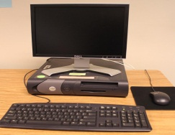  Desktop computer |  | A desktop computer is larger than a laptop computer – and too big to carry around.
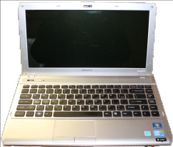  Laptop computer |  | A computer that is small enough for you to pick it up and carry.
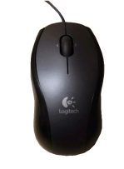  Mouse |  | If you are using a desktop computer, you need a mouse to move the mouse pointer across the screen and to point and click something on the screen.  You can also use a mouse with a laptop computer.
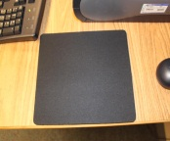  Mouse Pad |  | A small rubber pad below the mouse. You don't need a mouse pad, but it can help make a mouse work better.
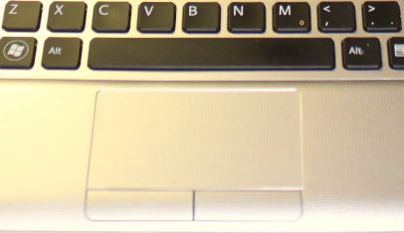  Touchpad |  | Use a touchpad to point and click something on the screen. A touchpad is only used with a laptop.
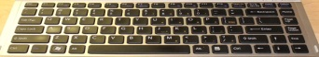  Keyboard |  | A keyboard has all of the alphabet characters and numbers so you can type. It also has a lot of special keys that are used to control the computer.
Mouse Pointer |  | The mouse pointer is a small arrow that moves across the screen to show you what your mouse is pointing at on the screen.
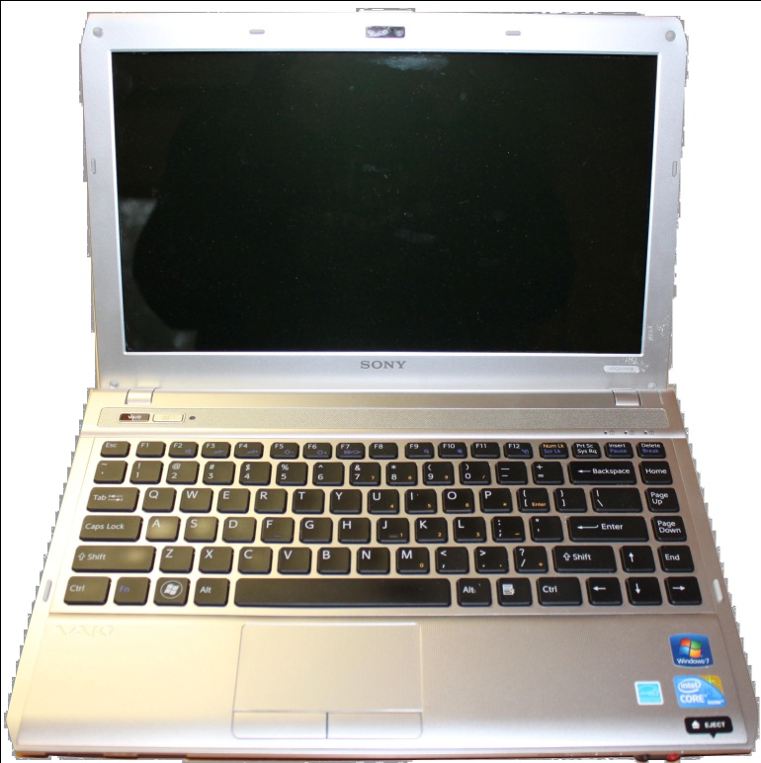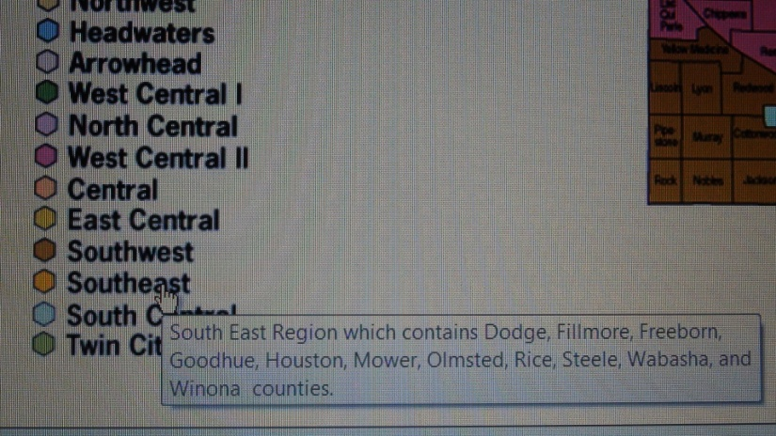  Tooltip Text |  | “Tooltip Text” are words that appear in a small pop-up box when you move your mouse over something on the screen.
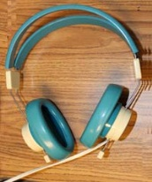  Headphones |  | Headphones are used when you have sound playing, especially on a public computer, so you don’t disturb other people.
Adapted from Blandin MIRC Digital Literacy Training

Basic parts of a desktop computer

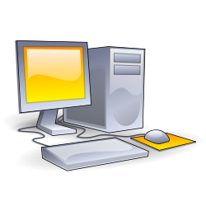 http://openclipart.org/clipart/computer/hardware/computer-aj_aj_ashton_01.svg
4
3
2
1
- Monitor (holds the screen)
- CPU (Central Processing Unit) or system unit
TIP: Computer Speed
The CPU or Central Processing Unit is like the brain of your computer. The speed of the CPU – combined with the amount of Memory available in your computer – affect how fast your computer runs.

- Mouse (laptops have touchpads)
- Keyboard
Printers, speakers, scanners and other devices are not typically part of a basic desktop computer.

How to use a mouse
Holding your mouse properly will make it easier to use.
Your entire right hand should rest on the mouse, with the cord (if it has one) and buttons pointing away from you. Your thumb should rest on the table surface on the left side of the mouse. Your pointer finger should be on the top left and your center finger on the top right.
Your pointer finger is now on the left click button and your middle finger on the right click button, even if they don’t look like buttons.
Between the left and right click buttons, there is probably a wheel.
To move the pointer up, move the mouse away from you. To move the pointer lower, pull the mouse toward you.
TIP: Left vs. Right Click
Left click is the most common use of the mouse. Use the left click to select options with your mouse.
The right click is used to bring up menus or display information about files or folders. It is not used to select options.
When instructions say just “click” (without including left or right), they mean LEFT click.
Sometimes you will single left click, and sometimes double left click. Don’t worry: if you double left clock on something that only requires a single click, it will still work.

It helps to have the mouse on a smooth surface, such as a mouse pad.
If you run out of room to move the mouse on your desk, just pick up the mouse and move it to a better position.
You can use the center wheel to move up and down in a document or on a web page.

If you are using a touchpad on a laptop computer, it works much the same way as a mouse. Just slide your finger across the touch pad and watch the pointer move across the screen. To click on a touch pad, either lightly tap the touchpad or click the buttons below the touchpad.
TIP: Customize your Mouse
If you want to use the mouse in your left hand or customize your mouse in other ways, try this.
- Go to the Start button
- Double-click Control Panel
- Double-click Hardware
- Double-click Mouse
Then explore the tabs across the top. You can also change the size of the pointer and other mouse icons as well as clicking speed and other settings from here.

When you left or right click, stop moving the mouse.
It is helpful to have part of your hand touching the table or desk you’re working at, but keep your wrist straight or it will get sore. (Also, take your hand off the mouse when you’re not using it.) After you click, give the computer a moment to respond. It may take a second or two for the computer to respond. Too many clicks will slow down your computer.
To . . . | Do this . . .
Point or Roll over | Move the mouse pointer so that the arrow rests on an area or a word. In many cases, just pointing to an area or word will bring up menus of help features.
Click | Press and quickly release the LEFT mouse button one time. This is the most common action.
Double-click | Press and quickly release the left mouse button TWO times.
Click and drag | Press and HOLD the left mouse button down while moving the mouse to a new position.
Right-click | Press and quickly release the RIGHT mouse button one time.
Click off | Click on an empty area of the screen. This will close any open menus or commands.

Mouse pointer icons
Arrow or Pointer | Allows you to select items by clicking.
“Eye” beam | Shows where your typing will start.
Hand pointer | Appears when you can click on a link.
Spinner | When your computer is busy trying to carry out a command, this will appear.
Timer or Hourglass | Your computer is telling you to wait a moment.
“Not” | This will appear when a command is not an option.
 | These arrows appear with shapes and illustrations. They are used to resize or move these objects.
The mouse pointer will change shape to let you know what the computer is doing, or to let you know what you can or cannot do when you are using a computer.
Adapted from Blandin MIRC Digital Literacy Training

Mouse Practice
You can get more practice using a mouse, keyboard and computer screen. Here are some tools you can use. If you do not have an Internet connection, you can find tools on your local computer.

Look for games installed on your local computer. You may think it’s silly to sit and play computer games. But, these games were created to give you practice using a mouse, keyboard and computer screen. They are a fun way for you to practice computer skills.
To find games on your computer:
- click the Windows Start Button Orb on the lower left corner of your screen (in the task bar): 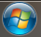

- Look for the word Games on the right side of the menu.

If you do not see the word Games in the menu, click “All Programs” at the bottom of the Start Menu. Then use your mouse to scroll down until you see the word “Games.” Click Games to see a menu of games available on your system. Click on a game to start it. Click “Help,” then “View Help” to get instructions on how to play a game. Try these games:

- Chess (teaches left-clicking and strategy)
- Mahjong (teaches left-clicking, strategy and ‘attention to detail’)
- Solitaire (teaches click and drag, and strategy)
- FreeCell (click and drag, and strategy)

If you do have Internet access, have a teacher, librarian, or someone else help you access these online tools to improve your mousing skills:
Online Mouse Practice:
http://www.pbclibrary.org/mousing/mousercise.htm
http://tech.tln.lib.mi.us/tutor/

Operating System
The most basic software or set of computer instructions is called the operating system. The operating system manages or operates your computer put hardware in a way that allows you to interact with it. It is used to start software programs, and manage files, memory, and hardware. It is different from program or application software, which is designed to do specific jobs.
Microsoft Windows is the most common operating system software, but is not the only operating system. Also, there are different versions of the Windows operating system. A very common older version is called Windows XP. A newer version is Windows Vista. The newest version is Windows 7.
There are different kinds of operating systems available for different types of computers: Microsoft Windows (XP & 7), Apple Mac OS X, and Ubuntu Linux. The majority of desktop and laptop computers run either a version of Microsoft Windows or Apple’s Mac OS. There are also mobile operating systems available for smartphones and tablets. Apple’s iOS and Google’s Android are the most popular. There are differences between these operating systems, but also many similarities.

Start, shutdown, restart, log on and off

Start
- First, check the power supply. Make sure your computer is plugged in to the wall socket!
- Look for a button that has the symbol below. It is often the largest button on a desktop computer. On a desktop computer, the start button might be on the side of the computer or on the front. On a laptop computer, it might be on the side or the top.
- If you are using a desktop computer, you will also need to turn on the monitor.

Shut down (or turn off)
DO NOT USE THE POWER BUTTON TO TURN OFF YOUR COMPUTER. It can cause you to lose changes you have made and over time it can make your computer run slower.
- Find the Windows Start button in the lower left corner of your screen – on the taskbar. You need to click the Windows Start button to find the Shut Down button. The start button looks like a blue circle with a colored flag.
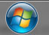
- Click once on the Windows Start button. You will see a button labeled “Shut down” on the menu that pops up.
- Move your mouse to the “Shut down” button and click once. This will make sure your files are saved properly and turns off your computer. (If your files are not closed properly, your computer will ask you what you want to do with them.)

Notice the arrow next to the shut down button. You have other options: switch user, log off, lock, restart, sleep and hibernate.

Switch user
If there is more than one user account on your computer, you can switch users without affecting your work on the computer. (If you have administrative access to your computer you can create new user accounts and give them different names.)
- Go to the Start button.
- Roll over the arrow next to the Shut down button.
- Click Switch user.
- Now, another user can log into the computer without closing your work. When they are done working, they can log off and their user account will close, but it will leave the computer running so you can log in and return to your work.

You can shut down, restart, or log off your computer from the start menu or from the Windows icon on your desktop. This is what your desktop or screen looks like if you are working in the Windows XP operating system and click the start button.
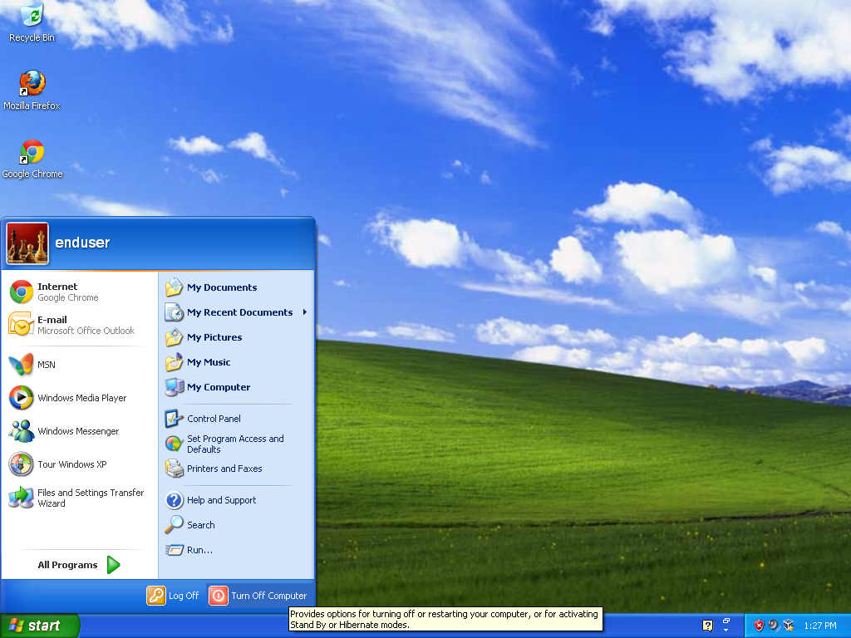
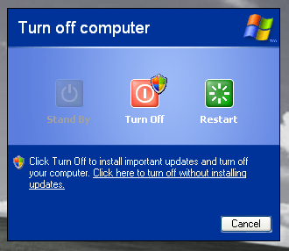
The Windows 7 operating system screen looks a little different.
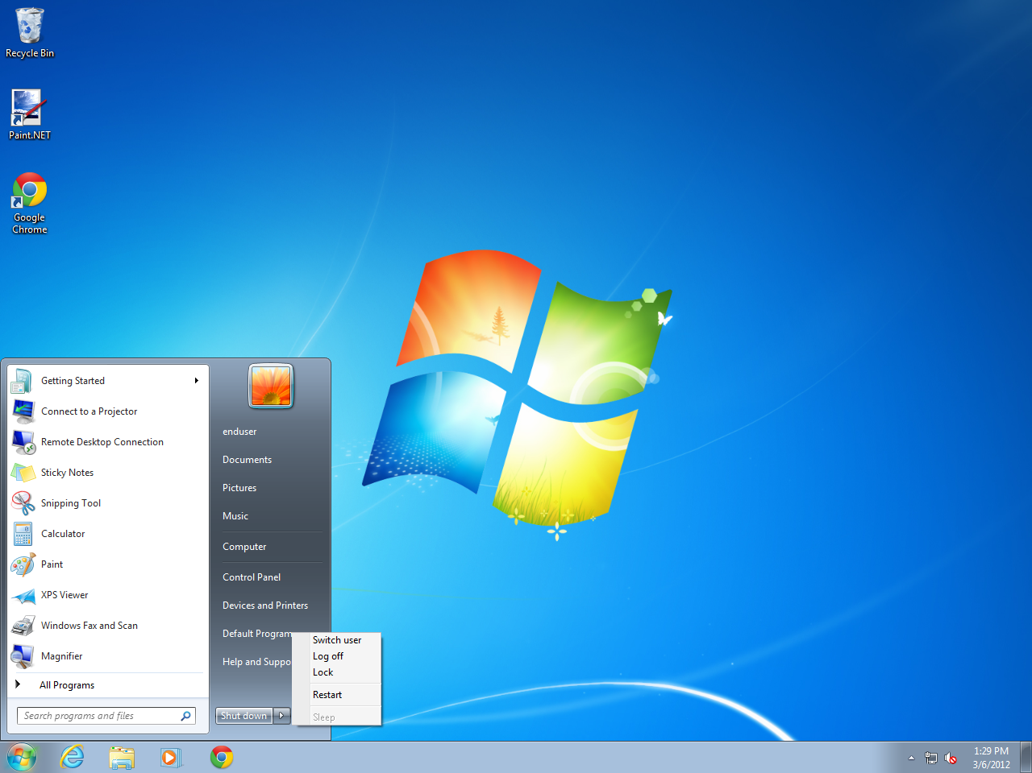

Lock, restart, sleep and hibernate

RESTART will turn off your computer and immediately turn it on again. Sometimes this may be required to finish a software update. It will close your files in an orderly manner and restart your computer without completely shutting off the power.
SLEEP and HIBERNATE are the other options. They both save power. Sleep leaves your work and settings in the computer’s memory so you can start everything very fast when you are ready to start working again. But it does use power. (If you’re using a laptop you may want to leave it plugged in so the battery doesn’t run down.)
HIBERNATE puts your work on your hard drive and shuts down your computer. So if you’re going to be away for a long time but don’t want to close all your work, this is an option.
There are different ways to “wake up” a computer if it is in sleep or hibernation mode. Try pressing any key on the keyboard or click the mouse button. Or sometimes you need to very quickly press the power button, but don’t hold it too long or it will turn off the power. You may want to check your computer manual to see which option works on your computer.
LOCK prevents people from accessing your computer. You need to enter a password to start working again. If you are working in an office and need to protect your work, lock is an option if you will be away for short periods of time.

Power Button | A laptop computer has one power button to turn on everything. A desktop computer has one power button to turn on the computer, and another power button to turn on the monitor.  Only use the power button to turn on a computer.  Do NOT use the power button to shut down a computer. This can leave fragmented files on your computer that can slow down the computer over time.
Windows Start Button | Use the Windows Start button to shut-down a computer.  It looks like a blue circle with a flag and is located on the lower left of the screen – on the task bar.  Click the Start button, then make a selection from the menu.
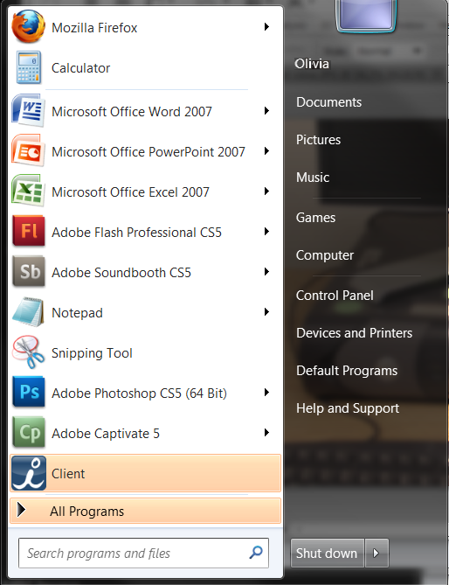  Start Menu Options | When you click the Windows Start button, you can choose many options. You can start programs, shut-down your computer, switch users, log off, lock, restart, or put your computer to sleep or in hibernation.  When you first start the computer, the desktop  appears on your screen or monitor.
Shut down button | Click the Windows Start button from the desktop. Then click the Shut down button to shut down your computer. A shut down will completely reset your computer and clear out the computer’s memory.
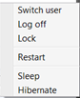  Restart | Adapted from Blandin MIRC Digital Literacy Training  Restart will reset your computer, but it does not completely shut it off, and does not completely clear the computer’s memory.
Switch User | You don’t have to, but you can create separate user logins for your home computer. Click the Windows Start button, then the arrow, to expand the menu options. Click Switch User to log in under a different user ID.
Log off | A user can log off of the computer, but leave it running by clicking the Windows Start button, then the arrow button, and then clicking Log off.
Lock | Some jobs require you to lock your computer for privacy reasons if you need to step away from your computer.  Click the Windows Start button, then the arrow button. Then click Lock to secure your computer.  NOTE: This will require you to unlock your computer when you return. You might need to press these 3 keys at the same time: Ctrl-Alt-Delete. Then type in your computer password to unlock the computer.
Sleep | If you plan to be away from your computer, Sleep mode lets you shut down parts of your computer, but keep your active work in the computer’s memory. This lets you conserve energy, but start working again very quickly when you return.  Click the Windows Start button, then the arrow button and click Sleep from the menu. Press any button on your keyboard to wake-up your computer again. Or, you might need to quickly tap the power button – careful that you do not turn off your computer.
Hibernate | Hibernate can be used if you need to be away from your computer for a longer time, but do not want to completely shut everything down.  Adapted from Blandin MIRC Digital Literacy Training

Connecting Devices to Your Computer

Computers are fairly easy to set up. There are lots of wires and connections, but most of them are easy to figure out by size, shape or color. Some plugs are round or oval with many prongs, some are single prongs, and some are rectangular.
Most of the places to plug things in have small icons or pictures by them, indicating what should be connected. For example, a symbol that look like the one below indidcates where to plug in your printer. Can you tell what the symbols below stand for?
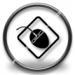
http://www.freestockicons.com/browse.php?p=5&pp=20&s=96&c=1&sc=15

USB or Universal Serial Bus
The small rectangular plugs are for USB connections. Many things you might want to plug in use a USB connection, like your digital camera, phone, or jump drive.
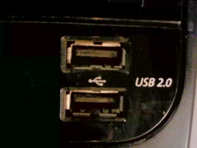
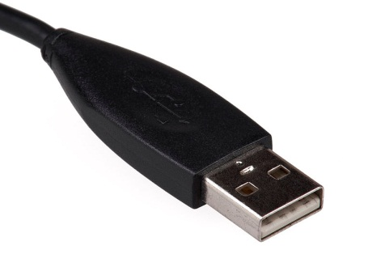
http://en.wikipedia.org/wiki/File:USB-Connector-Standard.jpg
http://en.wikipedia.org/wiki/File:USB_Front_Port.jpg
USB (universal serial bus) connections are very common. You'll recognize a USB connection by the symbol usually displayed on the connector.
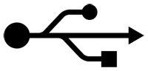 http://en.wikipedia.org/wiki/File:USB_Icon.svg
USB connection symbol
Many people use jump drives or flash drives to store their résumés or other files. Flash drives are small and easy to carry around. This is what a typical flash drive looks like. They are inexpensive. The price goes up with the amount of information they can hold. Note: to disconnect a flash drive, you must first EJECT it. This is covered in the Operating Systems section.
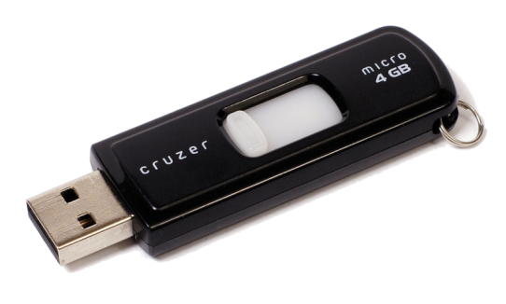http://en.wikipedia.org/wiki/File:SanDisk_Cruzer_Micro.png
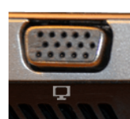
Video Display Connections
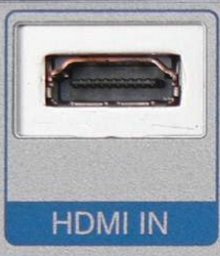
The two most common methods of connecting a screen or video display are VGA
and HDMI

Audio Connections
Computers are equipped with the ability to produce and record sound. The sound input is marked with a microphone symbol and the sound output is marked with a pair of head phones.
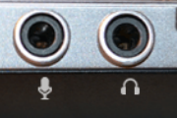
Laptop computers have built in speakers, but plugging in speakers or head phones is required to hear sound on most desktop computers.

Now, let’s see what you know. The checklist on the next page is a self-assessment of your basic computer skills.
After completing the checklist, have your teacher review it with you. Your teacher can direct you to resources to get these skills up to date before learning more computer skills. For example, the MIRC basic computer training is free online at www.bit.ly/mircmenu.
BASIC COMPUTER SKILLS | Not yet | With assistance | Independently
Identify types of computers: desktop (stationary), laptop (portable)
Turn computer and monitor on and off
Log on and log off of a computer
Shutdown and restart computer
Identify specific computer hardware: CPU, monitor, printer, keyboard, mouse or touchpad, USB port
Find and know function of keys: enter, shift, control, backspace, delete, arrow keys, tab, caps lock, number lock
Identify mouse, touchpad, touch screen
Hold a mouse
Use and know functions of mouse buttons: left button, right button, single click, double click
Know that mice can be customized for left-handed people and that the speed of clicking can also be customized
Recognize cursor shapes: typing, arrow, hand pointer, I-beam
Single click, double click, and right click
Click and drag
Use mouse to select check boxes, use drop-down menus and scroll
Identify icons on desktop
Open programs
Open files

Adapted from the St. Paul Community Literacy Consortium Digital Literacy Task Force

