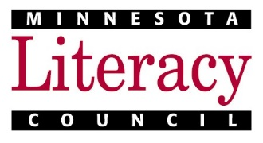
Journeys 2020: Preview of Submission Fields

This is not a submission form. To submit stories, use the Journeys 2020 submission webform: https://www.tfaforms.com/4752871. Email or USPS entries will not be accepted.

Here are the fields you will see in the 2020 Journeys submission webform.
Items marked with a * are required.
---------------------------------------------------------------------------------------------------------------------
Student Information
Student First Name *
Student Last Name *
Does the author wish to remain anonymous? *
- No. The author’s name WILL appear in Journeys.
- Yes, the author wishes to remain anonymous. Their name will NOT be published in Journeys. Please note that it is our wish that anonymity be granted only to authors who fear reprisal for their stories or words. Anonymous authors are not included in the Author Index.
Student City *
Student State *
Student Phone
Student Email
Student Age *
Student country of origin (or, if U.S., city and state of origin) *

Program Information
MN ABE Program Name *
Coordinator or Teacher Name *
Coordinator or Teacher Phone
Coordinator or Teacher Email *

Continued on back
Writing Submission
Title of Submission *
Please paste the text of the original story or poem here: *

Story Theme: *
- Challenges
- Culture and History
- Family and Friends
- Goals, Hopes, and Dreams
- Journey to the U.S.
- Letters About Literature
- Memories

By checking this box, the author affirms that the submission is an original story or poem. *
- Yes, the submission is an original story or poem.

By checking this box, the author gives permission for their story to be published in the 2020 publication of Journeys. Your work may appear online (our website, social media, etc.) or be used in the literacy council’s print materials to help promote Journeys and/or increase awareness of the literacy council’s mission. *
- Yes, I give permission for my story to be published in the 2020 publication of Journeys. If submitting to the Letters About Literature special theme, I also give permission to share my story with the Friends of the St. Paul Public Library, in advance of the publication of Journeys.

