**Word Unit: Day 4**

|  |  |
| --- | --- |
| **Objectives** *Learners will be able to…* | **Materials** |
| ***Computer Skill:*** saving to a folder  ***Computer Skill:*** *copy, cut and paste*  ***Literacy Skill:*** *Journal Entry* | **Make Student Copies**   * Copy, Cut and Paste Reference Sheet **(Tab 10)** * Day 4 Warm-up- one copy per two students **(Tab 11)** * **Props, Technology or Other Resources** * Computers * Projector * **USB Drives** |
|  | |
| **Lesson Plan** | |
| **Warm up for today’s Lesson:**  Description: students should pair off and each pair will receive a copy of Day 4 Warm-up. Explain that each pair needs to look through the strips of paper and they will see that they are the steps taken to save a new document. They should take these strips of paper and put them in the proper order.  Materials/Prep: copies of **Day 4 Warm-up** cut along the dashed lines (if you do not have USB drives, you might have to set this up a bit more)  **Activity 1: Cut and Paste, Editing**  Description: students will reorder instructions to learn cut and paste  Materials/Prep: copies of **Copy, Cut and Paste Reference Sheet**  **Activity 2: Copy and Paste, Editing**  Description: students will be introduced to prewriting and use copy and paste to organize skills  Materials/Prep:  **Activity 3: Saving to a Folder**  Description: students will learn how to create and save to a new document into a folder  Materials/Prep:  **If there is time:**  **Activity 4: Journal, Literacy**  Description:teacher will introduce the daily journaling activity and then students will write about their dream job  Materials/Prep: | |

**Teacher Directions: Activity 1: Cut and Paste Practice** ­-**Cut, Copy and Paste Reference Form**

Step 1: Activate prior knowledge

While students are working on the warm-up, or before class, type the steps of how to save a file out of order into a Word Document, or copy and paste the text below:

*“Create a name*

*Locate (E: ) Drive*

*Click on File*

*Click on My Computer*

*Click on Save As*

*Click on Save”*

Open it up for this activity

**Ask** students how to add bullet points

Step 2: Students type

Instruct students to type the list exactly as they see it, same order with bullet points

Step 3: Introduce cut and paste vocabulary

Sometimes you might be working on a list and you realize part of the way though that something is not in order

**Ask** if this list is in order

Or, you might be working on a document and realize you want to move a paragraph or a sentence to a different place

Instead of typing it all up again, you can simply remove the text from where it is, and place it somewhere else

This is called **cut and paste**

Step 4: Demonstrate cut and paste

Instruct learners to have their **EYES FORWARD AND HANDS OFF OF THEIR COMPUTERS, they should NOT work on their own computer until controlled practice**

**Ask** which step goes first to save a file: *click on File*

**Explain** that just like when formatting text, the first step to cut and paste is to **highlight** the text you want to move

**Highlight** the appropriate bullet point

Remind learners that they can use their hover tool to locate specific buttons on the **toolbar** on the **ribbon**

**Locate** the **cut** button; it looks like a pair of scissors which is helpful

**Click on it**

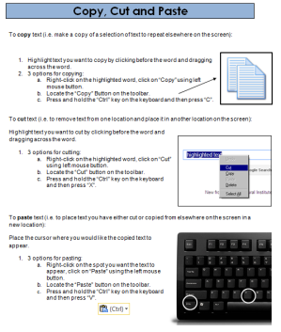**Click** where you want to move the file to

Step 5: Controlled Practice

Repeat the steps from Step 3 for a few more steps

Bring students up to the front to try it out on the classroom computer

Ask you continue through the list, try to have the students lead you through the steps

Step 6: Hand out reference form

Hand out the **Copy, Cut and Paste Reference Form**

**Explain** that there are many ways to do these three things: ribbon, right-click and shortcuts

Point out that the most transferable way to do it is to use right-click, but students will be tested on their ability to use the tools on the ribbon

Keep the document open for the second example

Step 7: Individual practice

Have students finish organizing the steps

Circulate to answer questions, address any confusion

**Teacher Directions: Activity 2: Copy and Paste**

Step 1: Context

Explain that occasionally users might be creating a document that includes the same phrase, sentence or heading multiple times. Sometimes you need multiples of something you have already typed. Again, instead of typing this all over, Microsoft Word has a shortcut.

We can use **copy:** it does just what it sounds like it does, it makes duplicates

Step 2: Demonstrate

Learners should have their **EYES FORWARD AND HANDS OFF OF THEIR COMPUTER**

**Demonstrate** using the ribbon, much like is activity 1, to copy and paste part of the document that was created in Activity 1

**Use right-click** to copy and paste a part of it as well

Step 3: Controlled Practice

**Explain** that the steps to Copy are very much the same as cut, except you select copy instead of cut

**Practice** copy and paste using the ribbon and right click with the learners

Ask them to walk you through, step by step

**Teacher Directions: Activity 3: Save to a Folder**

Step 1: What is a folder?

Ask students why it is important to Save Files?

Ask why it is important to pick a good name for a file? *Keeps things organized and easy to find*

**Explain** that there is another tool on the computer that allows users to organize their documents so that they can easily be found, they are called **folders**

**Folders** are exactly what you think of, they allow you to keep many documents on a related subject in one place.

**Example:** Just like you might have a folder for computer class handouts and a folder for GED class handouts, you could have an electronic folder to store documents you have created or downloaded that relate to the class

Step 2: Demonstrate creating a Folder to save something in

Learners should have their **EYES FORWARD AND HANDS OFF OF THEIR COMPUTER**

**Explain** that the steps are the **same as the ones to save a document**, until you get to the (E: ) Drive

**Click on File>**Click on Save As>Click on My Computer>Locate (E: ) Drive and open it

**Here** we will look for a button that allows you to **create a new folder**

If you click it, a box will appear asking you to name the folder

Name the folder **Your Name Word Class**

**Click OK**

You will now be in the folder, where you can name the document and save it

Review the steps to create a folder without actually creating one again

Step 3: Controlled Practice

Student can now use their computer as you all work together to create a folder

**Ask** them what the purpose of a folder is?

Try to have them lead you through the steps

Name the folder Students Name Word Class

Instruct them to save the document we created today

**Teacher Directions: Activity 4: Journal Entry- if there is time**

Note: Check to see if the previous class completed a journal activity. If they did, review with students how to open a previously saved document. It should be a folder that has the student’s name Journal.

Step 1: Directions

**Explain** that for many of the remaining classes we will end the day with a journal entry

The teacher will provide a prompt, and students will type until class is over.

Students should use complete sentences and type as much as possible during that time

Step 2: Prompt

Students should write about their dream job; what would they like to be when they “grow up”?

The first line of each entry should be the date aligned to the right, with the text starting on the line below aligned to the left

IF they did a journal the previous day of class, remind stduents that they are simply updating content of a journal they already saved. So they simply click the Save button on the Ribbon.

Otherwise:

Step 3: Save to Folder

With five minutes remaining, instruct students to stop typing

Take this time to review how to save to a folder

Create a new folder and name it **Student’s Name Journal**

Name the file Journal

**Day 4 Warm-up**

* **Click on File**
* **Click on Save As**
* **Click on My Computer**
* **Locate USB Drive**
* **Give the file a name**
* **Click on Save**

Copy, Cut and Paste

To **copy** text (i.e. make a copy of a selection of text to repeat elsewhere on the screen):



1. Highlight text you want to copy by clicking before the word and dragging across the word.
2. 3 options for copying:
   1. Right-click on the highlighted word, click on “Copy” using left mouse button.
   2. Locate the “Copy” Button on the toolbar.
   3. Press and hold the “Ctrl” key on the keyboard and then press “C”.

To **cut** text (i.e. to remove text from one location and place it in another location on the screen):

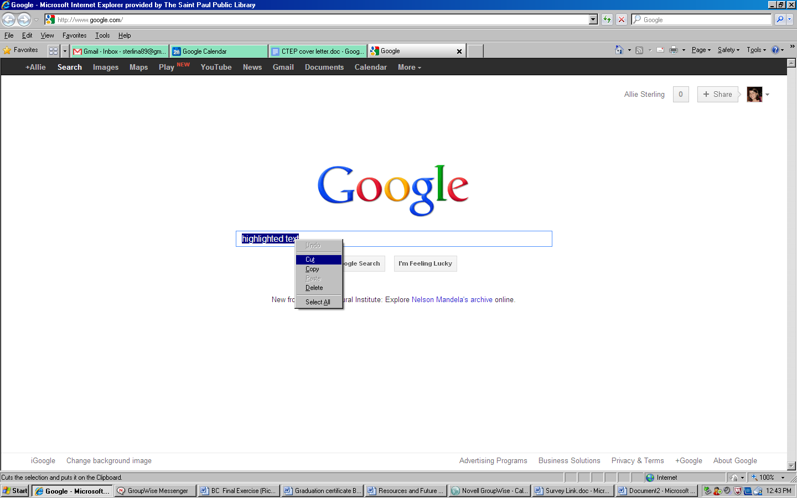Highlight text you want to cut by clicking before the word and dragging across the word.

1. 3 options for cutting:
   1. Right-click on the highlighted word, click on “Cut” using left mouse button.
   2. Locate the “Cut” button on the toolbar.
   3. Press and hold the “Ctrl” key on the keyboard and then press “X”.

To **paste** text (i.e. to place text you have either cut or copied from elsewhere on the screen in a new location):

Place the cursor where you would like the copied text to appear.

1. 3 options for pasting:
   1. Right-click on the spot you want the text to appear, click on “Paste” using the left mouse button.
   2. Locate the “Paste” button on the toolbar.
   3. Press and hold the “Ctrl” key on the keyboard and then press “V”.