Welcome to the Word unit of the Computers and Literacy Class

What to know about the class:
- Each lesson plan is built to fit a 2 hour time slot
- There are 12 lesson plans
- Each unit includes a TABE testing day (Day 10) and a North Star Digital Literacy Pre-Assessment (Day 2) and Post-Assessment (Day 11)
- This curriculum was written for students with a TABE score of 400 or higher

What you need for the class:

- A computer for each student
- Projector
- A USB drive for each student
- Headphones for each student
- The ability to print from the computer
- Microsoft Office*preferred, but OpenOffice would work as well
- Windows 7*preferred (same format as North Star Assessment)

What needs to be prepared?
- Instructor needs to load the following exercises either onto student USB drives or make sure they are online at http://www.mnliteracy.org/learning-centers/open-door-lake-street
  - Day 3 Formatting Practice
  - Day 7 Word Cover Letter Formatting
Note: if you are saving these files to USB drives, please be sure to save them in a Word Class Folder.

- Be sure teachers have access to the following PowerPoints
  - Day 1 Welcome to the Computer
  - Day 12 Jeopardy

How to become a North Star Digital Literacy Assessment proctor:
- You will need your learning centers username and password
- Go to digitalliteracyassessment.org/admin
- Type in username and password
- Look for “Don’t see your name on the list” and click on proctor training
- It takes about 20 minutes to complete, there is a quiz at the end

Word Unit: Day 1

Objectives Learners will be able to… | Materials
Literacy: Complete a cloze activity about computer vocabulary  Computer skill: Become familiar with parts of the computer  Computer Skill: Students begin practice with typing on keyboard | Make Student Copies  - Microsoft Word Expectations (Tab 1)  - Follow and Fill (Tab 2)  Props, Technology or Other Resources  - Projector  - Computer for every student  - Computer Signup Spreadsheet (Tab 3)  - Download “Welcome to the Computer” PowerPoint  - Print “Welcome to Computer” PPT Notes Pages (Tab 4)
Lesson Plan
Activity 1: Introduction to the class
Description: teacher will pick 3 get to know you questions that students and teachers will answer you will then go over the Computer and Literacy Expectations
Materials/Prep: copies of Microsoft Word Expectations, two copies of the Computer Signup Chart is using laptops, and School Phone Number for expectation sheet

Activity 2: Introduction to the Computer
Description: introduce introduction to computer vocabulary
Materials/Prep: “Welcome to the Computer” PowerPoint, teacher should have the PPT Notes Pages printed out to use a guide through the slides, copies of Follow and Fill (teacher should look this over before PPT, so they know what to focus on during presentation)

Activity 3: Typing Introduction and Opening Word
Description: The final slide on the PowerPoint has students write about themselves
Materials/Prep:

Wrap up for today’s lesson:
Description: Tour of back office, show students how to put their computers away
Materials/Prep: Room and COW keys

If there is time remaining: Introduce students have students do some typing practice. Directions in lesson plan

Teacher Directions: Activity 1: Introduction to Class -Microsoft Word Expectations
Step 1: Why are you in this class?
Take time to get to know students in the room
Handout a couple of post-it notes to each student
Instruct them to write down at least one reason why they are taking this Internet class
Once they write something down, have the students stick the post-it on the side of the board

Step 2: Teacher and Learner Introductions
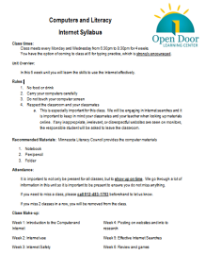
Write a couple other questions to get to know students on the board, create your own or use a few of the options below:
Examples: What is your name?
Where are you from?
If you got $10,000 what would you spend it on?
What is your favorite…?
Go around the room and do introductions, having students say a bit about themselves
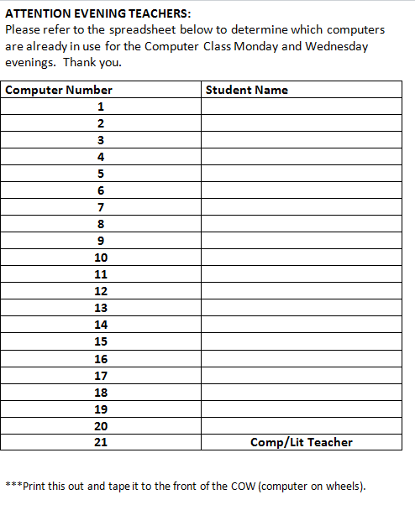
Once everyone does their introduction, go ahead and review the reasons why learners decided to take Internet

Step 2: Syllabus
Hand out Class Expectations and go over with students
Fill in the blanks with your own learning center information
Ask coordinator for the learning center phone number
Be sure to highlight respect aspect- students are varying levels, from varying backgrounds, but this is a space where we respect each other and focus on learning computer skills

Step 3: If using Laptops Get computers
If not done already, take this time to have students obtain a computer from the COW (computer on wheels)
Make a copy of Computer Sign-up sheet and fill in students names next to their assigned computers, fill in class times/days and tape it to the COW (this is to prevent other teachers from taking students’ computers)

Teacher Directions: Activity 2: Intro to the Computer -Follow and Fill
-Welcome to the Computer PPT Notes Page
Step 1: Set-up
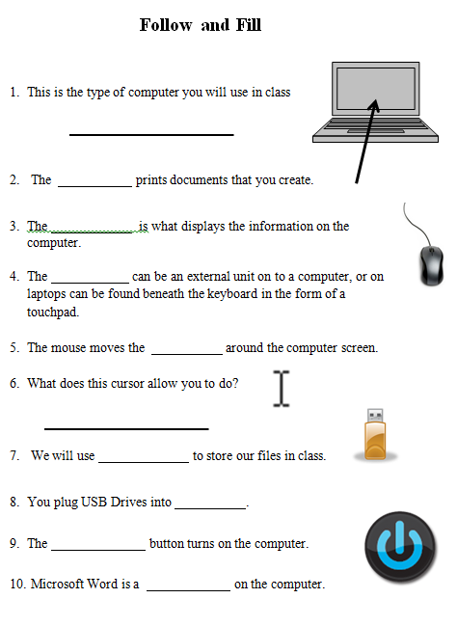
Explain that we will now be going over basic computer vocabulary
Step 2: Student Activity
Hand out Follow and Fill
Explain that learners will fill in the answers as they move through the exercise.
Step 3: PowerPoint
Go through Introduction to the Computer PPT
Be sure to have the NOTES PAGE printed out, this will give you information that will help you expand on topics discussed in the slides
Teacher Directions: Activity 3: Intro to Word and Typing
Step 1: Introduce Microsoft Word
Use last few slides of Welcome to Computers PowerPoint, starting with slide 15.

Step 2: Opening Microsoft Word
Ask if anyone knows how to open Microsoft Word? What do you look for? Icons
Explain that there are four ways to locate Word, each student might not be able to access Word the same way their neighbor did
- From the Desktop Screen you locate the Microsoft Word Desktop Icon and double click
  - Ask what the Word Icon looks like? Blue W
- Click on the Start menu, see if Word is located on the page that opens
- If not, click on all programs, locate Microsoft Office and then locate Microsoft Word
- Search function in Start menu if possible (need Windows 7 or higher)

Step 2: Typing
Go over basics of typing with students in a word document. Explain basic keys; space, enter, shift, caps lock, backspace, delete

Step 3: Individual Practice
Have students type the answers to the questions asked at the beginning of class. Try to work with them on proper grammar and spelling.
This is a typing practice, so you want to make sure they type the question, press enter, and then type the answer in a new line

If there is time remaining: Instruct students to practice typing. They should go on one of the following programs/websites, and will probably need teacher to demonstrate how to make it work.
- Mavis Beacon Teaches Typing Program (Directions in Page 8-9 in Lesson Plan online)
- Typingweb.com (click start typing, looks like they need to log in, but just click little read x in small window and it should take you to lessons)
- sense-lang.org
Teacher Directions: Wrap-up Activity 3: Put Computers Away Correctly
Show students where computers go, show them how to plug them in and place them safely on the rack so that the doors will close, put accessories in their appropriate place
***Print this out and tape it to the front of the COW (computer on wheels).

Computer Sign-up Sheet
These computers are in use and from ______to______
1
2
3
4
5
6
7
8
9
10
11
12
13
14
15
16
17
18
19
20
21 | Comp/Lit Teacher

Computers and Literacy
Microsoft Word Expectations
Class times:
- Class meets every and from to for 6 weeks. You have the option of coming to class at 30 minutes early for typing practice, which is strongly encouraged.
- If you need to miss a class, please call beforehand to let us know.
Rules:
- No food or drink
- Carry your computers carefully
- Do not touch your computer screen
- Respect the classroom and your classmates
- Put computers away in a neat and orderly fashion, teacher will instruct you on proper method at the end of today
- Follow the teachers instructions and complete activities as they are assigned

Unit Overview:
In this 6 week unit you will develop the skills to use Microsoft Word effectively and will create a cover letter.
Recommended Materials: Open Door Learning Center Lake Street provides the computer materials
- Notebook
- Pen/pencil
- Folder
One Final Expectation:
If you have a question, ASK IT.
Follow and Fill

- This is the type of computer you will use in class

- The prints documents that you create.

- The is what displays the information on the computer.
- The can be an external unit on to a computer, or on laptops can be found beneath the keyboard in the form of a touchpad.

- The mouse moves the around the computer screen.
- What does this cursor allow you to do?

- We will use to store our files in class.
- You plug USB Drives into .

- The button turns on the computer.

- Microsoft Word is a on the computer.

Mavis Beacon Teaches Typing

New User?
- Double-click on the Mavis Beacon Teaches Typing icon
- Click Run Mavis

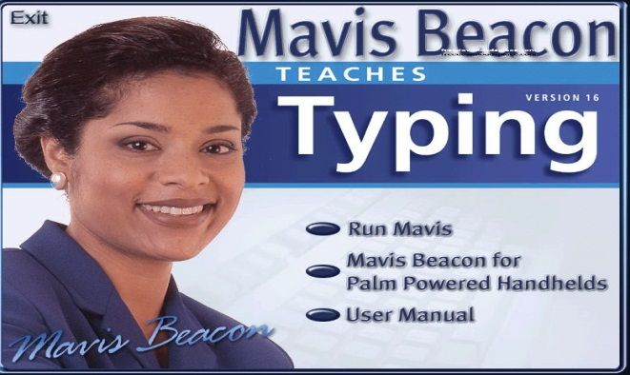
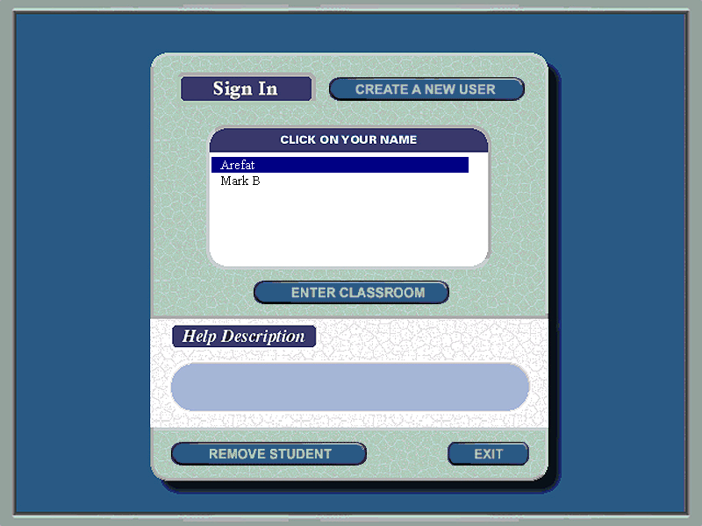
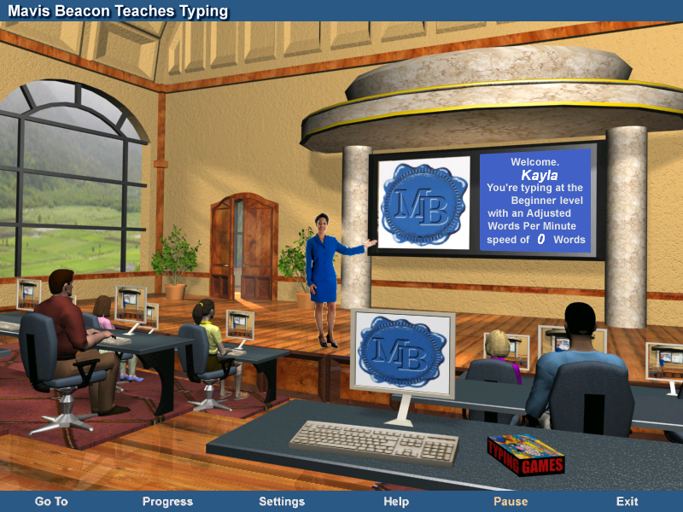
- Click on Create a New User

- Follow the directions as they are instructed
  - When you get to the page that asks about which keyboard you are using, 101 Standard Keyboard should already be selected, so you simply have to click “Next”
  - We will also be completing the Standard typing option
  - When you get to the page asking for WPM, the minimum amount that can be entered is 40
- Once learners complete registration, they will be sent to the typing classroom
- At this point, learners should typically click on the computer screen in the middle of the page; this is the typing lesson and testing area.

- Learners should then click “Beginning Level Typist”

- Click Start Lesson on the right side of the screen and begin typing

Mavis Beacon Teaches Typing
Returning User?
- Double-click on the Mavis Beacon Teaches Typing icon
- Click Run Mavis
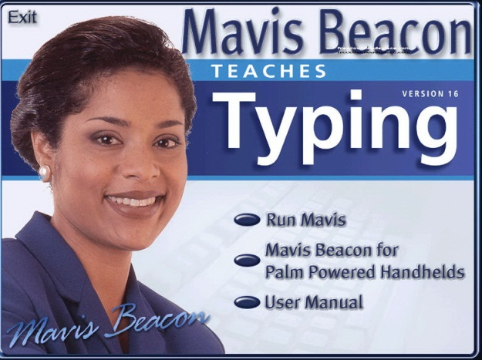
- Click on the name of the returning user from the list shown

- Then click Enter Classroom
- At this point the program will take you to the typing classroom.
- For beginner typists- learners should click on the Computer Screen in the typing classroom and then click on Beginning Level Typist. Once the lesson comes up, click on Start Lesson
- For more advanced typists, they can click on the computer screen, or they can click on Games next to the computer and play some practice games

