Reading and Writing for Job Search Day 8

Objectives Learners will be able to… | Materials
Computer skill: fill in information on a job application  Computer skill: open links  Literacy skill: understand basics of application  Literacy skill: identify good and bad references | - Job Application Information (Tab 24)  All other activities for today are online. If the internet or Schoology.com does not work, the appropriate activities are attached and will be in Tab (25)  Props, Technology or Other Resources  - Projector  - Computer for every student  - USB Drives
Lesson Plan | Vocabulary
Warm-up:  Description: Ask students what information is in this post. Can they see requirements? Preferred qualifications? What is the difference between those two? Wages? Company name? Keywords/skills? Is there any important info lacking?  Materials/Prep: pull of a job posting from a job search website  Activity 1: Schoology Sign in  Description: students will sign into a Schoology account, where the activities for today are stored  Materials/Prep:  Activity 2: Online Applications  Description: discuss what information is discussed in an application and what information you do not have to provide, then students will complete an online application  Materials/Prep: copies of Job Application Information  Activity 3: References  Description: students will complete a Schoology reading about what makes a good reference and will then post at information for at least one person who they believe would make a good reference  Materials/Prep:  If time Activity 4: Reading Comprehension  Description: if there is time, students will complete an job search reading comprehension activity on Schoology  Materials/Prep: | - Address Bar  - Sign in  - Username  - Password  - Application  - Asterisk  - Reference  - Professional vs. Personal
Teacher Directions: Activity 1: Schoology
Step 1: Get to website
Explain that everyone needs to get to the website Schoology.com
Ask learners how you get to a website
Click on Web Browser>Type Schoology.com into the address bar>Press Enter
Instruct learners to type Schoology.com into the address bar, correctly

Step 2: Where to sign in
Explain that this website h olds activities we will complete today, but we need to sign in to access them
Ask if anyone sees a place to sign in

Step 3: Sign in information
Be aware that this can take quite a bit of time
Teacher username: comp.lit.opendoor@gmail.com
Password: Opendoor (capital O)
Write the student information on the board, make it clear that they need to include their computer number after “comp” and not simply enter the # sign
Students:
Username: odcomp#@gmai.com NOTE: #=their actual computer number. So they should type in odcomp4@gmail.com and so on.
Password: Opendoor (capital O)

Step 4: What is Schoology?
Explain that Schoology is a service schools use to give students activities online
It is formatted in a say similar to Facebook
Instruct everyone to look for the word Courses once they log in
They should then click on Computer and Literacy
Then Reading and Writing for Job Search

Teacher Directions: Activity 2: Online Applications
-copies of Job Application Information
Reading and Writing for Job Search Day 8 Schoology Application
Step 1: Context
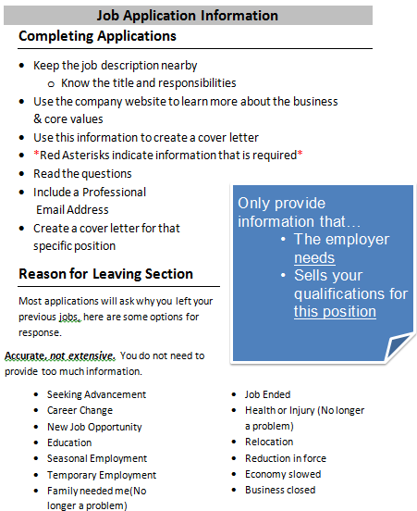
Explain that we will use this website to compete some activities for the day
The First of which: a job application
Ask learners what information they are typically asked for on a job application: make a list on the board
Hand out Job Application Information
Read through the rules with learners

Step 2: How the activity works
Learners should have their EYES FORWARD AND HANDS OFF OF THEIR COMPUTER
Teacher should open Reading and Writing for Job Search Day 8 Schoology Application and demonstrate downloading
Explain that learners will simply click in the line next to the text explaining what information is required and type
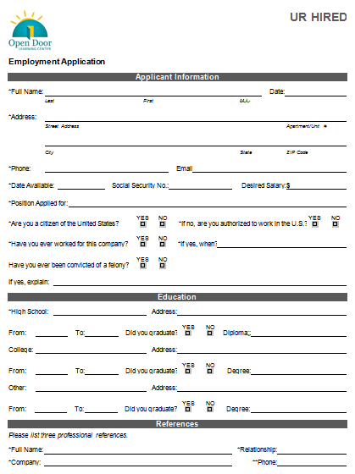
Ask if anyone knows what the asterisk means? It is required information
Learners will read through the information.
Explain that there are many pages to go through

Step 3: Students complete activity
Instruct students to begin the activity
Explain that when they are finished they should let the teacher know

Step 4: Saving
Review how to save the document
File>Save As> Click on Documents or Locate USB Drive>Name File>Click Save

Step 5: Return to Schoology
Ask students how to go back to the website you have open
Click on the program on the taskbar

Teacher Directions: Activity 3: References –References Reading
Note: It might come up that students ask if you, their teacher, can be a reference. This is up to you, but explain that they only way this would be possible is if the student has constantly been present in class, shows interest, stays on task and works hard.
Step 1: Context
Ask students qualities they believe make someone a good reference.
Ask what kind of people make good references?
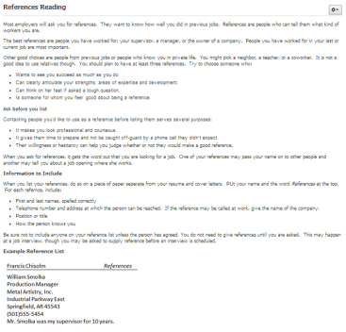
Instruct learners to open the References Reading on Schoology

Step 2: Read about References

Step 3: Time for questions

Step 4: Think of a reference
Once finished with the reading, open References Response
Read through directions as a class
Learners should NOT be typing at the point
Teacher should demonstrate responding to the post

Step 5: Students respond
Students should enter information about one of their own references into the post

If there is time: Teacher Directions: Activity 4: Reading Comprehension
-Day 8 Job Application Reading
Step 1: Assignment
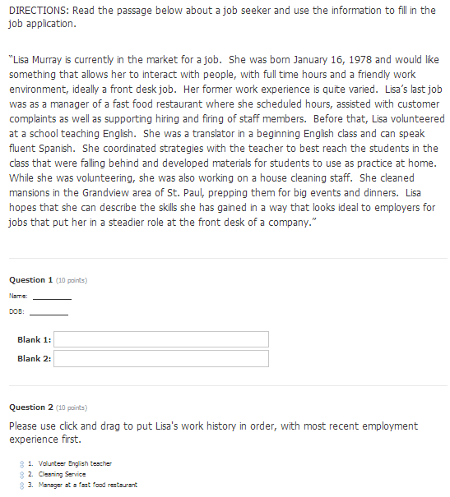
If there is time remaining, there is one more activity on Schoology that students can complete solo or as a class
Day 8 Job Application Reading
If you only have about 15 minutes, do it as a class, but if you have closer to half an hour, students should attempt independently

Note: If you do not get to this, no problem, it does not need to be made up. It is simply included if you have extra time or if students are really far ahead of their classmates.

Job Application Information

Completing Applications
- Keep the job description nearby
  - Know the title and responsibilities
- Use the company website to learn more about the business
& core values
- Use this information to create a cover letter
- *Red Asterisks indicate information that is required*
- Read the questions
Only provide information that…
  - The employer needs
  - Sells your qualifications for this position
- Include a Professional
Email Address
- Create a cover letter for that specific position
Reason for Leaving Section
Most applications will ask why you left your previous jobs, here are some options for response.
Accurate, not extensive. You do not need to provide too much information.

- Seeking Advancement
- Career Change
- New Job Opportunity
- Education
- Seasonal Employment
- Temporary Employment
- Family needed me(No longer a problem)
- Job Ended
- Health or Injury (No longer a problem)
- Relocation
- Reduction in force
- Economy slowed
- Business closed

UR HIRED

Employment Application

Applicant Information
*Full Name: |  |  |  | Date:
 | Last | First | M.I.

*Address:
 | Street Address | Apartment/Unit #

 | City | State | ZIP Code

*Phone: |  | Email

*Date Available: |  | Social Security No.: |  | Desired Salary: | $

*Position Applied for:

*Are you a citizen of the United States? | YES | NO | *If no, are you authorized to work in the U.S.? | YES | NO

*Have you ever worked for this company? | YES | NO | *If yes, when?

Have you ever been convicted of a felony? | YES | NO

If yes, explain:

Education
*High School: |  | Address:

From: |  | To: |  | Did you graduate? | YES | NO | Diploma::

College: |  | Address:

From: |  | To: |  | Did you graduate? | YES | NO | Degree:

Other: |  | Address:

From: |  | To: |  | Did you graduate? | YES | NO | Degree:

References
Please list three professional references.
*Full Name: |  |  | *Relationship:
*Company: |  |  | **Phone:
Address:
*Full Name: |  |  | *Relationship:
*Company: |  |  | *Phone:
Address:
*Full Name: |  |  | *Relationship:
*Company: |  |  | *Phone:
Address:

Previous Employment
*Company: |  | *Phone:
Address: |  | *Supervisor:

*Job Title: |  | Starting Salary: | $ | Ending Salary: | $

*Responsibilities:

*From: |  | To: |  | Reason for Leaving:

*May we contact your previous supervisor for a reference? | YES | NO

*Company: |  | *Phone:
Address: |  | *Supervisor:

*Job Title: |  | Starting Salary: | $ | Ending Salary: | $

*Responsibilities:

*From: |  | To: |  | Reason for Leaving:

*May we contact your previous supervisor for a reference? | YES | NO

*Company: |  | *Phone:
Address: |  | *Supervisor:

*Job Title: |  | Starting Salary: | $ | Ending Salary: | $

*Responsibilities:

*From: |  | To: |  | Reason for Leaving:

*May we contact your previous supervisor for a reference? | YES | NO

Military Service
Branch: |  | From: |  | To:

Rank at Discharge: |  | Type of Discharge:

If other than honorable, explain:

Disclaimer and Signature
I certify that my answers are true and complete to the best of my knowledge.
If this application leads to employment, I understand that false or misleading information in my application or interview may result in my release.
*Signature: |  | Date:

References Reading

Most employers will ask you for references. They want to know how well you did in previous jobs. References are people who can tell them what kind of workers you are.
The best references are people you have worked for: your supervisor, a manager, or the owner of a company. People you have worked for in your last or current job are most important.
Other good choices are people from previous jobs or people who know you in private life. You might pick a neighbor, a teacher, or a coworker. It is not a good idea to use relatives though. You should plan to have at least three references. Try to choose someone who:
- Wants to see you succeed as much as you do.
- Can clearly articulate your strengths, areas of expertise and development.
- Can think on her feet if asked a tough question.
- Is someone for whom you feel good about being a reference.
Ask before you list
Contacting people you'd like to use as a reference before listing them serves several purposes:
- It makes you look professional and courteous.
- It gives them time to prepare and not be caught off-guard by a phone call they didn't expect.
- Their willingness or hesitancy can help you judge whether or not they would make a good reference.
When you ask for references, it gets the word out that you are looking for a job. One of your references may pass your name on to other people and another may tell you about a job opening where she works.

Information to Include
When you list your references, do so on a piece of paper seperate from your resume and cover letters. PUt your name and the word References at the top. For each refernce, include:
- First and last names, spelled correctly
- Telephone number and address at which the person can be reached. If the reference may be called at work, give the name of the company.
- Position or title
- How the person knows you
Be sure not to include anyone on your reference list unless the person has agreed. You do not need to give references until you are asked. This may happen at a job interview, though you may be asked to supply reference before an interview is scheduled.
Example Reference List
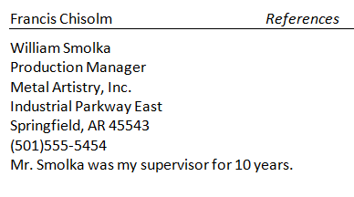
Sources:
Oppliger, Jurg. "Chapter 7." The Complete Get That Job!: A Quick and Easy Guide with Worksheets. Syracuse, NY: New Readers, 2001.40-42. Print.
Hering, Beth. "How to Choose Good Job References." How to Choose Good Job References. N.p., n.d. Web. 06
Day 8 Job Application Reading
DIRECTIONS: Read the passage below about a job seeker and use the information to fill in the job application.
“Lisa Murray is currently in the market for a job. She was born January 16, 1978 and would like something that allows her to interact with people, with full time hours and a friendly work environment, ideally a front desk job. Her former work experience is quite varied. Lisa’s last job was as a manager of a fast food restaurant where she scheduled hours, assisted with customer complaints as well as supporting hiring and firing of staff members. Before that, Lisa volunteered at a school teaching English. She was a translator in a beginning English class and can speak fluent Spanish. She coordinated strategies with the teacher to best reach the students in the class that were falling behind and developed materials for students to use as practice at home. While she was volunteering, she was also working on a house cleaning staff. She cleaned mansions in the Grandview area of St. Paul, prepping them for big events and dinners. Lisa hopes that she can describe the skills she has gained in a way that looks ideal to employers for jobs that put her in a steadier role at the front desk of a company.”
- Name: _
- DOB:
- Please select all of the skills Lisa has acknowledged in the passage that she could list on a job application.

- Computer Skills
- Communication
- Grant Writing
- Manufacturing
- Organized
- Social
- Customer Service
- Cooking
- Human Resources

- Put Lisa’s word history in order. Place a 1 next to the first job she had, a 2 next to the second and a 3 next to the most recent job she has had.

Volunteer English Teacher
Manager at a fast food restaurant
Cleaning service

