**Reading and Writing for Job Search Day 7**

|  |  |  |
| --- | --- | --- |
| **Objectives** *Learners will be able to…* | **Materials** | |
| ***Computer skill:*** *locate a job post online*  ***Computer skill:*** *get to a website*  ***Literacy skill:*** *create a resume*  ***Literacy skill:*** *understand job posts* | **Make Student Copies**   * **Understanding Job Posts PPT-** 4 slider per page **(Tab 21)** * **Job Search Exercise 6: Reading Job Posts:** print double sided **(Tab 22)** * **Job Search Websites (Tab 23)**   **Download**   * **Day 7 Understanding Job Posts PPT**   **Props, Technology or Other Resources**   * Projector * Computer for every student * USB Drives | |
|  | | |
| **Lesson Plan** | | Vocabulary |
| **Warm-up: 10 minutes Spell Check Practice**  Description: Open Word and type: “resurched community resaurces”. Ask students if there is anything wrong with the sentence/what does the red line mean? Ask them how to check the spelling? Right-click on top of misspelled word, click appropriate spelling.  Materials/Prep:  **Activity 1: Resume Writing**  Description: give students about 20 minutes to work on their resumes. Try to leave an hour and a half for the next activities.  Materials/Prep:  **Activity 2: Understanding Job Posts**  Description: teacher will explain how to read a job posting and the important information to take out of it. Important that students remember to read the whole post, not just pasts of it  Materials/Prep: download **Day 7 Understanding Job Posts PowerPoint**, copies of **Job Search Exercise 6: Reading Job Posts**  **Activity 3: Job Search Websites**  Description: teacher will handout a list of websites that students can use for their search and will practice searching and review internet vocabulary and important job post information  Materials/Prep: copies of **Job Search Websites** | | * Internet * Qualifications * Requirements * Wages * Benefits * Websites * Web Address * Web address * Address bar |

**Teacher Directions: Activity 1: Resume Writing**

Step 1: Open Previously Saved Document

**Ask** learners how to open a previously saved document; they should lead you through the steps

Open Word> Click on File>Click on Open> Locate Appropriate Drive> Click on Resume>Click on Open

Step 2: Students work on resume

Instruct students to work on their resumes for about 20 minutes (the warm-up and Activity 1 should only take up about 30 minutes, leaving 1 and a half hour for the second half of class)

Teacher should circulate to review resumes and offer assistance/suggestions

Step 3: Save

Remind learners to save their document

Ask them how

Point out the Save button on the toolbar, looks like a floppy disk

Ask what the difference is between save and save as

* Save as: when it has never been saved before or if you want to change the name/location
* Save: when you are simply updating the content of a document

**Teacher Directions: Activity 2: Understanding Job Posts**

**–Download Day 7 Understanding Job Posts PPT**

**-Job Search Exercise 6: Reading Job Posts**

Step 1: Context

**Explain** that the second half of this unit will be spend learning more about the searching for jobs, while the first part was creating a document needed for the job search

**Ask** learners what is often included in a job posting, what information do they see right away

Step 2: PowerPoint

**Download Day 7 Understanding Job Posts PowerPoint**

Go through with learners

Step 3: Practice

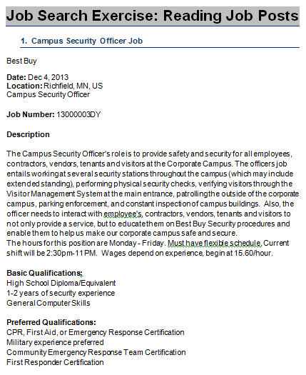 Last slide talks about a handout

Hand out **Job Search Exercise 6: Reading Job Posts**

Follow directions and go through as a class

**Teacher Directions: Activity 3: Job Search Websites -Job Search Websites**

Step 1: What do we know?

Ask learners if they have searched for jobs online before

Ask what websites they have used?

Step 2: Recommended Websites

**Hand out Job Search Websites Handout**

Go over the websites listed

Draw attention to websites students might have mentioned previously

Step 3: Internet Review

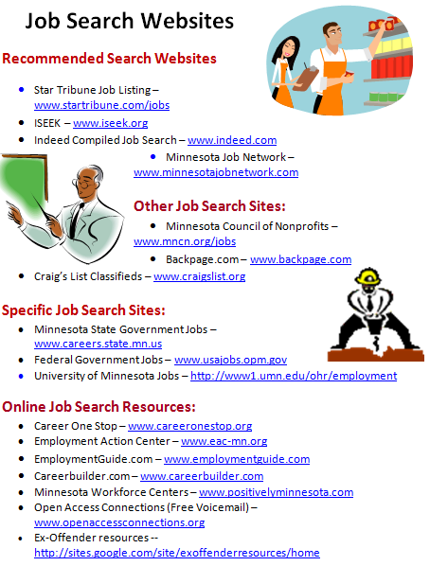 Ask learners how we get to the websites listed: *get online*

Direct learners to an internet browser: which one you use is up to teacher preference. If the computers have **Google Chrome it is recommended, but Internet Explorer is fine for these activities**

**Ask** learners if they remember how to get to a website: *type* ***web address*** *into* ***address bar***

**Ask** for an example of a **web address** from the handout

Step 4: Demonstrate Going to a Website

Learners should have their **EYES FORWARD AND HANDS OFF OF THEIR COMPUTER**

**Demonstrate** typing minnesotajobnetwork.com into the **address bar**

**Press enter**

**Ask** students which website you are at: minnesotajobnetwork.com

**Ask** if they can see where I could search for jobs

**Ask** how to get to the previous webpage you were on: *back arrow*

Step 5: Do together

As a class, go to minnesotajobnetwork.com

Have students explain steps as they go, using appropriate vocabulary

Remind them that spelling is important

NO SPACES IN A WEB ADDRESS

Everyone should type in a type of job, for practice type: assistant

Step 6: Explain results page

Point out how to open a result

Depending on how it opens, you will have to explain how to go back to the results page once you have finished reading

NOTE: tabs will be discussed Day 9, so do not go in depth

Step 7: Important Job Post information

**Instruct** learners to try to locate the important information we discussed during the last activity

What are the requirements? What are desired skills? Are you qualified?

Does it list wages?

# Job Search Exercise 6: Reading Job Posts

# Campus Security Officer Job

Best Buy

**Date:** Dec 4, 2013

**Location:** Richfield, MN, US

Campus Security Officer  
  
**Job Number:**13000003DY  
  
**Description**  
The Campus Security Officer's role is to provide safety and security for all employees, contractors, vendors, tenants and visitors at the Corporate Campus. The officers job entails working at several security stations throughout the campus (which may include extended standing), performing physical security checks, verifying visitors through the Visitor Management System at the main entrance, patrolling the outside of the corporate campus, parking enforcement, and constant inspection of campus buildings.

The hours for this position are Monday - Friday. Must have flexible schedule. Current shift will be 2:30pm-11 PM. Wages depend on experience, begin at 15.60/hour.   
  
**Basic Qualifications:**  
High School Diploma/Equivalent  
1-2 years of security experience  
General Computer Skills  
  
**Preferred Qualifications:**  
CPR, First Aid, or Emergency Response Certification  
Military experience preferred  
Community Emergency Response Team Certification  
First Responder Certification

|  |  |  |  |  |  |  |  |  |
| --- | --- | --- | --- | --- | --- | --- | --- | --- |
| Job Title: Teller Schedule Type: Regular  Work Hours: 30 | | | | | | | | |
|  | |  |  |  | | --- | --- | --- | |  |  |  | |  | |  | |  | **Job Description** | | |  | Our Expectation of our Tellers:   Tellers introduce customers to new products and services, and generate leads for other members of the sales team to close.  An excellent teller processes between 20-25 customer transactions each hour with no mistakes through patience, attention to detail, and the ability to follow procedures.   Every teller is responsible for maintaining and balancing a cash drawer. Identifies and makes sales referrals, recommends alternate channels, cross-sells bank services and products for Wells Fargo partners, provides excellent customer service.   At Wells Fargo, we have an outstanding diverse team.  We want people who pitch in and help others without being asked and want team members who are committed to the success of the team. | | |  | |  | |  | **Basic Qualifications** | | |  | 1+ years experience interacting with people or customers | | |  | |  | |  | **Minimum Qualifications** | | |  | Demonstrated skill in use of computers. Demonstrated ability to achieve individual and team goals. Positive approach in interactions with customers and team members.  Reliable attendance.  Good communication skills.  Ability to work a schedule that includes working weekends and some holidays. | | |  | |  | |  | **Preferred Skills** | | |  | Previous cash-handling experience, Previous experience selling products and services, Previous experience meeting customer satisfaction goals, Previous experience working in a fast paced environment, Ability to stand for extended periods of time, Multilingual speakers are encouraged to apply. | | |  |  |  |  |  |  |  |

C:\Users\knorman\AppData\Local\Microsoft\Windows\Temporary Internet Files\Content.IE5\RPKP7SMP\MC900432493[1].wmf**Job Search Websites**

**Recommended Search Websites**

* Star Tribune Job Listing – [www.startribune.com/jobs](http://www.startribune.com/jobs)
* ISEEK – [www.iseek.org](http://www.iseek.org)
* Indeed Compiled Job Search – [www.indeed.com](http://www.indeed.com)
* C:\Program Files\Microsoft Office\MEDIA\CAGCAT10\j0301252.wmfMinnesota Job Network –[www.minnesotajobnetwork.com](http://www.minnesotajobnetwork.com)

**Other Job Search Sites:**

* Minnesota Council of Nonprofits – [www.mncn.org/jobs](http://www.mncn.org/jobs)
* Backpage.com – [www.backpage.com](http://www.backpage.com)
* Craig’s List Classifieds – [www.craigslist.org](http://www.craigslist.org)

**Specific Job Search Sites:**

* Minnesota State Government Jobs – [www.careers.state.mn.us](http://www.careers.state.mn.us)
* Federal Government Jobs – [www.usajobs.opm.gov](http://www.usajobs.opm.gov)
* University of Minnesota Jobs – <http://www1.umn.edu/ohr/employment>

**Online Job Search Resources:**

* Career One Stop – [www.careeronestop.org](http://www.careeronestop.org)
* Employment Action Center – [www.eac-mn.org](http://www.eac-mn.org)
* EmploymentGuide.com – [www.employmentguide.com](http://www.employmentguide.com)
* Careerbuilder.com – [www.careerbuilder.com](http://www.careerbuilder.com)
* Minnesota Workforce Centers – [www.positivelyminnesota.com](http://www.positivelyminnesota.com)
* Open Access Connections (Free Voicemail) – [www.openaccessconnections.org](http://www.openaccessconnections.org)
* Ex-Offender resources -- <http://sites.google.com/site/exoffenderresources/home>