Reading and Writing for Job Search Day 5

Objectives Learners will be able to… | Materials
Computer skill: open previously saved document  Computer skill: use enter key to add empty space  Computer skill: use alignment buttons  Literacy skill: create summary of qualifications  All students should end with summary of qualifications at the top of their resume | Make Student Copies  - Day 5 Warm-up-print one per 2 students (Tab 16)  - Employable Qualities and Summary of Qualifications Mad Lib- print front and back (Tab 17)  Props, Technology or Other Resources  - Projector  - Computer for every student  - USB Drives
Lesson Plan |  | Vocabulary
Warm-up: 10 minutes-Refer to next page  Description: hand out Day 5 Warm-up. Explain that students will have to try to take the verbs provided and make them past tense so that they can be placed in a resume. Learners can work together. Demonstrate 1-3 examples.  Materials/Prep: copies of Day 5 Warm-up  Activity 1: Open Previously Saved Document  Description: teacher will demonstrate, you will do as a class, and then students will write down the steps  Materials/Prep:  Activity 2: Resume Writing  Description: review what was covered day 4 and then let students continue to work on the previous experience section of their resume  Materials/Prep:  Activity 3: Summary of Qualifications  Description: teacher will explain what it is and how to make one using a mad-lib type activity  Materials/Prep: copies of Employable Qualities and Summary of Qualifications Mad Lib  Activity 4: Writing  Description: students will learn how to enter space above existing text using the enter key and then will add their summary of qualifications to their resume |  | - Resume  - Action Verbs  - Previous Experience  - Job Responsibilities  - Summary of Qualifications

Teacher Directions: Activity 1: Open Previously Saved Document
Step 1: Open Previously Saved-Demonstration
Learners should have their EYES FORWARD AND HANDS OFF OF THEIR COMPUTER
Demonstrate how to open a previously saved document
Open Word>Click on File>Click on Open>Locate Appropriate Drive>Click on correct Resume file>click on Open button

Step 2: Do Together
Go through the steps as a class, ask student what comes next

Step 3: Write steps down
Instruct learners to write the steps down for themselves in the appropriate order

Teacher Directions: Activity 2: Resume Writing

Step 1: Where are we?
Ask learners what they worked on last class: resume>previous experience section
Ask if anyone filled in the information for three jobs with at least 3 responsibilities
If they did not, give them about 20 minutes to work on that today

Step 2: Review Responsibilities vs Duties
FIRST: What is the difference between responsibility and duty: job duties are everyday tasks while responsibilities are things you did that allowed company to run smoothly. Instead of cleaned, you organized, instead of drove, you operated, etc.
How should action verbs be used? Start each responsibility with an action verb

If students were not present for Day 5 they can start from scratch to develop their resume

Step 3: Resume writing time
Explain that students should now continue working on their resumes
They should move on to the job history section and really think about what to put into their job descriptions
Remind them to use the action verb list from Day 4

Step 3: Student’s work
While students are working, circulate to assist them
Point out areas that might need to be looked at a again or ways to change syntax

Step 4: Save Resumes
Remind learners to save as they go, but be sure to save at the end before shutting down

Teacher Directions: Activity 3: Summary of Qualifications
-Employable Qualities and Mad Lib
Step 1: Review
Ask students what the purpose of the summary of qualifications is: it is a quick sales pitch to an employer
Ask what information should be included: all skills that are relevant to the job/that separate you from a crowd, any gaps in employment, how you would benefit company
How long should it be: 3-5 sentences
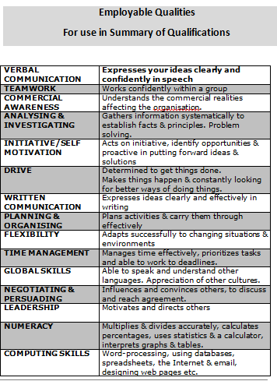
Step 2: Hand out Employable Qualities
Have students read through and circle up to 3 qualities they have that they want an employer to know about and put a star next to up to 2 qualities they want their employers to have

Step 3: Demonstrate
Learners should have their EYES FORWARD AND HANDS OFF OF COMPUTER
Use the Mad Lib to create a summary of qualifications
Explain what you are doing, step by step

Step 4: Hand out Mad Lib
Give students Summary of Qualifications Mad Lib
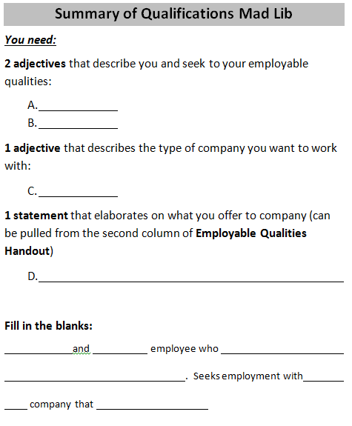
Explain each part
Do at least two examples together on the board

Step 5: Student Practice
Instruct students to try to put together their own summary of qualifications

Teacher Directions: Activity 4: Resume Writing

Step 1: How to Enter the Summary
Learners should have their EYES FORWARD AND HANDS OFF OF THEIR COMPUTER
Explain that we will now enter the summary of qualifications that we wrote into our own resumes
Demonstrate using the enter key to add space above the job experience text already entered
Bring cursor to right before first letter>Click>Press Enter twice>Type Summary of Qualifications:

Step 2; Do it together
Learners should now lead you through how to add empty space above existing text
Point out UNDO button

Step 3: Independent typing

Step 4: Save

Day 5 Warm-up

Directions: Write the correct verb in the sentence below. Be sure to write it in using past tense.

Communicate
Interpret
Train
Assist
Supervise

- medical information for Somali speaking patients
- elderly client with bathing, dressing and exercising
- new employees on how to use the copier
- 10 employees in the customer service department
- clearly with supervisors and other employees
Day 5 Warm-up

Directions: Write the correct verb in the sentence below. Be sure to write it in using past tense.

Communicate
Interpret
Train
Assist
Supervise

- medical information for Somali speaking patients
- elderly client with bathing, dressing and exercising
- new employees on how to use the copier
- 10 employees in the customer service department
- clearly with supervisors and other employees

Employable Qualities
For use in Summary of Qualifications

Directions:
- Circle 3 qualities you have that you want an employer to know about
- Place a *star next to 2 qualities you want your future company to have

Quality:  (adjectives) | How to express quality:
VERBAL  COMMUNICATOR | Expresses your ideas clearly and confidently in speech
TEAM WORKER | Works confidently within a group
COMMERCIALLY AWARE | Understands the commercial realities affecting the organization.
ANALYZER & INVESTIGATER | Gathers information systematically to establish facts & principles. Problem solver.
INITIATIVE/SELF MOTIVATED | Acts on initiative, identifies opportunities & proactive in putting forward ideas & solutions
DRIVEN | Determined to get things done.  Makes things happen & constantly looking for better ways of doing things.
WRITTEN COMMUNICATOR | Expresses ideas clearly and effectively in writing
PLANNR & ORGANIZER | Plans activities & carry them through effectively
FLEXIBILE | Adapts successfully to changing situations & environments
PRIORITIZER | Manages time effectively, prioritizes tasks and able to work to deadlines.
GLOBALLY MINDED | Able to speak and understand other languages. Appreciation of other cultures.
NEGOTIATER & PERSUADER | Influences and convinces others, to discuss and reach agreement.
LEADER | Motivates and directs others
NUMERICALLY MINDED | Multiplies & divides accurately, calculates percentages, uses statistics & a calculator, interprets graphs & tables.
COMPUTER LITERATE | Word-processing, using databases, spreadsheets, the Internet & email, designing web pages etc.
SELF AWARE | Aware of achievements, abilities, values & weaknesses & what you want out of life.
CONFIDENT | Presents a strong, professional, positive image to others which inspires confidence & commands respect.
LIFELONG LEARNER | Continues to learn throughout life. Develops the competencies needed for current & future roles
STRESS TOLERANT | Maintains effective performance under pressure
VIRTUOUS/HAS INTEGRITY | Adheres to standards & procedures, maintains confidentiality and questions inappropriate behavior.
INDEPENDENT | Accepts responsibility for views & actions and able to work under their own direction & initiative.
PROFESSIONAL | Pays care & attention to quality in all their work. Supports & empowers others.
ACTION PLANNER | Able to decide what steps are needed to achieve particular goals and then implement these.
DECISION-MAKER | Determines the best course of action. Evaluates options based on logic & fact & presents solutions
INTERPERSONAL | Recognizes & respects different perspectives. Open to the ideas & views of others
CREATIVE | Generates & applying new ideas & solutions
INNOVATIVE | Introduces new ideas, seeks new ways of doing things
CUSTOMER-CENTERED | Maintains supportive environment and considers clients’ needs and satisfaction the priority.

Summary of Qualifications Mad Lib
You need:
2 adjectives that describe you and seek to your employable qualities:

1 statement that elaborates on a quality you possess (can be pulled from the second column of Employable Qualities Handout)

1 adjective that describes the type of company you want to work with:

Fill in the blanks:
(a) and (b) employee who (c) . Seeks employment with (d) company that (companies mission statement).

