  - PowerPoint: Day 8
Objectives Learners will be able to… | Materials
Computer skill: slide transitions  Computer skill: review create own PPT  Literacy Skill: grading PPTs  Literacy Skill: TABE test | Make Student Copies  - PowerPoint Rubric (If student does not have PPT Packet)  - TABE Literacy Activity (Tab 20)  - TABE Literacy Activity Part 2 (Two per page, need to cut in half) (Tab 22)  Props, Technology or Other Resources  - Projector  - Computer for every student  - USB Drives  - Day 8 Presentation Example 1  - Day 8 Presentation Example 2
Lesson Plan | Vocabulary
Activity 1: Good vs. Bad Presentations -20 minutes  Description: teacher will present two PowerPoint Presentations, one is good, one is bad. Learners will review them and explain positives and negatives  Materials/Prep: PowerPoint Rubric, download Day 8 Presentation Examples 1 & 2, print Presentation Example 1 in Notes Form  Activity 2: Slide Transitions-25 Minutes  Description: learners will get an introduction to Slide Transitions  Materials/Prep:  Activity 3: TABE- 60 minutes at least  Description: learners will take TABE literacy Assessment  Materials/Prep: get tests from coordinator, determine any learners who do not need to be tested and print out PowerPoint Exercise 8: Practice | - Transitions  - Rubric

Teacher Directions: Activity 1: Good vs. Bad Presentations -PowerPoint Rubric
-Day 8 Presentation Example 1
Step 1: Context -Day 8 Presentation Example 2
Handout PowerPoint Packets that students began working on Day 6
Explain that we will you will be presenting two PowerPoint presentations
Learners should open their PPT Packet to the Day 8 Rubric
Hand out PowerPoint Rubric
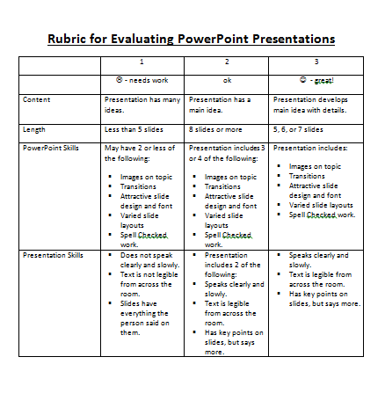
Quickly run through the rubric with learners
Explain animation and how learners should pay close attention to the transitions used in each presentation

Step 2: Presentation #1-go through and review
Download Day 8 Presentation Example 1
Print out the PPT in Notes Form because there are notes that allow you to expand on the information that is on the slides.
Explain that students should watch the presentation and make notes on the rubric as they go (they will use the same rubric for both Presentations)
Go through Presentation with students
Once finished, give learners a minute to fill in the rubric
Review reactions to first Presentation- students might be harsh, but they will see a bad presentation next, which will make it clear what is good and what is bad

Step 3: Presentation #2- go through and review
Download Day 8 Presentation Example 2
Just read this PowerPoint off of the slide. Let the transitions move slowly through to demonstrate how tedious they can be for the audience.
Same as before: Explain that students should watch the presentation and make notes on the rubric as they go
Go through Presentation with students
Once finished, give learners a minute to fill in the rubric

Step 4: Review and Compare
Review reactions to the second presentation and compare to the first presentation
What did the students like/dislike? What could have been better?

Teacher Directions: Activity 2: Transitions -Day 8 Presentation Example 1
-Day 8 Presentation Example 2
Step 1: Context
Explain that as was explained in the first activity, PPT presentations can be further enhanced by using fancy transitions
Ask what transitions are- how you move from one slide/paragraph/etc to another
Explain that there are many options for animation, but learners should be careful not to use ones that are too fancy/take too long to bring up information

Step 2: Demonstrate adding transitions
Demonstrate how to add a transition: Click on a Slide> Click on Insert>Click on Transitions
Remind learners again that they should not pick something that is showy/takes a long time to transition, they only have 5 minutes to present their slideshow and the audience often becomes impatient with long transitions
Go through and add some transitions and then present the slide show and ask learners which transitions were fun but not too showy

Step 3: Writing down steps
Instruct students to turn to Day 8 Slide Transitions in their Packet
Work together to write down the steps to insert a slide transition
Explain that this should be used to insert transitions into their own PPTs in the remaining classes
After the write down the steps, there are some review True or False Questions they should complete, if there is time.

Step 3: Learner practice
Practice opening any previously saved PowerPoint: (if PPT is open) File>Open>My Computer> (E: ) Drive>PPT file. (If PPT is not open) Start menu>My computer>(E: ) Drive>PPT file
Review with learners how to change slide transitions on the open PPT

Teacher Directions: Activity 3: TABE Test -TABE Literacy Activity
-TABE Literacy Activity Part 2
Step 1: Introduce TABE
Learners will take the TABE literacy test.
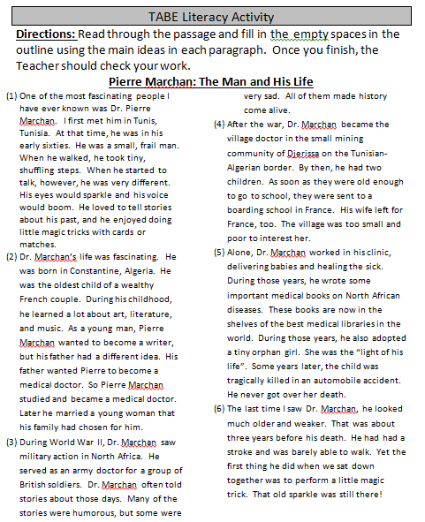
- Why? Open Door is a Literacy organization, so we have to incorporate literacy into all of our classes. MLC is required to give learners these tests in order to receive funding.
- Learners have 50 minutes to take the test
- Phones must be turned off and there will be no conversation between classmates
- Computers must be put away
- Exception: learners who do not have to take the assessment, those learners should be moved to the back of the class, with the TABE takers in front
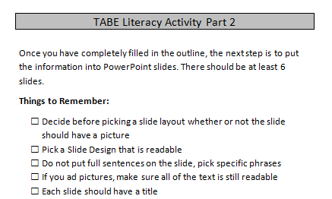
- Learners who take the test need to start on the page the answer key is in
  - There might be sample questions, those should not be answered. Start with the first REAL question

Step 2: For learners who do not take assessment
Again, be sure to put those who are not testing in the back of the room/separate from those testing
These students will be completing TABE Literacy Activity
They will read a passage, fill in an outline which will be checked by the Teacher-Answer key is with the handout (does not have to be perfect, they should try to get the gist though)
Once they have filled in the outline hand out TABE Literacy Part 2, they can turn the outline into a PPT

Potential Questions that may arise:
Do I have to take it? Yes. These tests are required of learners enrolled in Open Door Learning Center classes.
What can I do when I am finished? Once finished learners can either work on their PPT presentation, Mavis Beacon Typing or leave for the day.

STUDENTS MUST RETURN POWERPOINT PACKET AT THE END OF THE DAY. THESE PACKETS SHOULD NOT GO HOME WITH STUDENTS.
TABE Literacy Activity
Directions: Read through the passage and fill in the empty spaces in the outline using the main ideas in each paragraph. Once you finish, the Teacher should check your work.
Pierre Marchan: The Man and His Life

- One of the most fascinating people I have ever known was Dr. Pierre Marchan. I first met him in Tunis, Tunisia. At that time, he was in his early sixties. He was a small, frail man. When he walked, he took tiny, shuffling steps. When he started to talk, however, he was very different. His eyes would sparkle and his voice would boom. He loved to tell stories about his past, and he enjoyed doing little magic tricks with cards or matches.
- Dr. Marchan’s life was fascinating. He was born in Constantine, Algeria. He was the oldest child of a wealthy French couple. During his childhood, he learned a lot about art, literature, and music. As a young man, Pierre Marchan wanted to become a writer, but his father had a different idea. His father wanted Pierre to become a medical doctor. So Pierre Marchan studied and became a medical doctor. Later he married a young woman that his family had chosen for him.
- During World War II, Dr. Marchan saw military action in North Africa. He served as an army doctor for a group of British soldiers. Dr. Marchan often told stories about those days. Many of the stories were humorous, but some were very sad. All of them made history come alive.
- After the war, Dr. Marchan became the village doctor in the small mining community of Djerissa on the Tunisian-Algerian border. By then, he had two children. As soon as they were old enough to go to school, they were sent to a boarding school in France. His wife left for France, too. The village was too small and poor to interest her.
- Alone, Dr. Marchan worked in his clinic, delivering babies and healing the sick. During those years, he wrote some important medical books on North African diseases. These books are now in the shelves of the best medical libraries in the world. During those years, he also adopted a tiny orphan girl. She was the “light of his life”. Some years later, the child was tragically killed in an automobile accident. He never got over her death.
- The last time I saw Dr. Marchan, he looked much older and weaker. That was about three years before his death. He had had a stroke and was barely able to walk. Yet the first thing he did when we sat down together was to perform a little magic trick. That old sparkle was still there!

Title-
- Introductory paragraph
  - Main idea-
- Detail 1: Early years
  - Birth
  - Family
    - Oldest child
    - Father wanted him to be a doctor
    - Family chose young woman for him to marry
- Detail 2: World War II
  - Saw military action in North Africa
  - .
- Detail 3: After the war

- Detail 4: Living Alone

- Main Idea 5: Before his death

TABE Literacy Activity Part 2

Once you have completely filled in the outline, the next step is to put the information into PowerPoint slides. There should be at least 6 slides.
Things to Remember:
- Decide before picking a slide layout whether or not the slide should have a picture
- Pick a Slide Design that is readable
- Do not put full sentences on the slide, pick specific phrases
- If you ad pictures, make sure all of the text is still readable
- Each slide should have a title

TABE Literacy Activity Part 2

Once you have completely filled in the outline, the next step is to put the information into PowerPoint slides. There should be at least 6 slides.
Things to Remember:
- Decide before picking a slide layout whether or not the slide should have a picture
- Pick a Slide Design that is readable
- Do not put full sentences on the slide, pick specific phrases
- If you ad pictures, make sure all of the text is still readable
- Each slide should have a title
Answer key for teachers:
The Life of Pierre Marchan
- Introductory paragraph
  - Main idea- Pierre Marchan is an interesting man with many stories he enjoys sharing
- Early years
  - Born in Constantine, Algeria
  - Family:
    - Oldest child
    - Father wanted him to be a doctor
    - Family chose young woman for him to marry
- World War II
  - Saw military action in North Africa
  - Served as an army doctor
- After the war
  - Became village doctor
  - Had two children
  - Family moved to France
- Living Alone
  - Spent a lot of time in his clinic
  - Wrote medical books that are important today
  - Adopted a child
- Before his death
  - Had a stroke
  - Still had the same personality, no matter how frail
Day 8 PowerPoint Presentation Rubric
 | 1 | 2 | 3
 | - needs work | ok | - great!
Content | Presentation has many ideas. | Presentation has a main idea. | Presentation develops main idea with details.
Length | Less than 5 slides | 8 slides or more | 5, 6, or 7 slides
PowerPoint Skills | May have 2 or less of the following:  - Images on topic  - Transitions  - Attractive slide design and font  - Varied slide layouts  - Spell Checked work. | Presentation includes 3 or 4 of the following:  - Images on topic  - Transitions  - Attractive slide design and font  - Varied slide layouts  - Spell Checked work. | Presentation includes:  - Images on topic  - Transitions  - Attractive slide design and font  - Varied slide layouts  - Spell Checked work.
Presentation Skills | - Does not speak clearly and slowly.  - Text is not legible from across the room.  - Slides have everything the person said on them. | - Presentation includes 2 of the following:  - Speaks clearly and slowly.  - Text is legible from across the room.  - Has key points on slides, but says more. | - Speaks clearly and slowly.  - Text is legible from across the room.  - Has key points on slides, but says more.

Day 8 PowerPoint Presentation Rubric

This presentation mainly:

- entertains (For example - makes the viewer laugh)
- informs (for example - teaches the view something)
- persuades (For example - changes the viewer’s opinion)
- narrates (for example – tells a story)
- describes (for example – gives details about an object or location)

Write each answer in a complete sentence.
The main idea of this presentation was:

________________________________________________________________________________

Write something you enjoyed about the presentation:

Write something you believe could be improved about the presentation:

