PowerPoint: Day 7

Objectives Learners will be able to… |  | Materials
Computer skill: PowerPoint do’s and don’ts  Computer skill: translate an outline into slide format  Literacy skill: create an outline  Literacy Skill: learners will assess a presentation using a rubric | Make Student Copies  - PowerPoint True or False- two quizzes per page, so only print one page for every two students (Tab 18)  - For any students that missed day 6, copies of PowerPoint Packet (Tab 16)  - PowerPoint Presentation Rubric –for students who do not have PowerPoint Packet (Tab 19)  Props, Technology or Other Resources  - Projector  - Computer for every student  - USB Drives  - Day 7 Bad PowerPoint  - Day 7 Good PowerPoint  - Day 7 Practice Presentation
Lesson Plan |  |  | Vocabulary
Warm-up:  Description: Read through the lesson report for Day 6 and see if students got to the PowerPoint Exercise 8 (Tab 17). If not, review the 4 Scanning Tips (1. Determine Key Words, 2. Determine order, 3. Be Fast, 4. Be Accurate) and have them complete the exercise.  If students did complete Exercise 8, project a menu from a restaurant or movie times and ask students to scan for answers. Determine order, identify key words and do it quickly.  Materials/Prep: Read through lesson report from Day 6, either print PowerPoint Exercise 8 (Tab 17) or project a menu from online  Activity 1: PowerPoint Do’s and Don’ts-20 minutes  Description: teacher will go over a PPT that reviews good/bad PPT characteristics  Materials/Prep: make sure all students have the PPT Packet (we will use Day 7 Bad PPT and Good PPT), download Day 7 Bad PPT and Day 7 Good PPT, copies of PowerPoint True or False  Activity 2: Learner PPT Outline- 50 Minutes  Description: learners will create an outline of their main ideas and supporting ideas and then begin creating their PowerPoint  Materials/Prep: again, make sure all of the students have their PPT Packet (for this activity we will use Day 7 Outline and Slide Outline)  Activity 3: Presentation Grading-20 Minutes  Description: teacher will go through a PowerPoint and learners will review what was good/bad about it  Materials/Prep: download Day 7 Practice Presentation, PowerPoint Presentation Rubric |  |  | - Outline  - Good PowerPoint  - Bad PowerPoint  - Main Points  - Rubric
Teacher Directions: Activity 1: PowerPoint Do’s and Don’ts -PowerPoint Packet: Day 7
Step 1: Context -Download Day 7 Bad PowerPoint
Explain that as learners are working on their presentations, -Download Day 7 Good PowerPoint
there are several tips to keep in mind about making sure it -PowerPoint True and False
is a good presentation
Handout PowerPoint Presentation Packet from Day 6

Step 2: Explain information
Instruct learners to open their PowerPoint Packets to Day 7 Bad PowerPoint
Download Day 7 Bad PowerPoint
Review with students

Step 3: Good PowerPoint
Instruct learners to turn the page in their packet to Day 7 Good PowerPoint
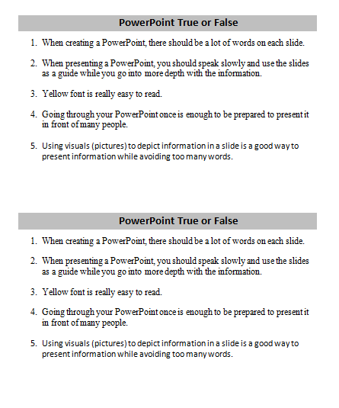
Download Day 7 Good PowerPoint and review with students

Step 3: Mini quiz
Instruct learners to put the Do’s and Don’ts handout under their desk/somewhere they cannot see it
Hand out PowerPoint True or False
Instruct learners to complete the quiz and remain quiet once finished
When everyone is done, review answers with learners

- F
- T
- F
- F
- T

Teacher Directions: Activity 2: Presentation -Teacher Outline Answer key (in lesson plan)
-PowerPoint Packet: Day 7 Outline
Step 1: Context
Explain that we will now be expanding the mini outline that was completed in Day 6 into a real outline as directed in the PowerPoint Packet

Step 2: Demonstrate
Instruct learners to open packet to Day 7 Teacher Practice Outline
Review: Write on the board the topic of My Childhood and have learners try to come up with supporting details (options): 1. Where Born/Hometown 2. School 3. Interests
Demonstrate how to take those main ideas and expand the main ideas into an outline- teacher outline is on next page, though you can adapt to your own childhood, simply a suggestion
Teacher should start the outline, but learners should lead you through the remainder
Learners should fill in as you go

Step 3: Individual Practice
Learners should now take their own supporting details from Day 6 on the first page of their packet and expand them into an outline

Teacher Practice Outline
Title: My Childhood
- Introductory slide
  - Title: My Childhood.
  - Main Idea .
  - Any visuals? Maybe a picture of myself
- Supporting Detail-Where born
  - When I was born .
  - Town born in .
  - Any visuals? Picture of my house
- Supporting Detail -School
  - Name of elementary school .
  - Friends/teachers/favorite subjects .
  - Any visuals?
- Supporting Detail -Interests/What I Liked
  - Biking .
  - Swimming .
  - Any visuals?
- Closing- Reiterate topic, main idea
  - Born in *blank* where I learned a lot and had fun with my friends .
  - .
  - Any visuals?
- Any questions? This slide is to allow for discussion/questions after the presentation
Step 4: Demonstrate
Teacher should open a new PPT and demonstrate how to fill the information in
Where does the title go? Where do the details go? Etc.

Step 5: Learner practice
Teachers should check learners’ Main Points, be sure they are clear and specific
Once learners have been cleared, instruct them to begin creating their own PPT

Step 5: Saving
Ensure that students are saving their PPTs
Review the steps to save and how to save using the button on the ribbon

Teacher Directions: Activity 3: Presentation Grading- 20 minutes
-PowerPoint Rubric (in packet)
Step 1: Set-up -Download Day 7 Practice Presentation
Direct students to Day 7 PowerPoint Rubric in their packet
Explain that this rubric is what will be used to grade presentations made throughout class
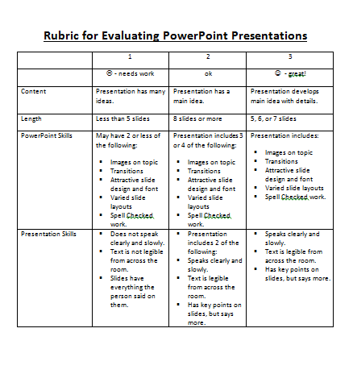
Go over the rubric and each aspect
Explain that you will be presenting a PowerPoint to the class and they should grade the presentation

Step 2: Review
Download Day 7 Practice Presentation
Once finished, review what learners thought was good/bad about presentation
Potential questions
- What was are the main ideas? Are there too many? Too few?
- What was the purpose? To inform
- What was good about presentation?
- What was bad?
- What do you recommend?
- Is this a good topic for a learner in this class to use? No, it is something that involved a lot of research. Topics for class should be discussing something we already know about

STUDENTS MUST RETURN POWERPOINT PACKET AT THE END OF THE DAY. THESE PACKETS SHOULD NOT GO HOME WITH STUDENTS.
PowerPoint True or False
- When creating a PowerPoint, there should be a lot of words on each slide.
- When presenting a PowerPoint, you should speak slowly and use the slides as a guide while you go into more depth with the information.

- Yellow font is really easy to read.
- Going through your PowerPoint once is enough to be prepared to present it in front of many people.

- Using visuals (pictures) to depict information in a slide is a good way to present information while avoiding too many words.

PowerPoint True or False
- When creating a PowerPoint, there should be a lot of words on each slide.
- When presenting a PowerPoint, you should speak slowly and use the slides as a guide while you go into more depth with the information.

- Yellow font is really easy to read.
- Going through your PowerPoint once is enough to be prepared to present it in front of many people.

- Using visuals (pictures) to depict information in a slide is a good way to present information while avoiding too many words.

PowerPoint Presentation Rubric
 | 1 | 2 | 3
 | - needs work | ok | - great!
Content | Presentation has many ideas. | Presentation has a main idea. | Presentation develops main idea with details.
Length | Less than 5 slides | 8 slides or more | 5, 6, or 7 slides
PowerPoint Skills | May have 2 or less of the following:  - Images on topic  - Transitions  - Attractive slide design and font  - Varied slide layouts  - Spell Checked work. | Presentation includes 3 or 4 of the following:  - Images on topic  - Transitions  - Attractive slide design and font  - Varied slide layouts  - Spell Checked work. | Presentation includes:  - Images on topic  - Transitions  - Attractive slide design and font  - Varied slide layouts  - Spell Checked work.
Presentation Skills | - Does not speak clearly and slowly.  - Text is not legible from across the room.  - Slides have everything the person said on them. | - Presentation includes 2 of the following:  - Speaks clearly and slowly.  - Text is legible from across the room.  - Has key points on slides, but says more. | - Speaks clearly and slowly.  - Text is legible from across the room.  - Has key points on slides, but says more.
PowerPoint Rubric

This presentation mainly:

- entertains (For example - makes the viewer laugh)
- informs (for example - teaches the view something)
- persuades (For example - changes the viewer’s opinion)
- narrates (for example – tells a story)
- describes (for example – gives details about an object or location)

Write each answer in a complete sentence.
The main idea of this presentation was:

________________________________________________________________________________

Write something you enjoyed about the presentation:

Write something you believe could be improved about the presentation:

