During Day 2 you will be proctoring the North Star Digital Literacy pre-assessment.
All the of the computers that learners use need to be registered (per direction on the North Star site) for the assessment,
- This can take anywhere from 20-40 minutes depending on the number of students and number of volunteers/coordinators who are setting the assessment up.
- REGISTER THE COMPUTERS BEFORE CLASS BEGINS
  - Use the computer sign-in sheet that was filled out Day 1 to determine which computers students are using and pull them out of the COW
DO NOT PRE-TEST STUDENTS IF (Use Computer Use Questionnaires to see what kind of experience learners have with computers):
- They are very uncomfortable with the computer
- You feel taking the assessment will overwhelm them (happens with brand new computer users)
Learners who do not take the pre-assessment can:
- Log in to Mavis Beacon and practice typing
  - If they seem to need help with the mouse, help them get to http://www.skyways.org/central/mouse/page1.html , which is a mouse usage practice site (mouserobics)
Students who come in late: Determining whether or they have time to take the assessment without cutting too much into class time depends on a few things:
DO pre-test them if:
- You feel you have time to register their computer
- They have a basic knowledge of the computer
- They took the previous unit
Do NOT pre-test them if:
- They come more than 10 minutes into the testing period
- They are not familiar with the computer
- They come in late and you are busy setting up learners who showed up on time and are not taking the assessment
*****One way to ensure you get to the tests quickly is by having all of the computers registered before class begins. This takes prep time, but saves important class time. ********
PowerPoint: Day 2

Objectives Learners will be able to… | Materials
Computer skill: entering text into slides  Computer skill: inserting slides  Literacy skills: give a presentation a title | Make Student Copies  - Day 2 Warm-up (Tab 5)  - PowerPoint Exercise 2 ( Tab 6)  Teacher needs:  - To project Page 4 of Lesson Pan (for Activity 1)  Props, Technology or Other Resources  - Projector  - Computer for every student  - USB Drives  - North Star How-To (Tab 24)
Lesson Plan |  | Vocabulary
Warm-up:  Description: Learners will complete a cloze activity in which they will fill in sentences with the appropriate word from the word bank.  Materials/Prep: Day 2 Warm-up (answer key is in the same tab as the warm-up)  Activity 1: North Star Digital Literacy Assessment  Description: Learners will take the North Star Digit al Literacy Assessment  Materials/Prep: Each computer needs to be signed in to take the test for each leaner, this needs to be done before class, directions in Tab 24, project page 4 of Lesson Plan  Activity 2: Introduction to PowerPoint-try to leave 20 minutes for the last portion of the class  Description: learners will develop basic knowledge of PowerPoint; what it is PowerPoint, how to enter text into slides, and how to change format of text  Materials/Prep: copies of PowerPoint Exercise 2  Activity 3: Titles  Description: learners will give a title to the Power Points they created  Materials/Prep:  Activity 4: Saving to the USB Drive- might be review, ask students if covered in previous class  Description: demonstrate how to save their Power Points to a USB drive  Materials/Prep: hand out USB drives to learners (they should be numbered to match their computer number) |  | - Program  - Operating System  - Insert  - Title  - Save

Teacher Directions: Activity 1: North Star Digital Literacy Assessment
Step 1:
Take this time to explain the Windows 7 North Star Digital Literacy Assessment and its purpose:
This can be read verbatim to the students: The North Star Digital Literacy Assessment has set the standards of what it means to be knowledgeable about different aspects of the computer. The purpose of this assessment is to provide learners with a standard with which everyone learns the computer to ensure that they will be successful outside of the classroom. The pre-assessment is meant to inform the teacher of what you know already and then we can see how you improve at the end of the class. If you pass the assessment with an 85% or higher, you will receive a certificate that proves your competency at the unit you were tested on. These certificates can also be presented to employers as proof of your computer skills when you apply for a job.
With this pre-assessment it is okay if you do not know anything. If you do not know the answer to a question, you are given the option to simply answer “I do not know” or you can take a guess. You are encouraged to guess on this assessment.

Step 2: How the assessment works
This can be read verbatim to the students: When it is time to begin, students will open the assessment titled Windows. The assessment begins with a test of the speakers. If you hear the piano playing, you will use your mouse to click the “Next” button.
Explain that if that student does not hear the piano playing, they can look above their keyboard at and they will see three buttons on the right. These are the volume buttons, one to turn down volume, turn it up, and turn it off.
Next, North Star will go through an orientation of how the assessment works. Each question asked in the assessment will be a function of the program, so your answer to the question will be performing that function. BE CAREFUL not to simply click when the page comes up because the assessment will read that as your answer and you cannot go back.
Teacher should pull up the Screen Shot page and review it with the students.

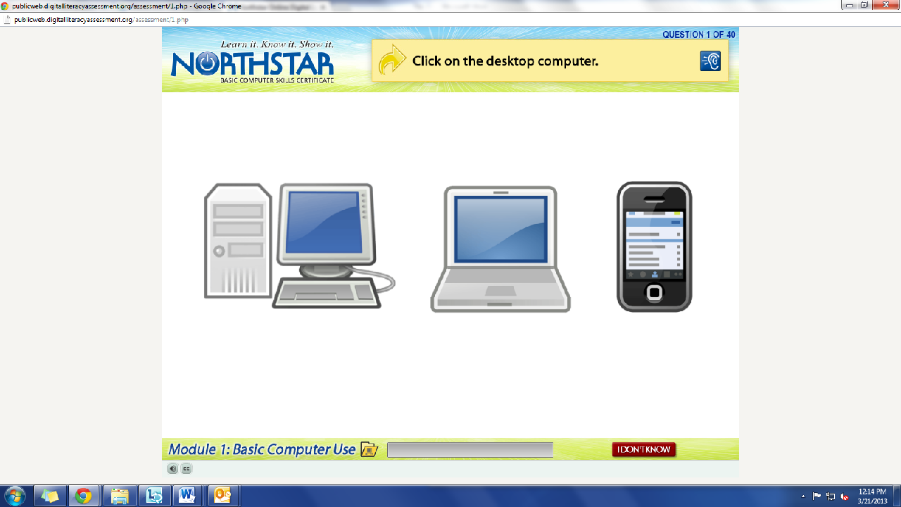
What is the question begin asked?
How do we answer it? We click on the answer.
You must listen carefully to the question being asked so that you know how to answer it.
Review Question: Which operating system is on this computer?
If you miss the question when it is read, you can either read it on the top of the page, or click the on the blue ear and it will read the question again.
If you do not know and do not want to guess, but once you click it, it will ask you if you are sure you want to skip the question, you have to answer “Yes” to move on. You are, however, encouraged to guess.

Step 3: Learner Code of Conduct
Read the Learner Code of Conduct to the students:
- Learner must listen carefully to all instructions given by proctor
- Learner must treat others with courtesy and respect during assessment process
  - This means no talking to each other during the assessment, if you have a question ask the proctor. If a learner finishes early, they must remain quiet until everyone is finished
- Learner should ask questions prior to the assessment if they are uncertain about the certification process
- Learner is responsible for his or her certificate: if the certificate is lost, s/he will have to retake the assessment
- Learner should inform the proctor if he or she believes that assessment conditions affected his or her results
Ask if there are any questions
Explain that the questions will be read aloud to them, so students need to be sure they are listening carefully. If they miss the question, is it also written at the top of the page.

Step 4: Take Windows 7 Assessment
If there are no questions, learners should scroll down the testing page and click on the Windows 7 Assessment
If students are frazzled during the test because they missed the reading of the question, there is a blue square in the top right corner with an ear in it. When it is clicked the question is read again

Step 5: After the assessment
Once the assessment is completed, learners should open up Mavis Beacon and practice typing.

Teacher Directions: Activity 2: Introduction to PowerPoint –PowerPoint
Exercise 2
Step 1: Define PowerPoint
What is PowerPoint? What is it used for?
- A program of Microsoft office operating systems
  - What are other programs on the computer and what do they do?
    - Word-creates documents, Excel-spreadsheets
- Used to create PowerPoint presentations

Step 2: Open PowerPoint
Have learners lead you through how to open PowerPoint from the desktop, start menu, and All Programs
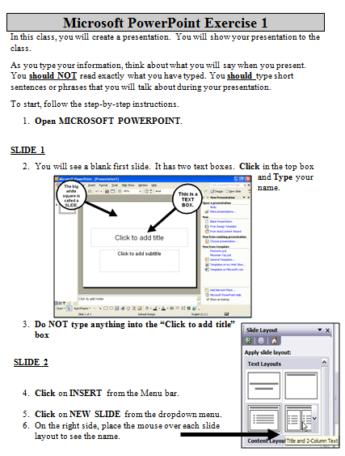
Demonstrate how to enter text into a PowerPoint
Point out that the formatting tools covered in Day 1 are the same in PowerPoint as they were in Word

Step 3: Inserting and formatting text
Instruct learners to insert the name of this school into the first slide
Explain that the first slide is typically known as the title slide- where the title of the presentation goes
- What is the definition of a “title”- a name
Demonstrate how to insert new slides (at this point, explaining the format of a slide is not important, it will be covered later)
Two ways to insert slides- ask students if they can find a button or menu tab that would allow them to insert a slide
IGNORE THE SLIDE LAYOUT BOX- this will be discussed Day 4.
- Insert slides button on the toolbar
- Click on the Insert button on the toolbar>Click on New Slide

Step 4; Controlled Practice
Hand out PowerPoint Exercise 2
Work through creating a basic PPT (no pictures, just words) about dessert; do not put in a title

Teacher Directions: Activity 3: Title
Step 1: Review definition and importance of title
Ask learners what is missing from this presentation- a title
Review what a title is- a name
Why is it important?-Lets audience know what to expect, what your presentation is about

Step 2: Picking Titles
Have learners try to come up with a title for the PowerPoint they created
Some options:
- Types of Dessert
- Favorite Desserts

It is okay if you do not get to this: Teacher Directions: Activity 4: Saving to USB drive
Step 1: Purpose of saving
Ask learners what they might do if they want to leave this presentation now, but come back to it later? Save it
Ask if anyone remembers the name of the storage device we use in class- USB Drive
What does the USB Drive plug into? USB Port

Step 2: Demonstrate Saving
Instruct learners to follow along with you as you Save the PowerPoint to your USB drive
File>Save As>My Computer>Locate the part of the computer the USB is in (either E or F drive)
- Explain that the USB drive is either in the (E: ) or (F: ) Drive on the computer, it is determined by looking at the name of the drive to make sure it matches the name of the device
Once drive it located> Name file(naming is like a Title)> click Save

North Star How-To
Teacher A- Generating Codes:
1. Go to https://www.digitalliteracyassessment.org/admin
2. Login information:
3. PLEASE SEE YOUR SITE COORDINATOR FOR NORTH STAR LOGIN INFORMATION!
4. Select your name from the drop-down menu
5. Click Submit
6. Click on Generate User Codes
7. Simply type in students’ names and a click enter
8. The code next to their name will be used to register their computer
Teacher B- Registering each computer:
1. Turn on student computers
2. Go to digitaliteracyassessment.org/assessment/proctored
3. Username: SEE YOUR SITE COORDINATOR
4. PIN: SEE YOUR SITE COORDINATOR
5. Type in student’s name and then enter the code you got from Part 1
6. Click Confirm and Start
7. Minimize the page
8. Instruct students not to close out of any programs you have opened on their computer
Note: As you spend more time in the classroom you get to know the students who show up early and who show up late. Register the students who usually show up early as soon as you arrive, that way they can begin typing as soon as they get to class.

Day 2 Warm-up

USB Drive
Double-click
Right-click
PowerPoint
Enter
Cursor
Shift
Left
Power Button
Formatting

- The program that will be used in this class is called .
- When you want to open a program like PowerPoint, you must use the mouse and on the icon.
- The is moved by the mouse.
- A is a type of portable storage device that we will use in this class.
- When the teacher tells you to click, this means you use the button on the mouse.
- You use to open a menu.
- When the computer is on, the turns blue.
- The key moves the cursor down to the next available line.
- You must press the key and the 1 at the same time to get an exclamation point.
- Changing the look of text is called the text.
Teacher Answer Key: Day 2 Warm-up

USB Drive
Double-click
Right-click
PowerPoint
Enter
Cursor
Shift
Left
Power Button
Formatting

- The program that will be used in this class is called PowerPoint .
- When you want to open a program like PowerPoint, you must use the mouse and double-click on the icon.
- The cursor is moved by the mouse.
- A USB DRIVE is a type of portable storage device that we will use in this class.
- When the teacher tells you to click, this means you use the LEFT button on the mouse.
- You use RIGHT-CLICK to open a menu.
- When the computer is on, the POWER BUTTON turns blue.
- The ENTER key moves the cursor down to the next available line.
- You must press the SHIFT key and the 1 at the same time to get an exclamation point.
- Changing the look of text is called FORMATTING the text.

Microsoft PowerPoint Exercise 2
In this class, you will create a presentation. You will show your presentation to the class.
As you type your information, think about what you will say when you present. You should NOT read exactly what you have typed. You should type short sentences or phrases that you will talk about during your presentation.

To start, follow the step-by-step instructions.
- Open MICROSOFT POWERPOINT.

SLIDE 1
- You will see a blank first slide. It has two text boxes. Click in the top box and Type your name.
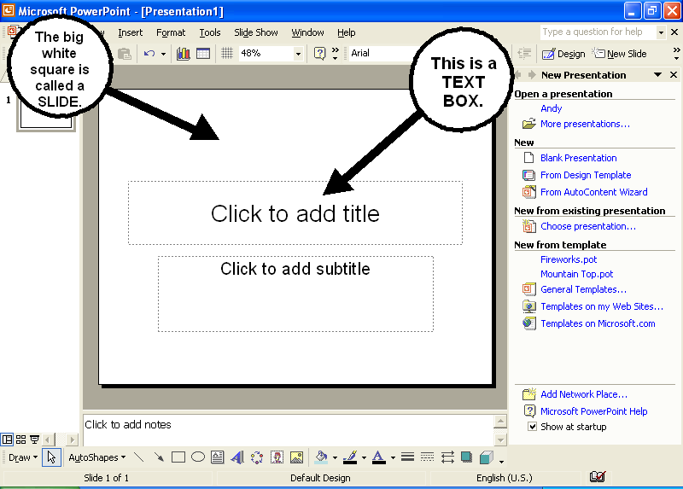

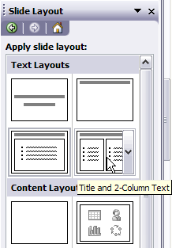
- Do NOT type anything into the “Click to add title” box

SLIDE 2

- Click on INSERT from the Menu bar.

- Click on NEW SLIDE from the dropdown menu.
- Choose a slide layout for slide 2. Click to insert it.

- Click in the boxes and type the name of a dessert, any dessert

SLIDE 3
- Click on INSERT from the Menu bar.

- Click on NEW SLIDE from the dropdown menu.

- Click in the boxes and type a description of the dessert listed in Slide 2 and make the text bold

SLIDE 4
- Click on INSERT from the Menu bar.
- Click on NEW SLIDE from the dropdown menu.
- Insert Slide 4.
- Type another dessert in slide 4 and change the font to CASTELLAR

SLIDE 5
- Insert Slide 5
- Type a description of the dessert listed in slide 4 and underline the text.

