During Day 11 you will be proctoring the North Star Digital Literacy assessment.
All the of the computers that learners use need to be registered (per direction on the North Star site) for the assessment,
- This can take anywhere from 20-40 minutes depending on the number of students and number of volunteers/coordinators who are setting the assessment up.
- REGISTER THE COMPUTERS BEFORE CLASS BEGINS
  - Use the computer sign-in sheet that was filled out Day 1 to determine which computers students are using and pull them out of the COW
PowerPoint: Day 11
Objectives Learners will be able to… | Materials
Computer skill: review of windows basics  Literacy skill: scanning  Literacy skill: peer editing | Make Student Copies  - PowerPoint Review-print with 6 slides on each page (Tab 23)  - PowerPoint Partner Rubric (Tab 19)  Props, Technology or Other Resources  - Projector  - Computer for every student  - USB Drives  - North Star How To (Tab 24)
Lesson Plan | Vocabulary
Activity 1: Review PPT-20 minutes
Description: teacher will go through a review PPT with students
Materials/Prep: Print out PowerPoint Review with 6 slides on each page

Activity 2: North Star Digital Literacy Assessment
Description: Learners will take the North Star Digital Literacy Assessment
Materials/Prep: every computer must be registered for the test, pull up the Screen Shot Test Page from the lesson plan (Page 3), directions for registering computers in Tab 24

Activity 3: Learner PPT
Description: as learners finish the North Star, they should continue working in their PPT. When everyone is finished, students will pair off and do a practice run through with a partner
Teacher Directions: Activity 1: Review PPT
Step 1: Context
Handout PowerPoint Review
Explain that as you go through the PPT, learners will be following along answering the questions that are asked on the PPT
After the quiz we will be taking the North Star Assessment

Step 2: Explain scanning in context
***Explain that regardless of whether it was covered in this class, the answer is on the screen shown and uses skills learned throughout the course of the class
Slide 2 has the teacher demonstrate how this is done-practice question

Step 3: PPT
Starting with Slide 3, run through the PPT and have learners do their best to find the locate the correct answers

Teacher Directions: Activity 2: North Star Digital Literacy Assessment
Step 1:
Take this time to explain the Windows 7 North Star Digital Literacy Assessment and its purpose:
This can be read verbatim to the students: The North Star Digital Literacy Assessment has set the standards of what it means to be knowledgeable about different aspects of the computer. If you pass the assessment with an 85% or higher, you will receive a certificate that proves your competency at the unit you were tested on. These certificates can also be presented to employers as proof of your computer skills when you apply for a job.
If you do not know the answer to a question, you are given the option to simply answer “I do not know” or you can take a guess. You are encouraged to guess on this assessment.

Step 2: How the assessment works
This can be read verbatim to the students: When it is time to begin, students will open the assessment titled Windows. The assessment begins with a test of the speakers. If you hear the piano playing, you will use your mouse to click the “Next” button.
Explain that if that student does not hear the piano playing, they can look above their keyboard at and they will see three buttons on the right. These are the volume buttons, one to turn down volume, turn it up, and turn it off.
Next, North Star will go through an orientation of how the assessment works. Each question asked in the assessment will be a function of the program, so your answer to the question will be performing that function. BE CAREFUL not to simply click when the page comes up because the assessment will read that as your answer and you cannot go back.

Step 3: Test Page Layout
Teacher should pull up the Screen Shot page (next page) and review it with the students.

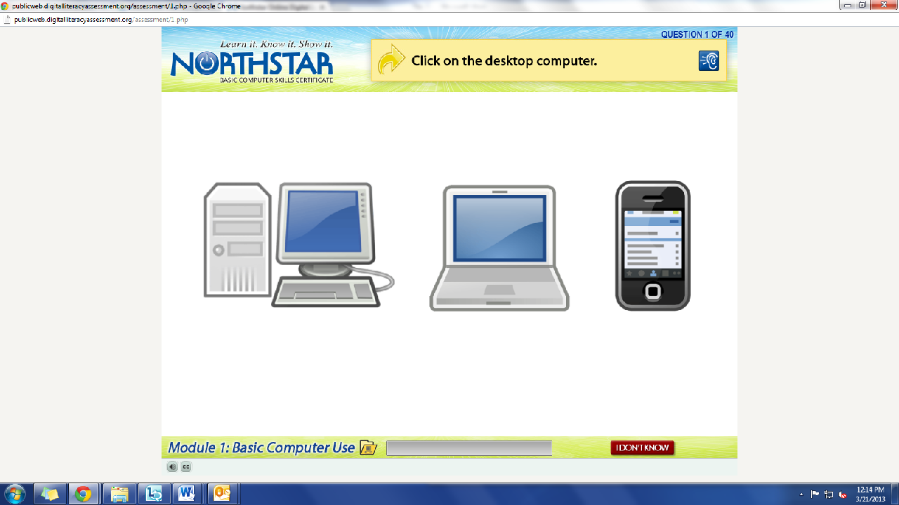
Review Question: Which operating system is on this computer?
What is the question begin asked?
How do we answer it? We click on the answer.
You must listen carefully to the question being asked so that you know how to answer it.
If you miss the question when it is read, you can either read it on the top of the page, or click the on the blue ear and it will read the question again.
If you do not know and do not want to guess, but once you click it, it will ask you if you are sure you want to skip the question, you have to answer “Yes” to move on. You are, however, encouraged to guess.

Step 4: Learner Code of Conduct
Read the Learner Code of Conduct to the students:
- Learner must listen carefully to all instructions given by proctor
- Learner must treat others with courtesy and respect during assessment process
  - This means no talking to each other during the assessment, if you have a question ask the proctor. If a learner finishes early, they must remain quiet until everyone is finished
- Learner should ask questions prior to the assessment if they are uncertain about the certification process
- Learner is responsible for his or her certificate: if the certificate is lost, s/he will have to retake the assessment
- Learner should inform the proctor if he or she believes that assessment conditions affected his or her results
Ask if there are any questions
Explain that the questions will be read aloud to them, so students need to be sure they are listening carefully. If they miss the question, is it also written at the top of the page.

Step 5: Take Windows 7 Assessment
Remind students to remain quiet throughout the test, once they have finished they will work on their Power Points, but they should remain quiet.
Students should now take the assessment; teachers can answer questions about the structure of the test, but not about content. This can be difficult because the answer is often more than simply clicking on a or b, but it requires the student to actually do tasks on the computer
If there are no questions, learners should scroll down the testing page and click on the Windows Assessment
If students are frazzled during the test because they missed the reading of the question, there is a blue square in the top right corner with an ear in it. When it is clicked the question is read again

Step 6: After Assessment
Once learners finish, they should quietly work on their personal PPT until everyone is finished
Teacher Directions: Activity 3: Practice Presentation -PowerPoint Packet: Partner
Assessment Rubric

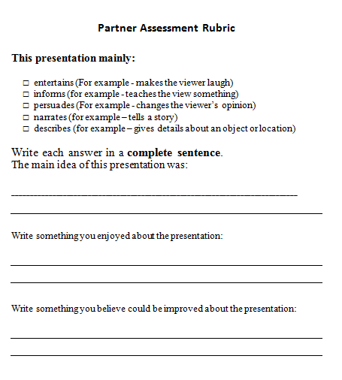
Step 1: Introduce
Once everyone is finished with the assessment, explain that students will not practice presenting their PPT’s to a partner
Pair students off
Learners can turn to the final page in their PPT Packet and locate Partner Assessment Rubric
Each learner will present their PPT to their partner (whatever they have finished) and their partner will complete the rubric
Explain that if the PPT is more than 5 minutes long, it should be cut down

Step 2: Presentation
Learners will now present their PPT’s to their partner
There should be discussion between partners about what went well and what could be improved after the presentation
Circulate to assist/answer questions

Step 3: Put suggestions into effect
Once the pairs have presented to each other, learners should take the rest of class to adjust to any of the suggestions their partner presented
Point out that if a learner’s partner did not clearly understand the main idea, adjustments should be made to the presentation to make that clear

STUDENTS MUST RETURN POWERPOINT PACKET AT THE END OF THE DAY. THESE PACKETS SHOULD NOT GO HOME WITH STUDENTS.

North Star How-To
Teacher A- Generating Codes:
1. Go to https://www.digitalliteracyassessment.org/admin
2. Login information:
3. PLEASE SEE YOUR SITE COORDINATOR FOR NORTH STAR LOGIN INFORMATION!
4. Select your name from the drop-down menu
5. Click Submit
6. Click on Generate User Codes
7. Simply type in students’ names and a click enter
8. The code next to their name will be used to register their computer
Teacher B- Registering each computer:
1. Turn on student computers
2. Go to digitaliteracyassessment.org/assessment/proctored
3. Username: SEE YOUR SITE COORDINATOR
4. PIN: SEE YOUR SITE COORDINATOR
5. Type in student’s name and then enter the code you got from Part 1
6. Click Confirm and Start
7. Minimize the page
8. Instruct students not to close out of any programs you have opened on their computer
Note: As you spend more time in the classroom you get to know the students who show up early and who show up late. Register the students who usually show up early as soon as you arrive, that way they can begin typing as soon as they get to class.

PowerPoint Presentation Partner Rubric
 | 1 | 2 | 3
 | - needs work | ok | - great!
Content | Presentation has many ideas. | Presentation has a main idea. | Presentation develops main idea with details.
Length | Less than 5 slides | 8 slides or more | 5, 6, or 7 slides
PowerPoint Skills | May have 2 or less of the following:  - Images on topic  - Transitions  - Attractive slide design and font  - Varied slide layouts  - Spell Checked work. | Presentation includes 3 or 4 of the following:  - Images on topic  - Transitions  - Attractive slide design and font  - Varied slide layouts  - Spell Checked work. | Presentation includes:  - Images on topic  - Transitions  - Attractive slide design and font  - Varied slide layouts  - Spell Checked work.
Presentation Skills | - Does not speak clearly and slowly.  - Text is not legible from across the room.  - Slides have everything the person said on them. | - Presentation includes 2 of the following:  - Speaks clearly and slowly.  - Text is legible from across the room.  - Has key points on slides, but says more. | - Speaks clearly and slowly.  - Text is legible from across the room.  - Has key points on slides, but says more.

Day 8 PowerPoint Presentation Rubric

This presentation mainly:

- entertains (For example - makes the viewer laugh)
- informs (for example - teaches the view something)
- persuades (For example - changes the viewer’s opinion)
- narrates (for example – tells a story)
- describes (for example – gives details about an object or location)

Write each answer in a complete sentence.
The main idea of this presentation was:

________________________________________________________________________________

Write something you enjoyed about the presentation:

Write something you believe could be improved about the presentation:

