**PowerPoint: Day 10**

Any learners who missed the TABE Test Day 8 will need to take it today.

|  |  |
| --- | --- |
| **Objectives** *Learners will be able to…* | **Materials** |
| ***Computer skill:*** *animation (part of Challenge)*  ***Computer skill:*** *spell check (part of Challenge)*  ***Literacy skill:*** *accurate grading* | **Make Student Copies**   * **PowerPoint Presentation Rubric-**If students do not have PowerPoint Packet **(Tab 19)**   **Props, Technology or Other Resources**   * Projector * Computer for every student * USB Drives * **Day 10 PowerPoint Challenge** |
|  | |
| **Lesson Plan** | Vocabulary |
| **Activity 1: Learner Challenge**  Description: learners will complete a review “challenge”  Materials/Prep: make sure students have access to Day 10 PowerPoint Challenge (either online or on their USB drives), **if they do not have USB drives**, print the PPT with 2 slides on each page and instruct them to open a new PPT and create 5 slides, and then follow the directions in the handout  **NOTE:** if you are using Open Office, the differences might be too great. You could go through each challenge as a class and find the answers.  **Activity 2: Learner PPT**  Description: learners will continue working on their PPTs that will be presented to the class  Materials/Prep:  **Activity 3: Practice PowerPoint**  Description: learners will practice grading a PPT and will then present their PPT to a partner to practice providing helpful criticism  Materials/Prep: copies of **PowerPoint Presentation Rubric** if students do not have PowerPoint Packet | * Animation * Spell Check * Constructive Criticism |

**Teacher Directions: Activity 1: PowerPoint Challenge -Day 10 PowerPoint Challenge**

Step 1: Open/Download PPT Challenge Activity

**Explain** that we will now be playing a game to see how much everyone has learned in this class

**Ask** learners how you can open a previously saved file: **Click on start menu>my computer>find USB Drive, often (E: ) Drive>PowerPoint Folder>Open Day 10 PowerPoint Challenge**

**Explain** that there will be a couple of things in this PPT that we have not yet learned, but the directions for completing the task are on the slide

Step 2: Complete Challenge

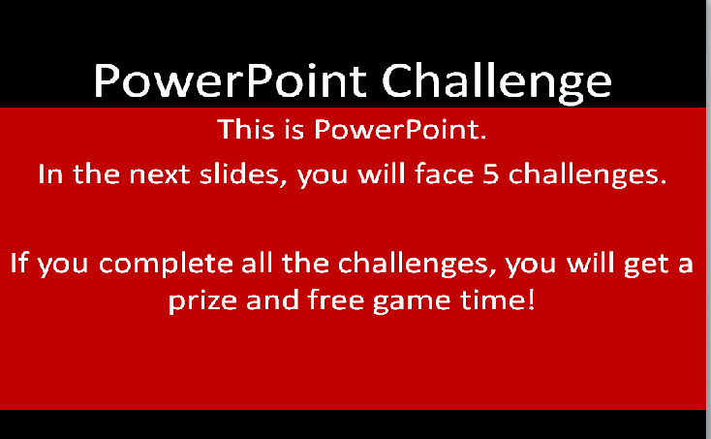 Ensure everyone has the challenge open on their screen

**Explain** that the directions for what to do are on each slide of the PPT, the learners simply have to look through the PPT and complete what is asked

**Learners** should work on this on their own as much as they can, but they should always ask the teacher if they have any questions

Step 3: Save Challenge

Once each learner finishes, i**nstruct** learners to save the PPT

**Teacher Directions: Activity 2: Learner PPT**

Step 1: Individual Work

Handout PowerPoint Presentation Packets

As learners finish the challenge, **instruct** them to open their personal PPT and continue working on it

Write the goals for the day on the board:

* All information in the PPT
* 3 pictures added
* Transitions on at least 4 slides

**Remind** learners that they only have today and one more day to work on their PPTs and then they will be presented

**\*\*\*\*Note: While students are working go ahead and create your own PowerPoint about a topic you know about. This will be presented to the class and graded using the rubric in Activity 3.**

**Teacher Directions: Activity 3: Practice Presenting -PowerPoint Presentation Rubric**

Step 1: Grade the teacher

The previous day the teacher should have created a PPT and saved it to the teacher USB drive

Open the PPT

**Direct students to Day 10 Presentation Rubric in their Presentation Packet**

You will present the PPT and the learners will grade it, giving advice on how to improve it.

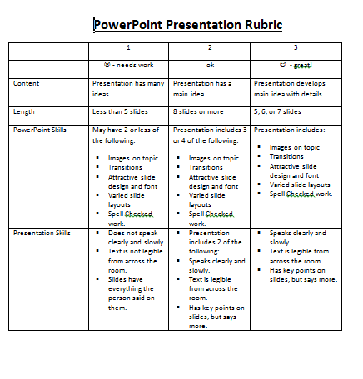Point out what can be said that is considered **constructive criticism**

Step 2: Partner Practice

Pair students off

**Instruct** them to present their PPT to their partner, who will grade their PowerPoint, say something they liked and something they think could be improved.

Remind learners that their **PPT should only be about 5 minutes long**



**STUDENTS MUST RETURN POWERPOINT PACKET AT THE END OF THE DAY. THESE PACKETS SHOULD NOT GO HOME WITH STUDENTS.**

**Day 10 PowerPoint Presentation Rubric**

|  |  |  |  |
| --- | --- | --- | --- |
|  | 1 | 2 | 3 |
|  | ☹ - needs work | ok | ☺ - great! |
| Content | Presentation has many ideas. | Presentation has a main idea. | Presentation develops main idea with details. |
| Length | Less than 5 slides | 8 slides or more | 5, 6, or 7 slides |
| PowerPoint Skills | May have 2 or less of the following:   * Images on topic * Transitions * Attractive slide design and font * Varied slide layouts * Spell Checked work. | Presentation includes 3 or 4 of the following:   * Images on topic * Transitions * Attractive slide design and font * Varied slide layouts * Spell Checked work. | Presentation includes:   * Images on topic * Transitions * Attractive slide design and font * Varied slide layouts * Spell Checked work. |
| Presentation Skills | * Does not speak clearly and slowly. * Text is not legible from across the room. * Slides have everything the person said on them. | * Presentation includes 2 of the following: * Speaks clearly and slowly. * Text is legible from across the room. * Has key points on slides, but says more. | * Speaks clearly and slowly. * Text is legible from across the room. * Has key points on slides, but says more. |

**Day 10 PowerPoint Presentation Rubric**

**This presentation mainly:**

* entertains (For example - makes the viewer laugh)
* informs (for example - teaches the view something)
* persuades (For example - changes the viewer’s opinion)
* narrates (for example – tells a story)
* describes (for example – gives details about an object or location)

Write each answer in a **complete sentence**.

The main idea of this presentation was:

________________________________________________________________________________

Write something you enjoyed about the presentation:

Write something you believe could be improved about the presentation: