Welcome to the PowerPoint unit of the Computers and Literacy Class

What to know about the class:
- Each lesson plan is built to fit a 2 hour time slot
- There are 12 lesson plans
- Each unit includes a TABE testing day (Day 8) and a North Star Digital Literacy Pre-Assessment (Day 2) and Post-Assessment (Day 11)
- This curriculum was written for students with a TABE score of 400 or higher

What you need for the class:
- A computer for each student
- Projector
- A USB drive for each student
- Headphones for each student
- The ability to print from the computer
- Microsoft Office*preferred, but OpenOffice would work as well
- Windows 7*preferred (same format as North Star Assessment)

Preparations for class:
- Instructor needs to load the following exercises either onto student USB drives or make sure they are online at your learning centers mnliteracy.org curriculum webpage
  - Day 3 Recycling PowerPoint
  - Day 10 PowerPoint Challenge
- Be sure teachers have access to the following PowerPoints

  - Day 1 Introduction to the Computer
  - Day 4 Main Idea Practice
  - Day 4 PPT Design
  - Day 7 Bad PowerPoint Presentation
  - Day 7 Good PowerPoint Presentation
  - Day 7 Practice Presentation
  - Day 8 Practice Presentation 1
  - Day 8 Practice Presentation 2
  - Day 10 PowerPoint Challenge
  - Day 11 Review

Note: if you are saving these files to USB drives, please be sure to save them in a PowerPoint Class Folder.

How to become a North Star Digital Literacy Assessment proctor:
- You will need your learning centers username and password
- Go to digitalliteracyassessment.org/admin
- Type in username and password
- Look for “Don’t see your name on the list” and click on proctor training
PowerPoint: Day 1

Objectives Learners will be able to… | Materials
Computer skill: cover the basics of the computer, its hardware and its software  Computer skill: learners will develop basic typing and formatting skills  Computer skill: Learners will Save a new document | Make Student Copies  - PowerPoint Syllabus (Tab 1)  - Day 1 Mingle Activity (Tab 2)  - Follow and Fill (Tab 3)  - PowerPoint Exercise 1: Typing Practice (Tab 4)  Props, Technology or Other Resources  - Projector  - Computer for every student  - USB Drives  - PowerPoint Day 1 Intro to the Computer PPT + Notes Page (Tab 25)  - Computer Sign-up Sheet (Tab 24)
Lesson Plan | Vocabulary
Activity 1: Introduction and Expectations  Description: students will complete a mingle activity and then the class will go over expectations  Materials/Prep: copies of PowerPoint Syllabus, copies of Day 1 Mingle Activity, one copy of Computer Sign-up Sheet taped to the front of the Computer Storage Shelf  Activity 2: Computer skills, Literacy  Description: introduce introduction to computer vocabulary  Materials/Prep: load “Welcome to the Computer” PowerPoint, copies of Follow and Fill  Activity 3: Typing and Formatting  Description: learners will develop basic knowledge of important keys on the keyboard and formatting tools (this is abridged from units like Word) students will then learn how to save a file if there is time  Materials/Prep: PowerPoint Exercise 1: Typing Practice | - Formatting  - Laptop  - Desktop  - Mouse  - USB Drive  - Monitor  - Cursor  - Double Click  - Save As  - Formatting  - Keyboard  - Highlight

Teacher Directions: Activity 1: Introductions and Expectations
-Day 1 Mingle Activity
-PowerPoint Syllabus
-Computer Sign-up Sheet
Step 1: Basic Name Introductions
Go around the room and have simply state their name and one interested fact about themselves
Teachers will do the same

Step 2: Mingle Activity
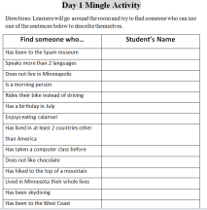
Hand out Day 1 Mingle Activity
Explain that students will get up and ask their classmates if any of the statements in the table are things they can say about themselves
Teacher demonstration: Go up to a student and ask “Have you ever been to the Spam museum?” If they say yes, mark their name, if not, you can ask them another question or move on to another student
Instruct students to get up and complete activity
Do this for about 10 minutes

Step 3: Review Answers
Ask students who fills in what space. Example: Fred, did you find anyone who has been to the Spam Museum?
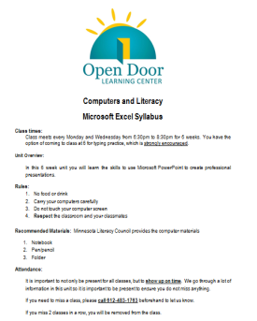
Step 2: Syllabus
Hand out Class Syllabus and go over with students
Fill in the blanks with your own learning center information
Ask coordinator for the learning center phone number
Be sure to highlight respect aspect- students are varying levels, from varying backgrounds, but this is a space where we respect each other and focus on learning computer skills

Step 3: Get computers
If not done already, take this time to have students obtain a computer from the COW (computer on wheels)
Make a copy of Computer Sign-up sheet and fill in students names next to their assigned computers, fill in class times/days and tape it to the COW (this is to prevent other teachers from taking students’ computers)

Teacher Directions: Activity 2: Intro to the computer –Follow and Fill
Step 1: Introduce topic
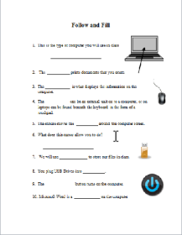
Download “Welcome to the Computer” PowerPoint from Curriculum website and handout Follow and Fill exercise
Go through the Power Point with the notes provided on the Notes Pages printed from the presentation
Have students fill in blanks of the Follow and Fill handout as you go through the presentation.
Step 2: Reviewing answers activity
Have students go over answers for Follow and Fill handout in pairs.
Then, pull the handout up on the computer and have students write the answers in the open spots on the board. It is necessary to correct spelling errors.
Give the student the option to go back to their seat and try to find the correct spelling and come back up and edit it on their own.

Teacher Directions: Activity 3: Intro to Typing –PowerPoint Exercise 1: Typing Practice
Step 1: How to open programs
Show learners how to open Microsoft Word from desktop, start menu and all programs
Have learners open Microsoft Word and explain that we will be using this program to practice typing just for today

Step 2: Typing and Formatting overview
Hand out PowerPoint Exercise 1 and use it as a guide to teach learners important keys on the keyboard and then formatting tools
Learners should write next to the word or picture what that key/tool does
Demonstrate what happens if you click a formatting button and then type
Demonstrate how to highlight text and change formatting
Example: Type your name, and decide you want it to be in a different font, highlight the text (click and drag)

Step 3: Individual typing practice
Learners should now type their answers to the questions that were asked in the beginning of class
Remind them to use full sentences and proper punctuation
As learners are typing, hand out USB drives

Step 4: Save As- MIGHT NOT GET TO THIS, which is okay, be sure to note in the lesson report
Introduce learners to the concept of saving new documents
Explain that saving allows someone to come back and look at a document/presentation again later on or continue editing it after they have to leave their computer
Ask students if this document has been saved before? No.
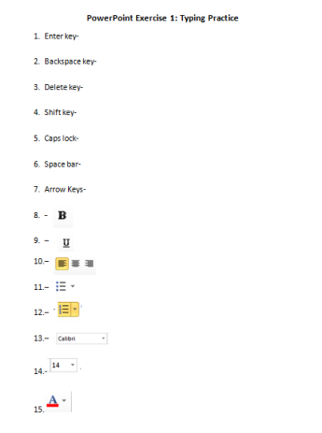
Explain that in this class we will be saving to an assigned USB drive, and because of that the steps to save are a bit different than they would be if you were simply saving right to the computer
File>Save As> My computer> REMOVABLE DISK (E: ) Drive (sometimes (F: ) drive)> They should now be in the USB Drive
Take this time to explain that if they look in the “File In” line, it says where you currently are in the computer
Explain that is incredibly important to check that you are saving to the place you have wanted
The second most important thing is to NAME the file something that will make it easy to find later

Extra time? Have students log on to Mavis Beacon and practice typing. If students seem very beginning, help them open up the internet and go to http://www.skyways.org/central/mouse/page1.html which will help them practice their typing.
Day 1 Mingle Activity
Directions: Learners will go around the room and try to find someone who can use one of the sentences below to describe themselves.
Find someone who… | Student’s Name
Has been to the Spam museum
Speaks more than 2 languages
Does not live in Minneapolis
Is a morning person
Rides their bike instead of driving
Has a birthday in the summer
(June-August)
Enjoys eating calamari
Has lived in at least 2 countries other than America
Has taken a computer class before
Does not like chocolate
Has hiked to the top of a mountain
Has lived in Minnesota their whole lives
Has been skydiving
Has been to the West Coast
Has been to a movie this month
Snoozes their alarm in the morning
Has cut their hair in the last month

Computers and Literacy
Microsoft PowerPoint Syllabus
Class times:
Class meets every and from to for 6 weeks.
You have the option of coming to class 30 minutes early for typing practice, which is strongly encouraged.

Unit Overview:
In this 6 week unit you will learn the skills to use Microsoft PowerPoint to create professional presentations.
Rules:
- No food or drink
- Carry your computers carefully
- Do not touch your computer screen
- Respect the classroom and your classmates

Recommended Materials: Minnesota Literacy Council provides the computer materials
- Notebook
- Pen/pencil
- Folder
Attendance:
It is important to not only be present for all classes, but to show up on time. We go through a lot of information in this unit so it is important to be present to ensure you do not miss anything.
If you need to miss a class, please call beforehand to let us know.
If you miss 2 classes in a row, you will be removed from the class.
Computer Sign-up Sheet
These computers are in use and from ______to______
1
2
3
4
5
6
7
8
9
10
11
12
13
14
15
16
17
18
19
20
21 | Teacher Computer

Follow and Fill

- This is the type of computer you will use in class

- The prints documents that you create.

- The is what displays the information on the computer.
- The is a piece of hardware that can either be an external unit or, on laptops, can be found beneath the keyboard in the form of a touchpad.

- The mouse moves the around the computer screen.

- What does this cursor allow you to do?

- We will use to store our files in class.

- You plug USB Drives into .
- The button turns on the computer.

- Microsoft Word is a on the computer.

PowerPoint Exercise 1: Typing Practice
- Enter key-
- Backspace key-
- Delete key-
- Shift key-
- Caps lock-
- Space bar-
- Arrow Keys-
- –
- –
- –

 
 
 
 

