During Day 11 you will be proctoring the North Star Digital Literacy pre-assessment.
All the of the computers that learners use need to be registered (per direction on the North Star site) for the assessment, the directions to do this are in the Volunteer Binder
- This can take anywhere from 20-40 minutes depending on the number of students and number of volunteers/coordinators who are setting the assessment up.
- REGISTER THE COMPUTERS BEFORE CLASS BEGINS
Internet: Day 11
Any learners that were not present for the TABE on Day 10 must take the test once they are finished with North Star
Objectives Learners will be able to… | Materials
Computer skill: students will review before the test  Computer skill: North Star Assessment  Computer skill: internet search  Literacy Skill: summarize | Make Student Copies  - Day 11 Internet Review PPT- printed two sided with 4 slides on each page (Tab 26)  Props, Technology or Other Resources  - Projector  - Computer for every student  - Day 11 Internet Review PPT  - Day 11 PPT Notes Page (in lesson)  - North Star How-To (Tab 8)
Lesson Plan |  | Vocabulary
Activity 1: Review  Description: go over the Internet Review PPT with learners  Materials/Prep: download Day 11 Internet Review  Activity 2: North Star Digital Literacy Assessment  Description: learners will take the North Star Assessment  Materials/Prep: All computers should be registered before class begins, download the visual on page 3 of this lesson plan to be projected  Activity 3: Research Project  Description: as students finished the North Star Assessment, they should go onto Schoology to locate their assignment for the day  Materials/Prep: on Schoology.com |  | - All Review
Teacher Directions: Activity 1: Review -Day 11 Review PPT Slides for students
-Day 11 Review PPT Notes Page for Teachers
Step 1: Hand out Packet -Download Day 11 PPT
Hand out the printed PPT (4 slides per page)
Teacher should have Notes Pages printed (in lesson)
Explain that students should answer the questions on their sheets as they slide comes up
You will all then review the question together
Step 2: Review PPT
Go through the review PPT and have students silently answer the question in their packet and then do it all together
Remind learners that if they have any questions now is the time to ask

Don’t know the answer? GOOGLE IT. Seriously, if a student asks you a question and you are unsure of the answer, there is no better way to practice internet skills than to practice Internet Searches that encompass answering questions for yourself.

Teacher Directions: Activity 2: North Star Digital Literacy Assessment
Step 1:
Take this time to explain the Internet North Star Digital Literacy Assessment and its purpose:
This can be read verbatim to the students: The North Star Digital Literacy Assessment has set the standards of what it means to be knowledgeable about different aspects of the computer. The purpose of this assessment is to provide learners with a standard with which everyone learns the computer to ensure that they will be successful outside of the classroom. If you pass the assessment with an 85% or higher, you will receive a certificate that proves your competency at the unit you were tested on. These certificates can also be presented to employers as proof of your computer skills when you apply for a job.
If you do not know the answer to a question, you are given the option to simply answer “I do not know” or you can take a guess. You are encouraged to guess on this assessment.
Step 2: How the assessment works
This can be read verbatim to the students: When it is time to begin, students will open the assessment titled Internet. The assessment begins with a test of the speakers. If you hear the piano playing, you will use your mouse to click the “Next” button.
Explain that if that student does not hear the piano playing, they can look above their keyboard at and they will see three buttons on the right. These are the volume buttons, one to turn down volume, turn it up, and turn it off.
Next, North Star will go through an orientation of how the assessment works. Each question asked in the assessment will be a function of the program, so your answer to the question will be performing that function. BE CAREFUL not to simply click when the page comes up because the assessment will read that as your answer and you cannot go back.

Step 3: Test Page Layout
Teacher should pull up the Screen Shot page (next page) and review it with the students.

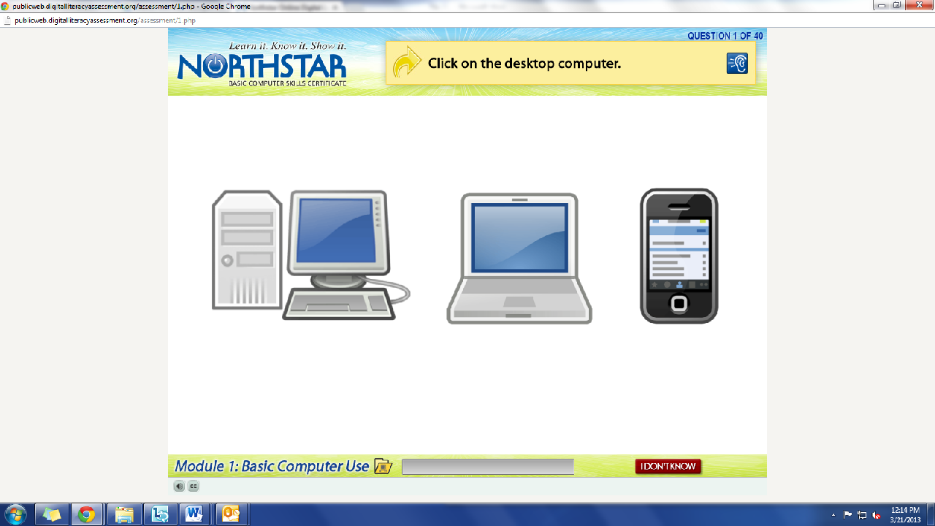
What is the question begin asked?
How do we answer it? We click on the answer.
You must listen carefully to the question being asked so that you know how to answer it.
If you miss the question when it is read, you can either read it on the top of the page, or click the on the blue ear and it will read the question again.
If you do not know and do not want to guess, but once you click it, it will ask you if you are sure you want to skip the question, you have to answer “Yes” to move on. You are, however, encouraged to guess.

Step 2: Learner Code of Conduct
Read the Learner Code of Conduct to the students

- Learner must listen carefully to all instructions given by proctor.
- Learner must treat others with courtesy and respect during the assessment process.
- Learner should ask questions prior to the assessment if they are uncertain about the certification process.
- Learner is responsible for his or her certificate: if the certificate is lost, s/he will have to retake the assessment.
- Learner should inform the proctor in advance for any accommodations.
- Learner must represent him or herself honestly during the assessment, and put away all electronic devices during the assessment.
- Learner should inform the proctor if he or she believes that assessment conditions affected his or her results.

Ask if there are any questions or concerns

Step 3: Assessment
Remind students to remain quiet throughout the test, once they have finished they will work on an activity, but they should remain quiet.
Students should now take the assessment; teachers can answer questions about the structure of the test, but not about content. This can be difficult because the answer is often more than simply clicking on a or b, but it requires the student to actually do tasks on the computer

Step 4: Assessment
Once learners finish, quietly assist them as they log in to Schoology and read the assignment for Day 11

Teacher Directions: Activity 3: Research Projects
Step 1: Schoology Login
Go to Schoology.com
Username: odcomp#@gmail.com (not #, but the actual computer number should go here)
Password: Opendoor

Step 2: Locate Assignment
Go to Courses>Click on Computer and Literacy>Click on Internet Class> Click on Day 11
Student should read through and complete the assignment

North Star How-To
Teacher A- Generating Codes:
1. Go to https://www.digitalliteracyassessment.org/admin
2. Login information:
3. PLEASE SEE YOUR SITE COORDINATOR FOR NORTH STAR LOGIN INFORMATION!
4. Select your name from the drop-down menu
5. Click Submit
6. Click on Generate User Codes
7. Simply type in students’ names and a click enter
8. The code next to their name will be used to register their computer
Teacher B- Registering each computer:
1. Turn on student computers
2. Go to digitaliteracyassessment.org/assessment/proctored
3. Username: SEE YOUR SITE COORDINATOR
4. PIN: SEE YOUR SITE COORDINATOR
5. Type in student’s name and then enter the code you got from Part 1
6. Click Confirm and Start
7. Minimize the page
8. Instruct students not to close out of any programs you have opened on their computer
Note: As you spend more time in the classroom you get to know the students who show up early and who show up late. Register the students who usually show up early as soon as you arrive, that way they can begin typing as soon as they get to class.

