Welcome to the Internet unit of the Computers and Literacy Class

What to know about the class:
- Each lesson plan is built to fit a 2 hour time slot
- There are 12 lesson plans
- Each unit includes a TABE testing day (Day 10) and a North Star Digital Literacy Pre-Assessment (Day 2) and Post-Assessment (Day 11)
- This curriculum was written for students with a TABE score of 400 or higher

What you need for the class:

- A computer for each student
- The ability to print from the computer
- Headphones- for North Star Assessments
- Internet Access

How to become a North Star Digital Literacy Assessment proctor:
- You will need your learning centers username and password
- Go to digitalliteracyassessment.org/admin
- Type in username and password
- Look for “Don’t see your name on the list” and click on proctor training
- It takes about 20 minutes to complete, there is a quiz at the end

What needs to be prepared?
- A few assignments are saved online at Schoology.com (if Schoology does not work, paper assignments are attached to corresponding Lesson Plans)
  - Teacher Username: comp.lit.opendoor@gmail.com
  - Password: Opendoor (capital O)
- Be sure teachers have access to the following PowerPoints

  - Day 1 Introduction to the Computer
  - Day 5 Internet Safety
  - Day 6 Wikipedia Intro
  - Day 11 Review

Note: if you are saving these files to USB drives, please be sure to save them in a Word Class Folder.
Internet Day 1

Objectives Learners will be able to… | Materials
Computer skill: identify basic hardware on the computer  Computer skill: understand different between hardware and software  Literacy skill: learners will complete a listening activity and correctly fill in key terms | Make Student Copies  - Internet Syllabus (Tab 1)  - Internet Activity 1 (Tab 2)  - Internet Activity 2: Internet Intro (Tab 3)  Props, Technology or Other Resources  - Projector  - Computer for every student  - Speakers  - Day 1 Introduction to the Computer PPT (Tab 4)  - Computer Sign-up Sheet (Tab 5)
Lesson Plan | Vocabulary
Activity 1: Welcome to Class  Description: Introductions, syllabus, expectations  Materials/Prep: post-it notes, copies of Internet Syllabus, two copies of the Computer Assignment Spreadsheet (one for in class, one to tape to the COW)  Activity 2: What do we know?  Description: learners will write down things they know about the internet, and then things they hope to learn  Materials/Prep: post-it notes, draw T-Chart on the board  Activity 3: Intro to the Computer  Description: learners will go over basic computer hardware vocabulary and complete a matching activity  Materials/Prep: post-it notes, notes pages for Introduction to the Computer (Tab 3), copies of Internet Activity 1  Activity 4: Intro to the Internet  Description: learners will watch a video that introduces how the internet works and compete a questionnaire in the process  Materials/Prep: make sure link in the activity works, copies of Internet Activity 2: Internet Introduction, http://www.youtube.com/watch?v=90cfeFBid68 | - Hardware  - Laptop  - Monitor  - Mouse  - Right-click  - Click  - Double-click  - Browser  - Web Browser  - Web Address  - Scroll bar  - Minimize  - Maximize  - Close out  - Taskbar

Teacher Directions: Activity 1: Introduction to Class -Internet Syllabus
-Computer Sign-up Sheet
Step 1: Why are you in this class?
Take time to get to know students in the room
Handout a couple of post-it notes to each student
Instruct them to write down at least one reason why they are taking this Internet class
Once they write something down, have the students stick the post-it on the side of the board

Step 2: Teacher and Learner Introductions
Write a couple other questions to get to know students on the board
Examples: What is your name?
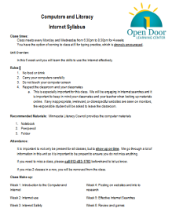 Where are you from?
If you got $10,000 what would you spend it on?
What is your favorite…?
Go around the room and do introductions, having students say a bit about themselves
Once everyone does their introduction, go ahead and review the reasons why learners decided to take Internet

Step 2: Syllabus
Hand out Class Syllabus and go over with students
Fill in the blanks with your own learning center information
Ask coordinator for the learning center phone number
Be sure to highlight respect aspect- students are varying levels, from varying backgrounds, but this is a space where we respect each other and focus on learning computer skills
IMPORTANT: Be sure to explain that this is an internet class and we will be doing internet searches. This does not mean you (the student) get free reign to do what you want on the internet. Respect this space, and before you go onto a website be sure to ask yourself if that is something you want me (the teacher) to see you doing. If you (the student) are caught on a website that does not relate to class instruction, is inappropriate or might make other learners uncomfortable, you will be immediately asked to leave.

Step 3: Get computers
If not done already, take this time to have students obtain a computer from the COW (computer on wheels)
Make a copy of Computer Sign-up sheet and fill in students names next to their assigned computers, fill in class times/days and tape it to the COW (this is to prevent other teachers from taking students’ computers)

Step 4: Computer assignments
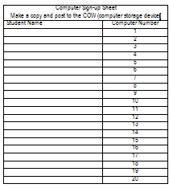Learners might have already received their computer, but take this time, if not done so already, to ensure that every learner has a computer
Attached to this lesson plan is a Computer Assignment list, be sure to write down each student’s name and the computer they are using
Teacher Directions: Activity 2: What do you know?

Step 1: Set-up
Draw a T-Chart on the board, one side should be labeled “What we Know” and the other “What we want to know”
Hand out either post-its or pieces of paper to learners (at least two per student)

Step 2: What do you know about the computer?
Ask learners what they already know about the internet? What is it used for?
Learners should write their answers on post-it notes (or a piece of paper)
Once it is written, learners should post their submission on the appropriate side of the T-Chart

Step 3: What do you want to know?
Now, students should write something they WANT to learn about the internet
Learners should write their answers on post-it notes (or a piece of paper)
Once it is written, learners should post their submission on the appropriate side of the T-Chart

Step 4: Why did we do this?
Explain that we all have a lot to learn about the internet, so we will all do our best to make sure we are present and efficient in the classroom to learn as much as we can
Take note of any consistent requests that students make and post them in the lesson report

Teacher Directions: Activity 3: Intro to the Computer
-Introduction to the Computer PPT Notes Page
-Internet Activity 1
Step 1: Set-up
Explain that we will now be going over basic computer hardware vocabulary
Hand out post-it notes, each student will need 6 post-its
Explain that within the PowerPoint there are 6 words that are circled in red
Instruct learners to write down each word on its own post-it note and pay close attention to the function of that tool

Step 2: Explanation of Vocabulary Words
Go through Introduction to the Computer PPT
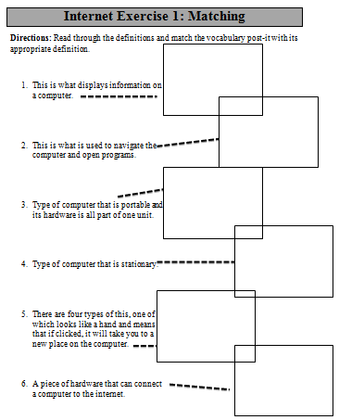Be sure to have the NOTES PAGE, this verifies which words students should write down and explains definitions of the words discussed

Step 3: Activity
Hand out Internet Activity 1: Matching
Explain that learners will match the vocab words they have written on their post-it notes to the appropriate definition or picture on the hand out
Demonstrate completing the first question, do as a class if you feel inclined

Teacher Directions: Activity 4: Intro to the Internet
Step 1: What is the internet? -Internet Exercise 2: Internet Intro
Ask learners what the internet is/what does it do/what is it used for
What other names have they heard for internet? – World Wide Web
Step 2: Watch Video
Explain that the class will now watch a video that explains what the internet is
Hand out Internet Exercise 2: Internet Intro
Learners will watch the video listed below once and try to answer as many questions as possible; we will watch the video a second time to answer the remaining questions
Open http://www.youtube.com/watch?v=90cfeFBid68 (if it does not work, try http://www.commoncraft.com/video/world-wide-web )
This is a video that explains how the internet works
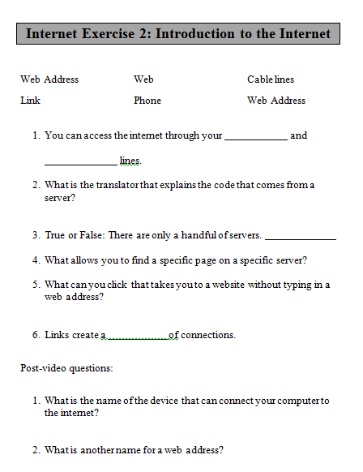
Step 2: Review Answers
Go through the handout with learners to reviews answers
Utilize the follow up questions
Answers:

- Phone and cable lines
- Web browser
- False
- Web Address
- Link
- Web

Post video questions:
- Modem
- URL (Uniform Research Locator, if asked)

Step 3: Web browsers
The video mentions Web Browsers
What is a web browser? A web browser (commonly referred to as a browser) is a software application for retrieving, presenting and traversing information resources on the World Wide Web.
Ask learners to go onto their computer and look for something that might take them to the internet
Explain that they might have a few different options to get them to the internet, Internet Explorer, Google Chrome or Firefox
For class, use Google Chrome if loaded on all computers, if not have everyone use Internet Explorer

Step 4: Open, Close, Minimize Webages
Demonstrate how to open a browser (double-click) and give them some time to explore the different browsers
Explain that when they open the window, each student might see something a little different from those around them. This is home screen, it can be changed, but nothing to worry about
Explain where learners can close and minimize windows (explain that mimizing brings the window into the taskbar)
Point out Scroll Bar and explain how to use it

Step 5: Extra time? Review
If you have extra time, go ahead and review the vocab words for the day and what they mean.

Computer Sign-up Sheet
These computers are in use and _______ from ______to______
Student Name | Computer Number
 | 1
 | 2
 | 3
 | 4
 | 5
 | 6
 | 7
 | 8
 | 9
 | 10
 | 11
 | 12
 | 13
 | 14
 | 15
 | 16
 | 17
 | 18
 | 19
 | 20
Computers and Literacy
Internet Syllabus
Class times:
Class meets every and from to for 6 weeks.
You have the option of coming to class at 6 for typing practice, which is strongly encouraged.

Unit Overview:
In this 6 week unit you will learn the skills to effectively use the tools available on the Internet.
Rules:
- No food or drink
- Carry your computers carefully
- Do not touch your computer screen
- Respect the classroom and your classmates
- This is especially important for this class. We will be engaging in Internet searches and it is important to keep in mind your classmates and your teacher when looking up materials online. If any inappropriate, irrelevant, or disrespectful websites are seen on monitors, the responsible student will be asked to leave the classroom.

Recommended Materials: Minnesota Literacy Council provides the computer materials
- Notebook
- Pen/pencil
- Folder
Attendance:
It is important to not only be present for all classes, but to show up on time. We go through a lot of information in this unit so it is important to be present to ensure you do not miss anything.
If you need to miss a class, please call beforehand to let us know.
If you miss 2 classes in a row, you will be removed from the class.
Class Make-up:

Week 1: Introduction to the Computer and Internet
Week 2: Internet use
Week 3: Internet Safety
Week 4: Posting on websites and intro to research
Week 5: Effective Internet Searches
Week 6: Review and games

Internet Exercise 1: Matching
Directions: Read through the definitions and match the vocabulary post-it with its appropriate definition.

- This is what displays information on a computer.

- This is what is used to navigate the computer and open programs.

- Type of computer that is portable and its hardware is all part of one unit.

- Type of computer that is stationary.

- There are four types of this, one of which looks like a hand and means that if clicked, it will take you to a new place on the computer.

- A piece of hardware that can connect a computer to the internet.

Internet Exercise 2: Internet Introduction

Web Address
Link
Web
Phone
Cable lines
Web Browser

- You can access the internet through your and
lines.
- What is the translator that explains the code that comes from a server?

- True or False: There are only a handful of servers.
- What allows you to find a specific page on a specific server?

- What can you click that takes you to a website without typing in a web address?

- Links create a of connections.
Post-video questions:
- What is the name of the device that transmits data to connect your computer to the internet?

- What is another name for a web address?

