During Day 11 you will be proctoring the North Star Digital Literacy assessment.
All the of the computers that learners use need to be registered (per direction on the North Star site) for the assessment,
- This can take anywhere from 20-40 minutes depending on the number of students and number of volunteers/coordinators who are setting the assessment up.
- REGISTER THE COMPUTERS BEFORE CLASS BEGINS
  - Use the computer sign-in sheet that was filled out Day 1 to determine which computers students are using and pull them out of the COW
Excel Day 11

Objectives Learners will be able to… | Materials
Computer skill: spreadsheet creation  Computer skill: North Star Digital Literacy Assessment  Literacy skill: reading comprehension | Make Student Copies  - Day 11 Review PPT- print with 2 slides on each page (Tab 21)  - Excel Exercise 14: Survey Reading (Tab 22)  Props, Technology or Other Resources  - Projector  - Computer for every student  - USB Drives  - Download Day 11 Review PPT  - Teacher copy of PPT Notes Page  - North Star How-To (Tab 23)
Lesson Plan | Vocabulary
Activity 1: Review
Description: students will review the skills they need to know for the North Star Assessment
Materials/Prep: download Excel Day 11 Review PPT, copies of PPT with 4 slides per page for students, one copy of Notes Page printed for teacher

Activity 2: North Star Assessment
Description: students will take the Windows 7 Assessment
Materials/Prep: all computers must be registered for the test before class begins, directions are in Tab 23

Activity 3: Survey Reading Comprehension
Description: Students will complete a reading comprehension activity about surveys
Materials/Prep: copies of Excel Exercise 14: Survey Reading
Teacher Directions: Activity 1: Review -Download Day 11 Review PowerPoint
-Day 11 PPT 4 Slides per page for students
-Day 11 PPT Notes page for Teacher
Step 1: Set-up
Write the following words on the board:

- Desktop
- Taskbar
- Operating System
- Start Menu

Explain that these are key vocabulary words that will help you find the answers to questions and understand the basis of the test

Step 2: Context
Handout PowerPoint Review Slides to students
Teacher should have notes page to expand on information on the slide

Step 3: Explain scanning in context
***Explain that regardless of whether it was covered in this class, the answer is on the screen shown and uses skills learned throughout the course of the class
Slide 2 has the teacher demonstrate how this is done-practice question

Step 4: Go through PPT
Explain that as you go through the PPT, learners will be following along answering the questions that are asked on the PPT

Step 5: Any Questions
Ask students if they are confused about anything that was gone over

Teacher Directions: Activity 2: North Star Digital Literacy Assessment
Step 1: Assessment Explanation and its purpose
Take this time to explain the Windows 7 North Star Digital Literacy Assessment and its purpose:
This can be read verbatim to the students: The North Star Digital Literacy Assessment has set the standards of what it means to be knowledgeable about different aspects of the computer. The purpose of this assessment is to provide learners with a standard with which everyone learns the computer to ensure that they will be successful outside of the classroom. If you pass the assessment with an 85% or higher, you will receive a certificate stating you passed the Windows assessment. These certificates can be presented to employers as proof of your computer skills when you apply for a job.
This assessment is going to be difficult for most of you because it is using a version of Windows that we have not used in class. Use the clues that are provided in the question to locate the answers that will be on the page.

Step 2: How the assessment works
This can be read verbatim to the students: When it is time to begin, students will open the assessment titled Windows. The assessment begins with a test of the speakers. If you hear the piano playing, you will use your mouse to click the “Next” button.
Explain that if that student does not hear the piano playing, they can look above their keyboard at and they will see three buttons on the right. These are the volume buttons, one to turn down volume, turn it up, and turn it off.
Next, North Star will go through an orientation of how the assessment works. Each question asked in the assessment will be a function of the program, so your answer to the question will be performing that function. BE CAREFUL not to simply click when the page comes up because the assessment will read that as your answer and you cannot go back.
Teacher should pull up the Screen Shot page and review it with the students.

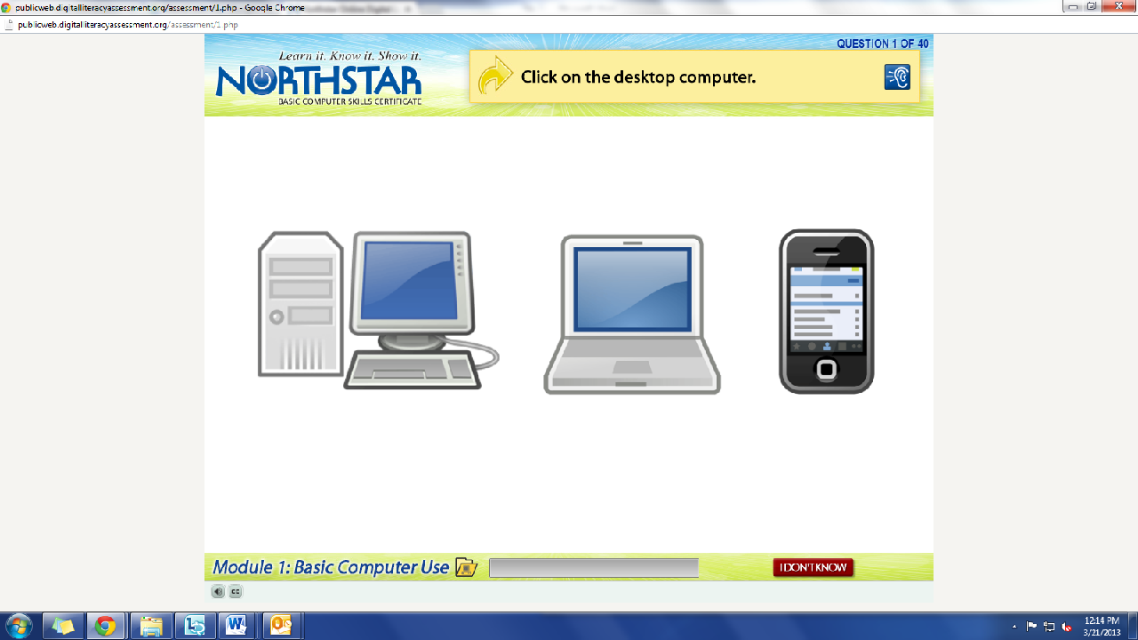
What is the question begin asked?
How do we answer it? We click on the answer.
You must listen carefully to the question being asked so that you know how to answer it.
Review Question: Which operating system is on this computer?
If you miss the question when it is read, you can either read it on the top of the page, or click the on the blue ear and it will read the question again.
If you do not know and do not want to guess, but once you click it, it will ask you if you are sure you want to skip the question, you have to answer “Yes” to move on. You are, however, encouraged to guess.

Step 3: Learner Code of Conduct
Read the Learner Code of Conduct to the students:
- Learner must listen carefully to all instructions given by proctor
- Learner must treat others with courtesy and respect during assessment process
  - This means no talking to each other during the assessment, if you have a question ask the proctor. If a learner finishes early, they must remain quiet until everyone is finished
- Learner should ask questions prior to the assessment if they are uncertain about the certification process
- Learner is responsible for his or her certificate: if the certificate is lost, s/he will have to retake the assessment
- Learner should inform the proctor if he or she believes that assessment conditions affected his or her results
Ask if there are any questions
Explain that the questions will be read aloud to them, so students need to be sure they are listening carefully. If they miss the question, it is also written at the top of the page

Step 4: Take Windows 7 Assessment
If there are no questions, learners should scroll down the testing page and click on the Windows 7 Assessment
If students are frazzled during the test because they missed the reading of the question, there is a blue square in the top right corner with an ear in it. When it is clicked the question is read again

Step 5: Post assessment Activity
Explain that after learners finish with the assessment, they should raise their hand
Teacher should review the results with the student and then hand them the activity for the last part of the day, Excel Exercise 14: Grocery Day Survey
Remind learners to remain silent until everyone is done with their assessment

Teacher Directions: Activity 3: Post-Assessment Activity
- Excel Exercise 14: Grocery Day Survey
Step 1: Assist students
Hand out Excel Exercise 14 to students as they finish the assessment
Remind them to remain quiet until everyone is finished
Assist them as they work through it

Step 2: Challenge Activities
For students who finish early, here are some things you can ask them to do, you can write this on the board
- Have them bold the labels
- Right-align the categories
- Merge and Center a title
- Insert a graph (or two or three)
- Ask them to assist students who are struggling

Step 3: Upon Completion
Once students finish, they should compare their graph to a neighbors

Step 4: Save
Ask learners if they should use Save or Save As? Why?; Save, new spreadsheet

North Star How-To
Teacher A- Generating Codes:
1. Go to https://www.digitalliteracyassessment.org/admin
2. Login information:
3. PLEASE SEE YOUR SITE COORDINATOR FOR NORTH STAR LOGIN INFORMATION!
4. Select your name from the drop-down menu
5. Click Submit
6. Click on Generate User Codes
7. Simply type in students’ names and a click enter
8. The code next to their name will be used to register their computer
Teacher B- Registering each computer:
1. Turn on student computers
2. Go to digitaliteracyassessment.org/assessment/proctored
3. Username: SEE YOUR SITE COORDINATOR
4. PIN: SEE YOUR SITE COORDINATOR
5. Type in student’s name and then enter the code you got from Part 1
6. Click Confirm and Start
7. Minimize the page
8. Instruct students not to close out of any programs you have opened on their computer
Note: As you spend more time in the classroom you get to know the students who show up early and who show up late. Register the students who usually show up early as soon as you arrive, that way they can begin typing as soon as they get to class.
Excel Exercise 14: Grocery Day Survey
Directions: Once everyone finishes assessment, read through the passage as class. Underline the question being asked and then underline the categories that should be labels in the spreadsheet. Once you finish reading, there are steps to follow as you complete the worksheet.
In 2009 a group of college students took a survey to see what day of the week people are more likely to do their grocery shopping. The students completed a door-to-door survey of the Phillips neighborhood, asking them what day of the week they tend to do their grocery shopping.
The group interviewed 15,266 Phillips residents. The found that 3,564 people did their grocery shopping on Sunday, 2,770 went to the grocery store on Monday, 895 people typically shopped on Tuesday, 2,398 on Wednesday, 1,742 on Thursday, Friday had 1,286 shoppers and Saturday totaled 2,611 shoppers.
- Open a new Excel spreadsheet.
- Merge and Center cells A1-C1
How to Merge and Center:
  - Highlight necessary cells
  - Locate the Merge and Center button the toolbar

- Type “Grocery Day Survey” into the newly merged cell
- Type “Sunday” into A3
- Use the Fill Function to fill in the rest of the days down Column A

  - Place cursor in bottom right hand corner of the cell, it should look like a black plus sign.
  - Click and drag the cursor down Column A until all of the days of the week are filled in to Saturday

- Enter the numbers of shoppers for each day into Column B.
- Use auto-sum in cell B11 to calculate the total number of shoppers.
- Enter a formula into C3 to calculate the percentage of shoppers on Sunday. You will need to divide the number of shoppers on Sunday by the total number of shoppers.

Step by Step:
  - Click on cell C3.
  - Press the equals (=) key.
  - Click on cell B3. This represents the number of shoppers on Sunday.
  - Press the forward slash (/) key to perform division.
  - Click on cell B11. This represents the total number of shoppers.
  - Press the F4 key. You will see $ signs added ($B$11) which means it has been locked. This will let Excel know that you want to keep B11 as the total number of shoppers for all of your formulas. If you do not press F4, future steps will not work.
  - Your formula should now look like this =B3/$B$11
  - Press enter.

- Use auto-fill to calculate the percentage of shoppers for the other days of the week.
  - Click on cell C3.
  - Place your cursor in the bottom right hand corner of the cell; it should look like a black plus sign.
  - Double-click.

- Highlight cells C Press the % button the toolbar.
- Use auto-sum in cell C11.
- Highlight cells C3:C11 and press the % button on the toolbar.
- Add labels to cells A2, B2, C2 and A11.
- Make the title and all labels bold.
- If you have extra time, try making a pie chart of the survey.

ANSWER KEY Excel Exercise 14: Grocery Day Survey
DO NOT MAKE STUDENT COPIES
When students are finished, their spreadsheet should look something like this.

Grocery Day Survey
Day of the Week | Number of Shoppers | Percentage of Shoppers
Sunday | 3564 | 23%
Monday | 2770 | 18%
Tuesday | 895 | 6%
Wednesday | 2398 | 16%
Thursday | 1742 | 11%
Friday | 1286 | 8%
Saturday | 2611 | 17%
Total Shoppers | 15266 | 100%

