Email: Day 12

Objectives Learners will be able to… | Materials
Computer skill: go over any final questions  Computer Skill: create a professional email  Computer skill: following directions | Make Student Copies  - Email Exercise 13-only half of students need the handout (Tab 25)  Props, Technology or Other Resources  - Projector  - Computer for every student
Lesson Plan | Vocabulary
Warm-up:
Description:
Materials/Prep:

Activity 1: Review
Description: learners will complete a final activity during which one partner will describe an email to their partner who must create it without seeing the original copy. Again, only one of the pair will see Exercise 13.
Materials/Prep: copies of Email Exercise 13 for half of the students, the other half should never see the handout

Activity 2: Any Remaining Questions
Description: take some time to go over any remaining questions learners have regarding email.
Materials/Prep:

Activity 3: Awards and Certificates
Description: hand out attendance awards (if relevant) and North Star Certificates to students who passed
Materials/Prep: check will coordinator to see if they created the Certificates

Teacher Directions: Activity 1: Final Game -Email Exercise 13
Step 1: Set-up
Instruct learners to pair off-try to ensure that partners are not unevenly matched. We do not want someone doing all of the work
Instruct partners to discuss who will be the Pilot and who will be the Navigator

Step 2: Directions
Explain that you will be handing out and exercise with a picture of an email that needs to be sent, the only person that can look at this picture is the Navigator
The Navigator will explain what needs to be done, using vocabulary learned in the class
THE Pilot will create what the Navigator should be typing
IMPORTANT: The Navigator should NEVER touch the computer and the Pilot should NEVER look at the exercise

Step 3: Demonstrate activity
Take a minute and model how the activity should be done
Ideally, you have two teachers, but if you need to, pick a student
- Determine roles (if it is one teacher and one student, the teacher should be the Navigator)
- Instruct the Pilot to leave the room for a minute
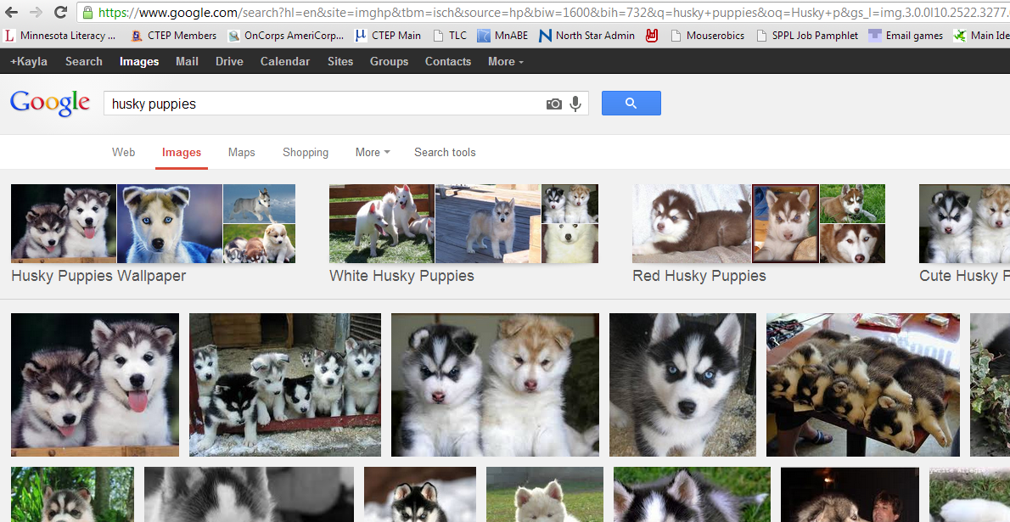
- Project the following picture onto the board for a minute, ask learners what is shown, ask them how to get there

- Take down projection and bring Pilot back in

- Navigator describes how to get to the picture why the Pilot does all the work
  - Open Internet Explorer
  - Type google.com into the address bar
  - Click on Images
  - Search for Husky puppies
Explain that this is a bit different from the task students will be doing, because they will be creating new email

Step 4: Review
Before learners begin, review what the roles mean
Ask the class what each roles responsibility is
Ask them what the goal of the activity is: create an email that looks exactly like the one in the picture
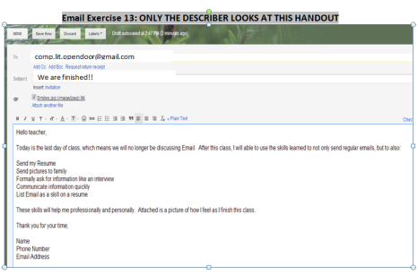
Ask if there are any remaining questions

Step 5: Learners complete activity
Have the Navigators raise their hand
Instruct them to stand behind the Pilots, so they cannot see the paper
Hand the Navigator Email Exercise 13
Remind them to pay attention to spaces between paragraphs and any additions to the email
Instruct them to begin
Circulate to answer questions
Once students are finished, they should send the email. Teacher can check their formatting when it is sent

Teacher Directions: Activity 2: Final Questions
Step 1: Any Questions
Take some time to go over any final questions students still have about what we have learned in email
If they don’t have any: ask them to tell you a new thing they learned. Ask them how they will use this knowledge in the future. Ask what they liked about the class and what they think could be improved on
The answer to specifically the third question should be entered into the lesson report for the coordinator to see
Teacher Directions: Activity 3: Awards and Certificates
Step 1: Hand out Attendance Awards
If applicable

Step 2: Hand out North Star Certificates
Coordinators should have printed out the North Star Certificates for learners who passed the assessment. Recognize those students, but do remind the whole class that whether or not they passed the assessment does not determine if they can take the next class. Anyone who has not taken the same unit previously is able to continue on with Computer and Literacy classes no matter their North Star score.

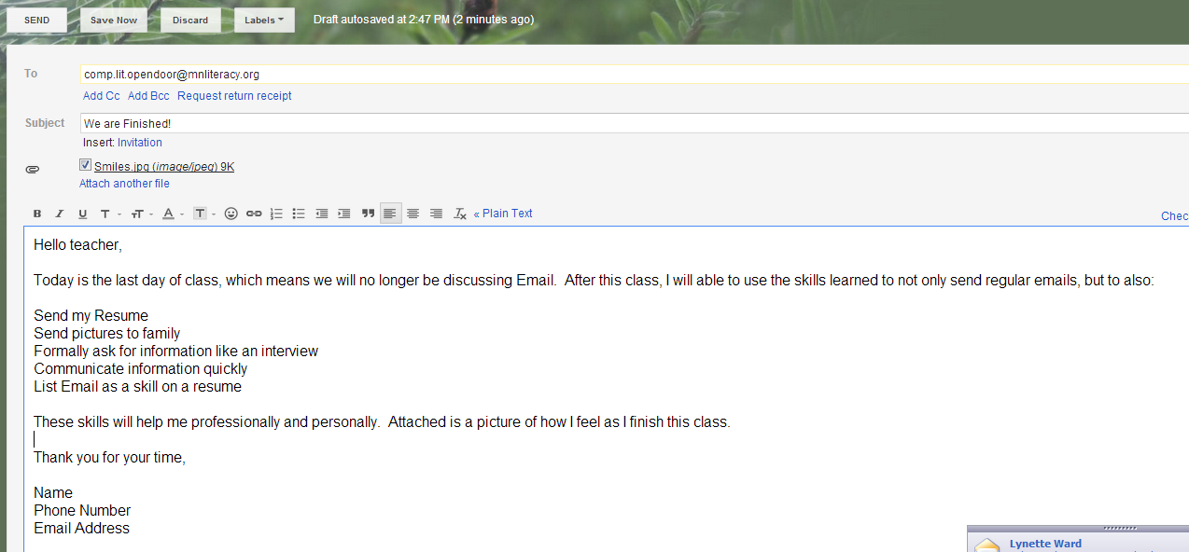
Email Exercise 13: ONLY THE NAVIGATOR LOOKS AT THIS HANDOUT
We are finished!!
comp.lit.opendoor@gmail.com

