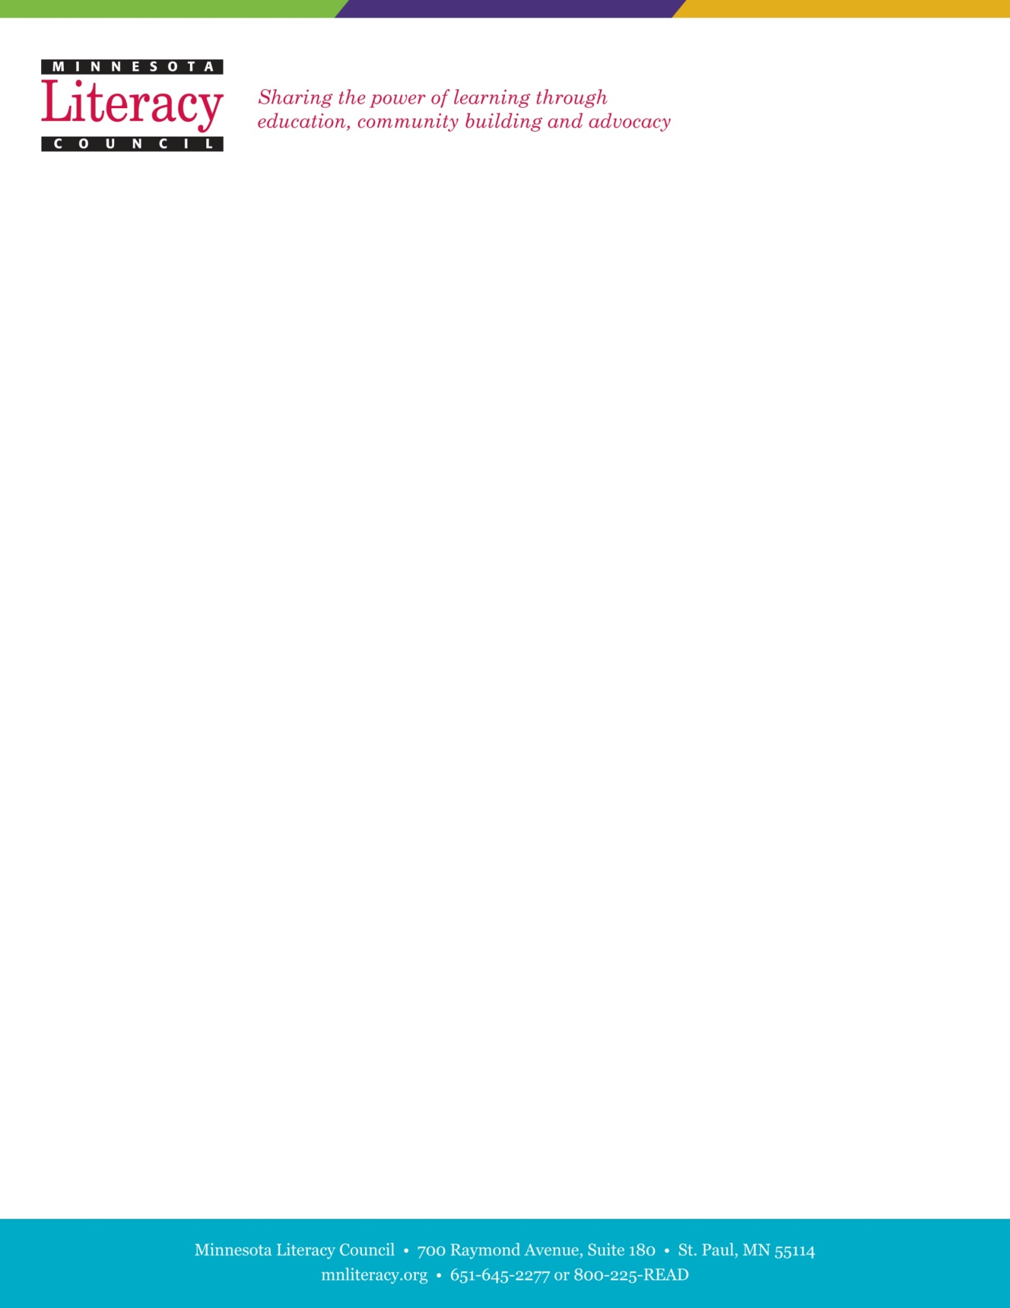

**Student Literary Journal**

**Copyeditor Internship**

The Minnesota Literacy Council is a nonprofit organization dedicated to improving literacy throughout our state. We offer literacy services, including ESL and GED, for adults and at-risk children, native-born citizens and recent immigrants, and urban and rural residents.

***Journeys*** is a student literary journal featuring the writings and artwork of Minnesota adult learners. The purpose of the journal is to empower adult learners to share their voices and unique perspectives with the larger Minnesota community. The journal receives over 500 submissions of writing and artwork annually. Please visit the following website for more information on the journal: www.mnliteracy.org/journeys

**Purpose of Position:**

We are seeking copyeditors to edit, format, and proof the 2018 version of *Journeys*. These unpaid internships will include using desktop publishing software and working with formatting and layouts.

**Qualifications:**

1. Experience with Adobe InDesign, Photoshop, and Windows Office including Word and Excel, or an aptitude for learning technical graphics software.
2. Have an excellent understanding of the English language as well as English grammar.
3. Demonstrated ability to meet deadlines and work collaboratively to complete a project.
4. Preference will be given to those who are enrolled students at a post-secondary institution.
5. Be comfortable with email and online communication.
6. Be responsible and punctual.
7. Be open and respectful to diversity.
8. Be encouraging, creative, flexible, and friendly.

**Time Commitment:**

The time commitment is, on average, 10 hours per week between January and May, 2018. The majority of the hours will be during February through April. Some of the editing work can easily be accomplished from off-site locations, such as home or school. Flexible working hours are available. Interns are requested to attend a community event and reading in late May.





**Responsibilities:**

1. Edit all submissions.

* Copy editing up to 400 submissions for typos and grammatical errors.
* Review content for inappropriate or offensive language.

2. Proofread all entries.

* Use standard proofing techniques to eliminate errors and improve understandability.
* Classify entries by theme and/or reading level (or other criteria).

3. Assist the layout of document in Adobe InDesign.

* Update cover, spine, title, introductory, and informative pages.
* Select and place artwork for the title page and the section/chapter intro pages.
* Determine section/theme order.
* Format for title, author and text for each submission.

4. Final proofreading.

5. Create and proof the index of authors.

6. Review the printer's proof and make necessary changes.

**Benefits:**

* Publishing and editing experience in a non-profit environment.
* Practical experience using publishing software, including Adobe InDesign.
* Knowledge of Adult Basic Education and literacy programs in Minnesota.

**To apply:**

Please email cover letter and resume by November 27th, 2017 to:

Liam Shramko, Distance Learning and Database Specialist

[lshramko@mnliteracy.org](mailto:lshramko@mnliteracy.org)

700 Raymond Ave., Ste. 180, St. Paul, MN 55114