Voter Education 2018
I am a citizen; now, how do I vote?

Five lessons on Elections and Voting
For English Language Learners,
Adult Basic Education and Citizenship Classes

Five classroom lessons based on stories for students to read, using a ‘real-life’ approach to learning. Follow Hawa, Fatima, Carlos, William, Nhong, Mai and Tran as they register to vote, learn about the candidates and issues, make choices, and finally cast their vote in the 2018 election.

In these lessons, students develop skills in reading, writing, speaking and critical thinking while they learn about a significant facet of life in the United States – voting and elections. All lessons include an original story, related vocabulary, a worksheet with questions for discussion, an activity, and relevant information for the instructor. Each lesson takes 15-25 minutes, depending upon discussion time.

Links are provided to websites for more information on the election process and candidate information. Pre-registration forms are included and absentee ballots may be downloaded; websites are included.

Lesson 1 Registering to vote
Lesson 2 Learning about levels of government
Lesson 3 Learning about the candidates and the issues
Lesson 4 Making a choice
Lesson 5 Casting a vote
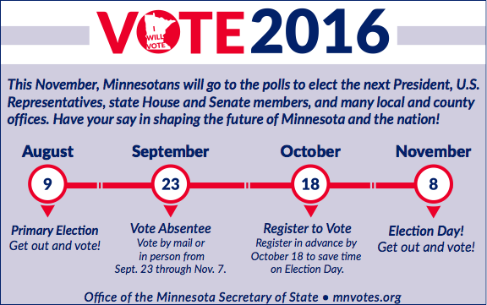
Information for the five lessons is from the Minnesota Secretary of State’s Office and the League of Women Voters.

Written as a contribution to Democracy and Education
by Meredith Sommers mjsommers38@gmail.com
ESL/English Language Teacher and Citizenship Teacher
Centro Guadalupano, Minneapolis, MN

Thanks to Minnesota Literacy Council for encouragement and distribution of this curriculum.

Permission is granted by author to download, copy and use all or part of the lessons. Your comments are appreciated.

Voter Education
I am a citizen; now, how do I vote?

Lessons on Elections and Voting in Minnesota
For English Language Learners, ABE and Citizenship Classes

Thousands of students who are taking English, Adult Basic Education or Citizenship classes are, or will be, eligible to vote in the upcoming elections. Even if students are not eligible to vote, they can encourage and coach others on the voting process. They also have values and opinions that they can express to friends or family who are eligible voters.

These lessons are designed for residents of Minnesota, whether they are long-time citizens and have never voted, or immigrants and forengn-born residents who have passed the rigorous examination to become citizens. Now they have the opportunity to vote in elections, and you, as a teacher, have the opportunity to help their participation by preparing them to vote.

The basic message of these lessons is the importance of voting as one way to be involved in one’s community and country. Voting is a right of all citizens, and it is the responsibility of all citizens and residents to be informed about the issues and candidates prior to voting.

Voter Education for English Language, ABE and Citizenship Classes is a primer on the basics of voting. It is written for students with intermediate through advanced English language proficiency. These lessons are relevant for all students, even if some students in the class are not citizens. They can still learn about the issues, have opinions about candidates, and talk to others about their views.

- Lesson 1 Registering to Vote is about eligibility and voter registration. A registration form in English is included in the lesson, with instructions for downloading the form in ten other languages. Teachers are encouraged to actually register eligible voters in class, up until 20 days before the election. Otherwise, students can fill out the registration form in class, and take it with them when they vote.

- Lesson 2 Learning about Levels of Government uses a map to teach about boundaries for federal, state, and local jurisdictions so students can better understand what levels of government handle various issues, such as foreign policy, immigration, education, etc.

- Lesson 3 Learning about Candidates and Issues is how to become informed about the candidates. The subject of political issues is introduced, to help students discern what positions candidates support. In this case, the issue is obtaining a Minnesota Driver’s License.

- Lesson 4 Making a Choice continues the quest for information in deciding how to vote. Students learn how to find information about candidates, the political parties and their platforms, so they can make their own decisions.

- Lesson 5 Election Day focuses on procedures for voting, both absentee and going to the polls. Included is a sample polling place diagram and an application for an absentee ballot. Students end the lesson series when they make a sticker to wear that says “I Will Vote!” or “I will encourage others to vote!”

Recommended sources for you and your students:

- Voter’s Guide, published by the StarTribune; available at public libraries and other locations, free of charge; StarTribune newspaper voter’s guide: www.startribune.org

- Secretary of State’s Office: www.sos.state.mn.us. Go to Elections and Voting. This official site has forms for voter registration and absentee voting, a guide to voting, links to candidates’ websites, and a 15 minute, on-line video, “Voting in Minnesota: What You Can Expect”.

- League of Women Voters of Minnesota Voter Guide: statewide nonpartisan publication that includes, in one issue, all the candidates for statewide offices for all the major and registered minor parties; photos and biographies of candidates; and responses to questions by candidates. www.lwvmn.org

Lesson 1 Registering to Vote

Any person can provide registration cards and assistance to help register new voters, and the ESL, ABE and Citizenship classrooms are ideal places to do voter registration. When new voters take this first step of filling out the registration form, they are more likely to actually cast their vote on the day of the election or vote absentee before election day. All teachers have a good opportunity to pre-register eligible voters. You can keep a list of names and phone numbers of the people you register to call and remind to vote the day before the election.

Eligibility requirements in Minnesota are:
- 18 years of age or older
- A citizen of the United States
- Have lived in Minnesota for at least 20 days before the election
- Have any felony conviction record dismissed

Pre-registration is accepted up to 20 days prior to an election. Voters who register by this deadline will receive a postcard in the mail with information about their polling location. Eligible voters who have not pre-registered can register at their polling place on the day of the election. In order to vote, residents need a Minnesota driver’s license or a Minnesota ID. Seventeen-year-olds can pre-register if they are 18 by election day.

Note: U.S. citizens may not be deprived of the right to vote because they cannot read, write or speak English.

Teacher preparation: Make copies of the following story, questions and voter registration form for all students. You also may get a supply of voter registration cards, available in English, Hmong, Spanish, Somali, Vietnamese, Lao, Khmer, Chinese, Oromo Amharic and Russian, at one of the following locations:
- County Government Center
- Local Library
- City Hall
- Secretary of State’s Office on-line www.sos.state.mn.us

Essential vocabulary:
Voter registration, pre-registration
Eligibility
Polling place
Secretary of State

Lesson Preparation: Write the Minnesota voter eligibility requirements on the board or Power Point for all students to see.

Story: Hand out a copy of the story and worksheet to each student.
- Read story aloud while students follow along.
- Ask if there are words or phrases students don’t understand and then explain and clarify as you go along. Teachers may need to explain unfamiliar vocabulary or concepts before reading the story.
- Give students time to go over the story silently and underline anything they don’t understand or want explained. Work with the words or phrases students underlined, and help them understand the concepts in the story.
- Read the story aloud again, asking students to take turns reading.

Worksheet Questions: Have students work in pairs to write answers to questions on the worksheet, using complete sentences. Ask for volunteers to write answers on the board. Use questions as a catalyst for discussion.

Activity: Hand out the attached Minnesota Voter Registration Form to all students. Go step-by-step over the form and ask all students to complete it whether or not they are citizens. For those who are citizens and want this pre-registration to be official, it must be mailed to the Secretary of State’s Office to complete the process., within 10 days of signing the form. Teachers may facilitate this by having envelopes and stamps available. Other students can use the form to interview a partner and fill in the card for the partner (without their signature). Mail only those forms that have certified eligibility and a signature.

Mail to: Secretary of State, 60 Empire Drive, suite 100, St Paul, MN 56103

Remind students that this is pre-registration They can also register at their polling place on Election Day.

If computers are available to students, go to sos.state.mn.us/elections. Explore the information that is available. Pre-registration may be done on-line providing an email address is provided.

Story 1: Hawa Registers to Vote

Hawa is 34 years old. She became a United States citizen in 2008 but she has never voted. She didn’t register to vote when she became a citizen. Haha meets the requirements to vote:
- 18 years of age or older
- A citizen of the United States
- Has lived in Minnesota for at least 20 days before the election
- Has any felony conviction record dismissed

Now, there is going to be an election, and Hawa wants to vote. Hawa asks her teacher, John, “What do I need to do to vote?”

John says, “First you need to register. You can register to vote before the election. This is called pre-registration. That puts you on the list of voters so it will be easier when you vote. You can also register on election day at your polling place.”

“What is a polling place?” asks Hawa.

“A polling place is the room where you vote. Polling places also are called ‘polls,’” says John. “Polls may be in schools, apartment buildings, churches and community buildings. Your polling place is in your neighborhood. The Secretary of State’s Office can give directions to your polling place. Their web site is www.sos.state.mn.us.”

“I want to register before the election. I want to pre-register.” says Hawa.

“I will bring a registration card to the next class and you can pre-register.” John answers. “Do you want the card in English or Somali? They also are available in Hmong, Spanish, Vietnamese, Lao, Khmer, Chinese, Oromo, Amharic and Russian.”

“Please get me a card in English, so I can practice my English,” says Hawa. “Will you help me if I don’t understand the instructions?”

John gets a voter registration card in English at the public library. It is free. He could also get voter registration cards on-line at sos.state.mn.us/elections. He brings it to class the next day. He also gets a card in Somali for Hawa to give to her husband. They need to pre-register 20 days before the election. Hawa completes the card in English, using a pen, not a pencil. It is very easy. Now she needs to find out where to mail the voter pre-registration. It should be sent to the voter registration office in her county or to: Secretary of State, 60 Empire Drive, suite 100, St Paul, MN 55104.

On her way home, Hawa gets a postage stamp and mails her voter registration. When she gets home, she gives the other registration card to her husband. Now she can help him fill it out. She can be his teacher.
Questions 1: Hawa Registers to Vote

- What did Hawa need to do before she could vote?

- What are the eligibility requirements for voting in Minnesota? Is Hawa eligible to vote? Are you eligible to vote?

- Voter registration cards are available in English. What are the other languages used for voter registration cards?

- How do you find out where to send your voter pre-registration form? What is the address?

- How do you find out where to vote?

- Where does John get registration cards? Where else can you get a voter registration card?

- Can Hawa help her husband register? Can you help other people register?

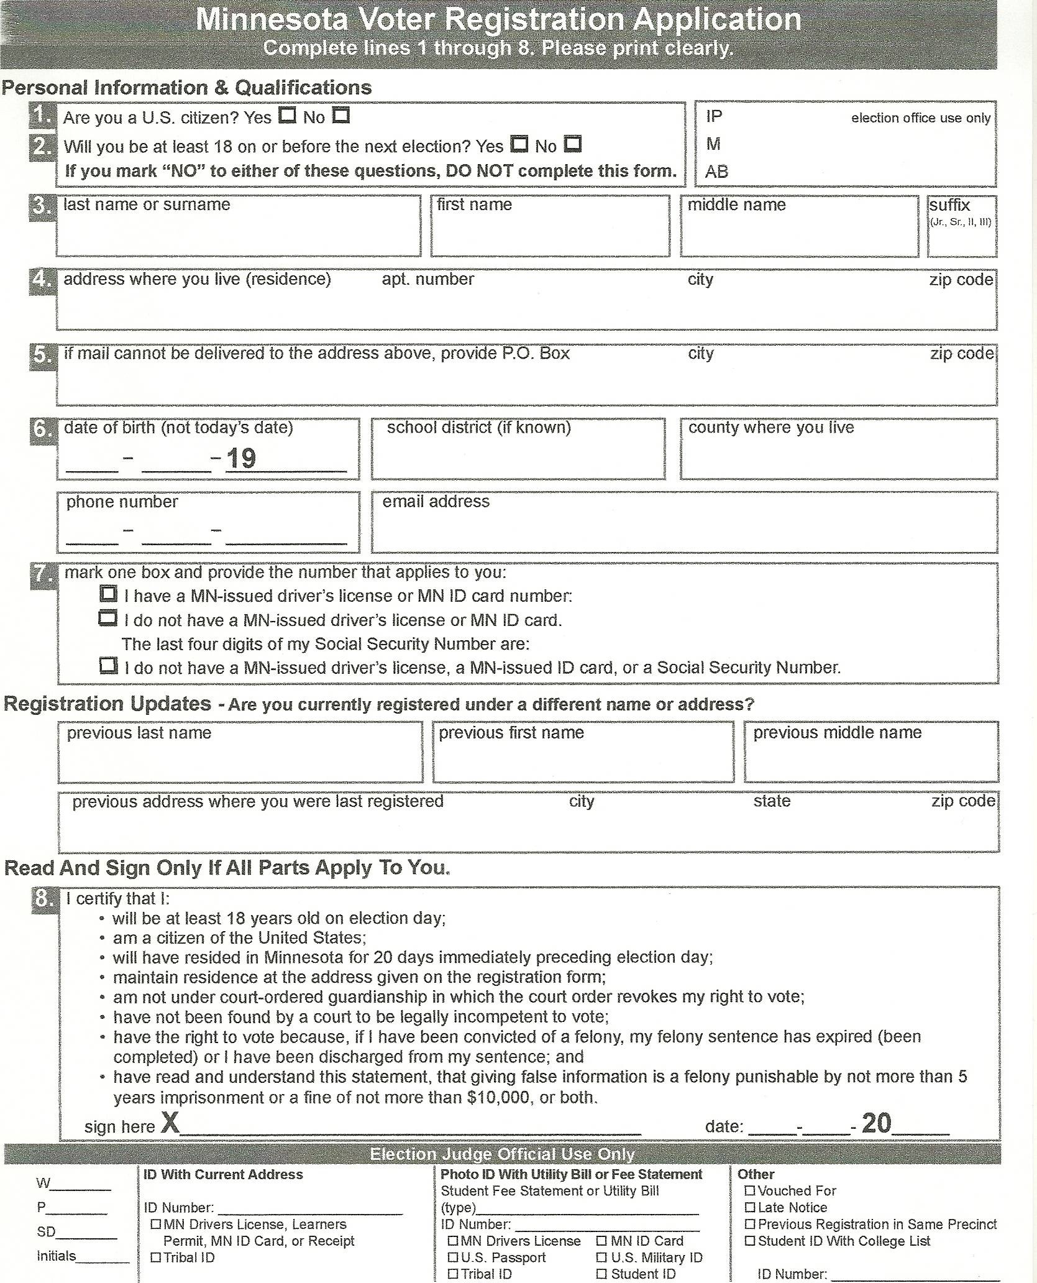
Lesson 2 Learning about Levels of Government

Students often are confused about the different levels of government, and what decisions are made at different levels. The vocabulary and concepts are difficult, and to help, you need a U.S. map to provide a visual image of political boundaries. Be prepared to talk about which level of government handles different issues. Many issues are handled at many levels.

Teacher preparation:
- Bring a map of the United States and pin it on the wall, or use a projected map.
- Make copies of the following story and questions for all students.

Review of previous lesson: Write vocabulary words you learned in the previous lesson on the board for review. Ask students to reconstruct the story of the previous lesson, and then ask for questions or thoughts about this lesson, or if they need further help submitting pre-registration.

Warm up: Ask students to go to the U.S. map and identify where they live now, and other places they have lived. Explain that there is the same national government for all people living in the United States, called the federal government. Each state also has its own government, as does every county and every city. Point out the geographical areas and corresponding levels of government.

Story and Questions: See instructions for Lesson 1.

Activity: When students read about the levels of government, copy the grid of levels of government from the story on the board and use the map to show the boundaries, or jurisdictions, of government. You may want to expand the information by including other responsibilities of government and other jurisdictions.

Closure: Review the vocabulary words, and repeat the main themes of the lesson. Ask students if they know what office levels of government are being decided in the up-coming election. For example, is there a race for governor, or mayor of their city? If there is confusion, review the terms of office.

Ask students to talk about one thing they learned today.

Vocabulary:
Federal Government, President, Senators and Representatives
State Government, Governor, Senators and Representatives
City Government, Mayor, Council
Elected officials
Candidates

Story 2: Fatima Studies a Map

Fatima moved from Afghanistan to Minnesota in 2009. She has lived in the United States more than five years, and soon she will become a citizen. Fatima is taking a Citizenship class because she wants to vote in the general election in November. She knows that voting is one of the rights and responsibilities in a democracy. She remembers that democracy is government “of the people, by the people and for the people.”

Last week her Citizenship class listened to some candidates who were having a debate. Fatima listened carefully to the candidates but she was confused. The candidates gave their opinions about schools, parks, and libraries. Fatima wanted to know their opinions about the fighting in Afghanistan, but they didn’t talk about war.

Fatima asked her teacher why the candidates didn’t talk about war. Her teacher, Amy, explained, “These candidates don’t make decisions about war. The candidates in this debate are running for the city government, and they make decisions about things in the city, like schools, parks, and libraries.

“The President and the Federal government in Washington D.C. make decisions about things that effect the entire country. Some of these issues are war, defense and national security, trade between countries, immigration, health care and Social Security. Our state has two Senators and eight Representatives that help make these decisions.

“The state elected officials and the Governor make decisions about state roads and bridges, road safety and driver’s licenses, and many other things.

“There are other levels of government, too, and voters elect people to these governments, also. Here are some of the levels of government and the titles of the elected officials.”

Amy brought out a map of the United States, and wrote this on the board:

United States of America State of Minnesota City or Town

President & Vice President Governor Mayor
U.S Senators (2 per state) State Senators City Council
U.S. Representatives (8) State Representatives

“That helps me understand the levels of government, and what are some of the responsibilities,” said Fatima. “Now I need to write a letter to the President, my U.S. Senators and my U.S. Representative to tell them my opinion about the war in Afghanistan.”

“That’s a great plan!” said Amy. “You are a responsible citizen. And you know your rights.”

Questions 2: Fatima Studies a Map

- What did Fatima want to learn from the candidate’s debate? Did she get the information she wanted? Why or why not?

- What are the elected officials called that voters choose in the federal government? What are some of the responsibilities of the federal elected officials? Are there elections for any of these offices this year?

- What are the elected officials called that voters choose in the state (Minnesota) government? What are some of the responsibilities of these officials? Are there elections for any of these offices this year?

- What are some of the responsibilities of the elected officials in the city government? Are there elections for any of these offices this year?

- Who does Fatima need to write to about her concern about war in Afghanistan?

- What do you think Fatima can do, in addition to voting, to be responsible citizens?

Lesson 3: Learning about Candidates and Issues

Teacher preparation: Bring to class any kind of information that is related to candidates in the upcoming election, such as articles in the newspaper, voters’ guides, campaign literature, party platforms, web sites, etc. Make sure you have materials on all the major candidates running for the same office. You may want to choose to focus on the presidential, state or city elections.
Make copies of the following story and questions for all students

Review of previous lesson: Write vocabulary words you learned in the previous lesson on the board for review. Ask students to reconstruct the story of the previous lesson, and then ask for questions or thoughts about that lesson.

Warm up: Introduce the lesson by asking students if they have ever voted, either in the U.S. or their country of origin. Ask how they decided upon a candidate. Explain there are many ways in the U.S. to learn about the candidates and the issues. Show the materials you have brought to class as an example of ways to learn about the candidates.

Story and Questions: See instructions for Lesson 1.

Closure: Show again the materials you brought to class about candidates. Review the vocabulary words you learned, and repeat the main themes of the lesson. Ask students to talk about one thing they learned today. Ask students to look for campaign literature or articles and bring them to the next class.

Essential Vocabulary
Campaign literature
Voter’s Guide
Party platform
Issues

For more information on the political parties, go to their individual websites
Also, go to www.mnvotes.org for information on candidates.

Story 3: Carlos Studies the Issues

On September 18, Carlos took the Citizenship test after he had lived in the U.S. six years. He passed the test, and now he can vote. An election is the coming up.

Carlos is excited to be a voter. He will help choose the future leaders of his city, state and country. But before he votes, he needs to learn about the candidates and some issues they support.

Some candidates have many ads on TV and the radio. Carlos sees the most signs, bumper stickers and billboards for one candidate everyday. He knows this doesn’t mean the candidate is better than the other candidates. He thinks this candidate has more money.

On his way to class, Carlos sees a picture of a candidate for school board named Pedro Benavides. “I think I will vote for Pedro Benavides,” Carlos tells his teacher, Sue. “He looks Latino, like me. He will understand what is best for the Latino people”

Sue says, “Just because candidates are the same country as you, it doesn’t mean that they have the same values or opinions you have. It is better to make a decision about the candidate’s values and past record. Look at what the candidate says on issues that are important to you.”

Then Sue asks, “What are the most important issues for you, Carlos?”

Carlos replies, “An important issue for me is getting a driver’s license. Before I was a citizen, it wasn’t possible to get a driver’s license and I drove without a license. Luckily, I was never in an accident and never was stopped. When I became a citizen, I was eligible to get a driver’s license. Now I have a Minnesota driver’s license and feel much safer. That is also the identification I used to register to vote.”

Carlos continued, “My brother doesn’t have a Minnesota identification card or a driver’s license, but he needs to drive to work. He can’t get one because of Minnesota law. I worry about him.”

Sue says, “The law on Drivers’ Licenses is made by elected officials in the Minnesota government. You can find state candidates’ positions on this issue if you go to their web site, or to www.mnvotes.org. Some candidates meet with groups of people or individuals. Or you can go to a town meeting where candidates speak and you can ask their opinions about this issue.”

Carlos thinks that is a good idea. He will ask his brother to go to the town meeting with him, but Carlos will drive the car.

Questions 3: Carlos Studies the Issues

- What did Carlos have to do to be eligible to vote?

- What does Carlos think about the candidate who has the most TV ads, bumper stickers and billboards? Do you agree or disagree with him?

- If a candidate is the same gender or from the same country as you, do you think they will have similar values or opinions that you have? Explain your opinion.

- What do you do to find information about candidates and their opinions?

- Becoming a legal citizen and getting a driver’s license were important issues for Carlos. What are important issues for you?

Lesson 4 Making a Choice

Teacher preparation:
- Get copies of the Voter’s Guide for students. These are produced by the League of Women’s Voters, www.lwvmn.org . The Star Tribune and other newspapers also publish a Voter’s Guide that is available at no charge in libraries and other public places.
- Make copies of the following story and questions for all students.

Review of previous lesson: Write vocabulary words you learned in the previous lesson on the board for review. Ask students to reconstruct the story of the previous lesson, and then ask for questions or thoughts about that lesson.

Warm up: Write on the board this incomplete sentence and brainstorm with students what some of the things you can do before you make a choice, such as get information, talk to friends, etc. Before I make a choice, I______________

Story and Questions: See instructions for Lesson 1

Activity: Hand out sample voters’ guides. Show students how the guide is organized and what information is available. Explain abbreviations that are used, such as DFL and GOP. Then have students work in pairs to get information about a candidate who is running for office in their city, state or nation. Have students report back, and when all have finished, have a mini-debate about the candidates. For homework, ask students to complete the sentence written above.

Closure: Review the vocabulary words you learned, and repeat the main themes of the lesson. Ask students to talk about one thing they learned today.

Extension lesson: Arrange for computers for students so they can go into websites of candidates by googling their names. They can look up their positions and platforms on issues of interest. Encourage them to choose one issue to investigate so they can make a comparison between candidates.

Essential vocabulary
Endorse
Liberal
Conservative
Democratic Party (DFL)
Republican Party (GOP)
Campaign literature
Party Platform
Story 4: William Makes a Choice

William is concerned about immigration. He was born in Minnesota and his girlfriend is from Ecuador. They want to get married and live in the U.S. William knows the U.S. government makes the laws about immigration policy, so he wants to vote in the upcoming election. He went on-line to learn about the candidates for president, U.S. Senator and Representative, and their political parties. He checked out the League of Women Voters website www.lwvmn.org.

In class, William told his classmates, “There are two major parties, and many other smaller parties. There is the Democratic party, also called the DFL in Minnesota, and the Republican party, the GOP. Candidates usually belong to one of the parties, and follow the platform of the party.

“The Democratic Party is the liberal party. Their web site says the Democratic Party believes that it is the government’s role to protect the health and welfare of individuals in the country.

“The Republican Party is the conservative party. The Republican Party web site says that they believe individuals can and should be able to take care of themselves with less government regulation.”

“So,” asked William, “if I know the party the candidates are in and the party platform, do I need to learn about the individual candidates ?”

“Yes,” said Sue. “It is also important to go to the candidate’s web site. Some candidates have their own positions. You are interested in immigration. I suggest you go to the political party web sites and the candidates’ web sites, and find their platforms. It’s very easy to do.”

“I have another question, said William. “What should I do if I don’t know anything about some of the candidates?”

“You don’t have to vote for everyone on the ballot,” said Sue. “Vote for the candidates you know about and you trust. That is the best anyone can do. The most important thing is that you vote.”

Now William will make his decision. First, he will go on-line to the candidate’s web site and the web site of their political party. Second, he will read the Voter’s Guide he can get at the library. Third, he will listen to a debate. And, he will talk to some friends who have studied the candidates and issues. He will ask for their opinions. Then, he will make his own choice.

Questions 4: William Makes a Choice

- What are the two major political parties? How are they different from one another?

- What is William planning to do before he makes his choice? Do you think he should talk other people before he makes his decision? How will William get more information before he votes?

- Did you go to candidates’ websites or political parties’ websites? What did you learn?

- What do you plan to do before you make your choice? Who are people you might talk to? Articles you might read?

Lesson 5 Casting a Vote

Basic information about voting: Citizens may choose how to vote, either absentee or at the polls. Absentee, or early voting, starts 46 days prior to the election and must be received at the county office on or before election day. As of 2018, the voter must go on-line for an application. It is not necessary to be registered to apply for absentee voting. An excellent guide to information about elections and voting, including absentee voting, is www.sos.state.mn.us. If computers are available for students, direct them to this website and click Elections and Voting.

For voting at the polling place on election day, citizens either need to be pre-registered, or they can register at the polling place, as long as they have accepted identification. Depending on when you registered to vote, you may need to bring proof of residence to the polling place.

One of four methods for identification may be used:

- Accepted identification with current name and address in their home precinct
  - MN driver’s license or permit or Minnesota ID card OR
  - Student ID card or fee statement with current address

- Photo ID with current utility bill that is due within 30 days of election and has voter’s name and current address

- School campus address list provided by school, used with student photo ID

- Vouching by a voter registered in the precinct, if the voter doesn’t have one of the above authorized proofs of identity

To find one’s polling place or address of county office for absentee address, go to the
Secretary of State’s website given above. Sample ballots and information on candidates also can be found there, under Elections and Voting.

Teacher preparation:
- Make copies of the following story, the sample polling place diagram and the flyer.
- Write the four methods for identification on the board.
- Bring blank stickers (2” x 3”) and markers to make I WILL VOTE or I WILL TELL OTHERS TO VOTE badges

Review of previous lesson: Write vocabulary words you learned in the previous lesson on the board for review. Ask students to reconstruct the story of the previous lesson, and then ask for questions or thoughts about that lesson.

Story and Questions: See Lesson 1 for instructions.

Activities:
- Using polling place diagram, have students take Mai and Tran through the voting procedure.
- Hand out absentee ballot application for students to complete, or use absentee ballot application that is included, if there are students who wish to use them.
- If computers are available, have students go to the Elections and Voting in the www.sos.state.mn.us website. There they will find is a video and accessible information.

Closure: Review the vocabulary words you learned, and repeat the main themes of the lesson. Ask students to talk about one thing they learned today.

Wrap-up: Hand out blank stickers and markers to students. Ask them to decorate a sticker and write I WILL VOTE, or another phrase of their choosing on the sticker, then put it on their clothing.

Essential vocabulary:
Accepted identification
Polling place (poll)
Absentee or early voting
Roster
Voting booth
Cast a vote
Vote tabulator

Story 5: Nhong, Mai and Tran Cast their Votes

Part 1

Nhong has been a citizen for eight years. She has gone to her polling place to vote for every election, but this year she will not be able to go. She is going to Vietnam to visit her family.

Voting is very important to Nhong. She asks her cousin, Mai, to help her. “How can I vote if I won’t be here on election day?”

“You can vote absentee,” he says. “Anyone can vote absentee. Many people vote this way because they are in the military or it is difficult to get to their polling place. Some people prefer to vote before the election because they don’t want to wait in line to vote on election day.”

Mai tells Nhong she can vote absentee a month before the election. Her vote is sent to her county’s election office and needs to get there by election day. She can go online to get an application and information about how to vote absentee. The web site is www.sos.state.mn.us.

The early votes are kept in a safe place in the county office, and they are counted on election day with all the other votes.

“Thanks for your help, Mai,” says Nhong.

Part 2

It is general election day, the first Tuesday in November. It is 7:00 am. The polls just opened. Mai and Tran are the first ones at their polling place. They have until 8:00 pm to vote, but they want to do it early. Mai has already registered to vote, but his mother, Tran, has never voted before. She just became a citizen in September.

Their polling place is at the public school in their neighborhood. They learned this by going online to www.sos.state.mn.us. They know which school door to enter because there is a United States flag outside. It is next to a sign that says VOTE HERE. Inside the school are signs telling them where to go.

When they go into the polling room, a man asks if they are registered. Mai says yes, he is registered, but his mother is not registered.

“Go over to that table, young man” the man says “the table with the sign that says Roster. Tell them your name so they can find it in the registration book. Then sign your name in the book. They will tell you what to do next.”

Then the man tells Tran to go to the Election Day Registration table. She doesn’t understand what the man says.

Mai says, “My mother doesn’t speak English. Is there anyone here who speaks Hmong and can interpret for her?”

The man replies, “Yes, there are interpreters here but they are busy now. You can interpret for your mother after you have voted. She can wait here. Do you want to do that?”

“OK,” says Mai. He goes to the Roster table to sign in and get his ballot. Then Mai goes to the Voting Booth. He brought a sample ballot from one of the political parties to help him remember the names of the candidates he will choose. Mai makes marks with a pencil next to the names of the people he has decided to vote for.

When he has finished voting, Mai puts his ballot in the Vote Tabulator. A woman gives him a red sticker that says, I VOTED. He puts it on his jacket. He feels good that he voted.

Now Mai helps his mother register. She has a Minnesota identification card, so she can register easily. Then they go together to all the rest of the tables and to the Voting Booth. After that, she puts her vote in the voting machine.

After voting, Tran also gets a sticker and puts it on her hat. She also feels good that she voted. Mai is proud of his mother.

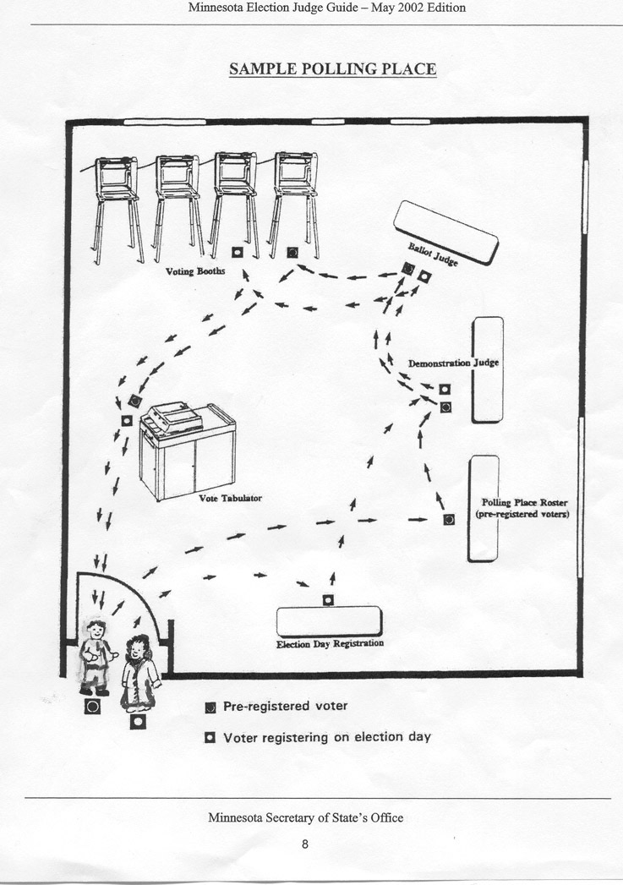

Questions 5: Nhong, Mai and Tran Cast their Votes

- Why does Nhong vote absentee? What are reasons other people vote absentee?

- Where do Mai and Tran go to vote? How did Mai find their polling place?

- Use the map to follow the pre-registered voter. How is this different from the voter who is registering on election day?

- What does Tran use for identification to register? What are other methods of identification? What method of identification do you use?

- Are there interpreters at the polling place? Why doesn’t Tran use an interpreter?

- What did Mai and Tran get after they voted?

