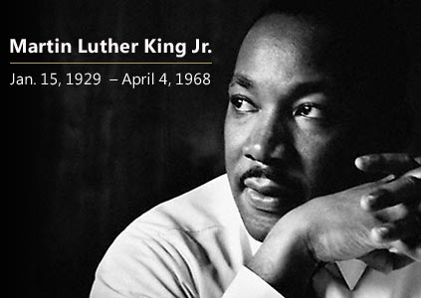
Martin Luther King, Jr. was born in Atlanta, Georgia on January 15, 1929. He was a very intelligent child, and did very well in school. He entered college when he was only fifteen years old. King graduated from college in 1948, when he was 19 years old. In 1951 he entered graduate school.

Martin Luther King, Jr. married Coretta Scott in 1953. They became the parents of four children. In 1954, King became the pastor of a Baptist Church in Montgomery, Alabama.

For many years, black Americans did not have the same rights as white Americans. Drinking fountains and rest rooms were labeled WHITE and COLORED. Black people had to sit in the back of buses. Many restaurants did not serve food to black people. In 1955, after Rosa Parks was arrested because she refused to sit in the back of the bus, Dr. King became a leader of the Montgomery bus boycott. This boycott helped end the separation of blacks and whites on buses.

Still, in some places black children and white children did not go to the same schools. Many black Americans could not vote. They also had a hard time getting jobs. Dr. King worked hard to make people’s lives better. He led many peaceful demonstrations. He showed people how to be heard without being violent. Change took place because of Dr. King’s peaceful ways and words.

Dr. King gave his most famous speech in Washington, D.C. in 1963. Almost 250,000 people listened to his “I Have a Dream” speech. His dream was that his children could live together with all Americans of all skin colors.

In 1964, Dr. King became the youngest person to ever receive the Nobel Peace Prize, a world-wide honor given to only a few every year. It honors people who work very hard for peace.

Dr. King is famous for his speeches given to persuade people that things must change. He inspired black and white people to fight for the fair treatment of blacks. King led many protest marches in the 1960s. He also wrote two books about black people’s struggle for the same rights as white people.

But there were still people who did not like his teachings. On April 4, 1968, Dr. King was shot and killed by one of these people. He was only 39 years old when he died. However, his dream of peace and better lives for all Americans is still alive today.

In August, 2011, the Dr. Martin Luther King, Jr. Memorial was dedicated on the Mall in Washington, D.C. The other memorials on the Washington Mall represent George Washington, “The Father of Our Country”, Thomas Jefferson, “The Author of the Declaration of Independence”, and Abraham Lincoln, “He freed the slaves”.
Find one or more sentences in the reading that describe each picture and write the sentences on the lines. After writing the sentences, practice telling the story to a partner.

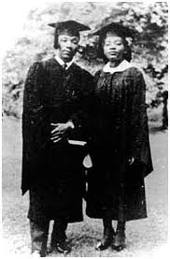

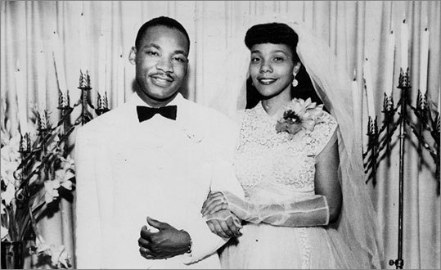

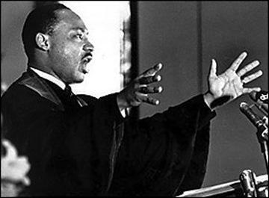

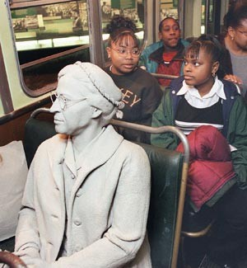

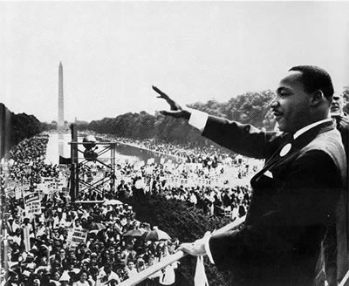

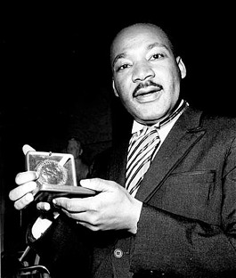

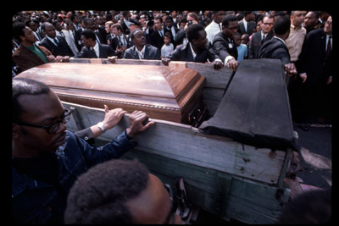

100 Question Review- Teacher Copy

9. What are two rights in the Declaration of Independence?
▪ life
▪ liberty
▪ pursuit of happiness
The second sentence of the Declaration of Independence states:
“We hold these truths to be self-evident, that all men are created equal, that they are endowed by their Creator with certain unalienable Rights, that among these are Life, Liberty and the pursuit of Happiness.”

48. There are four amendments to the Constitution about who can vote. Describe one of them.
▪ Citizens eighteen (18) and older (can vote).
▪ You don’t have to pay (a poll tax) to vote.
▪ Any citizen can vote. (Women and men can vote.)
▪ A male citizen of any race (can vote).

84. What movement tried to end racial discrimination?
▪ civil rights (movement)

85. What did Martin Luther King, Jr. do?
▪ fought for civil rights
▪ worked for equality for all Americans

