

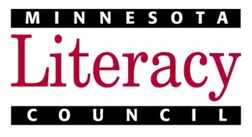

*Supported by the Minnesota Literacy Council*

**mnliteracy.org/hotline**



1. Call or visit us to make an intake appointment. Appointments are available Tuesday evenings or Thursday mornings.
2. At your appointment, you will fill out registration forms and take short placement tests.



* English (ESL)  
  Monday – Thursday 9 a.m. – 12 p.m.
* GED  
  Monday – Thursday 1 – 3 p.m.
* Citizenship  
  Friday 10 a.m. – 12 p.m.
* Computer skills  
  Tuesday/Thursday 12 – 4 p.m.





**Literacy Program Name Here**

**PHONE:** (651)555-5555 **EMAIL:** email@yourdomain.org

**ADDRESS:** 2222 Street Name, City, MN 55111

**WEBSITE:** yourdomain.org