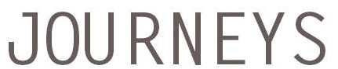
Student Reading
A Celebration of Students!
Reading Original Essays, Stories & Poems
Date & Time
Location
Friends and Family invited!
A Reception Will Follow
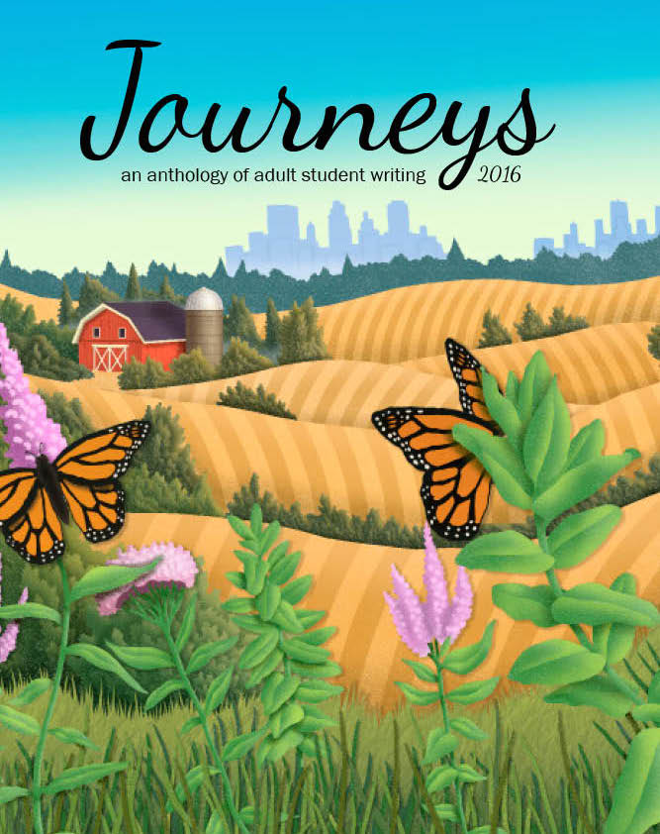
RSVP to
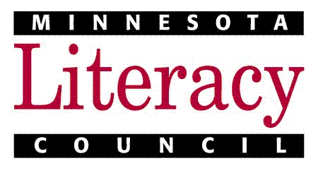
Journeys 2016: An Anthology of Adult Student Writing
is a publication of the Minnesota Literacy Council

