Journeys Student Reading Toolkit and Guide
The Minnesota Literacy Council sponsors an annual Journeys Reading event in the spring to celebrate the adult literacy community in Minnesota. Adult literacy students are invited to read their original stories and poems, many of which are featured in Journeys: An Anthology of Adult Student Writing.
At this year's event 74 courageous learners read their writing pieces, essays, poems or stories. It is a powerful experience for the readers, their families and friends, volunteers and staff. For pictures of this year’s event, visit the literacy council’s Facebook page, and for reading video from past years, go to our youtube site.
This kit has tools that will help you to put on your own ABE reading event: this introductory guide, templates for signs, invitation and fliers plus a task chart.
ABE programs who decide to hold a student reading can elect to sell Journeys as a fundraiser. The literacy council is offering 10 copies of Journeys as part of the mini grant. To order additional Journeys for your event, please call Lynette Ward at 651-251-9081.
Have a wonderful event!

What is a  Journeys Reading event? | A Journeys Reading event celebrates the accomplishments of adult students in your  community. The event spotlights Adult Basic Education (ABE) students reading their original stories and poems, some of whom are featured in Journeys 2016: An Anthology of Adult Student Writing.
What is in the Journeys Student Reading Toolkit? | - This guide sheet • Sign templates  - Task chart • Journeys Reading Event Flier  - Invitation template
Journeys books: | For programs hosting a reading event, you can order Journeys for your event. Please call Lynette Ward at 651-251-9081.
Space requirements: | - Chairs for audience and readers.  - If you have more than 15 readers consider having more than one room to run readings simultaneously.  - Consider using a microphone in a bigger room or auditorium.  - Space for reception and refreshments.
Reception: | A reception with refreshments can follow the student readings to give readers, families and friends a chance to meet and greet each other. It can be causal or decorated. You could serve a treat and beverages.
Task Signup Sheet | 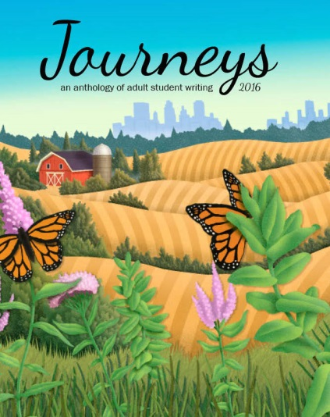  Use the Task Sign-up Sheet template to sign-up help for set-up, registration, greeting, the readings, emcee, reception and clean up.
Templates for Invitation, sign and fliers | Templates are in MS Word. Customize these documents to include:  - Your program name  - Location of the event  - RSVP contact information  - Date and Time

