*Journeys* is a publication of the Minnesota Literacy Council.

You are invited to a

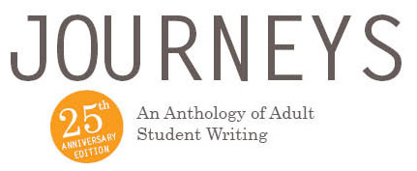

Student Reading

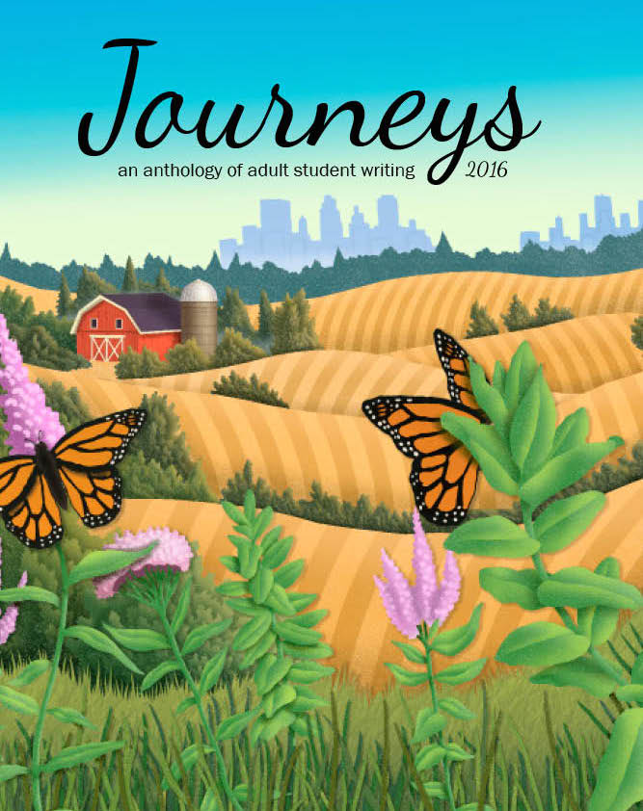**What:** *Journeys* Student Readings:  
A Celebration of Students!Adult learners will read their original stories and poems. A reception will follow.

**When:**

**Where**:

**Who:** Students, Friends and Families

Teachers, Coordinators, and Program Staff

**Calling all student readers!**

All adult learners are welcome to read their original written work! To sign up to read talk to your teacher.

**RSVP to**

**Journeys, a collection of ABE student writings, will be on sale. Proceeds will go to program needs.**

Add any other information you want to include here.