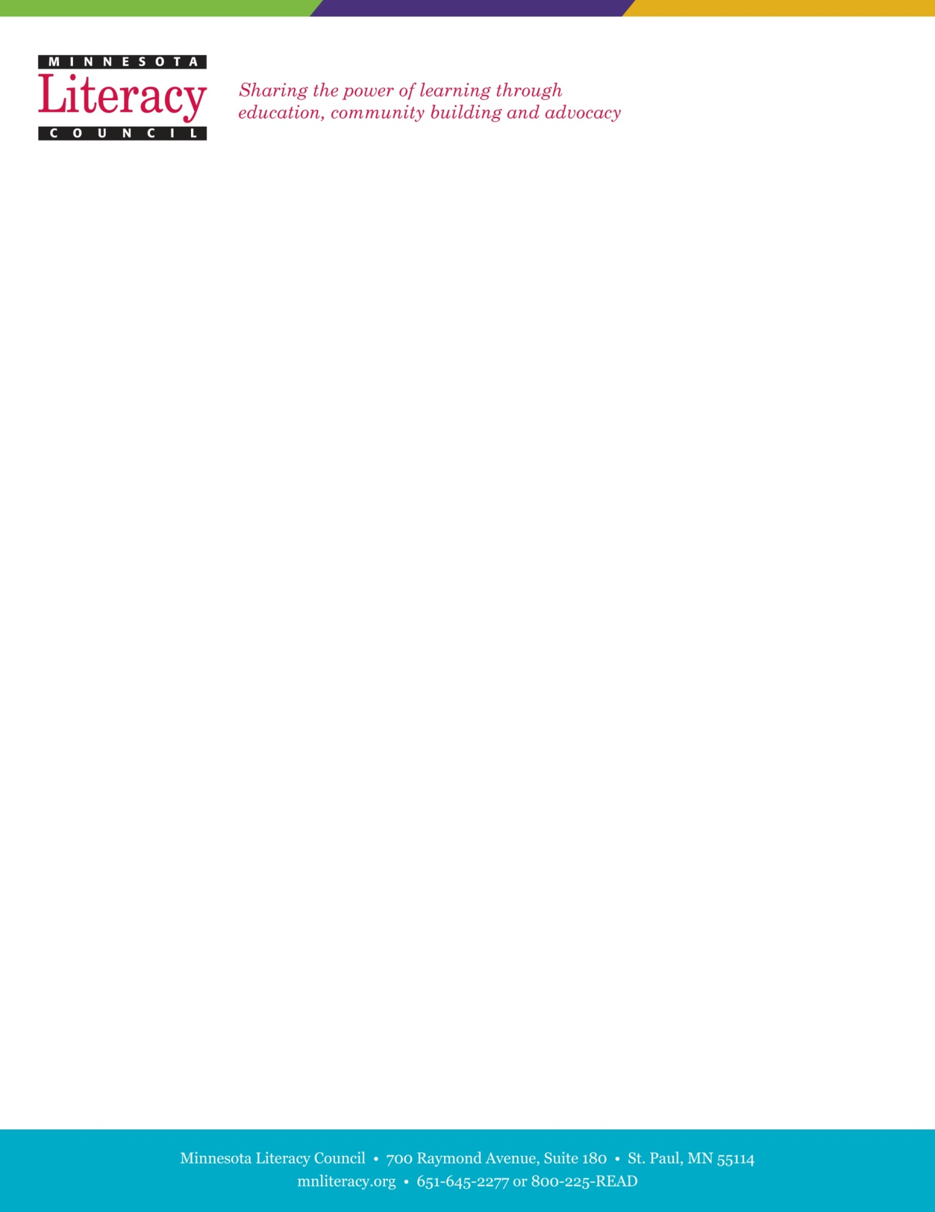

**Student Literary Journal**

**Graphic Design and Marketing Internship**

The Minnesota Literacy Council is a nonprofit organization dedicated to improving literacy throughout our state. We offer literacy services for adults and at-risk children, native-born citizens and recent immigrants, and urban and rural residents.

**Journeys** is a student literary journal featuring the writings and artwork of Minnesota adult learners. The purpose of the journal is to empower adult learners to share their voices and unique perspectives with the larger Minnesota community. The journal receives over 500 submissions annually. Please visit the following website for more information on the journal: www.mnliteracy.org/ journeys

**Purpose of Position:**

We are seeking a graphic design intern to create a book layout, import and set all submissions, and contribute to creating communication pieces for our literary journal: *Journeys*. The intern will be involved from the beginning of book production with the editing team to design and create the layout template in Adobe InDesign, import and set all submissions in the book layout and assist throughout production with layout issues and design features. Intern will be able to use all aspects of the book in their design portfolio. This is an unpaid internship position expected to require 80 hours of work between the months of January to May.

**Qualifications:**

1. Experience with Adobe InDesign and Photoshop, and Windows Office including Word and Excel.
2. Demonstrated experience in graphic design principles (can be class/course based projects).
3. Must have design portfolio and submit with application.
4. Have experience with creating publication layout templates in InDesign.
5. Demonstrated ability to meet deadlines and work collaboratively to complete a project.
6. Preference will be given to those who are enrolled students at a post-secondary institution.
7. Be responsible and punctual.
8. Be open and respectful to diversity.
9. Be encouraging, creative, flexible, and friendly.





**Time Commitment:**

The time commitment is expected to be an average of ten hours per week between January and May, 2018. Some of the work can easily be accomplished from off-site locations, such as home or school. Flexible working hours are available.

**Training:**

Training and on-site supervision will be provided. In-house graphic designer will be involved in approving designs and layouts.

**Responsibilities:**

1. Create a book layout in InDesign

* Develop a layout template that is creative and unique. Present **two** template options to editing team by February 13th.
* Create unique features throughout book that break up sections and text.
* Present, review, and edit layout plan as semester progresses based on needs from editing team

2. Import all submissions into layout

* Copyeditors will provide designer with around 500 submissions in MS Word documents to import into the book.
* Designer will work with editors to implement layout and structure of book

3. Develop key marketing and communication documents and advertisements

* Graphics will be created in InDesign or Photoshop.
* Key communication pieces include email templates in MailChimp and website pages. To be completed by April 17th.

4. Proofread all text and formatting.

5. Create index of authors.

6. Review and edit printers proof.

7. Prepare web version of book.

**Benefits:**

* Publishing and editing experience in a non-profit environment.
* Marketing and design experience in a non-profit environment
* Knowledge of Adult Basic Education and literacy programs in Minnesota.

**To apply:**

Please email cover letter and resume by November, 27th, 2018 to:

**Liam Shramko, Distance Learning and Database Specialist**

[lshramko@mnliteracy.org](mailto:lshramko@mnliteracy.org)

700 Raymond Ave., Ste. 180, St. Paul, MN 55114