Microsoft Word Day 8

Objectives Learners will be able to… | Materials
Computer skills: open previously saved document  Computer Skills: use formatting tools  Literacy: Students will be able to revise their own cover letter  Literacy: students will finish drafting their cover letter | Make Student Copies  - Good Cover Letter Examples 1&2 (Tab 14)  - Microsoft Word Exercise 8 (Tab 19)  Props, Technology or Other Resources  - Computers  - USB  - Projector
Lesson Plan |  | Vocabulary
Warm up for today’s Lesson: 15 Minutes Maximum  Description: Students will look through magazines for 3-4 minutes and pick a picture that says something about themselves, they will then type up a description of the picture and write why they chose it, including 3 details.  Materials/Prep: A stack of magazines, coordinator will be able to tell you where to find them  Activity 1: Good Cover Letters – 20 minutes  Description: learners will read through cover letter sand go over what they like/dislike about each one, these are meant to be examples of good cover letters  Materials/Prep: copies of Good Cover Letter Examples 1&2  Activity 2: Drafting Continued  Description: leaners can take about 50 minutes to draft a version of their cover letters  Materials/Prep:  Activity 3: Introduce Revising Step -25 minutes  Description: learners will learn how to revise and begin revising their cover letter  Materials/Prep: copies of Microsoft Word: Exercise 8 |  | - Revising  - Clarity  - Details

Teacher Direction: Activity 1: Good Cover Letters -Good Cover Letter Examples 1&2

Step 1: Pre-reading
Ask learners what needs to be included in a cover letter
- Introduction: what is the position, how you heard of it, why you are interested
- Sales Pitch: How are you a good fit for this job and for this company? Explain how you have shown your skills in the past, do not simply say you have skills
- Call to action: ask for an interview, thank them for their time
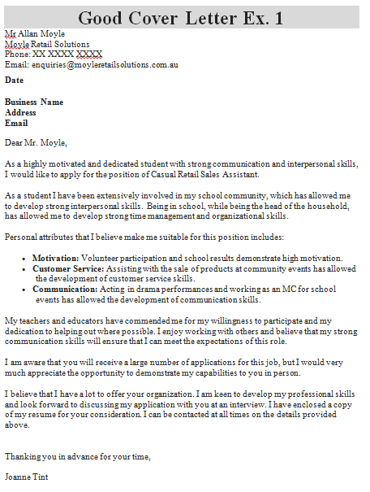
Step 1: Set-up
Hand out Good Cover Letter Examples 1&2
Read through them as a class

Step 3: Post reading
Ask students what they liked/didn’t like about the cover letters
Ask if they met all of the expectations that were set up in the Cover Letter Format from Day 7

Step 4: Takeaways
Instruct students to keep these examples in mind, they are more than welcome to pull phrases from the examples for their own cover letters

Teacher Direction: Activity 2: Drafting/Formatting a Letter

Step 1: Review
Review the purpose of a cover letter, prewriting and drafting
- Prewriting- determine subject, audience, details
- Drafting- organizing details into a clear order, expanding details into sentences and paragraphs
- Cover letter- a document which is sent to an employer that includes where you learned of the job opening, skills that will benefit the company, and a request for an interview

Step 2: Open Previously Saved Cover Letters
Ask students how you go about opening previously saved documents
Click on File(or Start Menu)>Click on Open (not if you did my computer)> Click on My Computer> Locate USB Drive>Locate your Cover Letter

Step 3: Continue Drafting
Explain that students have half of the class to draft a cover letter
Remind them to include the introduction, sales pitch, and thank you/request for interview

Step 4: Saving
After a bit of writing, have students stop and save their letter
Remind them to save as they work through the document

Step 4: If students finish early
If students finish early, instruct them to begin reading through the letter to make sure it is clear and organized. They are beginning the revising stages

Teacher Direction: Activity 3: Revising –Microsoft Word Exercise 8

If you do not get to this, be sure to write it in the lesson report. Teacher should start with this activity Day 9.

Step 1: Explain revising
Explain the goals of revising and write them on the board and do not erase until after this activity, these are questions writers need to ask themselves about what they are writing
- Are my details clear?
- Should I add or take out parts?
- Have I used the best ideas and words?
- Are all my sentences complete?
- Is my writing in a sensible order?

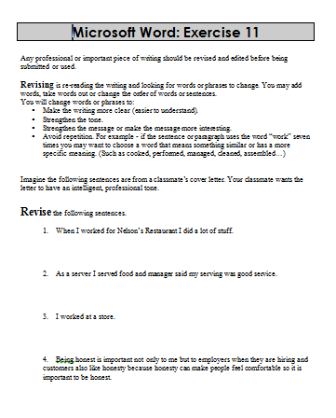
Step 2: Demonstrate
Learners should have their EYES FORWARD AND HANDS OFF OF THEIR COMPUTER
Demonstrate how to revise examples with students:
When I worked at Rainbow, I did a lot of stuff.
I worked for 3 years.
My boss said I did a good job.
I worked with customers at Best Buy.

Step 3: Controlled Practice
Hand out Microsoft Word Exercise 8
Have students think about how to revise the sentences, they can give it a try, and then everyone goes over revisions they came up with together

Step 4: Independent Practice
If students have not already begun turning putting their information into the cover letter format, have them do so now.
After they put information into the format, have them read over their letter and revise it. Students should refer to the questions on the board and make sure they are answering them as they revise
Remind students to save their document as Cover Letter+their name

Microsoft Word: Exercise 8
Any professional or important piece of writing should be revised and edited before being submitted or used.
Revising is re-reading the writing and looking for words or phrases to change. You may add words, take words out or change the order of words or sentences.
You will change words or phrases to:
- Make the writing more clear (easier to understand).
- Strengthen the tone.
- Strengthen the message or make the message more interesting.
- Avoid repetition. For example - if the sentence or paragraph uses the word “work” seven times you may want to choose a word that means something similar or has a more specific meaning. (Such as cooked, performed, managed, cleaned, assembled…)

Imagine the following sentences are from a classmate’s cover letter. Your classmate wants the letter to have an intelligent, professional tone.
Revise the following sentences.
1. When I worked for Nelson’s Restaurant I did a lot of stuff.

2. As a server I served food and manager said my serving was good service.

3. I worked at a store.

4. Being honest is important not only to me but to employers when they are hiring and customers also like honesty because honesty can make people feel comfortable so it is important to be honest.

Good Cover Letter Ex. 1
Mr Allan Moyle
Moyle Retail Solutions
Phone: XX XXXX XXXX
Email: enquiries@moyleretailsolutions.com.au
Date
Business Name
Address
Email

Dear Mr. Moyle,

As a highly motivated and dedicated student with strong communication and interpersonal skills, I would like to apply for the position of Casual Retail Sales Assistant.

As a student I have been extensively involved in my school community, which has allowed me to develop strong interpersonal skills. Being in school, while being the head of the household, has allowed me to develop strong time management and organizational skills.

Personal attributes that I believe make me suitable for this position includes:

- Motivation: Volunteer participation and school results demonstrate high motivation.
- Customer Service: Assisting with the sale of products at community events has allowed the development of customer service skills.
- Communication: Acting in drama performances and working as an MC for school events has allowed the development of communication skills.

My teachers and educators have commended me for my willingness to participate and my dedication to helping out where possible. I enjoy working with others and believe that my strong communication skills will ensure that I can meet the expectations of this role.

I am aware that you will receive a large number of applications for this job, but I would very much appreciate the opportunity to demonstrate my capabilities to you in person.

I believe that I have a lot to offer your organization. I am keen to develop my professional skills and look forward to discussing my application with you at an interview. I have enclosed a copy of my resume for your consideration. I can be contacted at all times on the details provided above.

Thanking you in advance for your time,

Joanne Tint
Good Cover Letter Ex. 2
584 Example 7th Street
Pittsburgh, PA 52447
(999) 222-2222
April 15, 2012

Ms. Jane Smith
V.P. Operations
Wolverine Services, LLC
233 Some Street
Pittsburgh, PA 54116

Dear Ms. Smith:
I am writing to express a strong interest in the position of Plumber at Wolverine Services, as announced in the April job listing at the City Placement Center. I am also sending a resume, showing that my capability accurately matches the requirements listed in the position advertisement.
This position particularly caught my eye, because I have a strong plumbing background, a proven history in pipefitting skills and a demonstrated ability to:
• Install and carry out maintenance on piping systems for water, storm, air, natural gases, steam and condensate return, and sanitary sewer lines
• Install and fix plumbing fixtures including sinks, water coolers, closets, gas and electric water heaters, and pumps
• Fabricate piping systems by means of pipe manufactured from terra cotta, steel, copper, ABS, PVC, poly gas service, and cast iron soil pipe
• Read and interpret blueprints, plans and specifications
I have always admired the success of Wolverine Services, LLC, particularly in Pittsburgh, where I found the technical developments challenging and rewarding, and would very much enjoy discussing the possibility of our working together. I will call your office next week to follow-up my application. In the interim, I can be reached at (999) 222-2222. I look forward to hearing from you.
Thank you for your time and consideration.

Sincerely,
(Signature)
Peter Joe

