**Word Unit: Day 6**

|  |  |
| --- | --- |
| **Objectives** *Learners will be able to…* | **Materials** |
| ***Computer Skill:*** *create a bulleted list*  ***Computer Skill:*** *create a numbered list*  ***Literacy Skill:*** *identify steps of the writing process*  ***Literacy Skill:*** *understand the goal of prewriting* | **Make Student Copies**   * **Microsoft Exercise 5: Writing Process (Tab 15)** * **Microsoft Exercise 6: Prewriting-print with graphic organizer on the back of the page (Tab 16)**   **Props, Technology or Other Resources**   * Computers * Projector * **USB Drives** |
|  | |
| **Lesson Plan** | |
| **Warm up for today’s Lesson:**  Description: Ask learners how you could go about opening a previously saved document: Click on File>Open>My Computer>Locate USB Drive>Locate File>Click Open  Materials/Prep:  **Activity 1: Creating Lists**  Description: learners will review creating lists and then will learn how to create columns through a step by step worksheet  Materials/Prep:  **Activity 2: Intro to the Writing Process**  Description: students will learn what goes into each step of the writing process, a short introduction  Materials/Prep: copies of **Microsoft Word Exercise 5: Writing Process**  **Activity 3: Prewriting**  Description: students will learn what goes into prewriting and will begin the prewriting process to create a cover letter  Materials/Prep: copies of **Microsoft Exercise 6: Prewriting** | **Vocabulary:**   * Bullets * Numbers * Writing Process * Prewriting * Brainstorming * Graphic Organizer |

**Teacher Directions: Activity 1: Create Lists**

Step 1: Context

Ask students if they ever write lists, what kind of lists

Ask if they have ever typed a list

When might this be a good idea: shopping list, recipe, sharing instructions?

Explain that Word has tools that allow you to organize a list

Step 2: Point out Bullets and Numbering buttons

Learners should have their **EYES FORWARD AND HANDS OFF OF THEIR COMPUTERS**

**Remind** learners of the **hover to discover** function, use it to locate buttons that give you bullets and numbers

Step 3: Demonstrate

Learners should have their **EYES FORWARD AND HANDS OFF OF THEIR COMPUTERS**

**Create a grocery list**

**Walk students through steps of how to add bullets**

**Add numbers**

Step 4: Controlled Practice

With students, everyone should create a list of colors

Altogether, turn that list into a bulleted list

Then turn it into a numbered list

**Review copy and paste** to create a duplicate

Step 5: When to use bullets and when to use numbers-Organizational Skill

**Draw a T-chart on the board**

**Label** one side “**bullets”** and the other **“numbers”**

Go through the list below and **ask students** if they would list these items using bullets or numbers?

* Grocery List
* List of people attending a meeting
* Steps to make dinner
* Number of students who live in Minneapolis
* Types of dogs
* Countries you have visited
* Parts of the computer

**Ask why someone would use numbers?** If there was a specific order or if you were trying to keep track of how many of something

**Explain** that for many of the items, they can go either way depending on how you plan to use the information

**Example: Types of dogs** if a general list of types is being created, you can use bullet points, but if you want to keep track of the number of dog breeds you would number the list

Step 4; Individual Practice

Instruct everyone to make a list of all of the places they have been

Once they finish that, they should use copy and paste to re-order the list and then change the labels to numbers.

**Teacher Directions: Activity 2: Intro to the Writing Process**

**– Microsoft Word Exercise 5: Writing Process**

Step 1: Set up context

**Ask** what kind of writing learners do in daily life? What kind of writing do you HAVE to do? How do you feel about writing?—try to direct them towards letters

**Write** students answers on the board

**Explain** that writing is a process of communicating thoughts and ideas. The process includes thinking and creating ideas, which can be difficult, but there is a process which helps to organize thoughts regarding a subject. **The writing process.**

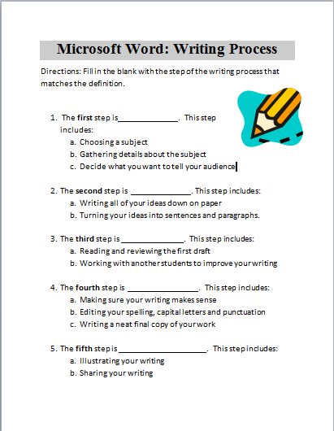Step 2: Introduce writing process

**Handout Microsoft Word Exercise 5: Writing Process** and explain that students should fill in the answers as we go through the steps of the writing process

**Write** the steps of the writing process on the board

1. Prewriting- choosing a topic, decide who the audience is, generating ideas, gathering details
2. Drafting- organize ideas, turn ideas into sentences and paragraphs
3. Revising- reading and reviewing, sharing with a peer, ensure clear details
4. Editing- spell check, check grammar, make sure writing makes sense
5. Sharing- illustrate, share, publish

**Go over** the purpose of each step with the students; ask them if they know before you tell them

**Explain** the importance of the writing process

It allows the writer to organize their thoughts and present well-written and properly developed documents

**Teacher Directions: Activity 3: Writing Process/Prewriting**

**– Microsoft Exercise6: Prewriting**

Step 1: Explain purpose of Prewriting

Today we will focus on Prewriting

**Explain** that prewriting forces the writer to focus their ideas

**Explain** that prewriting starts in your head and you slowly move towards paper then to Microsoft Word

Step 2: Demonstrate brainstorming to pick a subject/topic

**Demonstrate** how to prewrite for a topic, start with **brainstorming,** thinking about a topic

Example: Writing about computer class.

Too broad, want to be more specific

**Ask** students for specific topics relating to computers- opening a document, types of documents you can create in word, formatting tools

**Write** them all on the board

**Pick one**

**Repeat** for another topic

Step 3: Gather details

**Ask** students to think about details that might be discussed regarding topic chosen

**Example:** If you are discussing formatting tools, you would list the different buttons on the ribbon

**Write** down the details under the subject

**Explain** that the details should only be one to two words

Step 4: Organization

**Explain** that there are different ways to organize your ideas

**Explain** that what is on the board is a simple list of ideas

**Demonstrate** putting that information into a graphic organizer- bubble sheet

Step 6: Individual Practice

**Write** the following prompt on the board

*Sending a letter to ask about a job*

**Ask** students open ended questions to help them get to a subject that will detail their skills

Example: When applying for a job, what do we want to inform the hiring agent about?

**Handout Microsoft Exercise 6: Prewriting**

**Explain** that in the details section, there are two examples of organizing the details.

**Instruct** students to put information into the list template provided as well as the bubble organizer

**Circulate** to assist students

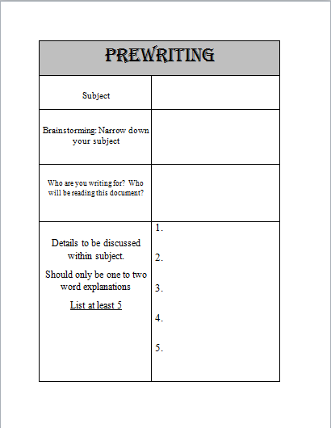**Explain** that students need to keep this handout because we will be using it in the next class to start with the second stage

**Microsoft Word Exercise 5: Writing Process**

C:\Users\knorman\AppData\Local\Microsoft\Windows\Temporary Internet Files\Content.IE5\LGGU2JLX\MC900410605[1].wmfDirections: Fill in the blank with the step of the writing process that matches the definition.

1. The **first** step is . This step includes:
   1. Choosing a topic
   2. Gathering details about the subject
   3. Decide what you want to tell your audience
2. The **second** step is . This step includes:
   1. Writing all of your ideas down on paper
   2. Turning your ideas into sentences and paragraphs.
3. The **third** step is . This step includes:
   1. Reading and reviewing the first draft
   2. Checking for clarity of information
4. The **fourth** step is . This step includes:
   1. Making sure your writing makes sense
   2. Editing your spelling, capital letters and punctuation
   3. Writing a neat final copy of your work
5. The **fifth** step is . This step includes:
   1. Illustrating your writing
   2. Sharing your writing

|  |  |
| --- | --- |
| Exercise 6: Prewriting | |
| Subject |  |
| Brainstorming: Narrow down your subject |  |
| Who are you writing for? Who will be reading this document? |  |
| Details to be discussed within subject.  Should only be one to two word explanations  List at least 5 | 1.  2.  3.  4.  5. |

Topic

Prewriting

Organizer