Word Unit: Day 3

Objectives Learners will be able to… | Materials
Computer skill: Formatting  Computer skill: Undo Button  Computer skill: saving a new file | Make Student Copies  - Day 3 Activity Packet-double sided and stapled (Tab 8)  Props, Technology or Other Resources  - Computers  - Projector  - USB Drives  - Download Formatting Practice (Tab 9, if needed)
Lesson Plan
Warm up for today’s Lesson:
Description: Learners will complete a screen fill activity that will require them to hover over buttons on the toolbar to discover what they do (this is a part of the Activity Packet, make sure they only do the first page)
Materials/Prep: copes of Day 3 Activity Packet

Activity 1: Formatting Practice
Description: go through another example of formatting text, including how to highlight using the shift button
Materials/Prep: Download Formatting Practice (from lesson plan, page 4), either from USB drives (if done at beginning of class) or from the web at http://www.mnliteracy.org/learning-centers/open-door-lake-street under attachments

Activity 2: Undo Button
Description: teacher will go over the undo button, and its greatness
Materials/Prep: keep the Formatting Practice Open

Activity 3: Saving Documents
Description: go over the steps to save a new document and then explain Save versus Save As
Materials/Prep: copies of Microsoft Word Exercise 2: Saving

Teacher Directions: Activity 1: Formatting Practice
Step 1: Activate prior knowledge
Have students point out where to find the Bold, Italics, Underline, Left/Right/Center Align, font and font size buttons
Review how to highlight text- click and drag

Step 2: Introduce shift to highlight
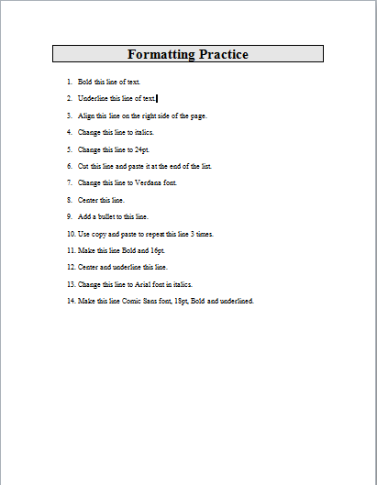
Ask how many people struggle with the click and drag motion
Explain that there are a few ways to select text. Two do not involve clicking and dragging, so they might be easier for some.
Ask what highlighting text allows you to do-this is review, it allows you to format text
Introduce the shift key in selecting text
Highlight using the shift key.
Demonstrate this a few times to be sure students understand that it is simply click, shift, click.

Step 3: Teacher downloads Formatting Practice
Teacher should download the formatting practice onto their computer
Students should NOT DO THIS until later
Download Either from USB Drive:
Explain how to open a document from a USB Drive
Start Menu>My Computer>Word Folder>Formatting Practice
Or from the web:
Explain each of these steps thoroughly
Everyone needs to open the internet>type mnliteracy.org into the address bar>scroll down till they see “My Learning Center” and click on it> Click on the name of their learning center>Click on Curriculum Tab>Under attachments, they should see Word Day 3 Formatting Practice

Step 4: Demonstrate
Teacher should demonstrate using click and drag and shift to highlight
Teacher should do first couple examples

Step 5: Controlled Practice
Learners should have their EYES FORWARD AND HANDS OFF OF THEIR COMPUERS
Have students come up and use the shift keys to change the format of the first few sentences

Step 5: Individual Practice
Instruct students to follow your directions
Every student should download the same Formatting Practice
They should complete the exercise on their own

Teacher Directions: Activity 2: Undo Button

Step 1: Context
Ask if anyone has ever made a mistake while typing or changing formatting
Explain that Word has a secret shortcut to fix mistakes that might be one of the best things ever invented

Step 2: Locate Undo and Redo buttons
Ask students to use their hover without clicking skills to locate the undo and redo buttons

Step 3: Demonstrate using Undo
Change the format of a Word
Explain that this is not what you wanted to do
Ask students what they can do to correct their error
Click on Undo

Teacher Directions: Activity 3: Saving Documents -Day 3 Activity Packet Page 2-3

Step 1: Demonstrate
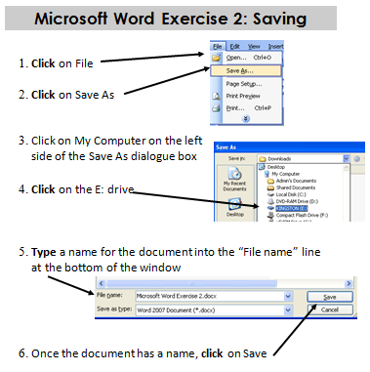
Learners should have their EYES FORWARD AND HANDS OFF OF THEIR COMPUTER
Demonstrate how to save a document
Explain that there are two important things to remember when saving:
- Be sure you save it in the place you meant to
- Give the file a name that will easily remind you what the file is
Click on File>click on Save As>Click on My Computer>Locate the drive that the USB is located, typically the (E: ) Drive>Give the File a name
Point out the File In line a the top of the dialogue box
Explain that this reminds you where you are within the computer

Step 2: Controlled Practice
Go through these steps with the learners
Do them at least 2 times, having them lead you more and more each time

Step 3: Handout
Direct students to Day 3 Activity Packet Page 2
Explain that this is the reference form for how to save from now on

Step 4: Save vs Save As
Explain that Save As is used at three points in the saving process.
Write these on the board under the heading Save As
- When saving a document that has never been saved before
- When changing the name of a document
- When changing the location of a document
Review these a couple of times
Explain that there is another option to save a document and that is to simply click on the Save Icon, which looks like a floppy disk
When to use Save;
- When you simply change the content of a document
Demonstrate changing something in the document you have saved and then click on the Save Button

Teacher Directions: Activity 4: Journal Entry- if there is time

Step 1: Directions
Explain that for many of the remaining classes we will end the day with a journal entry
The teacher will provide a prompt, and students will type until class is over.
Students should use complete sentences and type as much as possible during that time

Step 2: Prompt
Students should write about their life motto. What is a motto? A short sentence or statement that states your beliefs or ideals about life.
Examples: Honesty is the best policy. Respect above else.
The first line of each entry should be the date aligned to the right, with the text starting on the line below aligned to the left

Step 3: Save to Folder
With five minutes remaining, instruct students to stop typing
Take this time to review how to save to a folder
Create a new folder and name it Student’s Name Journal
Name the file Students Name Journal

Formatting Practice

- Bold this line of text.

- Underline this line of text.

- Align this line on the right side of the page.

- Change this line to italics.

- Change this line to 24pt.

- Change this line to Verdana font.

- Center this line.

- Add a bullet to this line.

- Make this line Bold and 16pt.

- Center and underline this line.

- Change this line to Arial font in italics.

- Make this line Comic Sans font, 18pt, Bold and underlined.

Day 3 Activity Packet
Warm-up
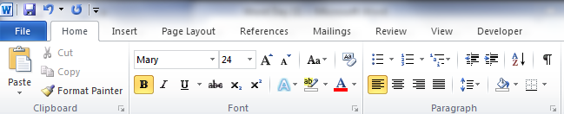
Directions: Open a Word Document. Hover over buttons on the ribbon on your computer to determine what they do. Fill in the blanks that match each button on the document below.
5
3
1
1. .
6
4
2

2. .
3. .
4. .
5. .
6. .
The ribbon includes the and .

Day 3 Activity Packet
How to Save a Document
Directions: in the space below, please list the steps you take to save a document. Once you finish that, please answer the questions at the bottom of the page.

True or false:
- When saving a file for the first time, you go to file and click on Save As.
- When you are updating the content of a file you have already saved, you need to rename it.
- When you are updating the content of a file you have already saved, you can simply click on the save button on the ribbon.

Day 3 Activity Packet: Save Reference Sheet
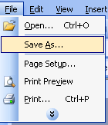
- Click on File
- Click on Save As

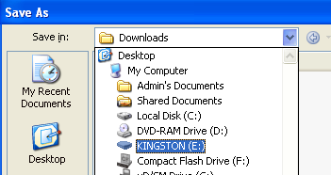
- Click on My Computer on the left side of the Save As dialogue box

- Click on the E: drive

- Type a name for the document into the “File name” line at the bottom of the window
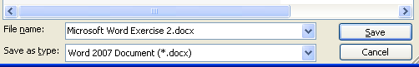

- Once the document has a name, click on Save

