During Day 2 you will be proctoring the North Star Digital Literacy pre-assessment.
All the of the computers that learners use need to be registered (per direction on the North Star site) for the assessment,
- This can take anywhere from 20-40 minutes depending on the number of students and number of volunteers/coordinators who are setting the assessment up.
- REGISTER THE COMPUTERS BEFORE CLASS BEGINS
  - Use the computer sign-in sheet that was filled out Day 1 to determine which computers students are using and pull them out of the COW
DO NOT PRE-TEST STUDENTS IF (Use Computer Use Questionnaires to see what kind of experience learners have with computers):
- They are very uncomfortable with the computer
- You feel taking the assessment will overwhelm them (happens with brand new computer users)
Learners who do not take the pre-assessment can:
- Log in to Mavis Beacon and practice typing
  - If they seem to need help with the mouse, help them get to http://www.skyways.org/central/mouse/page1.html , which is a mouse usage practice site (mouserobics)
Students who come in late: Determining whether or they have time to take the assessment without cutting too much into class time depends on a few things:
DO pre-test them if:
- You feel you have time to register their computer
- They have a basic knowledge of the computer
- They took the previous unit
Do NOT pre-test them if:
- They come more than 10 minutes into the testing period
- They are not familiar with the computer
- They come in late and you are busy setting up learners who showed up on time and are not taking the assessment
*****One way to ensure you get to the tests quickly is by having all of the computers registered before class begins. This takes prep time, but saves important class time. ********
Microsoft Word Day 2

Objectives Learners will be able to… | Materials
Computer skill: students will learn the basics of formatting  Computer skill: North Star Pre-Assessment | Make Student Copies  - How much do you know about your laptop? (Tab 5)  - Microsoft Word: Exercise 1 (Tab 6)  Props, Technology or Other Resources  - Computers  - Projector  - USB drives  - North Star How-to (Tab 7)
Lesson Plan |  | Vocabulary
Warm up for today’s Lesson:  Description: “How Much do you Know About Your Laptop” Quiz  Materials/Prep: copies of “How Much do you Know About Your Laptop” Quiz, while students are taking the quiz, wrap up registering their computers for the assessment  Activity 1: North Star Digital Literacy Assessment  Description: students will take a pre-assessment to see where they sit in terms of knowledge about  Materials/Prep: all computers need to be registered for North Star before the class begins  Activity 2: Formatting Practice  Description: explain what formatting is and how to do it including and explanation of the ribbon, highlighting and toolbar options  Materials/Prep: Microsoft Word: Exercise 1 |  | - Document  - Ribbon  - Toolbars  - Format  - Tab  - Highlight  - Font  - Style  - SAVE  - Folder

Teacher Directions: Activity 1: North Star Digital Literacy Assessment
Step 1:
Take this time to explain the Microsoft Word North Star Digital Literacy Assessment and its purpose:
This can be read verbatim to the students: The North Star Digital Literacy Assessment has set the standards of what it means to be knowledgeable about different aspects of the computer. The purpose of this assessment is to provide learners with a standard with which everyone learns the computer to ensure that they will be successful outside of the classroom. The pre-assessment is meant to inform the teacher of what you know already and then we can see how you improve at the end of the class. If you pass the assessment with an 85% or higher, you will receive a certificate that proves your competency at the unit you were tested on. These certificates can also be presented to employers as proof of your computer skills when you apply for a job.
With this pre-assessment it is okay if you do not know anything. If you do not know the answer to a question, you are given the option to simply answer “I do not know” or you can take a guess. You are encouraged to guess on this assessment.

Step 2: How the assessment works
This can be read verbatim to the students: When it is time to begin, students will open the assessment titled Word. The assessment begins with a test of the speakers. If you hear the piano playing, you will use your mouse to click the “Next” button.
Explain that if that student does not hear the piano playing, they can look above their keyboard at and they will see three buttons on the right. These are the volume buttons, one to turn down volume, turn it up, and turn it off.
Next, North Star will go through an orientation of how the assessment works. Each question asked in the assessment will be a function of the program, so your answer to the question will be performing that function. BE CAREFUL not to simply click when the page comes up because the assessment will read that as your answer and you cannot go back.
Teacher should pull up the Screen Shot page and review it with the students.

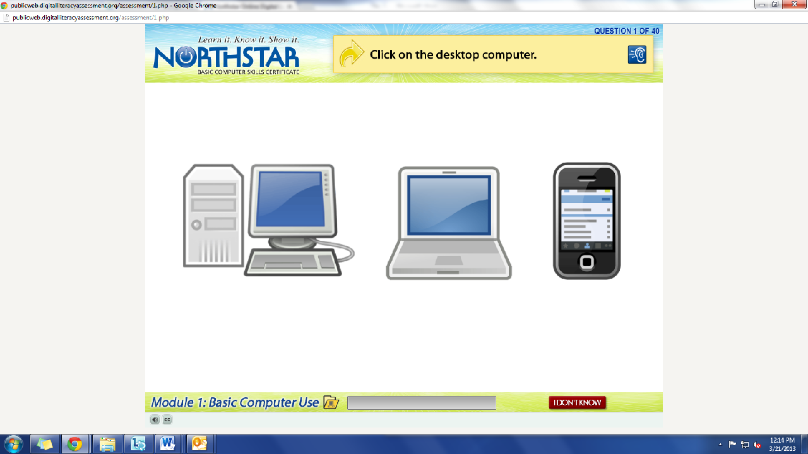
What is the question begin asked?
How do we answer it? We click on the answer.
You must listen carefully to the question being asked so that you know how to answer it.
If you miss the question when it is read, you can either read it on the top of the page, or click the on the blue ear and it will read the question again.
If you do not know and do not want to guess, but once you click it, it will ask you if you are sure you want to skip the question, you have to answer “Yes” to move on. You are, however, encouraged to guess.

Step 3: Learner Code of Conduct
Read the Learner Code of Conduct to the students:
- Learner must listen carefully to all instructions given by proctor
- Learner must treat others with courtesy and respect during assessment process
  - This means no talking to each other during the assessment, if you have a question ask the proctor. If a learner finishes early, they must remain quiet until everyone is finished
- Learner should ask questions prior to the assessment if they are uncertain about the certification process
- Learner is responsible for his or her certificate: if the certificate is lost, s/he will have to retake the assessment
- Learner should inform the proctor if he or she believes that assessment conditions affected his or her results
Ask if there are any questions
Explain that the questions will be read aloud to them, so students need to be sure they are listening carefully. If they miss the question, is it also written at the top of the page.

Step 4: Take Word Assessment
If there are no questions, learners should scroll down the testing page and click on the Word Assessment
If students are frazzled during the test because they missed the reading of the question, there is a blue square in the top right corner with an ear in it. When it is clicked the question is read again

Step 5: After the assessment
Once the assessment is completed, learners should open up Mavis Beacon and practice typing.

Teacher Directions: Activity 2: Introduction of topic -Microsoft Word Screen Fill
-Microsoft Word: Exercise 1
Step 1: Activate prior knowledge
Go over quiz.
Ask students to open a Word document. Have them close the document.
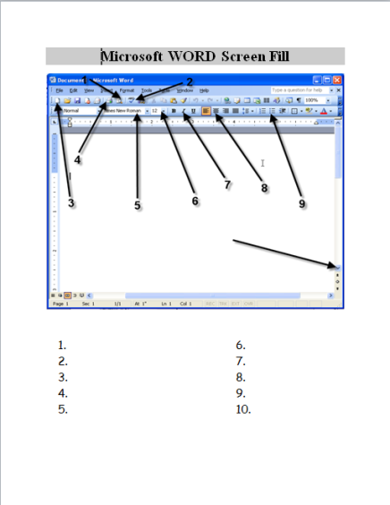
Typing practice: have students type the day of the week, then the month. On a new line have them type their full name. Then have them type the question “How do I format my text?” They need to put in the question mark.
The question leads to the topic for the day.

Step 2: Introduce vocabulary
Instruct learners to have their EYES FORWARD AND HANDS OFF OF THEIR COMPUTER for this portion of the class
T should open a new Word document
Ask students what they think formatting means? Organizing the information in your document, emphasizing certain words/phrases
Explain that Word provides the tools to format text
Point out the ribbon: the ribbon is the space at the top of the Word screen that includes the toolbars and menu tabs. Technically, the ribbon only exists on the newer versions of Word, but students will be tested on it, so pretend the toolbar area is called the ribbon

Step 3: What is the ribbon?
Ribbon is where all of the toolbars and tabs are to format your document
Explain Menu Tabs - compare to a folder, tab labels what is inside
Explain toolbars- format and standard are the ones needed most commonly.
Instruct learners to hover over the button that looks like a B without clicking; they should see a
small text box that pops up that says what the button does
Click on the Bold button>type your name
Have students use this hover tool to see what other buttons do
Most common- Font, Font Size, bold, underline, italics

Step 4: Highlighting text
Explain how to highlight text: use click and drag
Students should write a sentence about themselves, something as simply as “My favorite color is blue”.
Demonstrate highlighting the whole sentence and then click on italics
Instruct learners to do the same after you do
Demonstrate highlighting one or two words and then change the font to Ariel
Instruct learners to do the same after you do
Explain that users can highlight as much or as little of the text as they want

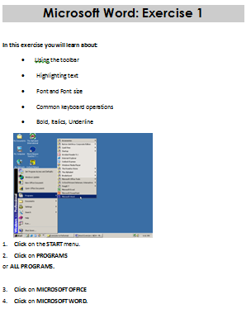
Step 4: Independent Practice
Instruct learners to close out of the document they have opened, the exercise will have them start fresh
Hand out and have students complete Microsoft Word: Exercise 1
Circulate to answer questions, make corrections

North Star How-To
Teacher A- Generating Codes:
1. Go to https://www.digitalliteracyassessment.org/admin
2. Login information:
3. PLEASE SEE YOUR SITE COORDINATOR FOR NORTH STAR LOGIN INFORMATION!
4. Select your name from the drop-down menu
5. Click Submit
6. Click on Generate User Codes
7. Simply type in students’ names and a click enter
8. The code next to their name will be used to register their computer
Teacher B- Registering each computer:
1. Turn on student computers
2. Go to digitaliteracyassessment.org/assessment/proctored
3. Username: SEE YOUR SITE COORDINATOR
4. PIN: SEE YOUR SITE COORDINATOR
5. Type in student’s name and then enter the code you got from Part 1
6. Click Confirm and Start
7. Minimize the page
8. Instruct students not to close out of any programs you have opened on their computer
Note: As you spend more time in the classroom you get to know the students who show up early and who show up late. Register the students who usually show up early as soon as you arrive, that way they can begin typing as soon as they get to class.
How Much Do You Know About Your Laptop?
1. What are the three rules to remember when using the laptops?
1. ___________________________________

2. ___________________________________

3. ___________________________________
2. Which of these sentences is NOT true?
a. You should always change your battery at the beginning of class.
b. When you take your computer out of the cart you should make sure the cord is neatly on the shelf, ready to be plugged back in.
c. You should tell a teacher if you notice something strange with your laptop.

3. How can you turn the sound off or on?
a. Ctrl + End
b. Press the mute button at the top of the keyboard
c. Fn + End
d. Unplug the headphones.

4. When you want to turn off the computer, the first thing you should do is…
a. Close the laptop
b. Click on Start and select Turn Off the Computer
c. Press the power button
d . Take out the battery

Microsoft Word: Exercise 1

In this exercise you will learn about:
• Using the toolbar
• Highlighting text
• Font and Font size
• Common keyboard operations
• Bold, Italics, Underline
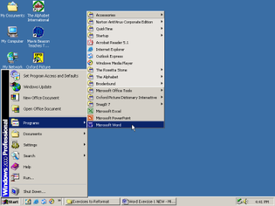
1. Click on the START menu.
2. Click on PROGRAMS
or ALL PROGRAMS.

3. Click on MICROSOFT OFFICE
4. Click on MICROSOFT WORD.

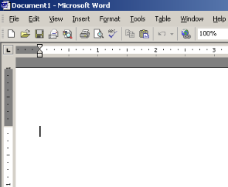
5. Now the program, Microsoft Word, is open. Look at the screen.
Are the words Microsoft Word at the top of the screen?

6. Slowly Move the Cursor across the Standard Toolbar. It looks like the picture below.
Don’t Click. When you point to a picture you will see the name for that picture or tool.

7. Type the alphabet in lower-case letters. No spaces.
Like this: abcdefghijklmnopqrstuvwxyz

8. Click and Drag from the “a” to the “z”. This is called Highlighting. When all the letters are highlighted. Take your finger off the mouse.
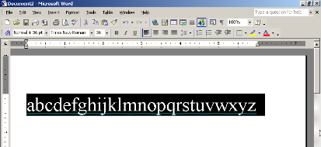
9. Once highlighted, click outside of the text. Text is no longer highlighted. Practice a few times.

10. Before next step, make sure text is highlighted.

11. Now, look at your Formatting Toolbar.
12. Click on the little arrow next to “Times New Roman” or “Calibri”.

13. Click on another font name to change the way the letters look.

14. Change the font 3 times for practice.

Click on the arrow next to the number 12.
Click on a larger number.
This will change the size of the letters.

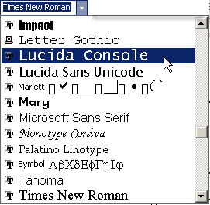
15.

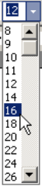
16. Press the Enter button.
17. Type the alphabet again on the next line. You should now have two alphabets.

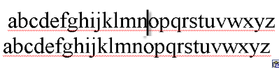

18. Click between the “n” and “o” in the first alphabet to place the cursor there.
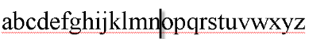

19. On your keyboard, Press the BACKSPACE key several times to erase everything before “o.”
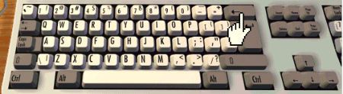

20. Click just after “d” in the second alphabet to place your cursor there.
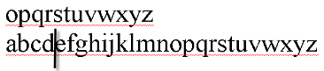

21 On your keyboard, Press the Delete key several times to erase everything between “d” and “o.”

22. Highlight all of the text. (Click and drag across the letters).
23. Click on the Center button from the Formatting Toolbar.
24. When the text is highlighted, Click on the B to make the text bold. 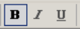
25. Click on the I button on the Formatting Toolbar to make the text italic.

26. Click on the Underline button to add a line under the words. 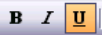

27. Now you are done.

Ask a teacher to check your work.

