During Day 11 you will be proctoring the North Star Digital Literacy assessment.
All the of the computers that learners use need to be registered (per direction on the North Star site) for the assessment,
- This can take anywhere from 20-40 minutes depending on the number of students and number of volunteers/coordinators who are setting the assessment up.
- REGISTER THE COMPUTERS BEFORE CLASS BEGINS
  - Use the computer sign-in sheet that was filled out Day 1 to determine which computers students are using and pull them out of the COW
Microsoft Word Day 11

Objectives Learners will be able to… | Materials
Computer skill: review  Computer skill: North Star Assessment  Literacy Skill: Editing | Make Student Copies  - Word Exercise 10: Editing- there are 3 exercises on each page, so only print one page per 3 students and cut (Tab 22)  Props, Technology or Other Resources  - Computers  - Projectors  - USB  - North Star How-To (Tab 7)
Lesson Plan |  | Vocabulary
Activity 1: Review
Description: learners will complete a review activity to get them ready for the North Star Assessment
Materials/Prep: learners will need to download Day 11 Review and complete

Activity 2: North Star Assessment
Description: leaners will take the North Star Digital Literacy Word Assessment.
Materials/Prep: each students computer must be registered before the class begins

Activity 3: Cover Letter Edits
Description: students will continue editing cover letters with assistance from Teacher
Materials/Prep: copies of Word Exercise 10: Editing
Teacher Directions: Activity 1: Review -Download Day 11 Review
IMPORTANT: Repeatedly remind students NOT to close out of programs that are open on their computers. Be sure students do not close out of the opened assessment.
Step 1: Locate File
Ask students how they can open a file from their USB drives?
See if they can lead you through the steps
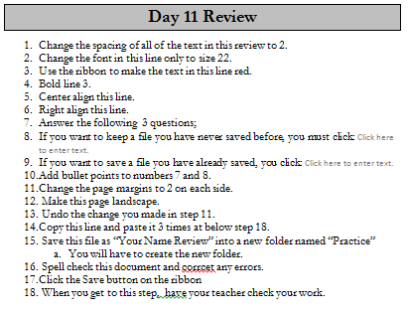
Click on Start Menu>Click on My Computer>Locate USB Drive>Open Excel Class>Click on Day 11 Review

Step 2: Instructions
Explain to students that they should read through the exercise and complete the assignment step by step
Explain that this is review, so they should try to find the answer on their own, but can ask if they are really stumped

Step 3: Independent Practice
Instruct students to complete the exercise and explain they have 40 minutes to do so

Teacher Directions: Activity 2: North Star Assessment
Step 1:
Take this time to explain the Microsoft Word North Star Digital Literacy Assessment and its purpose:
This can be read verbatim to the students: The North Star Digital Literacy Assessment has set the standards of what it means to be knowledgeable about different aspects of the computer. The purpose of this assessment is to provide learners with a standard with which everyone learns the computer to ensure that they will be successful outside of the classroom. If you pass the assessment with an 85% or higher, you will receive a certificate that proves your competency at the unit you were tested on. These certificates can also be presented to employers as proof of your computer skills when you apply for a job.
Students are encouraged to guess on the test, but if they truly do not know, there is an option at the bottom on each question page to click “I do not know”.

Step 2: How the assessment works
This can be read verbatim to the students: When it is time to begin, students will open the assessment titled Word. The assessment begins with a test of the speakers. If you hear the piano playing, you will use your mouse to click the “Next” button.
Explain that if that student does not hear the piano playing, they can look above their keyboard at and they will see three buttons on the right. These are the volume buttons, one to turn down volume, turn it up, and turn it off.
Next, North Star will go through an orientation of how the assessment works. Each question asked in the assessment will be a function of the program, so your answer to the question will be performing that function. BE CAREFUL not to simply click when the page comes up because the assessment will read that as your answer and you cannot go back.
Teacher should pull up the Screen Shot page and review it with the students.

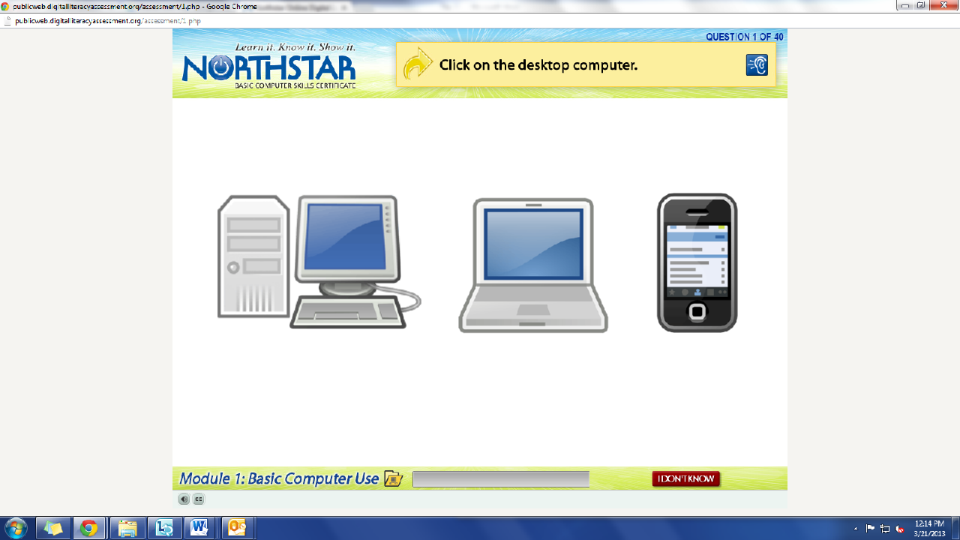
Review question: What operating system is on this computer?
What is the question begin asked?
How do we answer it? We click on the answer.
You must listen carefully to the question being asked so that you know how to answer it.
If you miss the question when it is read, you can either read it on the top of the page, or click the on the blue ear and it will read the question again.
If you do not know and do not want to guess, but once you click it, it will ask you if you are sure you want to skip the question, you have to answer “Yes” to move on. You are, however, encouraged to guess.

Step 3: Learner Code of Conduct
Read the Learner Code of Conduct to the students:
- Learner must listen carefully to all instructions given by proctor
- Learner must treat others with courtesy and respect during assessment process
  - This means no talking to each other during the assessment, if you have a question ask the proctor. If a learner finishes early, they must remain quiet until everyone is finished
- Learner should ask questions prior to the assessment if they are uncertain about the certification process
- Learner is responsible for his or her certificate: if the certificate is lost, s/he will have to retake the assessment
- Learner should inform the proctor if he or she believes that assessment conditions affected his or her results
Ask if there are any questions
Explain that the questions will be read aloud to them, so students need to be sure they are listening carefully. If they miss the question, is it also written at the top of the page

IMPORTANT NOTE: The Word Assessment has a question that asked students to Save and Close the document. DO NOT CLOSE OUT OF THE TEST WINDOW. The test has its own screen within the testing window. Use the tools you learned to close out of that.

Step 4: Take Word Assessment
If there are no questions, learners should scroll down the testing page and click on the Word
Assessment
If students are frazzled during the test because they missed the reading of the question, there is a blue square in the top right corner with an ear in it. When it is clicked the question is read again

Teacher Directions: Activity 3: Edit Cover Letters –Word Exercise 10: Editing
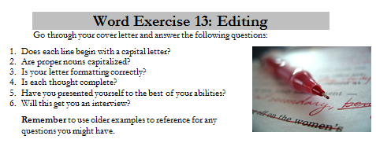
Step 1: Work on cover letters
As students finish their assessments, hand out Microsoft Word Exercise 10: Editing
Instruct them to read through and follow directions step by step

North Star How-To
Teacher A- Generating Codes:
1. Go to https://www.digitalliteracyassessment.org/admin
2. Login information:
3. PLEASE SEE YOUR SITE COORDINATOR FOR NORTH STAR LOGIN INFORMATION!
4. Select your name from the drop-down menu
5. Click Submit
6. Click on Generate User Codes
7. Simply type in students’ names and a click enter
8. The code next to their name will be used to register their computer
Teacher B- Registering each computer:
1. Turn on student computers
2. Go to digitaliteracyassessment.org/assessment/proctored
3. Username: SEE YOUR SITE COORDINATOR
4. PIN: SEE YOUR SITE COORDINATOR
5. Type in student’s name and then enter the code you got from Part 1
6. Click Confirm and Start
7. Minimize the page
8. Instruct students not to close out of any programs you have opened on their computer
Note: As you spend more time in the classroom you get to know the students who show up early and who show up late. Register the students who usually show up early as soon as you arrive, that way they can begin typing as soon as they get to class.

Day 11 Review
- Change the spacing of all text in this review to 2.
- Change the font to size 22 in this line only.
- Use the ribbon to make the text in this line red.
- Bold line 3.
- Center-align this line.
- Right-align this line.
- Answer the following questions;
- If you want to keep a file you have never saved before, you must click:
- If you want to save a file you have already saved, you click:
- Change questions 7 and 8 to bulleted items instead of numbered items.
- Change the page margins to 2 on each side.
- Make this page Landscape.
- Undo the change you made in the previous step.
- Copy this line and paste it 3 times after the last line.
- On your USB drive, create a new folder named “Practice”.
- Save this file as “Your Name Review” into a new folder named “Practice”
- Spell check this document and corrcet any errors.
- Click the Save button on the ribbon
- When you get to this step, have your teacher check your work.

Day 11 Review Answer Key
- Change the spacing of all of the text in this review to 2.
- Change the font in this line only to size 22.
- Use the ribbon to make the text in this line red.
- Bold line 3.
- Center this line.
- Right align this line.
- Answer the following 3 questions;
- If you want to keep a file you have never saved before, you must click: Save As
- If you want to save a file you have already saved, you click: Save
- Add bullet points to numbers 7 and 8.
- Change the page margins to 2 on each side.
- Make this page landscape.
- Undo the change you made in step 10.
- Copy this line and paste it 3 times at below step 16.
- Save this file as “Your Name Review” into a new folder named “Practice”
  - You will have to create the new folder.
- Spell check this document to correct any errors.
- Click the Save button on the ribbon
- When you get to this step, have your teacher check your work.

- Copy this line and paste it 3 times at below step 18.

- Copy this line and paste it 3 times at below step 18.
- Copy this line and paste it 3 times at below step 18.

Word Exercise 10: Editing
Go through your cover letter and answer the following questions:
- Does each line begin with a capital letter?
- Are proper nouns capitalized?
- Is your letter formatting correctly?
- Is each thought complete?
- Have you presented yourself to the best of your abilities?
- Will this get you an interview?
Remember to use older examples to reference for any questions you might have.

Word Exercise 10: Editing
Go through your cover letter and answer the following questions:
- Does each line begin with a capital letter?
- Are proper nouns capitalized?
- Is your letter formatting correctly?
- Is each thought complete?
- Have you presented yourself to the best of your abilities?
- Will this get you an interview?
Remember to use older examples to reference for any questions you might have.

Word Exercise 10: Editing
Go through your cover letter and answer the following questions:
- Does each line begin with a capital letter?
- Are proper nouns capitalized?
- Is your letter formatting correctly?
- Is each thought complete?
- Have you presented yourself to the best of your abilities?
- Will this get you an interview?

Remember to use older examples to reference for any questions you might have.

