|  |
| --- |
| Computers and Literacy Volunteer Manual |
| E:\Open Door Logo.jpgUpdated November, 2013 |
|  |

Computers and Literacy Volunteer ManuAl

TABLE OF CONTENTS

Basic Class Information 2-7

Checklist for EACH DAY 3

Position Description 4-5

Class Syllabus 6

Where to Find Curriculum 7

How to Write the LESSON REPORT 7

Teaching information 8-16

Troubleshooting 9-10

Tips for teachers 11

Teacher Email Account 12

Typing Websites 13

Mavis Beacon Information 14-16

How to Register a New User 14

How to sign in an Returning User 15

When MB Freezes 16

Testing information 17-27

What is the TABE test? 18

North Star information 19-27

What is it? 19-20

How to become a Proctor? 21

Admin Page Login 21

How to Register Learners to take the Assessment 22

Resources available on the admin site 23

North Star Digital Literacy Standards 24-26

How to print Certificates 27

Low-prep Time Fill Activities 28-32

For any class 29

Excel 30

Word 30

Email 31

Reading and Writing for Job Search 32

Internet 32

Resources for Students 33-37

Low-to-no-Cost Computers 34-36

Free Online Resources for Learning 37

Basic Class Information

**Daily Volunteer Checklist**

Before class:

* Check lesson report from previous class
* Read through curriculum
* Assist any students typing practice set up
  + Mavis Beacon Teaches Typing Program if you have it (Directions are on Page 8-9 of Day 1 lesson Plan)
  + Typingweb.com (click start typing, looks like they need to log in, but just click little read x in small window and it should take you to lessons)
  + Sense-lang.org
* Make copies of necessary handouts as listed in the curriculum
* Bring in/turn on projector
* Hand out USB drives to students (if the lesson plan requires saving or opening previously saved files)
* Make sure any links/necessary downloads in the curriculum work

After class:

* **If you have mobile lab**: Let students into back office to put their computers away, **neatly**
  + The computer should be plugged in and pushed all the way onto the shelf with the cord tucked in
* Put projector away/turn off
* Count USB drives to make sure none are missing
* Clean off white board
* Make sure room is tidy (chairs pushed, trash cleaned up off the ground and off the tables)
* Turn off lights
* Make sure everything in the room is neat and turned off

**MLCB&W8-11**

**Volunteer Position Description**

**Title of Position: Computer and Literacy Teacher**

**Purpose of Position:** To help English-language learners and native English speakers improve their computer skills.

**Requirements of Position:** basic understandingofMicrosoft Office Suite, Email and Internet; troubleshooting skills; ability to speak, read, and write English; dependability, promptness, patience, non-judgmental attitude; openness to collaboration and suggestions regarding teaching strategies; ability to maintain confidentiality.

**Training Provided:** Attend the Minnesota Literacy Council’s 12-hour ESL Pre-Service Training. Attend initial orientation meeting with program coordinator. Observe a 2-hour class. Co-teach one or more 2-hour classes as you begin your volunteer experience. Receive observation from a coordinator/teacher during your first solo class.

**Time Commitment:** 3 hours/week (one 2 hour class, 1 hour prep and lesson reporting) for a minimum of 4 months.

We also offer computer skills small groups at *North Side* from 5-6pm Tuesday and Wednesday Evenings.

**Duties:**

* 1. Arrive to the learning center 30-45 minutes prior to your class; regularly teach your class.
  2. Read your curriculum and plan a portion of your lesson before your arrival at the Learning Center.
  3. Establish and foster an immersion environment in your classroom—speak only English during class.
  4. Record class attendance accurately.
  5. Work cooperatively with coordinators and other volunteers to plan roles within lessons.
  6. Have fun and get to know your students!
  7. Ask questions when you are uncertain about any aspect of your teaching or volunteer commitment.
  8. Lead students and allow them to lead you.

**Reports Required:** Teacher will be responsible for taking accurate attendance and completing a lesson report after every class.

**Benefits:**

* Training and guidance from program staff
* Hands-on experience working with diverse adults in a community setting
* Opportunity to empower others by sharing your skills and knowledge



**Computers and Literacy**

**Overview of class with important information for teachers**

**Units:**

There are six units that use the North Star Digital Literacy Standards as building blocks for the curriculum. The Units are:

* Microsoft Word
* Microsoft Excel
* Microsoft PowerPoint
* Internet
* Email
* Reading and Writing for Job Search

**Rules:**

1. No food or drink
2. Carry your computers carefully
3. Do not touch your computer screen
4. Respect the classroom and your classmates

**Recommended Materials:** Open Door provides the computer materials

1. Notebook
2. Pen/pencil
3. Folder

**Attendance Policy:**

It is important to not only be present for all classes, but to **show up on time**. We go through a lot of information in this unit so it is important to be present to ensure you do not miss anything.

If you need to miss a class, students need to call the school phone to let us know. Coordinator should then let volunteers know.

If students miss 3 classes in a row, you will be removed from the class.

**Where to find curriculum?**

Curriculum should not only be in a binder somewhere in the classroom (for Open Door at Lake Street it is in the bottom drawer of the storage unit at the front of the classroom), but it will also be posted online.

1. Go to mnliteracy.org
2. In the bottom right hand corner of the page you will see a link named “My Learning Center”. Click it.
3. Click on the name of the learning center at which you are teaching.
4. Click on the Curriculum tab
5. The second to last link in the list of classes is Computer, click on that.
6. The curriculum for the current unit should be posted.
7. Click on the day of class you are in.

**Submitting Lesson Reports**

**What are they?** After each session at least one of the volunteers needs to write about what happened in the session, what you covered and what you did not get to. This is important for the volulnteer who teaches the next session so that they know what to review/what has not been covered.

**How do I post them?** The lesson reports are posted in the same webpage that you find the curriculum.

1. Go to mnliteracy.org
2. In the bottom right hand corner of the page you will see a link named “My Learning Center”. Click it.
3. Click on the name of the learning center at which you are teaching.
4. Click on the Lesson Reports tab.
5. **Ask coordinator for login information**
6. Click on “Submit a new lesson report” under the tabs and above the Filter by Class line
7. Be sure to enter all of the requested information and be clear about what when on during class. Any successes, challenges, requests for change, etc.

Teaching Information

**Troubleshooting**

**Questions regarding the class:**

1. What level of experience do I need to have with computers to be in the class?

None. Learners are not expected to come into the classroom with any experience. Each unit starts with basics assuming the learner knows nothing. It is important for learners who are new to computers to understand that being present every day offers their best opportunity for success.

1. I just want to learn (one thing), I do not care about grammar/English/reading skills, why are we doing this?

This is a Computer **AND** Literacy Class. We learn computer skills while developing English skills. We cannot simply skip to the activity you want to learn because we are building up the skills to be successful with the computer program overall.

1. I do not care for typing practice; I just want to learn computer skills.

Being efficient at typing makes it easier to be successful on the computer and allows to you keep up with the classroom. The open lab time before class is time to work on typing or ask questions regarding previous class materials, not for surfing the web or playing online games. Please respect this time.

1. Do I have to take the North Star Digital Literacy Assessment?

Yes. This is the only way we have to assess learner progress and success in the classroom.

In terms of the **pretest** on Day 2, if a learner does not have any experience with computers, they do not have to take the assessment. Taking the assessment could prove overwhelming to the learner and scare them off, so instead they should continue practicing with **Mouserobics** on http://www.skyways.org/central/mouse/page1.html or practice typing on **Mavis Beacon**.

1. What is the point of the Digital Literacy Assessment?

The North Star Digital Literacy Assessment is meant not only to assess progress made over the period of a class, but it is also meant to assist learners in job search efforts. When a learner passes the assessment (with an 85% or higher), they receive a certificate which can be presented to employers to prove proficiency at different computer programs.

**Regarding technology:**

1. My mouse is not working!

Wireless mouse- make sure the sliding button on the bottom on the mouse is “on”. If so, make sure the mouse is labeled the same number as the computer. If so, make sure the USB which connects the mouse to the computer is in the drive. If it still isn’t working, it probably needs new batteries. To do this, slide the back cover off and put two new batteries in.

Corded mouse- Check that it is plugged directly into the USB drive.

1. My internet is not working!

This happens fairly often. Make sure the wireless internet button on the left side of the computer (same area as the USB drive) is turned to the “connect” position.

If that does not work, close out of the internet and open it again. Sometimes it just needs time to connect.

1. My sound is not working!

Show learner where the sound buttons are. They should be able to simply hit the “mute” button and their sound should turn on.

1. I do not see the same toolbar buttons! (Meant for Word 2003 and older)

The best way to avoid this issue is to start every class that uses formatting by reminding students which two toolbars we use in class and how to get them. Toolbars=Standard and Formatting. View>Toolbars>Check Standard and Formatting

If they have those toolbars but are still missing buttons, there is an arrow at the end of the toolbar. When clicked, it reveals any buttons that have not been used recently. When you click on a button, it will become visible on the toolbar.

1. Can I print/copy/fax/scan with Open Door’s Equipment?

It is always possible to print/copy materials that are being worked on in the classroom, as for materials that are personal/not class related, the **general answer is no**, especially for extremely personal information. **Exceptions** can be made, but always check with the coordinator if you are unsure.

We do tend to allow students to use our **fax machine**. Just ask the coordinator for assistance.

**Issues with teacher equipment/students:**

1. The projector is not working.

Make sure all of the cords are plugged in (cord from projector to computer, from projector to cart, from cart to wall). Oftentimes a projector has been taken off of the cart and used by another class, so it simply needs to be plugged in again.

Also, the laptops used in class are often older, so the projector cord often falls out of the plugin.

If the projector is not projecting the screen/is projecting a color like blue or purple, it could be an issue with the bulb. Simply ask the coordinator for assistance, if it is an issue that cannot be fixed before class time, try to locate another projector for the time being.

1. A student returns after missing more than 3 days.

The solution to this problem is often up to the teacher’s discretion. The attendance policy states that if students miss 3 classes in a row, they are dropped from the roster. On the other hand, things in life do come up that make it difficult to make it to class. If the student will not be a distraction to the material covered and you feel they can catch up quickly, then it should be fine to allow them to return.

If you are having issues determining what to do/have to tell a student they cannot continue with this unit, get a coordinator for assistance. They can be the bad guy.

**Teaching Tips**

**Do not assume any prior knowledge.**

**Repetition**- asking questions about what has just been explained is rarely a bad idea. You will notice that throughout this curriculum things that have literally just been explained are being reviewed minutes later. This helps keep the lower level learners up to speed and is good practice for those who already know it.

**Ask questions**- Instead of simply telling learners how to do something, keep them involved. The goal of this class is to teach participants how to LEARN because there is not enough time to go over every little aspect of the programs we teach. Ask questions like: is there anywhere on this page that looks like it might allow you to…do you see a button that looks like it would…

**It’s okay if you do not know!** - Oftentimes learners will ask questions that you do not know the answer too. That’s okay! Things come up that we have to figure out how to do as you go, so it is up to you to decide if it is important for students to learn at that time or if you can simply say “This is something that we will have to bypass for today.” Sometimes going off track can take a lot longer than expected due to new tools being used.

**Google it!**- When you do not know an answer, often times you can type keywords of your question into Google, and someone within the world wide web will know.

**Don’t do it for them!** - When learners are struggling, it is best to make sure they keep working to figure things out. Ask them leading questions like “is there a button that looks like it might do what you are looking for?”

**Keep learners on task** – Some learners are more advanced and find themselves reviewing skills they already know, and many of them skip over those activities. The best way to address this is ask them about their progress on the activity. Also, remind them that it is necessary to stay on task so that you can see what they can do and what they need help with.

**Give learners leadership roles**­- As often as you can, give learners more responsibility in the classroom. This is especially important if you are teaching solo. Potential leadership roles:

* Have one learner hand out USB drives
* Have learners who finish early help those who are struggling. This can be especially helpful to match up people who speak the same language, but encourage them to speak English as much as possible.
* Have one learner read directions to an activity

Teacher Email Account:

Email address: [comp.lit.opendoor@gmail.com](mailto:comp.lit.opendoor@gmail.com)

Password: Volunteer12

(capital V)

**Note:** Teachers should not feel have to use their own email addresses. Instead, use the email address above during the email class and any other time students are interested in send you an email.

**Exception:** When you discuss email spam in the class and you know your personal email has spam in it, you are encouraged to show students real life examples of spam in mail boxes.

**Typing Websites:**

* artypist.com
* sense-lang.org/typing/
* <http://www.typingweb.com/> - it looks like you have to sign up, but when the pop-up to do so appears, simply click the red “x” in the corner

**Learn for Free:**

* [gcflearnfree.org/](http://www.gcflearnfree.org/)

**Typing Websites:**

* artypist.com
* sense-lang.org/typing/
* www.typingweb.com/ - it looks like you have to sign up, but when the pop-up to do so appears, simply click the red “x” in the corner

**Learn for Free:**

* [gcflearnfree.org/](http://www.gcflearnfree.org/)

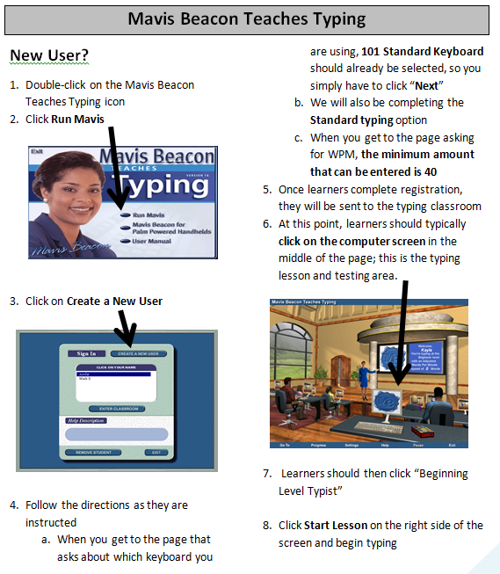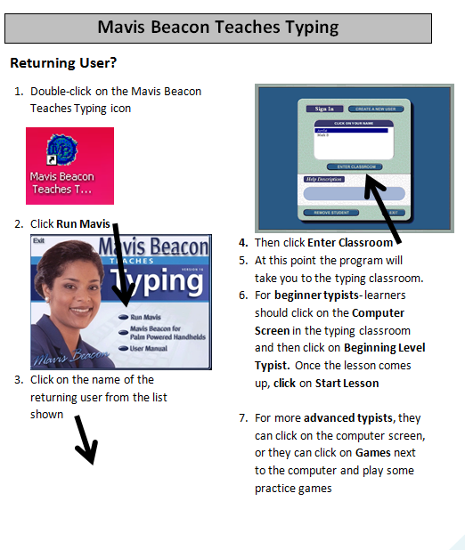

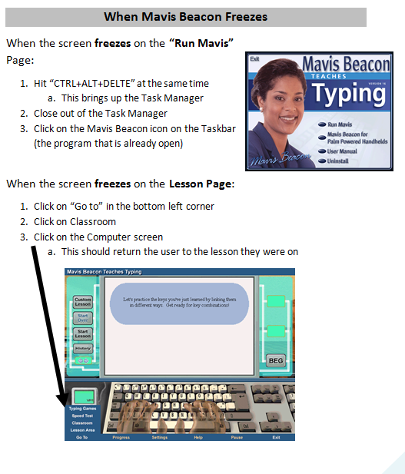

TESTING INFORMATION

* TABE Tests
* North Star Tests
* North Star Standards

What is the TABE test?

Essentially, the TABE is a placement test. (The name stands for Test of Adult Basic Education.)

**How does it work?**

Once every unit, students will take the TABE test. Each student might get a different test, but it is important to note that every student **MUST START ON THE PAGE THE ANSWER KEY IS IN**. Often students will pull out the answer key and start at the beginning. This action will require them to take the assessment again.

**How much time do students get to take it?**

The length of time students get depends on the test they are taking. It will say at the top of their answer sheet which test east student should be taking. They are also color coded, so you can write end times on the board like so: x color sheet 7:35, y color sheet 7:30

Reading Test gets 50 Minutes

Language Test gets 55 Minutes

**Why do they have to take it during a computer class?**

The short answer is because these tests allow us to get funding. All participants in Minnesota Literacy Council programming, which includes all Open Door Sites, must have their literacy skills tested about once a month.

**What if a student misses testing day?**

Tell your coordinator that the student was gone and make a note in the lesson report to tell the next teachers. If the student returns to class, they must be pulled out to test.

**What if a student says they took their test already?**

It happens. Because of the testing system, depending on how long students have been in programming, they might see the same test again. This is not an issue, unless the student feels it will hinder their ability

If you have ANY questions about TABE testing, feel free to ask your coordinators.

North Star Information

**What is the North Star Digital Literacy Project?**

The North Star Digital Literacy Project defines basic skills needed to perform tasks on computers and online. The ability of adults to perform these tasks can be assessed through online, self-guided modules. Included are basic computer **digital literacy standards** and **modules** of six main areas: Basic Computer use, Internet, Windows Operating System, Mac OS, Email and Word Processing.

**Goal of Assessments**

The goal of this assessment is to evaluate your knowledge of the program this class will be addressing. You will be both pre and post tested to see if there has been any change and/or improvement in your computer skills during this 6 week unit. The post-test will take place on one of the last days of class and if you receive a passing score, which is an 85%, you will receive a certificate stating that you have completed the requirements for this unit.

**Certification Process**

It is possible to receive a certificate for many of the computer units that are offered at Minnesota Literacy Council. These certificates can be used when applying for jobs; you can show or give a copy of the certificate to an employer to prove that you have knowledge of the skills necessary to use a specific program on the computer.

**Pre-Assessment Explanation**

This assessment is meant to assess where you are with computers without any instruction. It is possible that you will not know any of the answers on the assessment, in which case you can simply click ‘I don’t know’ in the bottom right-hand corner. It is alright if you do not know everything, or anything, we expect that people come into this class with no knowledge of the computer. If the idea of taking the assessment on the computer seems too intimidating, let me know and I can get you a paper copy of the assessment.

**Structure of the assessment**

The assessment is going to start with a page that asks if you can hear piano music. Make sure your headphones are plugged all the way in and the sound is on. If you are having any issues, please let me know. You will then hear an orientation, listen to all of it; it will explain the assessment a bit more.

To answer the questions, you will go through the actions on the [program] screen. Be careful not to click on something before you listen to the whole question. Where ever you click, the assessment will think is your answer to the question and you cannot go back to a previous question.

The questions will be read to you, but they will also be written at the top of the page. If you need to hear a question again, click on the blue square with a picture of an ear in it in the top right corner next to the question.

**Learner Code of Conduct**

* Learner must listen carefully to all instructions given by proctor
* Learner must treat others with courtesy and respect during assessment process
  + This means no talking to each other during the test, if you have a question ask the proctor. If a learner finishes early, they must remain quiet until everyone is finished
* Learner should ask questions prior to the assessment if they are uncertain about the certification process
* Learner is responsible for his or her certificate: if the certificate is lost, s/he will have to retake the assessment
* Learner should inform the proctor if he or she believes that assessment conditions affected his or her results

**How to become a North Star Digital Literacy Assessment Proctor**

**Takes about 20 minutes-good to do during a TABE Test**

**You need HEADPHONES in order to complete the training.**

1. Go to digitalliteracyassessment.org/admin
2. Use the login information from the Confidential page in the manual
3. Underneath the drop down menu with names, there is a sentence that starts with **“Don’t see your name on the list?”**
4. At the end of that sentence, click where it says “Click here to launch training.”
5. Go through the training, you cannot click ahead; it will allow you to move ahead once the voiceover is finished on each slide.

How to login to the Admin Page

1. Go to digitalliteracyassessment.org/admin
2. Ask your site coordinator for you log in information
3. Click on your name in the Drop Down menu
4. Click Submit
5. You should now be in the Admin Page

**How-To Register Learners for North Star Assessments**

**If you do not see your learning centers Logins and Passwords, ask your coordinator**

**Teacher A- Generating Student Codes:**

1. Go to [www.digitalliteracyassessment.org/admin](https://www.digitalliteracyassessment.org/admin/login.php)
2. **Login information**:

* Please ask your site coordinator for log in information.

1. Select your name from the drop-down menu
2. Click Submit
3. Click on **Generate User Codes**
4. Simply type in students’ names and a click enter
5. The code next to their name will be used to register their computer

PIN found on Admin page, click on **View Computer Authorization PIN**

**Teacher B- Registering each computer:**

1. Turn on student computers
2. Go to digitaliteracyassessment.org/assessment/proctored
3. **Log in Information: See your site coordinator**
4. Type in student’s name and then enter the code you got from Part 1
5. Click Confirm and Start
6. Minimize the page
7. Instruct students not to close out of any programs you have opened on their computer

**Note:** as you spend more time in the classroom, you get to know the students who show up early and who show up late. Register the students who usually show up early as soon as you arrive, that way they can begin typing practice as soon as they get to class.

**Finding More North Star Resources**

Once you become a registered proctor, you can access the backend of information, including enhances directions on generating codes and certificates, registering students for the test and reviewing results of assessments.

See Assessment Results and print a certificate from this link.

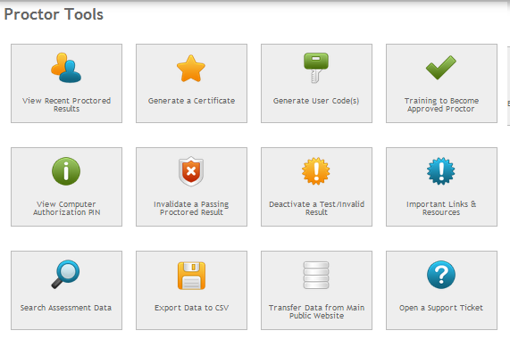

Create testing codes for learners.

See PIN number to register each learners computer.

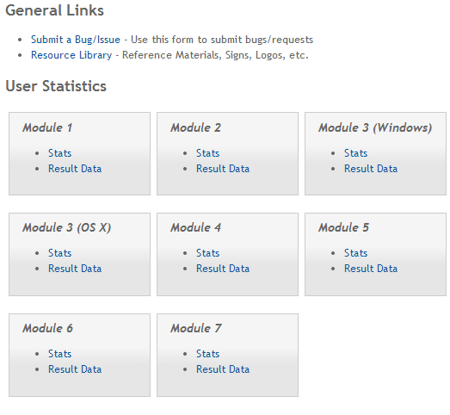

View information about assessments taken. If you click on stats, you can see top 5 correct/incorrect questions .

Submit any issues you have with the assessments here.

**Below are the standards that students will be tested on during the accompanying unit. All standards can be found at digitallitracyassessment.org:**

**World Wide Web- Internet Unit**

1. Identify an Internet Service Provider and identify the main options for connecting to the internet: Dial-up, High Speed (cable or DSL), or wireless connection.
2. Identify commonly used browsers (Internet Explorer, Firefox, Chrome, Safari) and demonstrate knowledge of function.
3. Identify the address bar and enter a URL address.
4. Identify a website.
5. Identify a homepage.
6. Identify the following browser toolbar buttons and demonstrate the ability to use them: home, refresh, stop, back, forward
7. Use scroll bars to view different portions of webpages
8. Identify a hyperlink and demonstrate the ability to use a hyperlink to access other webpages.
9. Create a new tab, open a webpage in a tab, and move between tabs.
10. Enlarge the displayed text size
11. Fill out an online form.
12. Correctly enter CAPTCHA security codes.
13. Use zoom function to enlarge image (CTRL+ or CTRL-)
14. Identify search engines (Google, Yahoo!, Bing) and enter search terms into the search engine.
15. Identify pop-up windows and close them.
16. Identify pop up windows have been blocked and enable individual pop up windows as needed
17. Identify common domain types: com, org, gov, edu.
18. Demonstrate knowledge that there are ways to increase Internet safety for children.
19. Identify antivirus software providers and function of antivirus software (Norton, McAfee, AVG).
20. Avoid providing personal or financial information unless on a secured website (https://)

**Windows 7- PowerPoint and Excel Unit**

1. Identify the operating system used by a computer.
2. Shutdown, restart, and log off a computer.
3. Open, close and switch between windows
4. Minimize and maximize windows
5. Identify the toolbar and menus.
6. Identify the taskbar.
7. Start, and exit programs (Microsoft Word, Excel, PowerPoint)
8. Identify drives on a computer: CD/DVD, floppy, hard drive (C), USB port, network drives (A, B, D, F, H, etc.)
9. Access the help menu.
10. Identify the desktop.
11. Demonstrate knowledge of Windows file organizational system and use it to locate files/documents (desktop, My Document, My Computer)
12. Use "Search" to locate a file or document
13. Delete documents or files.
14. Open programs.
15. Identify basic office software programs (Microsoft Word, Excel, PowerPoint), demonstrate knowledge of their functions, and identify their corresponding file extensions.
16. Open files using appropriate programs

**Email- Email Unit**

1. Define: email
2. Register for new email account in online program
3. Create username and secure password
4. Log into email
5. Create an email message
6. Address an email, including to more than one recipient
7. Send an email
8. Open an email
9. Reply to only the sender of an email or to all recipients (reply all)
10. Forward an email
11. Add an attachment to an email
12. Open an attachment in an email
13. Move or delete an email and retrieve an email from the trash
14. Understand basics of email etiquette: don't use all capital letters, fill in the subject line, use appropriate greetings & closings
15. Use caution when opening an email from an unfamiliar or unexpected source and avoid opening suspicious attachments
16. Avoid giving out personal information (especially financial information) or email address to unfamiliar people
17. Identify and delete junk mail, including spam
18. Be selective and cautious about forwarding email to large groups of people
19. Define: Computer virus
20. Define and tell the difference between a URL and an email address (see World Wide Web)

**Word- Microsoft Word and Reading and Writing for Job Search Unit**

1. Create a new document
2. Save and close a document
3. Open existing document
4. Identify ribbon and toolbars
5. Demonstrate knowledge of the difference between "Save" and "Save As" functions.
6. Use Save As to save to a particular folder or file location and name the document.
7. Use undo and redo arrows
8. Cut, copy and paste
9. Use spell check and grammar check
10. Format the size, color and type of font
11. Align text: left, center and right justify
12. Set single or double spacing
13. Use bullets and automatic numbering
14. Use print preview and print.
15. Set margins
16. Select portrait or landscape
17. Identify file extensions, corresponding document types and associated programs used to open them: pdf, xls, doc, docx, rtf, pub, ppt, pptx

**How to Print North Star Certificates**

1. Go to digitalliteracyassessment.org/admin
2. Type in the login information from page 22
3. 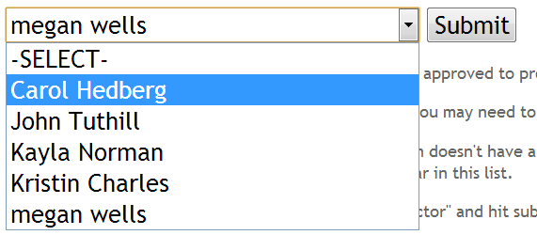Select your name (or any name if you are not proctored) from the drop-down menu

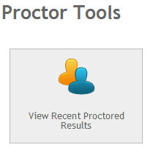

1. Click Submit
2. Click on View Recent Proctored Results
   1. You will see a list of all assessments ever taken
3. If you see a green **Yes!** Under the **Passed** category, click on the button under Action.

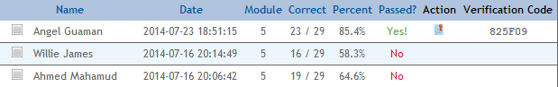

1. Click on Print Certificate for each student eligible
   1. Double check the date to make sure it is the most recent test
2. Print certificates on card stock
3. Sign the bottom right line
4. Distribute

Low-to-No-Prep Time-fill Activities

Each of the options includes probable time it could take. They offer a range because you could have students attempt to do as much as possible in the available time frame, but the minimum time is needed to introduce, demonstrate and practice the activity together.

**For any class:**

1. Giving students time to practice typing (online or on Mavis Beacon) is never a bad thing.
2. 10-20 minutes (depending on how many sentences you use).

Set up:

Explain to learners that you know that they are all at different typing speeds, so they should type as much as they can, but should not worry because the sentence will be repeated.

Students should open Microsoft Word and type the number 1 and then type a closed parenthesis, explain where to find that. Shift>0. These sentences should be in list form. Read the following sentences aloud slowly, pause and then read them again. Choose any number of sentences to dictate.

Once finished dictating, have students review their sentences with a partner to fix any mistakes and fill in missing information. You should then review the sentences covered.

Typing Dictation

1) They are going to their aunt’s house at noon.

2) We go to school at Open Door Learning Center.

3) We will meet at 3:00 in the library on Tuesday.

4) The school is located on the corner of Lake and 27th.

5) Give the tickets to the director at the entrance.

6) The car is merging on the highway.

7) His interview is at 4:30 in the conference room.

8) She loves to hike in the park in the spring and summer.

9) The children are skating at the indoor rink in Roseville.

10) The students will take a break in 15 minutes in their classroom.

1. 10 minute activity:

Grab 10-15 (about 3 more than the number of students present) magazines from the back office. Lay them out in the front of the room and give students 2 minutes to find a picture in the magazine that says something about themselves. They should then return to their computer, open a Word document and type for 5 minutes about why the picture describes them.

**For Excel:**

1. 10-15 Minutes

Have students try to locate different tools:

* How to add a picture?
* How to change the color of cells?
* How to check spelling?

1. Have students come up with a survey question, something they want to learn about their classmates that has a definite number of answers. “Favorite color”, “Favorite types of food”, “Where they live”, “

Once they have their question, students should conduct the survey, take note of the answers and then graph the answers.

1. Find an article online and give students 4 minutes to read through it and write a quick recap of what it says. This exercises their scanning abilities.

**For Word:**

1. 5-15 Minutes:

Have students type the steps to: save a document, open a new document, copy and paste, add a toolbar to their ribbon, etc.

1. 5 Minutes:

(Could be a challenge activity) Have students try to figure out how to enter a picture into their document. Insert>Clip Art

1. 20-40 minutes

Have students write a letter to the president about why Digital Literacy is important and why it should receive more funding.

1. 10-20 Minutes

Locate a news article and have students read through it and circle any words of which they do not know the definition. They should then type the word, look up the definition and type a sentence using the word.

1. About 20-30 Minutes

Print out the following letter and have students edit the letter to fix grammar and punctuation issues:

“dear john!

i hade such a wonderful time in kansas that i wanted to right an let you no ? I loved the whirlwind ride at thee kounty fair. all of my freinds want my cowardly lion that Uncle lester won for me on the midway. i sleep with the lion every nite

I hope you and uncle lester can comme visit me next summer. Wi’ll go to Emerald city Fun Fair and eet popcorn and cotton candy?

love always

jane”

**For Email:**

1. 10-20 Minutes

Have learners open a Word document and type one of the following (meant to be a review of previously cover material)

* 1. How to send an email, step by step.
  2. How to reply to an email, step by step.

1. 10-15 Minutes

Find 10-15 brochures, flyers, etc. Have students look them over and locate the company’s website and email address.

**Expand:** Once they find the website, they can type it into the address bar and determine what the company does/services provided.

1. 15-20 minutes. Set up:

Explain to learners that you know that they are all at different typing speeds, so they should type as much as they can, but should not worry because the sentence will be repeated.

Students should open Microsoft Word and type the number 1. These sentences should be in list form. Read the following sentences aloud slowly, pause and then read them again.

* He paced back and forth, little beads of sweat falling down his cheeks, awaiting the announcement of who won.
* The leaves had fallen and the skies were grey as we watched him leave us forever.
* They all held hands in a quiet circle, humming a hopeful song.

Learners should compare their sentences with a neighbor to fill in any missing information. After they have done that, review

Once you have reviewed the sentences, write the following examples of tone on the board and have the learners try to match the tone to the sentence. These are examples of tone that are not discussed in class.

* **Anxious**
* **Depressing**
* **Peace and acceptance**

**For Job Search:**

1. 10-20 Minutes

Have students type in a new document in Word the steps they have taken to previously get a job. Instruct them to use bullet points.

1. 10-30 Minutes

Have students write two lists:

* 1. Goals they have for themselves
  2. Goals they have for their loved ones (children, parents, friends, family)

1. For Days 10-12: Write information for an imaginary job seeker on the board or in a MS Document and have them seek out a job that fits their needs.

**Example information:**

* Education: GED, 2 year degree
* Skills/Interests: Literate in Microsoft Word, Excel and PowerPoint, previously employment in data entry, keeps to himself (not overly social),
* Wants: Full time, constant work schedule, somewhere in the Twin Cities, preferably Minneapolis

**For Internet:**

1. 15-20 Minutes

Flyer Activity: Locate a few flyers from around your learning center that have a website on them. Instruct learners to locate the website. They should circle the domain extension, what does this tell us about the company?

Once they determine that, they should go into the address bar and go to the website on their flyer. It is great if you have a few different organizations that students can look up. Ask students what this organization does? Do they offer some sort of service? Do they sell things? Share around the class.

1. 10-40 Minutes (could be as long as you want it, or you could just introduce website)

Direct students to **gcflearnfree.org**

Explain that this website offers free information on anything from Algebra to blogging. Give a basic demonstration of how to look through the website and then let students explore on their own.

Great if students have a specific request that you cannot get to in class, direct them to this website and see if there is a tutorial on said subject.

Resources for Students



Pc’s For People

Eligibility

To receive a computer from PCs for People a potential recipient must be below the 150% poverty level or be currently enrolled in a government assistance program. Below is the current 2013 poverty guidelines and examples of programs that are eligible:

|  |  |
| --- | --- |
| Persons in Family | Max Allowed Income |
| 1 | $17,235.00 |
| 2 | $23,265.00 |
| 3 | $29,295.00 |
| 4 | $35,325.00 |
| 5 | $41,355.00 |
| 6 | $47,385.00 |
| 7 | $53,415.00 |
| 8 | $59,445.00 |

* Adult & Child Mental Health Case Management
* Employment Services
* Medicaid
* Food Support of Financial Assistance
* Supplemental Security Income (SSI)
* Section 8 or other Federal Public Housing Assistance
* Low-Income Home Energy Assistance Program (LIHEAP)
* The National School Lunch Program's "Free Lunch" Program
* Head Start

For households that qualify under the net income test (150% poverty level) the following documentation will be acceptable as part of the application process:

* The prior year's state, federal or tribal tax return
* Three consecutive months’ worth of income statements from an employer or paycheck stubs within the current calendar year
* A Social Security statement of benefits
* A Veteran Administration statement of benefits
* A retirement/pension statement of benefits
* An Unemployment/Workmen's Compensation statement of benefits
* Federal or tribal notice letter of participation in General Assistance
* A divorce decree, child support or other official document

**University of Minnesota Urban Research and Outreach-Education Center**

**Applying for a Refurbished Computer**

Website with application information: <http://www.bced.umn.edu/Apply-Computer.php>

|  |  |  |  |  |
| --- | --- | --- | --- | --- |
| **What are the program requirements?**  People who aren't able to afford a computer can apply to receive a refurbished computer.  To receive a computer from the Computer Technology Services program, you must:   * Fall below the 150% poverty level * Complete application and show proof of address and income * Be a permanent resident * Pay $15 for licensing fees * Attend two computer classes of your choice and an Internet Safety class (please check out the[**computer class page**](http://www.bced.umn.edu/CTW.php) for a list of classes)   If you don't fall under the 150% poverty line, you have the option to buy a refurbished computer at a very low cost.  **All applicants must come in and provide proof of address and income as well as get signed up for classes. To set up an appointment, please call Katie Douglass at 612-624-3478.**    **Eligibility**  To receive a refurbished computer from Computer Technology Services, you must live in the Twin Cities area, have some type of income and fall below the 150% poverty level.  Below are the current 2013 poverty guidelines:   |  |  | | --- | --- | | **Below are the 2013 poverty guidelines:** | | | **Persons in Family** 1 2 3 4 5 6 7 8 | **Max Allowed Income**  $17,235  $23,265  $29,295  $35,325  $41,355  $47,385  $53,415  $59,445 | |
| For those who fall under the income guidelines and may be receiving government assistance, documentation for the application process includes any of the following:   * MFIP benefits statement * General Assistance (GA) benefits statement * The prior year's state, federal or tribal tax return * Three consecutive months’ worth of income statements from an employer or paycheck stubs within the current calendar year * A Veteran Administration statement of benefits * Supplemental Security Income (SSI) * Social Security statement * An Unemployment/Workmen's Compensation statement of benefits * Federal or tribal notice letter of participation in General Assistance * Class enrollment for college bound students   http://www.bced.umn.edu/images/Refurbished%20computer%20steps%20small%20image.PNG  **Computer Warranties**  Our refurbished computers come with a 90-day warranty.  Once the 90-day warranty has expired, you have the option to buy a 12-month extended warranty for $20.  **WHAT WE COVER** The warranty will cover any hardware failure that occurs (i.e. CD/DVD drive stops functioning, hard drive fails, fan breaks, etc.).  If we can’t fix the hardware part, we will replace it.  If we can’t replace or fix the part, we will replace the system.  **WHAT WE DON’T COVER** The warranty does not cover any software repairs including virus removal, the monitor, physical damage to the hardware (i.e. damaged keyboard, mouse, tower, etc.), lack of maintenance, tampering, exposure to poor conditions and servicing done by yourself or others.  If your computer needs any type of software repair (i.e. virus removal, missing icons, software reinstallation, etc.) we will charge a flat fee of $25.  **Note: we will NOT fix your computer if you get viruses from illegal activities (i.e. illegal downloading) or visiting adult websites.**    **Application**  Go to <http://www.bced.umn.edu/Apply-Computer.php> and download the application at the bottom of the page. |

FREE ONLINE RESOURCES

**Hennepin County Library**

http://www.hclib.org/pub/

**A database of tutorials**

http://www.gcflearnfree.org/

http://www.commoncraft.com

**A database of videos about the basics of computers**

<http://www.bbc.co.uk/webwise/courses/computer-basics/lessons/computer-basics>

**Mouse Practice Websites**

<http://www.skyways.org/central/mouse/page1.html> - (or just google Mouserobics and it should be the first result)

<http://www.seniornet.org/howto/mouseexercises/mousepractice.html>

**Online Classes**

Khan Academy

Coursera



**What is it?**

The misson at Free Geek Twin Cities is to reuse or recycle computers and to provide access to computers, the internet, education and job skills in exchange for community service.

**How does it work?**

Community members can come in and volunteer for 24 hours in exchange for $40 credit at their store. This $40 gets a volunteer a desktop computer, keyboard, mouse, etc.

Volunteer will learn how to refurbish computers, a great skill.

**What experience is needed?**

They say that students do NOT need any computer experience to volunteer.

**How do I get involved?**

Give them a call at **(612) 223-5967**

Every volunteer must come to an orientation. New volunteer orientations are at 2pm every Saturday and take about half an hour.

**Contact:**

2537 25th Ave S Website: freegeektwincities.org

Minneapolis, MN

Phone: **(612) 223-5967**

**Technology Literacy Collaborative**

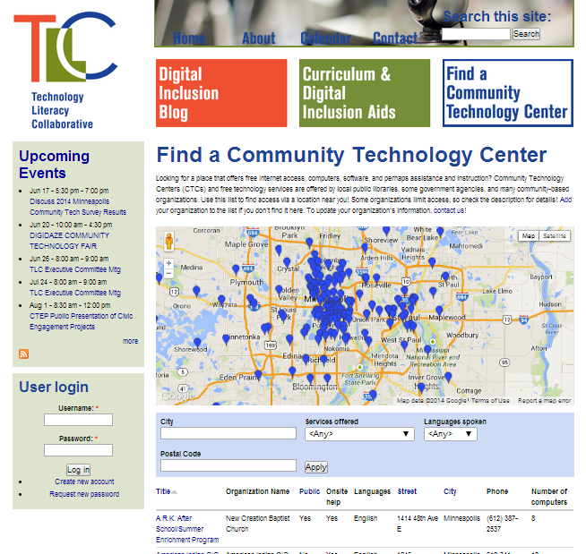

Enter your address to find classes close to you!

**Website:** tlc-mn.org

**What is it?** Locates computer classes around the Twin Cities

**How does it work?** Go to the website and click on “**Find a Community Technology Center**”. You will see a map of different centers around the Twin Cities. Underneath you can type in your address or zip code and find classes close to you.