Reading and Writing for Job Search Day 6

Objectives Learners will be able to… | Materials
Computer skill: correct resume formatting  Computer skill: type the education section  Computer skill: use spell check  Literacy skill: identify correct spelling of words | Make Student Copies  - Job Search Exercise 3: Put it Together-print one copy per 3 or 4 students because they will be grouped off (Tab 18)  - Example Resume #2 (Tab 19)  - Job Search Exercise 5: Spell Check (Tab 20)  Download from Lesson Plan  - Job Search Exercise 4: Resume Formatting  Props, Technology or Other Resources  - Projector  - Computer for every student  - USB Drives
Lesson Plan | Vocabulary
Activity 1: Put a Resume in Order  Description: students will move into groups of three and will take the pieces of the resume from the exercise and put it in order of an appropriate resume, this will lead into conversations about résumé organization  Materials/Prep: one copy per group of Job Search Exercise 3: Put it Together  Activity 2: Formatting Resume  Description: students will learn the important of uniformity when formatting a resume and practice editing the format of example resumes  Materials/Prep: copies of Resume Example #2 and teacher should download Job Search Exercise 4: Resume Formatting from lesson plan and project  Activity 3: Spell Check  Description: students will learn how to check the spelling of a document  Materials/Prep: copies of Job Search Exercise 5: Spell Check  Activity 4: Writing resumes  Description: students will take what they learned and continue developing their resumes, and hopefully enter their Education section | - Resume  - Consistency  - Formatting  - Spell Check
Teacher Directions: Activity 1: Put a Resume in Order
-Job Search Exercise 3: Put It Together
Step 1: Context
Ask students what goes into a resume? What are the sections?
- Who you are
- Summary of qualifications
- Job History
- Education
- Other relevant information
Ask what goes into the Summary section? Relevant job skills that set you apart from other applicants.

Step 2: Exercise
Put students into groups of three
Hand out Job Search Exercise 3: Put it Together
Explain that students have strips of paper that, when put in the correct order, will create someone’s resume
Ask what always goes at the top of a resume? Name and contact information
Instruct learners to try their best to put the resume in order
The correct order=the order as listed under step 1

Step 3: Review
Once everyone is done, explain that people might have put their exercise is varying orders, and people might have seen resumes in orders different than the one we discussed
Explain that some sections of a resume can be adjusted depending on the job to which you are applying
Most Common Examples:
If you have recently taken college courses or gained a degree in something that relates to the job, put that at right under the summary section
Ask if students have seen another way to organize a resume, discuss

Teacher Directions: Activity 2: Formatting Resume -Resume Example #2
Download and Project Job Search Exercise 4: Formatting Practice
Step 1: Set-up
Hand out Resume Example #2
Explain that today we are going to focus on formatting and cleaning up the resume
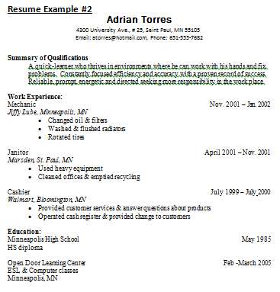
Ask learners what kind of formatting they see: italics, bold, underline, font changes, alignment
Point out the consistency throughout the document
- All company names have same formatting
- All positions have same formatting
- All responsibilities are bulleted
- All category titles are the same
Explain that students can copy this format on their own resume

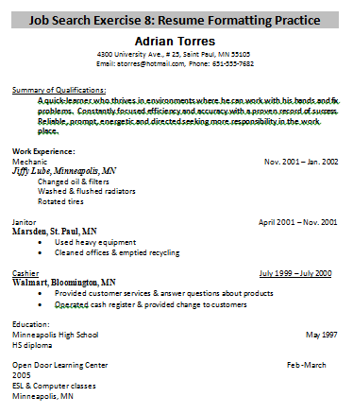
Step 2: Demonstration
Teacher should proejct Job Search Exercise 8: Formatting Practice from Page 15 of Lesson plan
Teacher will demonstrate how to change formatting of one aspect of the resume
Once demonstrated, undo all of the changes

Step 3: All together
Instruct students to come up one by one to change the formatting of the document resume to match the example that was distributed during Step 1
Encourage students to assist those who are struggling using vocabulary words, not just yelling nonsense
Note: you will have to explain line spacing

Step 4: Independent practice
Review how to open previously saved documents, ask learners how
Open Word>Click on File>Click on Open>Locate appropriate drive>Locate Resume>Click Open
Students should refer to the example resume and try to format what exists in their own personal resume

Teacher Directions: Activity 3: Spell Check –Job Search Exercise 5: Spell Check
Step 1: Set-up
Write “My anme is” on the board and draw a red wavy line underneath “anme”
Ask students if they have ever seen that read line? Do they know what it means?
The red line is Microsoft Word saying that it does not recognize the word you are saying and that it thinks you spelled it wrong
Explain that Word wants to help, so it will offer suggestions
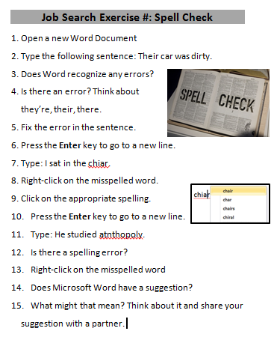
Step 2: Demonstrate Right-click
Open a Word Document and type what you wrote on the board
Demonstrate using right-click and how it will give you options for correct spelling
Practice this a few times

Step 3: Controlled Practice
Have students deliberately type incorrectly and walk though how to fix it

Step 4: Explain inconsistencies
Type “I turned on the lamb so that I could read my book.”
Ask learners if they see anything wrong with this sentence?
Point out that it says “lamb” instead of “lamp” which is incorrect, but Word does not recognize it
This is why it is important not to rely on Spell Check and always read through your work many times before submission

Step 5: Individual Practice
Hand out Job Search Exercise 8 Spell Check
Instruct learners to read through the steps and follow them one by one

Step 6: After exercise
As learners finish the exercise, they should return to their resume and check for any spelling mistakes

Teacher Directions: Activity 4: Writing Resumes
Step 1: Open Previously Saved
Students should open the Resume they began creating Day 5
If students were not present for Day 5 they can start from scratch to develop their resume

Step 2: Instructions
Explain that students should now continue working on their resumes
They should move on to the job history section and really think about what to put into their job descriptions
Goal for today: Add education section

Step 3: Student’s work
While students are working, circulate to assist them
Point out areas that might need to be looked at a again or ways to change syntax

Step 4: Save Resumes
Remind learners to save as they go, but be sure to save at the end before shutting down

Job Search Exercise 3

George Orwell
1111 Street Dr.
Big City,MN 51515
username@gmail.com
(651) 555-1234

Summary: Enthusiastic, hardworking individual seeking a position as a contractor for a fast-moving, innovative company.

Skills:
- Computer Literate
- Fluent in Spanish and English
- Can type 60 wpm
- 3 years of experience with customer service

Education:

Open Door Learning Center
2700 E Lake St.
Minneapolis, MN 55406

Work experience:
Lead Cashier

Osco Drugs,
Milwaukee, WI

- Operated cash register
- Assisted customers with photo orders
- Assisted store manager with supervisory duties

Staffing Specialist

AHL Staffing,
Rogers, MN

- Handled incoming calls
- Conducted surveys
- Completed and modified customer requests

Resume Example #2
Adrian Torres
4300 University Ave., # 25, Saint Paul, MN 55105
Email: atorres@hotmail.com, Phone: 651-555-7682

Summary of Qualifications
A quick-learner who thrives in environments where he can work with his hands and fix problems. Constantly focused efficiency and accuracy with a proven record of success. Reliable, prompt, energetic and directed seeking more responsibility in the work place.

Work Experience:
Mechanic Nov. 2001 – Jan. 2002

Jiffy Lube, Minneapolis, MN
- Changed oil & filters
- Washed & flushed radiators
- Rotated tires

Janitor April 2001 – Nov. 2001

Marsden, St. Paul, MN
- Used heavy equipment
- Cleaned offices & emptied recycling

Cashier July 1999 – July 2000

Walmart, Bloomington, MN
- Provided customer services & answer questions about products
- Operated cash register & provided change to customers

Education:
Minneapolis High School May 1985
HS diploma

Open Door Learning Center Feb -March 2005
ESL & Computer classes
Minneapolis, MN

Job Search Exercise 4: Resume Formatting Practice
Adrian Torres
4300 University Ave., # 25, Saint Paul, MN 55105
Email: atorres@hotmail.com, Phone: 651-555-7682

Summary of Qualifications:
A quick-learner who thrives in environments where he can work with his hands and fix problems. Constantly focused efficiency and accuracy with a proven record of success. Reliable, prompt, energetic and directed seeking more responsibility in the work place.

Work Experience:
Mechanic Nov. 2001 – Jan. 2002

Jiffy Lube, Minneapolis, MN
Changed oil & filters
Washed & flushed radiators
Rotated tires

Janitor April 2001 – Nov. 2001

Marsden, St. Paul, MN
• Used heavy equipment
• Cleaned offices & emptied recycling

Cashier July 1999 – July 2000

Walmart, Bloomington, MN
• Provided customer services & answer questions about products
• Operated cash register & provided change to customers

Education:
Minneapolis High School May 1997
HS diploma

Open Door Learning Center Feb -March 2005
ESL & Computer classes
Minneapolis, MN

Job Search Exercise 5: Spell Check

- Open a new Word Document
- Type the following sentence: Their car was dirty.
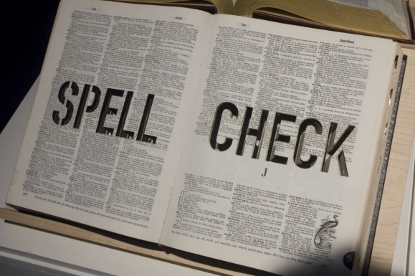
- Does Word recognize any errors?
- Is there an error? Think about they’re, their, there.
- Fix the error in the sentence.
- Press the Enter key to go to a new line.
- Type: I sat in the chiar.
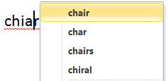
- Right-click on the misspelled word.
- Click on the appropriate spelling.
- Press the Enter key to go to a new line.
- Type: He studied bology.
- Is there a spelling error?
- Right-click on the misspelled word
- Does Microsoft Word have a suggestion?
- What might that mean? Think about it and share your suggestion with a partner.

