Reading and Writing for Job Search Day 4

Objectives Learners will be able to… | Materials
Computer and Literacy Skill: Put together previous employment and at least 3 responsibilities per job  Computer skill: identify formatting  Computer skill: create bulleted list  Literacy skill: be able to write a verb in past tense  Literacy skill: understand difference between duty and responsibilities | Make Student Copies  - Day 4 Warm-up: 2 copies per page, print one per two students (Tab 13)  - Day 4 Job Packet: print one for each student (Tab 14)  - Day 4 Resume PPT 3 Slides Per page for Learners (Tab 15)  Download  - Download Day 4 Resume PPT  For Teacher  - Resume Day 4 PPT Notes Page for Teacher (Tab 15)  Props, Technology or Other Resources  - Projector  - Computer for every student  - USB Drive
Lesson Plan |  | Vocabulary
Warm-up: 15 minutes  Description: Hand out Day 4 Warm-up and have students fill in the blanks with their own information. Only give them 15 minutes to do as much as they can. This is simply to get them brainstorming for the topic covered in class.  Materials/Prep: copies of Day 4 Warm-up  Activity 1: Introduction to Resumes  Description: go over the Day 4 Resume PPT and discuss with students what goes into a resume, what is the goal and purpose, and what the rules are.  Materials/Prep: download Day 4 Resume PPT, hand out Day 4 PPT 3 Slides per Page, and notes page for teacher  Activity 2: Job History  Description: handout Example Resume and go over what is included in previous employment section, the layout of it and the makeup of job responsibilities  Materials/Prep: copies of Day 4 Job Packet  Activity 3:Job Duties vs. Responsibilities  Description: go through handouts that explain best practices for writing job responsibilities and reinforce difference between responsibilities and duties. Students should then create a document which includes all information for at least one previous job  Materials/Prep: copies of Job Responsibilities Do’s and Don’ts (print front and back) |  | - Resume  - Previous Experience  - Past tense  - Responsibility  - Duty  - Action Verbs  - Bullet Points

Teacher Directions: Activity 1: Introduction to Resumes-Download Day 4 Resume PPT
-Day 4 Resume PPT 3 Slides Per page for Learners
-Resume Day 4 PPT Notes Page for Teacher
Step 1: Download PPT
The information for Activity 1 is in the Day 4 Resume PPT which is located on the MN Literacy page that lists the lesson plans
If not done so already, print out the PPT in notes form, it lists discussion questions for the day
Additionally, print out the slides with 4 slides per page for the learners to follow you as you present

Step 2: Go through PPT
Handout Day 4 Resume PPT- should be printed out with 3 slides per page
Make sure you ask students questions before providing the answers; this may bring up common misconceptions that you can talk through

Teacher Directions: Activity 2: Job History –Page 1-3 Job Packet
Step 1: Handout Resume
Explain that today we will focus on the previous experience section
Ask students what kind of information they think goes into this section, write their responses on the board
Hand out Day 4 Job Packet
Direct students to page 1: example resume
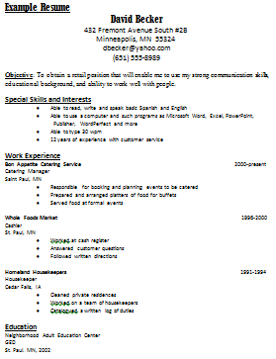
Instruct learners to circle the different categories

Step 2: Previous Experience
Did the students input match the example?
Any information that students listed that is not included?
Erase any extras and add any that were missed to the list which should look like:
  - Position Title
  - City and State
  - Dates of Employment
  - Company name
  - Job Responsibilities

Step 3: Layout
Explain that this is a good example of how to layout and format a resume
Ask what formatting sticks out right away? Any bold? Italics? Alignment changes?
Focus on previous experience: bullet points, bold, italics
Where are the responsibilities?
CONSISTENCY IS KEY

Step 4: Job Responsibilities
Ask what they immediately notice about the job responsibilities under each job
- Are they complete sentences?
- What part of speech does each start with? Action word/verb
- What is being described? Responsibilities, what kept the company running
- What tense are they written in? Past tense
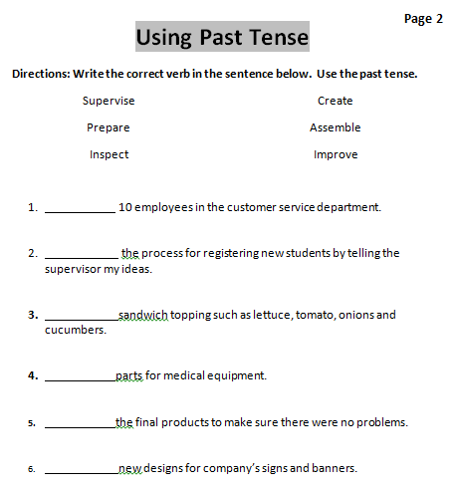
Step 5: Making it past tense
Write “organize paperwork for increased efficiency”
Ask students if this sentence looks like a job responsibility
  - Does it start with a verb?
  - Is it describing something that kept the company running?
  - Is it past tense?
Ask how we make it past tense? Add –ed to the end
“organized paperwork”

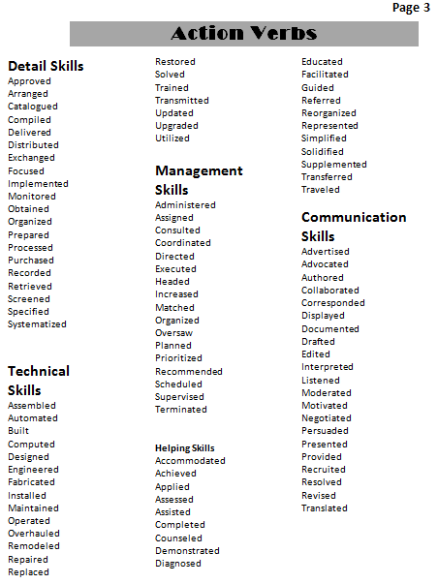
Step 6: Together
Turn to Job Packet Page 2: Past Tense
Go through the examples together

Step 7: Action verbs
Direct students to the action verbs on Page 3
Explain that these can be used in your resume and might even inspire some ideas for what to write

Step 8: Example
Use the words to come up with a few examples of responsibilities and write them on the board
Leave them on the board to be edited during activity 3

Teacher Directions: Activity 3: Job Responsibilities Activity
-Page 4&5 Job Packet
Step 1: Context
Explain that we have learned the general makeup of job responsibilities and now we need to learn what to include and what not to include
Ask if anyone can think of the different between job responsibilities and job duties

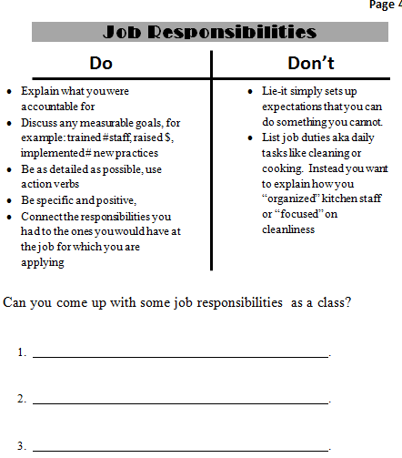
Step 2: Handout
Direct Students to page 4 of Packet: Job Responsibilities vs. Job Duties
Read through the Job Responsibilities Do’s and Don’ts as a class
Examples:
- Documented notes from phone calls received
- Repaired automobiles to top standards
- Administered appropriate doses of medication as needed

Step 3: Job Duty versus Responsibility
Go to page 5
Read through the directions and go through the handout as a class
Ask learners which answer is correct
Ask learners what the action verb is
Step 4: Demonstrate making list with bullet points
Learners should have their EYES FORWARD AND HANDS OFF OF COMPUTER
Teacher open Word and type a list of responsibilities you have had at work
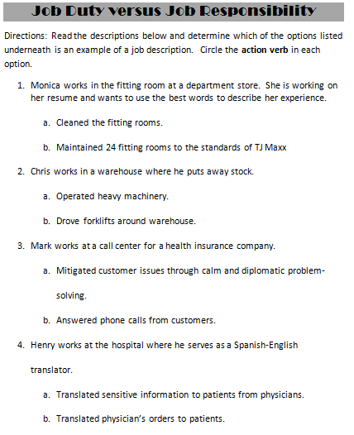
Demonstrate how to use enter key and how to add bullet points
Ask students what the action verbs are

Step 5: Do together
Learners should have their EYES FORWARD AND HANDS OFF OF COMPUTER
Teacher is the only one typing
Ask students to come up with some responsibilities as well
Provide them with a job title- Sales Associate
Put together the list; ask students how to add bullets

Step 6: Independent Typing
Go through how to open Word
Instruct students to type their previous job, title and responsibilities
They can use the handout from the warm-up

Step 7: Save
Review how to save a new document
Click on File> Click on Save As (new document, never saved before)> Click on My Computer> Locate appropriate drive (E drive if using USBs)>Name File “Your Name Resume”>Click Save

Day 4 Warm-up
Your Name:
Title of previous held position:
Name of Company:
What were 3 things you were responsible for in this position?
1.
2.
3.
Day 4 Warm-up
Your Name:
Title of previous held position:
Name of Company:
What were 3 things you were responsible for in this position?
1.
2.
3.

Day 4 Job Search Packet
Follow teacher’s instructions and do not move ahead
Example Resume David Becker
Page 1
432 Fremont Avenue South #2B
Minneapolis, MN 55324
dbecker@yahoo.com
(651) 555-8989

Summary of Qualifications
A dedicated employee who refuses to stop short of the best. Fluent in both English and Spanish in addition to knowledge of Microsoft Office computer programs. 12 years of customer service experience has taught the ins and outs of working with all types of customers in varying situations.

Work Experience
Bon Appetite Catering Service 2000-present
Catering Manager
Saint Paul, MN
♦ Responsible for booking and planning events to be catered
♦ Prepared and arranged platters of food for buffets
♦ Served food at formal events

Whole Foods Market 1996-2000
Cashier
St. Paul, MN
♦ Worked at cash register
♦ Answered customer questions
♦ Followed written directions

Homeland Housekeepers 1991-1994
Housekeeper
Cedar Falls, IA
♦ Cleaned private residences
♦ Worked on a team of housekeepers
♦ Kept a written log of duties

Education
Community Partners School
Training for Employable Computer Skills
St. Paul, MN, March 2004

Neighborhood Adult Education Center
GED
St. Paul. MN, 2002
Using Past Tense
Directions: Write the correct verb in the sentence below. Use the past tense.
Page 2

Supervise
Prepare
Inspect

Create
Assemble
Improve

- 10 employees in the customer service department.
- the process for registering new students by telling the supervisor my ideas.

- sandwich topping such as lettuce, tomato, onions and cucumbers.

- parts for medical equipment.
- the final products to make sure there were no problems.
- new designs for company’s signs and banners.

Action Verbs
Page 3

Detail Skills
Approved
Arranged
Catalogued
Compiled
Delivered
Distributed
Exchanged
Focused
Implemented
Monitored
Obtained
Organized
Prepared
Processed
Purchased
Recorded
Retrieved
Screened
Specified
Systematized

Technical
Skills
Assembled
Automated
Built
Computed
Designed
Engineered
Fabricated
Installed
Maintained
Operated
Overhauled
Remodeled
Repaired
Replaced
Restored
Solved
Trained
Transmitted
Updated
Upgraded
Utilized

Management
Skills
Administered
Assigned
Consulted
Coordinated
Directed
Executed
Headed
Increased
Matched
Organized
Oversaw
Planned
Prioritized
Recommended
Scheduled
Supervised
Terminated

Helping Skills
Accommodated
Achieved
Applied
Assessed
Assisted
Completed
Counseled
Demonstrated
Diagnosed
Educated
Facilitated
Guided
Referred
Reorganized
Represented
Simplified
Solidified
Supplemented
Transferred
Traveled
Communication Skills
Advertised
Advocated
Authored
Collaborated
Corresponded
Displayed
Documented
Drafted
Edited
Interpreted
Listened
Moderated
Motivated
Negotiated
Persuaded
Presented
Provided
Recruited
Resolved
Revised
Translated

Job Responsibilities
Page 4
Don’t

Do

- Explain what you were accountable for
- Discuss any measurable goals, for example: trained #staff, raised $, implemented # new practices
- Be as detailed as possible, use action verbs
- Be specific and positive,
- Connect the responsibilities you had to the ones you would have at the job for which you are applying
- Lie-it simply sets up expectations that you can do something you cannot.
- List job duties aka daily tasks like cleaning or cooking. Instead you want to explain how you “organized” kitchen staff or “focused” on cleanliness

Can you come up with some job responsibilities as a class?

- .

- .

- .

Job Duty versus Job Responsibility
Page 5
Directions: Read the descriptions below and determine which of the options listed underneath is an example of a job description. Circle the action verb in each option.
- Monica works in the fitting room at a department store. She is working on her resume and wants to use the best words to describe her experience.

  - Cleaned the fitting rooms.
  - Maintained 24 fitting rooms to the standards of TJ Maxx
- Chris works in a warehouse where he puts away stock.
  - Operated heavy machinery.
  - Drove forklifts around warehouse.
- Mark works at a call center for a health insurance company.
  - Mitigated customer issues through calm and diplomatic problem-solving.
  - Answered phone calls from customers.
- Henry works at the hospital where he serves as a Spanish-English translator.
  - Translated sensitive information to patients from physicians.
  - Translated physician’s orders to patients.

