Welcome to the Reading and Writing for Job Search unit of the Computers and Literacy Class

What to know about the class:
- Each lesson plan is built to fit a 2 hour time slot
- There are 12 lesson plans
- Each unit includes a TABE testing day (Day 10) and a North Star Digital Literacy Pre-Assessment (Day 2) and Post-Assessment (Day 11)
- This curriculum was written for students with a TABE score of 400 or higher

What you need for the class:

- A computer for each student
- Projector
- A USB drive for each student
- Headphones for each student
- The ability to print from the computer
- Microsoft Office*preferred, but OpenOffice would work as well
- Windows 7*preferred (same format as North Star Assessment)

Preparations for class:
- Instructor needs to load the following exercises either onto student USB drives or make sure they are online at your learning centers mnliteracy.org curriculum webpage
- Be sure teachers have access to the following PowerPoints
  - Day 1 Computer Introduction
  - Day 4 Resumes
  - Day 7 Understanding Job Posts

Note: if you are saving these files to USB drives, please be sure to save them in a Excel Class Folder.

How to become a North Star Digital Literacy Assessment proctor:
- You will need your learning centers username and password
- Go to digitalliteracyassessment.org/admin
- Type in username and password
- Look for “Don’t see your name on the list” and click on proctor training
- It takes about 20 minutes to complete, there is a quiz at the end

Reading and Writing for Job Search Day 1

Objectives Learners will be able to… | Materials
Computer skill: intro to the computer  Computer skills: keyboard recognition | Make Student Copies  - Class Syllabus (Tab 1) –teacher must fill in information  - Day 1 PPT (4 slides per page, front and back, stapled) (Tab 2)  - Job Search Exercise 1: Part 2 Mingle (Tab 5)  Print and cut out:  - Job Search Exercise 1: Part 1- be sure to read through directions on the handout, only one copy needs to be made (Tab 4)  Props, Technology or Other Resources  - Projector  - Computer for every student  - USB Drives  - Reading and Writing for Job Search Day 1 PPT + Notes Page (Tab 6)  - Computer Sign-up Sheet (Tab 3)
Lesson Plan |  | Vocabulary
Activity 1: Introductions and Expectations  Description: time to get to know each other and introduce class expectations  Materials/Prep: copies of Reading and Writing for Job Search Syllabus and write some get-to-know-you questions on the board  Activity 2: What you know-mind mapping 10 minutes  Description: learners will write down things that they already know about searching for jobs (some might know nothing, this is fine!)  Materials/Prep: locate post-it notes, Write “What we know about Job Searches ” in the middle of the board and circle it  Activity 3: Intro to Computer  Description: learners will get the basics of computer vocabulary  Materials/Prep: download Day 1 PowerPoint, print Day 1 PowerPoint notes pages if not done already, copies of Job Search Exercise 1: What am I? and Exercise 1 Part 2  Activity 4: Typing Introduction  Description: learners will briefly go over basic keys and Word information  Materials/Prep: |  | - Hardware  - Software  - Operating System  - Windows  - Mouse  - USB Drive  - desktop icon  - Double Click  - Start Menu  - Action point

Teacher Directions: Activity 1: Introductions and Expectations
–Job Search Syllabus
Step 1: Teacher and student introductions
Go around the room and have students and teachers introduce themselves by answering pre-determined questions
Example questions; choose 3-4:
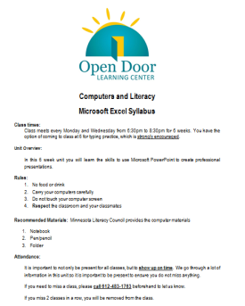
- What is your name?
- Why did you decide to take this class?
- What are your goals?
- What would you do if you won $10,000?
- What do you like to do in your free time?
- What is your favorite dessert?
- Choose your own

Step 2: Syllabus
Hand out Class Syllabus and go over with students
Fill in the blanks with your own learning center information
Ask coordinator for the learning center phone number
Be sure to highlight respect aspect- students are varying levels, from varying backgrounds, but this is a space where we respect each other and focus on learning computer skills

Step 3: Get computers
If not done already, take this time to have students obtain a computer from the COW (computer on wheels)
Make a copy of Computer Sign-up sheet and fill in students names next to their assigned computers, fill in class times/days and tape it to the COW (this is to prevent other teachers from taking students’ computers)

Teacher Directions: Activity 2: What you know-mind mapping
Step 1: Hand out materials
Should look something like this on the wall:
Pair learners off
Each pair needs a post-it and a circle

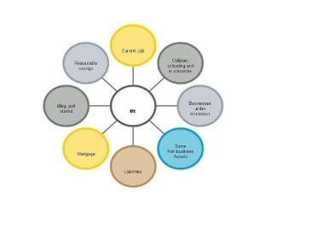
Step 2: Students write down what they know about Job Searching
Instruct learners to write what one thing they know about Job Searching/how have they searched for jobs in the past
Explain that if they cannot think of anything, that is okay, that is why we are in class
If they can think of a couple of things, they can use multiple post-its

Step 3: Post the post-it
The post-it’s that students have filled in should be stuck to the board around the “What we know about Reading and Writing for Job Search ” bubble, arranged like a mind map

Step 4: Review
Review what students wrote and explain that it is okay if they do not know much, because we have a lot to learn in the next six weeks

Teacher Directions: Activity 3: Intro to the Computer
-Reading and Writing for Job Search Day 1 PPT
- Job Search Exercise 1: What am I?
Step 1: Context --Exercise 1 Part 2: Mingle
Explain that the rest of the day we will be getting introduced to basic computer hardware and software and we will then start with Reading and Writing for Job Search intros
Remind learners to ask questions as they come up, explain that if they do not know something, they NEED to ask, otherwise they will never know

Step 2: Go through Day 1 PPT
Hand out Reading and Writing for Job Search Day 1 PPT with four slides per page (Tab 2)
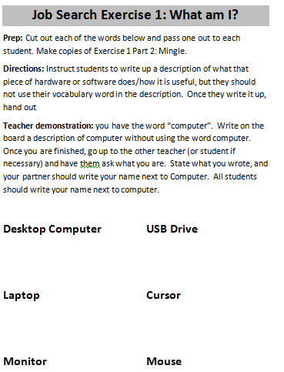
Download Day 1 PPT and go through it with students, if you print it in Notes Form you can expand on information in the slide (Tab 28)
The PPT is animated to allow students to try to give definitions/determine the vocab word before it is shown
Example: Slide 8: Ask learners what are the two types of computers
It is best if you can print out the PPT in Notes Form before class because there is more explanation of slides within the notes function

Step 3: Practice Activity
Hand out Job Search Exercise 1: What Am I?
Read through direction on the Exercise
Learners should determine whether each vocabulary word is software or hardware

Teacher Directions: Activity 4: Typing Introduction
Step 1: How to open a program
Demonstrate the three ways to open a program, explain each step as you go
- Double-click on the desktop icon
- Open start menu and check list for Reading and Writing for Job Search
- Open Start menu, go to all programs, locate Microsoft Office, Microsoft Reading and Writing for Job Search
As you go, demonstrate how to close the program

Step 2: What is Microsoft Word Used for
Once Word is open, ask students if they know what this program is used for?
Explain that a document like an essay, resume, letter or anything with many words is typically created in Microsoft Word
The resumes we create in this class will be created in Word

Step 3: Tools of word
Explain that when a user clicks in the blank page on Word, a blinking line will appear, this is the action point: anything you type will begin at the action point
Instruct learners to type their name
Explain the following keys and practice with them:

- Enter key
- Backspace
- Delete
- Tab
- Shift
- Caps Lock
- Space

Computers and Literacy
Reading and Writing for Job Search Syllabus
Class times:
Class meets every and from to for 6 weeks.

Unit Overview:
In this 6 week unit we will learn the skills necessary to develop a well written resume in addition to learning how to complete a safe and productive search for jobs online.

Week 1: Intro to the computer
Week 2: Assessment of skills
Week 3: Resume writing
Week 4: Email and Editing
Week 5: Job Search Websites
Week 6: Interview tips and review

Rules:
- No food or drink
- Carry your computers carefully
- Do not touch your computer screen
- Respect the classroom and your classmates

Recommended Materials: Minnesota Literacy Council provides the computer materials
- Notebook
- Pen/pencil
- Folder
Attendance:
It is important to not only be present for all classes, but to show up on time. We go through a lot of information in this unit so it is important to be present to ensure you do not miss anything.
If you need to miss a class, please call beforehand to let us know.
If you miss 2 classes in a row, you will be removed from the class.
Computer Sign-up Sheet
These computers are in use and from ______to______
1
2
3
4
5
6
7
8
9
10
11
12
13
14
15
16
17
18
19
20
21 | Teacher Computer

Job Search Exercise 1: What am I?
Prep: Cut out each of the words below and pass one out to each student. Make copies of Exercise 1 Part 2: Mingle.
Directions: Instruct students to write up a description of what that piece of hardware or software does/how it is useful, but they should not use their vocabulary word in the description. Once they write it up, hand out Exercise 1 Part 2:Mingle
Teacher demonstration: you have the word “computer”. Write on the board a description of computer without using the word computer. Once you are finished, go up to the other teacher (or student if necessary) and have them ask what you are. State what you wrote, and your partner should write your name next to Computer. All students should write your name next to computer.

Desktop Computer
Laptop
Monitor
USB Drive
Cursor
Mouse
Touchpad
Left-click
Double-click
Right-click
Headphones
Headphone Jack
Power Button
Modem
System Unit
Microsoft Word

Exercise 1 Part 2: Mingle
Directions: Find a partner and have them read off the description of their vocabulary word. Try to guess what the word is and when you figure it out, write your partners name next to the appropriate vocabulary word.
Vocabulary Word | Name
Laptop
Desktop Computer
Cursor
Monitor
Mouse
USB Drive
Touchpad
Left-click
Double-click
Right-click
Headphones
Headphone Jack
Power Button
Modem
System Unit
Microsoft Word

