PowerPoint: Day 4

Objectives Learners will be able to… | Materials
Computer skill: picking slide layout  Computer skill: picking slide design  Literacy skill: main idea | Make Student Copies  - Choosing a Slide Layout (Tab 11)  - PowerPoint Exercise 5: Slide Layout- two per page, needs to be cut in half (Tab 12)  - PowerPoint Exercise 6: Slide Design (Tab 13)  - Day 4 Main Idea Practice PPT- print with 3 slides per page so students can take notes (Tab 14)  Props, Technology or Other Resources  - Projector  - Computer for every student  - USB Drives  - Day 4 PPT Design  - Day 4 PowerPoint Design  - Day 4 Main Idea Practice PPT
Lesson Plan |  | Vocabulary
Warm-up:  Description: Instruct learners to go into Google images and find a picture of the place they would most like to visit (or is the teacher has another idea, go with that). They should copy the image and paste it into a Word document. They do not need to save it. This might require review, so go ahead and review the steps with learners.  Materials/Prep:  Activity 1:Picking Proper Slide Layout  Description: learners will develop skills to pick the proper slide layout when inserting a slide  Materials/Prep: copies of Choosing a Slide Layout and PowerPoint Exercise 5: Slide Layout  Activity 2: Slide Design  Description: learners will change the basic design and format of text in slides  Materials/Prep: download Day 4 PPT Design and copies of PowerPoint Exercise 6: Slide Design  Activity 3: Main Idea and Title  Description: learners will use skills they learned in the previous activities to practice their understanding of main idea and giving presentations titles  Materials/Prep: download Day 4 Main Idea Practice PowerPoint and print with 3 slides on each page so learners can take notes |  | - Layout  - Design  - Effects  - Main Idea  - Supporting Details/Evidence

Teacher Directions: Activity 1: Picking Slide Layout -Choosing a Slide Layout
Step 1: Define layout -PPT Exercise 5: Slide Layout
When creating a slideshow it is important to make the information as clear as possible, and often that is assisted by the layout of the information on the slide
Write Layout on the board
Ask if any learners know what that means- The way in which the parts of something are arranged or laid out.
As learners might have noticed, when a user inserts a slide, PPT offers different slide options. Certain ones fit the needs of the information presented best, and that is what will be discussed

Step 2: Why are there different options?
Hand out Choosing a Slide Layout (and/or pull up the Layout options on your computer)
Explain that each layout to meant to match the type of content included in each slide
Example: if you have a slide with just bulleted text (slide 2 on handout) vs. a slide with text and a picture, you will want to present that information differently. Slide layout options allow you to adjust to your needs
Explain that when determining slide layout, learners should think about what kind of content they are including in the slide- just text about one topic, two sides of an argument, text and a picture, just a picture?
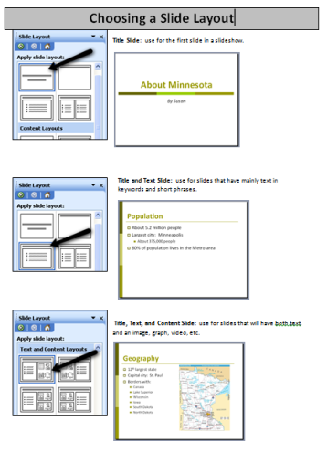
Step 3: Demonstrate
Teacher will now create a slide show titled “About Minnesota”
Handout Choosing a Slide Layout and use it to work through the PowerPoint
As you work through the PowerPoint, be sure to keep the learners involved in the process
How to change slide layout:
- Review: Ask learners if they remember how to insert a slide? Click on the Insert menu tab>New Slide>Slide layout sidebar pops up
- Right click on the slide>click on Slide Layout
Ask learners review questions like:
- How do I go about inserting a new slide?
- How do I enter text into the box?
- What if I want the text to be bold?
- How do I enter clip art?
- What if I cannot find clip art I am looking for in the PowerPoint options- look online

Step 3: Controlled Practice
Learners should open a new PPT
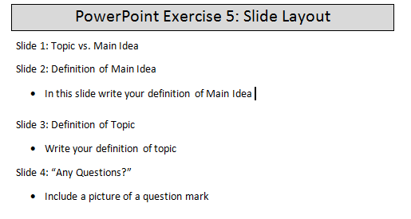
Handout PowerPoint Exercise 5: Slide Layout
Explain that this is an outline for a PPT and we need to decide which slide layout is best for each slide of information about Main Idea (the topic for the PPT)
Work through this together
Remind learners that sometimes PPT does not have the picture they are looking for in the clip art section, so ask them where they should look to find it

Step 4: Save
Review the steps of saving to a USB Drive
Learners should close this PPT

Teacher Directions: Activity 2: Slide Design -Day 4 PPT Design
-PowerPoint Exercise 6: Slide Design
Step 1: Define design versus layout
Review- ask what layout means- the way parts of something are arranged
Explain that in addition to picking the proper layout, it is important to pick a fitting design for the PPT that is created
What is slide design? The different backgrounds that can be set for a PPT

Step 2: Demonstrate adding Slide Design to all and to selected slides
Take a few minutes to show learners a few different Slide Design options
Click on the Format menu tab> Click on Slide Design
Add to all-simply click on desired design
Add to selected-hover over desired design>click on arrow that appears>click on Apply to Selected Slides
Explain that learners can take the lead on which design they want for the slide shows we create, but they need to be careful to make sure the font is a readable color

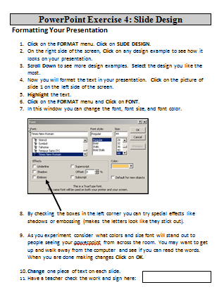
Step 3: Changing font
Demonstrate how to change the format of text within the design of slides
Click on Format>Click on Font>change the font, size, color to preferences
For this example, select a yellow font color and a thin font, click OK
Ask learners what is wrong with the font you selected
Open up the Font dialogue box again, having the learners walk you through the steps
Explain the “Effects” section of the box and show learners what some of the effects do to text
Learners will have time to explore the effects/font options in exercise 4

Step 4: Controlled Practice
Teacher should download Day 4 PPT Design and go through it with the learners
This PPT will ask students to come up to the teacher computer and practice changing font/design/style
You do not need to save this PPT

Step 5: Individual Practice
Hand out PowerPoint Exercise 6: Slide Design
Review how to open a PPT that has already been saved
Instruct learners to change the design and font of the text in the PowerPoint created in Activity 1 by following the steps of the exercise
Demonstrate how to open a previously saved PPT

If there is time: Teacher Directions: Activity 3: Main Idea –Day 4 Main Idea Practice PPT
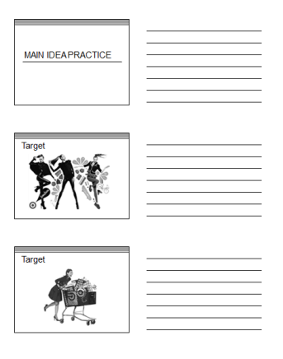
If you do not get to this activity, be sure say so in the lesson report. Inform the teachers of the next session to use this activity as a warm-up.
If you do not get through all the slides, write in the lesson report where you left off so that the teachers can use the rest as a warm-up.
Step 1: Review definition
Ask learners for the definition of main idea
- Definition: the most important or central though of information
Ask learners what the vocabulary learned was that defined the information that helped you find and describe the main idea: supporting details

Step 2: Controlled Practice
Download Day 4 Main Idea Practice PowerPoint
For each slide, ask learners for the topic/title, the main idea and the supporting details
- Slide 2: Topic=Target, Main Idea= Target is fashionable, supporting details?
- Slide 3: Topic=Target, Main Idea=Shopping at target is fun, supporting details?
- Slide 4: Topic=Minneapolis, Main Idea= Minneapolis is a busy city, supporting details?
- Slide 5: Topic=Minneapolis, Main Idea= Minneapolis is a cold tundra, supporting details ?
At this point, take a minute to ask learners about what their impressions of main idea are thus far
Explain that the content changes the main idea. Words work the same as pictures.

Independent Practice
For this next part, have students circle the main idea and underline the supporting details
- Slide 6: Topic=Dogs, Main Idea=Dogs are dangerous.
- Slide 6: Topic= Dogs, Main Idea= Dogs can be trained.
- Slide 8: Topic: Grandma, Main Idea= Grandma is old and weak
- Slide 9: Topic: Grandma, Main Idea= Grandma is loving
If you do not finish the Day 4 Main Idea PPT, be sure to note it in the lesson report. Day 5 will begin where this class left off.

Choosing a Slide Layout
Title Slide: use for the first slide in a slideshow.
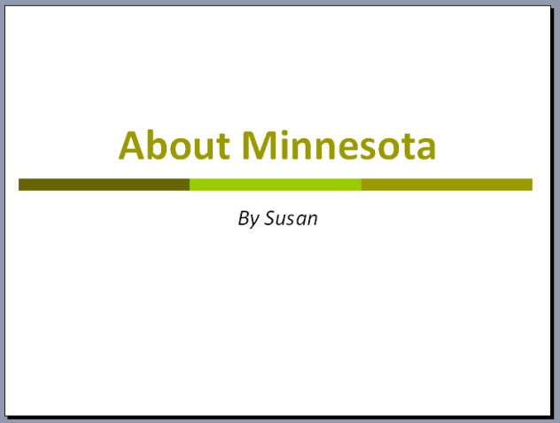

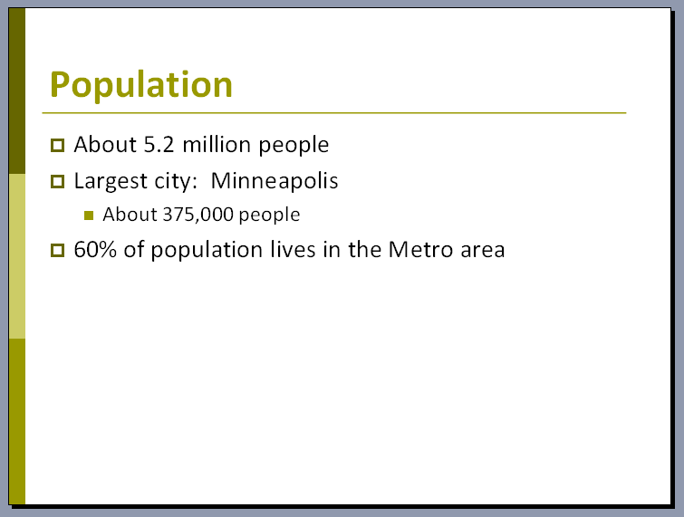
Title and Text Slide: use for slides that have mainly text in
keywords and short phrases.

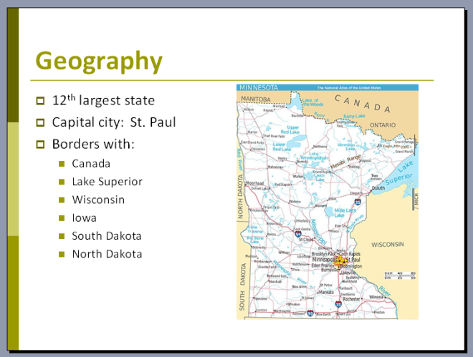
Title, Text, and Content Slide: use for slides that will have both text
and an image, graph, video, etc.

Title and Content Slide: use for slides that use a key word or
phrase for the title, with the majority of the slide showing an
image, graph, video, etc.
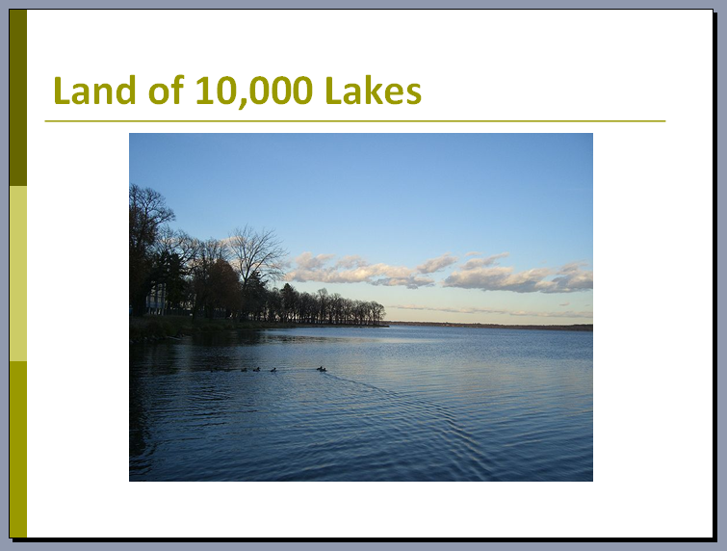

Content Slide: use for slides where a single image, graph, video, etc.
will fill the slide, and you will have no text.

Blank Slide: use when you want to design and plan your own
unique slide.
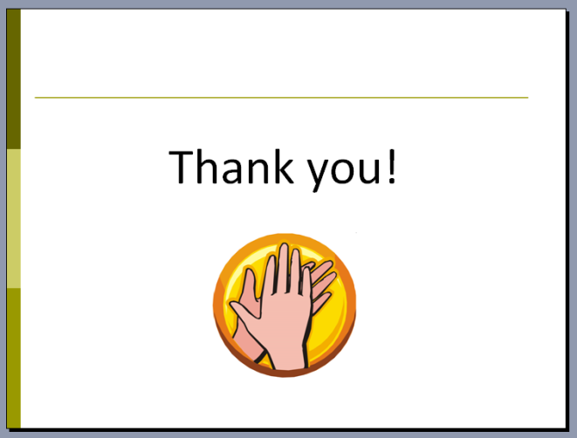

PowerPoint Exercise 5: Slide Layout
Slide 1: Topic vs. Main Idea
Slide 2: Definition of Main Idea
- In this slide write your definition of Main Idea

Slide 3: Definition of Topic
- Write your definition of topic
Slide 4: “Any Questions?”
- Include a picture of a question mark

PowerPoint Exercise 5: Slide Layout
Slide 1: Topic vs. Main Idea
Slide 2: Definition of Main Idea
- In this slide write your definition of Main Idea

Slide 3: Definition of Topic
- Write your definition of topic
Slide 4: “Any Questions?”
- Include a picture of a question mark

PowerPoint Exercise 6: Slide Design

Formatting Your Presentation
- Click on the FORMAT menu. Click on SLIDE DESIGN.
- On the right side of the screen, Click on any design example to see how it looks on your presentation.
- Scroll Down to see more design examples. Select the design you like the most.
- Now you will format the text in your presentation. Click on the picture of slide 1 on the left side of the screen.
- Highlight the text.
- Click on the FORMAT menu and Click on FONT.
- In this window you can change the font, font size, and font color.
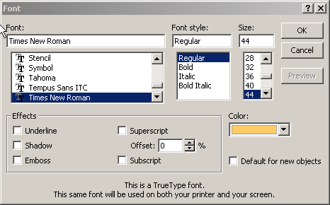

- By checking the boxes in the left corner you can try special effects like shadows or embossing (makes the letters look like they stick out).

- As you experiment consider what colors and size font will stand out to people seeing your powerpoint from across the room. You may want to get up and walk away from the computer and see if you can read the words. When you are done making changes Click on OK.

- Change one piece of text on each slide.
- Have a teacher check the work and sign here:

