**PowerPoint: Day 3**

|  |  |
| --- | --- |
| **Objectives** *Learners will be able to…* | **Materials** |
| ***Computer skill:*** *Copy, cut and paste*  ***Computer skill:*** *inserting pictures into a slide*  ***Computer Skill:*** *Google image search*  ***Literacy skill:*** *main idea* | **Make Student Copies**   * **Day 3 Warm Up (Tab 7)** * **Copy and Paste Reference Form (Tab 8)** * **PowerPoint Exercise 3: Finding Images (Tab 9)** * **PowerPoint Exercise 4: Main Idea (Tab 10)**   **Props, Technology or Other Resources**   * Projector * Computer for every student * USB Drives * **Day 3 Recycling Information PPT** |
|  | |
| **Lesson Plan** | Vocabulary |
| **Warm-up: give learners 15 minutes, activity 1 should start at 6:45**  Description: learners will give a title to different passages  Materials/Prep: copies of **Day 3 Warm-up, answers**   1. **B, 2. A**   **Activity 1: Copy and Paste**  Description: learners will take a PowerPoint and insert new slides while using Copy, Cut, Paste to give each slide a title  Materials/Prep: **Cut, Cut and Paste Reference Form**, download **Day 3 Recycling Information**  **Activity 2: Inserting Pictures into a slide**  Description: learners will insert clip art images into a slides 1-3  Materials/Prep:  **Activity 3: Finding pictures online**  Description: learners will locate pictures through a Google image search and practice copy and paste skills to move them to Slides 4 and 5 of the PPT  Materials/Prep: copies of **PowerPoint Exercise 3: Finding Images**  **Activity 4: Main Idea and Title**  Description: learners will use skills they learned in the previous activities to practice their understanding of main idea and giving presentations titles  Materials/Prep: copies of **PowerPoint Exercise 4: Main Idea** | * Copy * Cut * Paste * Image * Clip Art * Address Bar * Search Bar * Main Idea * Copyright * Public Domain * Supporting Details/Evidence |

**Teacher Directions: Activity 1: Copy and paste –Day 3 Recycling Information**

**- Copy and Paste Reference Form**

Step 1: Define

Sometimes when you are creating slides you have to type the same information more than once, there is a way to avoid having to do so.

Copy- making two of something

Cut- taking something from where it is and moving it

Paste- Taking the text that was either copied or cut and placing it where you want it to go

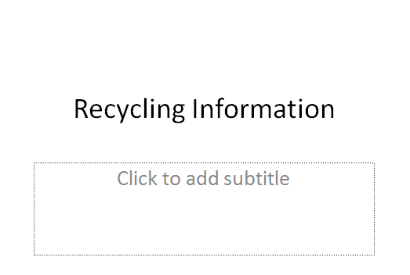

Step 2: Set-up Context

Everyone should **download Day 3 Recycling Information**

**Start Menu>My Computer>USB Drive>PowerPoint Class>Recycling Information**

Handout **Copy, Cut and Paste Reference Sheet**

Once downloaded, **ask** learners what the first slide tells them- the topic/title of the presentation

**Ask** them how many slides they see-4

**Ask** them what information is on slide 2- Recycling Categories

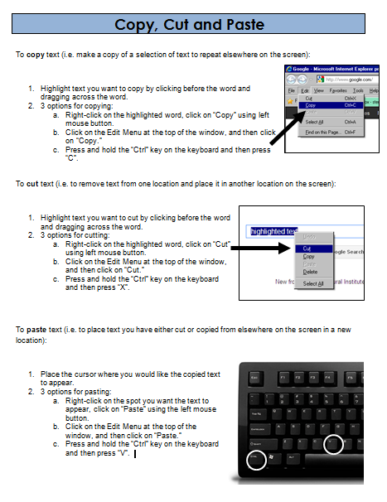 Slide 3: What is being listed? What is missing? ***A label***

Step 3: Demonstrate Copy and Paste

There should be a label on Slide 3, so we need to put it there

**Instruct** learners to keep their eyes on the projection of the Teacher’s screen and not on their own

Use the Ribbon (buttons on the toolbar) to **Copy “Cans and bottles”** from Slide 2 and paste it to label Slide 3

**Highlight “Cans and bottles” >Click on Copy button>move cursor in the top text box (title box)>Click on Paste button**

Next, **lead learners through** those steps as they work through them on their computer

Step 4: Demonstrate Cut and Paste (and practice inserting slides)

**Instruct** learners to keep their eyes on the projection of the Teacher’s screen and not on their own

**Demonstrate** using the ribbon to Cut the phrase on Slide 2 “Paper and cardboard”

Use the Paste Button to place the text onto 4

Now, **demonstrate** how to cut and paste using right-click (*show learners that it’s the same steps to copy and paste using right click)*

Step 5: Individual Practice

Instruct learners to use copy and paste to **label Slide 5**

Step 5: Save As

**Review** the steps to Save As

**Ask** leaners why they should use save as- it’s a new document/ giving it a name

**File>Save As>My Computer>(E: ) Drive> Name File>Save**

Learners should **keep the file open** for the next activity

**Teacher Directions: Activity 2: Adding a picture to a slide**

Step 1: Context

When creating a good presentation, it is important to do everything you can to draw the attention of the audience

**Ask** learners if there should be a lot of text on a PowerPoint slide- **NO**

**Why?** The audience will be focused on the slide and not on what the presenter has to say. It is distracting and often overwhelming

**Ask** learners if they can think of anything to add to a presentation to make it more appealing to the audience-**visuals or pictures**

**Example:** *Instead of having the different categories of “cans and bottles written” we can simply put pictures of the items*

Step 2: Demonstrate

We will be adding pictures to the PowerPoint that was edited in the first activity

**Instruct** learners to keep their eyes on the board and watch you as you demonstrate this function of PPT

**Once everyone’s eyes are on your screen, demonstrate** how to add a picture to the **Title Slide** of the PPT

**Click** on insert>Click on Picture>**Click** on Clip Art>Type in “Recycling”

The picture should automatically enter the slide

**Demonstrate** how to **resize** the picture- using **click and drag**

Step 3: Controlled practice

**Explain** that learners should now follow along as everyone works together to enter a picture for Slide 2

**Ask** them if the picture accurately represents one of the items in the list? If so, is it necessary to have both a picture and the words?

**Teacher Directions: Activity 3: Finding pictures online**

**-PowerPoint Exercise 3: Finding Images**

Step 1: Locating Images online

**Explain** that sometimes PowerPoint does not have the clip art options you are looking for

**Ask** if anyone can think of a data base on the computer that allows users to access internet from all over the world- **World Wide Web aka Internet**

Step 2: Opening internet

**Instruct** class to open internet explorer

Once opened, **explain** that the screen everyone sees when they open up the internet might be different from the one on the Teacher’s screen/their neighbor’s screen. No problem, this is the preset **home page**

Discuss difference between **Address Bar** and Search Bar

* **Address bar**- where the web site address or URL is typed in
* **Search bar**- where words or phrases are typed in to look for websites or images that reference that information

Remind learners to NEVER type a website (like facebook.com) into the search bar and they should ALWAYS check to make sure the spelling of the website is correct

Step 3: Go to Google

**Instruct** learners to type google.com into the address bar

Once they have done that, they should see a search bar on their page

They can type “**recycling”** into the search bar

Then click on **Images**

Step 4: Copy and Paste

**Demonstrate** how to use **right-click to copy the picture**

**Demonstrate** how to use the taskbar and/or minimize button to go back to the PPT

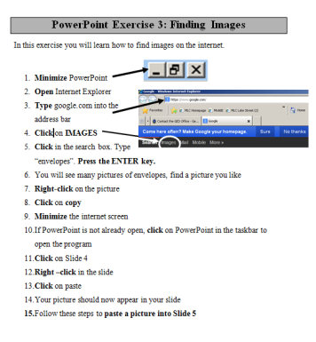**Demonstrate** how to use right-click to paste the picture in the appropriate slide, probably Slide 1

Step 5: Practice

Hand out **PowerPoint Exercise 3: Finding Images**

Learners should complete the exercise

Step 6: Save

Save the PPT

Ask Learners if they should use Save or Save As

* Use Save As when- saving a new document or renaming a document
* Use Save when- document has already been saved, simply updating content

**Teacher Directions: Activity 4: Main Idea - PowerPoint Exercise 4: Main Idea**

Step 1: Definition of Main idea

**Main Idea-**specific thought that is trying to be relayed to the reader

**Why important/relevant?** When creating a PowerPoint, it is important not to put a lot of information on the slide. The least amount of information is best, so often it is best to simply put the main ideas on the slide.

Step 2: Difference between main idea and topic

**Example:** You might overhear a conversation in which your name is mentioned several times. If you ask what they are talking about, they will say you. So you have the topic, but you have yet to know the main idea of the conversation aka what exactly they were talking about in regards to you. It could be positive, negative, it could be about your personality, appearance, behavior etc.

**Topic-** overall idea of the information

**Main idea-** point or thought being expressed in regard to the topic that is supported by details

**Step 3: Practice with Supporting Details**

**Ask** learners what the **topic/title** is of the PPT they have been working on**- Recycling Information**

**Ask** if anyone can think of the **main idea**- there are a few recycling categories to keep in mind when sorting

**Explain** that the main idea needs support, can be helpful to ask “how do you know that is the main idea? How is this idea shown? Proven?”

**Ask** what support exists to back up this main idea, aka how did you determine this main idea?

Refer back to the warm-up

Passage 1 Topic=Male Self Image, Main idea=society makes it hard for men to feel confident in their self-image.

**Explain** that the topic of Male Self Image does not tell us much itself, do men have positive or negative self-image? This is why there is a **main idea**

What support is there? How do we know what the main idea is?

Passage 2 Topic=Hunger for risk, Main idea=the safer the world gets, the more people seek out other forms of risk

What support is there?

**Explain** that the support is known as **supporting details or supporting evidence**

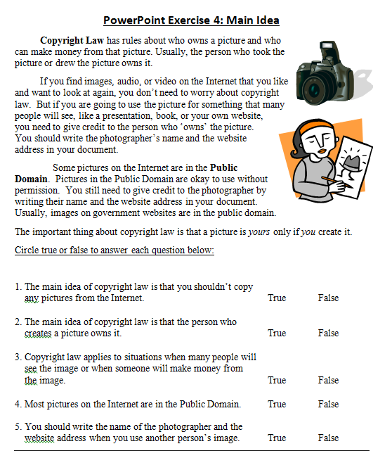

Step 3: Controlled practice

Hand out **PowerPoint Exercise 4: Main Idea**

**Instruct** learners to read through the passage and try to answer questions

Review the questions when everyone is done reading; be sure to ask students why question is true/false

* Question 1 Main idea: pictures on the internet are put there by someone who “owns” the picture on his or her computer and they should be given credit for those images

**Answers:**

1. F=Main idea: pictures on the internet are put there by someone who “owns” the picture on his or her computer and they should be given credit for those images
2. T
3. T
4. F
5. T

**Day 3 Warm-up**

Directions: Read each passage. Then circle the title that best fits each passage.

1. A number of recent books with titles like Raising Cain, Real Boys, and Lost Boys all focus on the same issue: Today’s teenaged boys are feeling more anxiety than ever before about their physical appearance. Bombarded by advertising featuring well-muscled, semi-clad young men, teenage boys are experiencing what teenage girls have been coping with for years. They are afraid that they cannot possibly live up to the media’s idealized image of their gender. Young boys below the average in height, weight, or both suffer the most. Often, they are brutally teased by their brawnier peers. Some react to the ridicule by heading for the gym and lifting weights. Yet even those who successfully “bulk up” don’t like feeling that they are considered worthless if they lose their hard-won muscle tone. Others, convinced that no amount of body building can help, often withdraw from social contact with their peers. This is their way of avoiding taunts about their size or shape. Still, they are understandably angry at being badly treated because of their body type. Although school psychologists generally recognize that boys today are having severe body image problems, they are at a loss about what to do to solve those problems.

Title?

* 1. Body Building
  2. Male Self Image

1. In 1997, the U.S. Consumer Products Safety Commission reported that skateboarding injuries were up by 33 percent. Mountain climbing injuries were also up by 20 percent. Similarly, snowboarding injuries showed an increase of thirty-one percent. By all accounts, many Americans are having a love affair with risky sports; as a result, they are injuring themselves in ever greater numbers. One reason for the growing participation in risky, or extreme, sports has been put forth by Dan Cady, a professor of popular culture at California State University. According to Cady, previous generations didn’t need to seek out risk. It was all around them in the form of disease epidemics, economic instability, and global wars. At one time, just managing to stay alive was risky, but that feeling has all but disappeared, at least for members of the privileged classes. To a degree Cady’s theory is confirmed in the words of adventure racer Joy Marr. Marr says that risk has been “minimized” in everyday life, forcing people to seek out challenges in order to prove themselves. (Source: Karl Taro Greenfield. “Life on the Edge.” Time. September 6, 1999, p.29).

Title?

a. The Constant Hunger for Risk

b. Sports

Copy, Cut and Paste

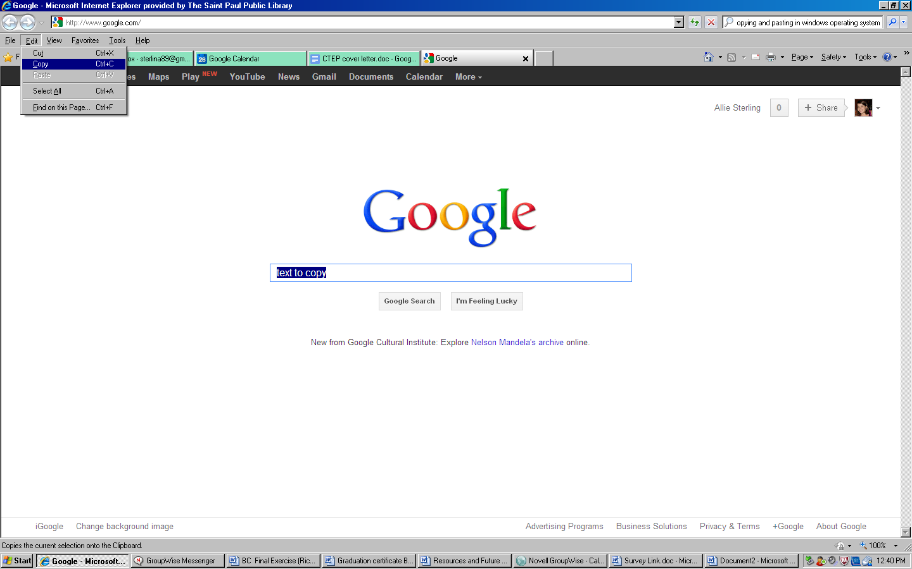To **copy** text (i.e. make a copy of a selection of text to repeat elsewhere on the screen):

1. Highlight text you want to copy by clicking before the word and dragging across the word.
2. 3 options for copying:
   1. Right-click on the highlighted word, click on “Copy” using left mouse button.
   2. Click on the Edit Menu at the top of the window, and then click on “Copy.”
   3. Press and hold the “Ctrl” key on the keyboard and then press “C”.

To **cut** text (i.e. to remove text from one location and place it in another location on the screen):

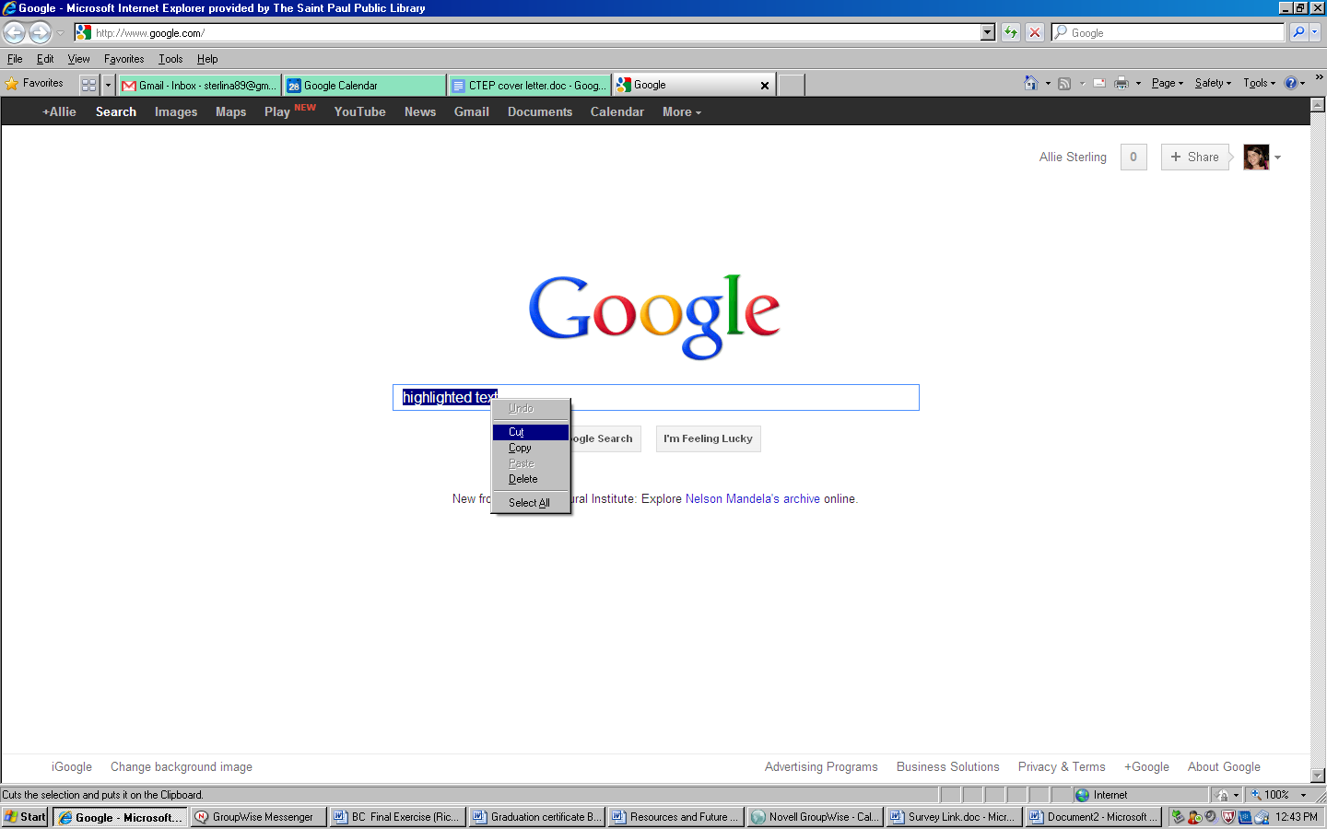

1. Highlight text you want to cut by clicking before the word and dragging across the word.
2. 3 options for cutting:
   1. Right-click on the highlighted word, click on “Cut” using left mouse button.
   2. Click on the Edit Menu at the top of the window, and then click on “Cut.”
   3. Press and hold the “Ctrl” key on the keyboard and then press “X”.

To **paste** text (i.e. to place text you have either cut or copied from elsewhere on the screen in a new location):

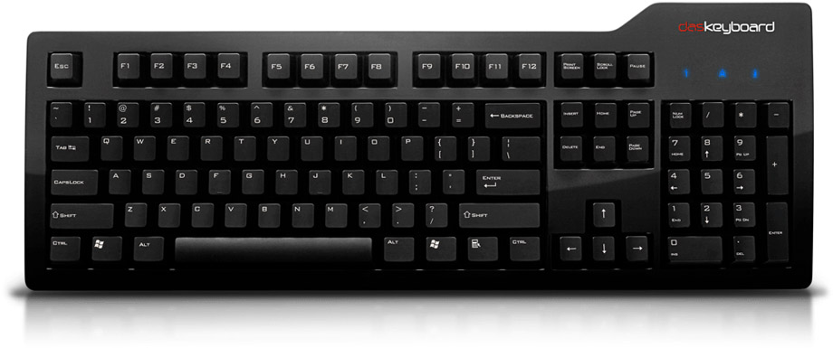

1. Place the cursor where you would like the copied text to appear.
2. 3 options for pasting:
   1. Right-click on the spot you want the text to appear, click on “Paste” using the left mouse button.
   2. Click on the Edit Menu at the top of the window, and then click on “Paste.”
   3. Press and hold the “Ctrl” key on the keyboard and then press “V”.

**PowerPoint Exercise 3: Finding Images**

In this exercise you will learn how to find images on the internet.



1. **Minimize** PowerPoint
2. 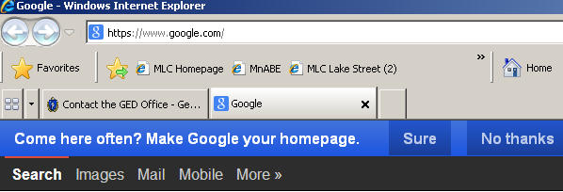**Open** Internet Explorer
3. **Type** google.com into the address bar
4. **Click** on **IMAGES**
5. **Click** in the search box. Type “envelopes”. **Press the ENTER key.**
6. You will see many pictures of envelopes, find a picture you like
7. **Right-click** on the picture
8. **Click** on **copy**
9. **Minimize** the internet screen
10. If PowerPoint is not already open, **click** on PowerPoint in the taskbar to open the program
11. **Click** on Slide 4
12. **Right –click** in the slide
13. **Click** on paste
14. Your picture should now appear in your slide
15. Follow these steps to **paste a picture into Slide 5**

**PowerPoint Exercise 4: Main Idea**

MCj03968360000[1] **Copyright Law** has rules about who owns a picture and who can make money from that picture. Usually, the person who took the picture or drew the picture owns it.

MCj02822920000[1]If you find images, audio, or video on the Internet that you like and want to look at again, you don’t need to worry about copyright law. But if you are going to use the picture for something that many people will see, like a presentation, book, or your own website, you need to give credit to the person who ‘owns’ the picture. You should write the photographer’s name and the website address in your document.

Some pictures on the Internet are in the **Public Domain**. Pictures in the Public Domain are okay to use without permission. You still need to give credit to the photographer by writing their name and the website address in your document. Usually, images on government websites are in the public domain.

The important thing about copyright law is that a picture is *yours* only if *you* create it.

Circle true or false to answer each question below:

1. The main idea of copyright law is that you shouldn’t copy

any pictures from the Internet. True False

1. The main idea of copyright law is that the person who

creates a picture owns it. True False

1. Copyright law applies to situations when many people will

see the image or when someone will make money from

the image. True False

1. Most pictures on the Internet are in the Public Domain. True False
2. You should write the name of the photographer and the

website address when you use another person’s image. True False