**Internet Day 3**

|  |  |  |
| --- | --- | --- |
| **Objectives** *Learners will be able to…* | **Materials** | |
| ***Computer skill:*** *identify key words for an internet search*  ***Computer skill:*** *identify domain extensions*  ***Computer skill:*** *CTRL+ to make text bigger*  ***Literacy skill:*** *summarizing* | **Make Student Copies**   * **Internet Exercise 3: Internet Search (Tab 9)** * **Summarizing Practice Activity (Tab 10)**   **Props, Technology or Other Resources**   * Projector * Computer for every student | |
|  | | |
| **Lesson Plan** | | Vocabulary |
| **Warm-up: 15 minutes maximum**  Description: Pair students up making on person partner A and one partner B. Teacher will ask either Partner A or Partner B to locate something on the computer/internet, and then the teacher will ask the other partner to explain what it does  **A action:** Point out where to go to open the internet*. B verbal answer*. What is an internet browser?  **B action:** Point out the address bar. *A verbal answer*: What does it do?  **A action:** Point out the back button. *B verbal answer*: What does it do?  **B action:** Point out the forward button. *A verbal answer.* What does it do?  **A action:** How do I refresh a page?  **B action:** How do I stop a page from loading?  *A verbal answer:* What is the first page that is seen when opening the internet called? *Home page*  **B action:** What button can you click to take you home from wherever you are in the internet? *Home button*  **Activity 1: Web Addresses/Domain Extensions 15 minutes**  Description: learners will identify different domain extensions  Materials/Prep:  **Activity 2: Intro to Google 15 Minutes**  Description: exploration of Google’s main page features  Materials/Prep:  **Activity 3: Internet Search**  Description: explanation of key word searches and basic search skills  Materials/Prep: copies of **Internet Exercise 3: Internet Search**  **Activity 4: Intro to Summarizing**  Description: learners get brief intro to how to summarize  Materials/Prep: copies of **Summarizing Practice Activity** | | * Domain Extensions * .gov * .edu * .com * .org * Search Engine * Scanning |

**Teacher Directions: Activity 1: Web Addresses/Domain Extensions**

Step 1: Review

**Review** how to open Internet Explorer

**Review** where to type a **web address** or **URL- address bar**

Step2: Introduction of Topic

Write on board/type into word and project the following:

* [www.google.com](http://www.google.com)
* [www.google.comm](http://www.google.comm)
* [www.mnliteracy.org](http://www.mnliteracy.org)
* ww.bbc.c.om
* [www.umn.edu](http://www.umn.edu)
* [www.umn@ com](http://www.umn@gmail.com)

**Ask** learners which of these are websites-1, 3, 5

**Discuss why** the others are not websites?

**In regard** to the 4th address, **remind** learners to be careful and double/triple check the web address they type in before hitting enter. The browser needs an exact website in order to get you to where you are going-*just like typing an address into a GPS or other navigation system or plugging in a phone number*

Step 3: Web address says a lot

**Ask** learners what they notice about the real web addresses/differences- **end of the address=domain extension, .org, .edu, .gov**

**Explain** that web addresses say a lot about the website you are going to

**Ask** if anyone has any idea what a URL that ends with “.edu” might say about the website- *it is from a school*

**Ask** about “.org”- The domain extension was originally created for non-profits, but today it is commonly used by schools, open-source projects, communities, and for-profit entities

**.com-** COM - This domain is intended for commercial entities, that is  
companies.

**Additionally:** .gov- This domain was originally intended for any kind of government  
office or agency.

Step 4: Demonstrate why useful

**Demonstrate** doing an internet search- type google.com into the address bar>search “population of Minnesota”

**Show** the results of the search

**Explain** that Google uses code to find websites that have information you are looking for, we will be practicing with this in the next activity

**Demonstrate** how to **zoom in on the page** to increase the size of text- CTRL +

**Explain** that not all of these websites will have valid information, but you can look at the domain extension and get an idea of the validity

**Example:** When searching for population, think about who does the census? The government, so we would be looking at .gov

**Example:** If we were looking for the side effects of lack of sleep, you might look for an .org or .edu site

**Demonstate** where to find the URL in a search

**Ask** if anyone sees a .gov website

**Teacher Directions: Activity 2: Intro to Google**

Step 1: Set-up

**Explain** that students need to remember those extensions for this activity

**Instruct** learners to type “google.com” into the **address bar**

**Explain** that Google is a **search engine-**software code that is designed to search for information on the World Wide Web, and there are other search engine options

**Ask** if anyone knows of any other search engines- Bing, Yahoo!

**Explain** that just like **web browsers**, each search engine is a little different and learners can take time on their own to determine which they like best, but we will be using Google

Step 2: Introduction to and exploration of Google

Ask students to explore the main page

* **Search bar is NOT the address bar**
* Navigation bar- this feature will be explained again during Day 4, but it is good to point it out now
  + Images
  + News
  + Example: if you know you are looking for news about a specific city, click on news
  + If you want directions, click on maps

**Teacher Directions: Activity 3: Internet Search -Internet Exercise 3: Internet Searches**

Step 1: Key Words

**Explain** that when completing an Internet search, it is important to think about the information you are seeking, and then pick key words to type into the search box

**Demonstrate examples:**

1. Do not type in a full question-no need
2. Explain opening a link
3. Explain using the back button to get back to Google page

**Examples:** What is the population of Minnesota? Type in “Population of Minnesota”

What are the effects of lack of sleep? Simply type in “Lack of sleep”

**Explain** that identifying key words takes practice

Step 3: Controlled Practice

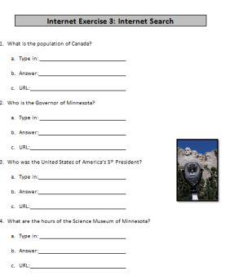 Hand out **Internet Exercise 3: Internet Search**

Go over the first 3 examples with the class

**Demonstrate** determining key words, typing into Google, finding an appropriate source, locating the information

**POINT OUT** that the cursors change depending on what it is hovering over, **show how it changes to a hand when over an URL**

**Note:** All sources should be .gov or .org

Website validity will be discussed more in depth during Day 4

Step 4: Individual Practice

Learners should now attempt to complete the exercise on their own

Circulate to assist learners

**Leave 25 minutes for the final activity**

The goal of this exercise is to practice with key words and locate URLs

If students do not finish, that is OKAY, some will get further than others, you need to leave time for final activity

Step 5: Review Answers

Take a few minutes to go over the answers learners found in their search

**Ask** learners if there was anything consistent about what they omitted when typing into Google? *Who, What, intro to the question*

**Teacher Directions: Activity 4: Intro to Summarizing –Summarizing Practice Activity**

Step 1: Context and definition

**Explain** that when working on the internet, often you will see a lot of information

It is important to be able to **summarize**

**Ask** learners what is means to **summarize:** give a brief statement of the main points of (something). It does not include details. It is a long text cut down to the bare essentials

Step 2: Examples

**Explain** that summarizing is one of the most difficult literacy skills to master, but it is incredibly important to learn

**Example:** Ask learners how long X-movie is (example, Titanic, Avatar, a recent release). If someone asks you to tell them about the movie, are you going to take 2/3 hours to explain? No, you are going to give a short summary **that includes the main plot points**

Step 3: Demonstrate

Write on the board in a column Who, What, Where, When, Why?

Teacher use a movie as an example and summarize, try to pick something many students have seen (use previous examples, or a suggestion from the class)

Write the answers next to the questions, and the basis for the plot should become clear

Do they get the idea? That’s summarizing

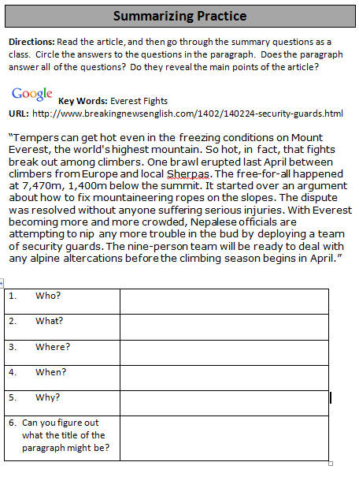Step 4: Controlled Practice

Explain that articles online are often quite long, and you do not always have time to read the whole thing

Hand out **Summarizing Practice Activity**

Go through exercise as a class

**Title of paragraph*:*** *Mount Everest security guards to stop fights*

**Internet Exercise 3: Internet Search**

1. What is the population of Canada?
   1. Type in:
   2. Answer:
   3. URL:
2. Who is the Governor of Minnesota?
   1. Type in:
   2. 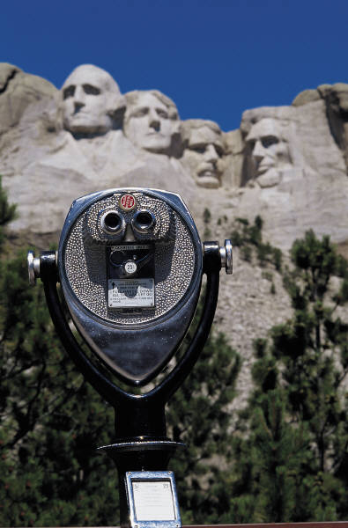Answer:
   3. URL:
3. Who was the United States of America’s 5th President?
   1. Type in:
   2. Answer:
   3. URL:
4. Where is the Minnesota Science Museum located?
   1. Type in:
   2. Answer:
   3. URL:
5. What is the current Billboard #1 song?
   1. Type in:
   2. Answer:
   3. URL:
6. What is the surface area of Malta?
   1. Type in:
   2. Answer:
   3. C:\Program Files\Microsoft Office\MEDIA\CAGCAT10\j0285750.wmfURL:
7. When was the first computer created?
   1. Type in:
   2. Answer:
   3. URL:
8. Who created the first computer?
   1. Type in:
   2. Answer:
   3. URL:

**Summarizing Practice**

**Directions:** Read the article, and then go through the summary questions as a class. Circle the answers to the questions in the paragraph. Does the paragraph answer all of the questions? Do they reveal the main points of the article?

 **Key Words:** Everest Fights

**URL:** http://www.breakingnewsenglish.com/1402/140224-security-guards.html

“Tempers can get hot even in the freezing conditions on Mount Everest, the world's highest mountain. So hot, in fact, that fights break out among climbers. One brawl erupted last April between climbers from Europe and local Sherpas. The free-for-all happened at 7,470m, 1,400m below the summit. It started over an argument about how to fix mountaineering ropes on the slopes. The dispute was resolved without anyone suffering serious injuries. With Everest becoming more and more crowded, Nepalese officials are attempting to nip any more trouble in the bud by deploying a team of security guards. The nine-person team will be ready to deal with any alpine altercations before the climbing season begins in April.”

|  |  |
| --- | --- |
| 1. Who? |  |
| 1. What? |  |
| 1. Where? |  |
| 1. When? |  |
| 1. Why? |  |
| 1. Can you figure out what the title of the paragraph might be? |  |