Internet: Day 10

Today learners will take the TABE test. This is a literacy test that is required of all students that are involved in Open Door programming, even computer students. Do not mention this test until 720 at the earliest, because students will get distracted from the activity at hand.

Learners will also take a Digital Literacy assessment, which will assess their skills with specific internet programs. Yes, they must take both the TABE and the North Star, they are requirements for the class.

There might come a point in the year when certain students do not have to take the TABE test, this will be rare. If that happens, instruct them to continue their research project during TABE testing time.

Objectives Learners will be able to… | Materials
Computer skill: locate hyperlinks  Computer skill: internet search  Literacy Skill: TABE Assessment | Make Student Copies  - Scavenger Hunt (Tab 26)  - Internet Search Summary- only for students who do not take assessment (Tab 23)  Props, Technology or Other Resources  - Projector  - Computer for every student
Lesson Plan | Vocabulary
Activity 1: Scavenger Hunt-50 minutes  This activity must be finished 50 minutes into class. That allows for a 10 minute break and leaves proper time for the TABE test.  Description: learners will complete an online scavenger hunt which will practice the skills they have learned up to today  Materials/Prep: copies of Scavenger Hunt  Activity 2: TABE Literacy Assessment-60 minutes, ask coordinator if you have questions about the time needed for assessment  Description: learners will take the TABE Literacy Assessment  Materials/Prep: obtain TABE Assessment Packets from coordinator | - Hyperlinks  - Wikipedia

Teacher Directions: Activity 1: Scavenger Hunt -Scavenger Hunt

Step 1: Set-up
Explain that learners are going to be given a handout that will ask them to find information online
Learners are encouraged to work in pairs

Step 2: Get to Wikipedia
Instruct learners to close out of anything they have open until they get to their desktop screen
Ask learners how to open the internet USING VOCABULARY WORDS: click on an internet browser
Ask where you would type in a web address: address bar
Instruct learners to go to Wikipedia.org=best if you can write or project this on the board
Have everyone click on English

Step 3: Review of what Wikipedia is
Ask if anyone remembers what Wikipedia is: free, online encyclopedia that anyone can edit
Ask if anyone sees a space to search, the search bar
Explain that today’s activity requires moving around articles in Wikipedia
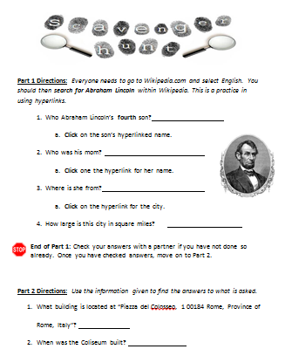
Step 4: Practice as a class
Hand out Scavenger Hunt
Do number one together
Explain the “contents” section, it allows you to find information faster

Step 5: Independent Practice
Instruct learners to practice on their own, but ask questions when they have them
Circulate to assist learners
Be sure they are checking answers with a partner

Note: If students do not finish in the 50 minutes allotted, that is OKAY. They MUST take the TABE assessment.

BREAK: Be sure to give students a 10 minute break before the assessment. During this time they should put their computers away. EXCEPTION: Any students that do not have to take the assessments, those students should continue their research project.

Teacher Directions: Activity 2: TABE Literacy Assessment

Step 1: Introduce TABE
Learners will take the TABE literacy test.
- Why? Open Door is a Literacy organization, so we have to incorporate literacy into all of our classes. MLC is required to give learners these tests in order to receive funding.
- Learners have 50 minutes to take the test
- Phones must be turned off and there will be no conversation between classmates
- Computers must be put away
- Exception: learners who do not have to take the assessment, those learners should be moved to the back of the class, with the TABE takers in front
- Learners who take the test need to start on the page the answer key is in
  - There might be sample questions, those should not be answered. Start with the first REAL question

Potential Questions that may arise:
Do I have to take it? Yes. These tests are required of learners enrolled in Open Door Learning Center classes.
What can I do when I am finished? Once finished learners can either work on Mavis Beacon Typing or leave for the day.

Students who do not take assessment: Review with them, quietly, how to login to Schoology.com. Hand out Internet Search Summary.
Username: odcompr#@gmail.com (# should be their computer number, not the pound symbol)
Password: Opendoor
Click on Courses>Click on Computers and Literacy>Click on Internet>Click on Day 10 Research Practice
Instruct learners to read through the directions and complete the assignment.

Part 1 Directions: Everyone needs to go to Wikipedia.com and select English. You should then search for Abraham Lincoln within Wikipedia. This is a practice in using hyperlinks.
- Who was Abraham Lincoln’s fourth son?
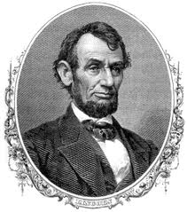
  - Click on the son’s hyperlinked name.
- Who was the son’s mom?
  - Click one the hyperlink for her name.
- Where is she from?
  - Click on the hyperlink for the city.
- How large is this city in square miles?
End of Part 1: Check your answers with a partner if you have not done so already. Once you have checked answers, move on to Part 2.

Part 2 Directions: Use the information given to find the answers to what is asked by searching Wikipedia.
- How tall is Minnehaha Falls?
- How does Minnehaha translate to English?
- Minnehaha Falls became a tourist destination after the publication of what?
- Who wrote that poem?
- What year was this poem written?
End of Part 2: Check your answers with a partner if you have not done so already. Once you have checked answers, move on to Part 3.

Part 3 Directions: This is the final portion of the scavenger hunt. Go to a search engine to seek out the answers to these questions. There is no one correct answer!
- Search for one fact about computers that you never knew before.

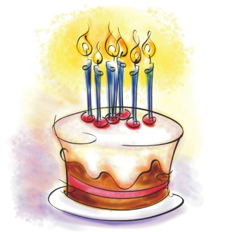
- Search for one historical event that happened in your birthday. What is the event?

Internet Search Summary

Write Research topic here:

Write the URL here (only write up to the domain extension):

- Who?
- What?
- Where?
- When?
- Why?
- Summarize in one sentence what you learned in this article:

PART 2:
- Open Day 7 Research Summary exercise in Schoology.
- In a comment, post the summary you developed in #6. Begin the post with your name and research topic.

