Excel Day 6

Objectives Learners will be able to… | Materials
Computer skill: use merge and center  Computer skill: use the sum function  Literacy skill: label cells | Make student copies:  - Excel Exercise 9 (Tab 13)  Props, Technology or Other Resources  - Projector  - Computer for every student  - USB Drives
Lesson Plan | Vocabulary
Warm-up: 10 minutes  Description: Ask learners what a budget is? What are expenses? What is income? Give some examples. What button is pressed to turn a numeric amount into a monetary value? Is currency qualitative or quantitative data? What kind data would be considered qualitative? If I am collecting data about a population, what am I doing? (Taking a survey)  Materials/Prep:  Activity 1: Labeling Budgets  Description: learners will put a budget in order  Materials/Prep: make one copy of Excel Exercise 9 and cut along the dashed lines, extra space is provided between categories for cutting. The monetary values should be but separated from the category, they should be cut into long strips  Activity 2: Merge and Center  Description: demonstrate how to use the merge and center button  Materials/Prep:  Activity 3: Auto sum Function  Description: learn how to use the auto sum function and learn the difference between static and dynamic cells  Materials/Prep: | - Merge and center  - Sum  - Static  - Dynamic  - Formula

Teacher Directions: Activity 1: Labeling a Budget -Excel Exercise 9
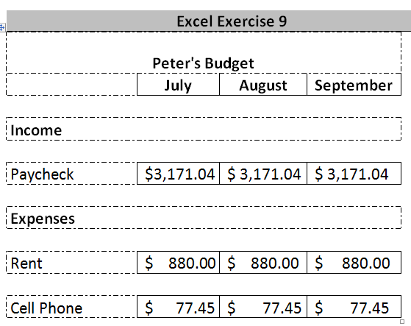
Step 1: Explain Activity
Excel Exercise 9 should be printed out and cut up into parts as marked by the dotted lines (should be in long strips, example; Paycheck strip should include the monetary values) Extra space is provided just for cutting
Keep the labels: expenses, income, Peter’s Budget
Tape the labels to the board, leaving room for the appropriate information underneath
Keep one category; distribute the rest to the learners
Explain that everyone has received part of a budget and they will need to place, one by one, each part of the budget to the board

Step 2: Model Activity-IMPORTANT
Model for the class how they should go about completing the activity.
Ask the learners where your category should be placed

Step 3: Complete Activity
Learners should come up one at a time to place their category under the appropriate label
Order of categories does not matter, just be sure to place under expense or income accordingly

Step 4: Turn into a spreadsheet
Once the data is organized correctly, learners should enter this data into a spreadsheet
Learners should ignore the label “Peter’s Budget” for now and start with income
Individually instruct slower typist to only enter information for July
Circulate to check and assist

Step 5: Save and keep open
Review how to save the file
Save or Save As, Why; Save As, new spreadsheet, never saved before
Do not close

Teacher Directions: Activity 2: Merge and Center

Step 1: Point out top label
Point out the Peter’s Budget label
Ask what this is labeling: the whole spreadsheet, tells you what it is

Step 2: insert a row above income
Ask learners how to insert a row above the Income row
Click on 1>right click>click on Insert

Step 3: Demonstrate Merge and Center
Learners should have EYES FORWARD AND HANDS OFF OF THEIR COMPUTERS
Highlight the cells that sit above the budget
Ask learners how you can locate buttons on the toolbar without clicking on them all: hover over to see what it does
Locate the merge and center button, click on it
Type “Peter’s Budget”- it should be centered above the budget
Ask learners how to make the label bold

Step 4: Controlled Practice
Work with learners to insert this label into their own spreadsheets

Step 5: Save
Learners should save the updates

Teacher Directions: Activity 3: AutoSum Function

Step 1: Goals of a budget
Ask learner what some goals of budgeting are: keep track of how much you are spending in relation to what you are making
Explain that an important part of that is seeing the total amount of money spent in a specific month, week or year

Step 2: Introduce Sum function
Ask how someone might total the amounts spent in our current budget?
Excel offers a tool to total everything for you
Write sum on the board
Ask if anyone knows what sum means: the total
Write 2+2 on the board; explain the sum of these two numbers is…

Step 3: Locate sum function
Ask learners how you can tell what a button on the toolbar does without clicking on it: hover over it
Ask learner to locate a button that tells you it will find the sum of the numbers

Step 4: Demonstrate how to use it
Learners should have EYES FORWARD AND HANDS OFF OF THEIR COMPUTERS
Demonstrate click and drag to select all of the cells you want totaled, click the auto sum button and the total will appear below those cells

Step 5: Static vs. Dynamic Cells
Click on the cell with the total in it
Ask learners what it says in the formula bar: shows the formula
Explain that because Microsoft realized how often people will need to find the sum, they created a button that creates the equation for you
Explain that this cell is a dynamic cell: there is more to it that just a number
Click on the cell for rent: what you see in the cell is the same in the formula bar: this information is static

Step 6: Controlled Practice of Sum Function
Learners can now use their computers
Go through using the sum function as a class step by step

Step 7: Insert row for Income sum
Explain that you want the sum for the income as well in order to compare numbers
Ask learners how to insert a row below the list of income
Click on row number below (they are inserted above), right click, click on insert
Instruct learners to use the sum formula to find total income

Step 8: Review
Click on different cells and ask if it is dynamic or static
What inferences could be made about Peter from this budget?

Excel Exercise 9
Peter's Budget
 | July | August |  |  |  | September
Income
Paycheck | $3,171.04 |  | $ 3,171.04 |  |  |  | $ 3,171.04
Dividends | $ 120.00 |  |  | $ 120.00 |  |  | $ 120.00
Expenses
Rent | $ 880.00 |  |  | $ 880.00 |  |  | $ 880.00
Cell Phone | $ 77.45 |  |  |  | $ 77.45 |  |  | $ 77.45
Car Payment | $ 151.29 |  |  |  | $ - |  |  | $ -
Netflix | $ 17.84 |  |  |  | $ 17.84 |  |  | $ 17.84
Savings | $ 550.00 |  |  |  | $ 550.00 |  |  | $ 550.00

