During Day 2 you will be proctoring the North Star Digital Literacy pre-assessment.
All the of the computers that learners use need to be registered (per direction on the North Star site) for the assessment,
- This can take anywhere from 20-40 minutes depending on the number of students and number of volunteers/coordinators who are setting the assessment up.
- REGISTER THE COMPUTERS BEFORE CLASS BEGINS
  - Use the computer sign-in sheet that was filled out Day 1 to determine which computers students are using and pull them out of the COW
DO NOT PRE-TEST STUDENTS IF (Use Computer Use Questionnaires to see what kind of experience learners have with computers):
- They are very uncomfortable with the computer
- You feel taking the assessment will overwhelm them (happens with brand new computer users)
Learners who do not take the pre-assessment can:
- Log in to Mavis Beacon and practice typing
  - If they seem to need help with the mouse, help them get to http://www.skyways.org/central/mouse/page1.html , which is a mouse usage practice site (mouserobics)
Students who come in late: Determining whether or they have time to take the assessment without cutting too much into class time depends on a few things:
DO pre-test them if:
- You feel you have time to register their computer
- They have a basic knowledge of the computer
- They took the previous unit
Do NOT pre-test them if:
- They come more than 10 minutes into the testing period
- They are not familiar with the computer
- They come in late and you are busy setting up learners who showed up on time and are not taking the assessment
*****One way to ensure you get to the tests quickly is by having all of the computers registered before class begins. This takes prep time, but saves important class time. ********
Excel Day 2

Objectives Learners will be able to… | Materials
Review:  Computer skill: identify parts of a spreadsheet  Computer skill: enter information into cells  New:  Computer skill: navigate cells  Computer and Literacy skill: identify parts of a table  Literacy skill: scanning | Make Student Copies  - Excel Exercise 2: Screen Fill-to be completed as students finish the assessment (Tab 4)  Props, Technology or Other Resources  - Projector  - Computer for every student  - USB Drives  - North Star How-To (Tab 23)
Lesson Plan | Vocabulary
Warm-up:  Description: Ask students how to open Excel: three ways (desktop icon, start menu, all programs)  Ask students what type of document is created in Excel: spreadsheet  Ask students what spreadsheets are made up of: cells  Ask students where the formula bar is  Ask students where cell B4 is?  Materials/Prep:  Activity 1: North Star Digital Literacy Assessment  Description: students will take a pre-assessment to determine baseline knowledge of computer skills  Materials/Prep: all computers must be registered before class begins, follow directions on the North Star How-To (Tab 23), download page 4 of this lesson to show what a test screen looks like  Activity 2: Intro to Tables  Description: go over basic Excel vocab and then learners will complete a screen fill activity  Materials/Prep:  Activity 3: Input data into cells and navigate cells  Description: Practice entering data into cells  Materials/Prep: | - Table  - Labels  - Columns  - Rows  - Cell  - Formula Bar  - Arrow Keys  - Enter  - Tab

Teacher Directions: Activity 1: North Star Digital Literacy Assessment
-Excel Exercise 2: Screen Fill
Step 1:
Take this time to explain the Windows 7 North Star Digital Literacy Assessment and its purpose:
This can be read verbatim to the students: The North Star Digital Literacy Assessment has set the standards of what it means to be knowledgeable about different aspects of the computer. The purpose of this assessment is to provide learners with a standard with which everyone learns the computer to ensure that they will be successful outside of the classroom. The pre-assessment is meant to inform the teacher of what you know already and then we can see how you improve at the end of the class. If you pass the assessment with an 85% or higher, you will receive a certificate that proves your competency at the unit you were tested on. These certificates can also be presented to employers as proof of your computer skills when you apply for a job.
With this pre-assessment it is okay if you do not know anything. If you do not know the answer to a question, you are given the option to simply answer “I do not know” or you can take a guess. You are encouraged to guess on this assessment.

Step 2: How the assessment works
This can be read verbatim to the students: When it is time to begin, students will open the assessment titled Windows. The assessment begins with a test of the speakers. If you hear the piano playing, you will use your mouse to click the “Next” button.
Explain that if that student does not hear the piano playing, they can look above their keyboard at and they will see three buttons on the right. These are the volume buttons, one to turn down volume, turn it up, and turn it off.
Next, North Star will go through an orientation of how the assessment works. Each question asked in the assessment will be a function of the program, so your answer to the question will be performing that function. BE CAREFUL not to simply click when the page comes up because the assessment will read that as your answer and you cannot go back.
Teacher should pull up the Screen Shot page and review it with the students.

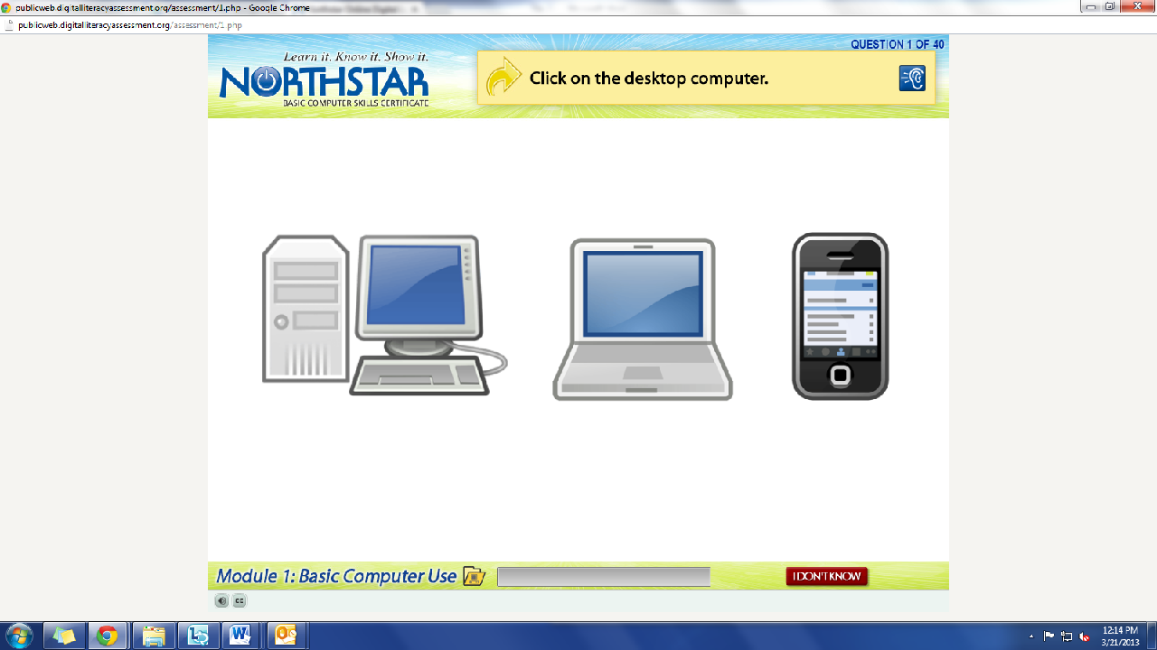
What is the question begin asked?
How do we answer it? We click on the answer.
You must listen carefully to the question being asked so that you know how to answer it.
Review Question: Which operating system is on this computer?
If you miss the question when it is read, you can either read it on the top of the page, or click the on the blue ear and it will read the question again.
If you do not know and do not want to guess, but once you click it, it will ask you if you are sure you want to skip the question, you have to answer “Yes” to move on. You are, however, encouraged to guess.

Step 3: Learner Code of Conduct
Read the Learner Code of Conduct to the students:
- Learner must listen carefully to all instructions given by proctor
- Learner must treat others with courtesy and respect during assessment process
  - This means no talking to each other during the assessment, if you have a question ask the proctor. If a learner finishes early, they must remain quiet until everyone is finished
- Learner should ask questions prior to the assessment if they are uncertain about the certification process
- Learner is responsible for his or her certificate: if the certificate is lost, s/he will have to retake the assessment
- Learner should inform the proctor if he or she believes that assessment conditions affected his or her results
Ask if there are any questions
Explain that the questions will be read aloud to them, so students need to be sure they are listening carefully. If they miss the question, is it also written at the top of the page.

Step 4: Take Windows 7 Assessment
If there are no questions, learners should scroll down the testing page and click on the Windows 7 Assessment
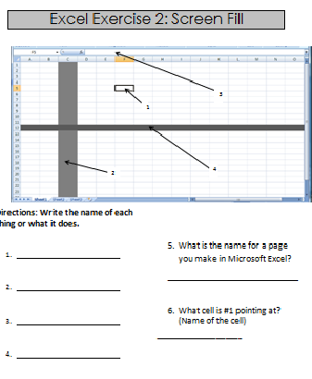
If students are frazzled during the test because they missed the reading of the question, there is a blue square in the top right corner with an ear in it. When it is clicked the question is read again

Step 5: After the assessment
As learners finish the assessment, hand out Excel Exercise 2: Screen Fill and instruct learners to work on it
If they finish that before others learners are done with the assessment, students should open up Mavis Beacon and practice typing.

Teacher Directions: Activity 2: Reading Tables, Charts and Spreadsheets
Step 1: What is a table?
Draw a blank table on the board (to the side so that you can project next to it)-4 rows, 3 columns
Explain that students may have heard this called a chart, table or spreadsheet
Ask students where they have seen them before? Bus schedules, time sheets, schedules, nutrition information, etc.

Step 2: Spreadsheet organization
Fill in the table with data
Example (draw exactly as drawn below, with blank spaces)
John Doe | 651-111-1111 | jdoe@gmail.com
Lady Girl | 651-121-1111 | ladygirl@gmail.com
Barack Obama | 651-111-1111 | bobama@yahoo.com
Ask learners how many rows and columns there are?
Ask learners what the information in second column has in common? All phone numbers
Ask about column 3: email addresses

Step 3: Labeling information
Ask how that information could be clear as soon as someone looks at the chart? Label it
Explain that labels keep your information organized and present it neatly to anyone who views it
Ask learners where to put the label “Phone Numbers”: above column 2

Step 4: Introduce Scanning
Explain that if information is organized and labeled well, it will allow the person reading it to find information quickly

Teacher Directions: Activity 3: Entering information into a spreadsheet
Step 1: Open Excel Spreadsheet
Review how to open a new Excel Spreadsheet

Step 2: Review naming cells
Click on a cell and ask learners how they would refer to the cells: column letter then row number

Step 4: Review entering data
Click on the desired cell>Type the name
Learners should put John Doe into cell A2

Step 5: Navigating Cells
Take a few minutes to point out how to move from cell to cell
- Arrow keys
- Tab
- Enter key

Step 6: Entering Data
With remaining time, have learners enter the data from the table that was created previously
Circulate to check progress
***Learners do not need to save, if you have time to introduce saving and pass out USB drives that is fine.***

North Star How-To
Teacher A- Generating Codes:
1. Go to https://www.digitalliteracyassessment.org/admin
2. Login information:
3. PLEASE SEE YOUR SITE COORDINATOR FOR NORTH STAR LOGIN INFORMATION!
4. Select your name from the drop-down menu
5. Click Submit
6. Click on Generate User Codes
7. Simply type in students’ names and a click enter
8. The code next to their name will be used to register their computer
Teacher B- Registering each computer:
1. Turn on student computers
2. Go to digitaliteracyassessment.org/assessment/proctored
3. Username: SEE YOUR SITE COORDINATOR
4. PIN: SEE YOUR SITE COORDINATOR
5. Type in student’s name and then enter the code you got from Part 1
6. Click Confirm and Start
7. Minimize the page
8. Instruct students not to close out of any programs you have opened on their computer
Note: As you spend more time in the classroom you get to know the students who show up early and who show up late. Register the students who usually show up early as soon as you arrive, that way they can begin typing as soon as they get to class.
Excel Exercise 2: Screen Fill

4
3
2
1

Directions: Write the name of each thing or what it does.

- What is the name for a page you make in Microsoft Excel?
____________________________

- What cell is #1 pointing at? (Name of the cell)
____________________________

