Email: Day 8

Objectives Learners will be able to… | Materials
Computer skill: send emails to multiple recipients  Computer Skill: reply all  Computer skill: reply versus reply all etiquette  Literacy Skill: determining tone (in order to decipher between using reply and reply all) | Make Student Copies  - Email Exercise 9: Email Etiquette-2 per page, print one for every 2 students (Tab 19)  Materials Needed  - Day 8 SWAT Warm up (Tab 20)  Props, Technology or Other Resources  - Projector  - Computer for every student
Lesson Plan | Vocabulary
Warm-up:
Description: class will need to be divided into two teams. Each team will send one member up to the board, the teacher will ask a question and the first learner that hits the right answer gets a point for their team. Then another member for each team come up to the board until you run out of questions
Materials/Prep: Print out SWAT Questions and SWAT Pictures, cut apart the pictures and tape each one to the board, you will also need two fly swatters (or two white board markers/erasers)

Activity 1: Sending Emails to Multiple Recipients
Description: teach learners how to send emails to many people
Materials/Prep:

Activity 2: Reply versus Reply All
Description: learners will take some time to explore the appropriate time to use Reply All
Materials/Prep: copies of Email Exercise 9: Email Etiquette

Teacher Directions: Activity 1: Sending Emails to Multiple Recipients
Step 1: Set-up
Explain that many times it might be beneficial to send one email to many recipients
Ask learners what a recipient is: the person who receives information, emails, etc.
Email allows us to share with many people, using one simple piece of punctuation; a comma

Step 2: Demonstrate
Demonstrate sending an email to multiple people: you do not need to use real email addresses
Explain that you must include a comma between each email address

Step 3: Controlled Practice
Instruct learners to send an email to themselves and the teacher email address
Work through this with them
Remind them to check spelling and add a comma between the addresses
Explain that just this once, they do not need to include the necessary parts of an email, because we are simply practicing sending to many recipients

Teacher Directions: Activity 2: Reply versus Reply All

Step 1: Context
Explain that when someone sends out an email to multiple recipients, there is an option to “Reply All”
Explain that is can be found in the same area as Reply and Forward
Reply all means just that, you are replying to all of the people included on an email
Step 2: When to use it?
Explain that there is a right and wrong time to use the reply all function
Reply All is to be used when information you are sending is relevant to everyone in an email
Do NOT use when the information you are sending is only relevant to one person in the email
Examples:
- Your Boss emails all employees asking for your mailing address: Should you Reply or Reply all?
  - Reply- There is no need to tell the whole office your mailing address
- You are on a team working on a presentation and one of the team members emails asking for updates-Should you Reply or Reply All?
  - Reply All- This is a team effort, it is important to keep team members in the loop about what is going on with the presentation

Step 3: Practice
Instruct everyone to open an email that was sent to them in the last activity
Ask everyone to locate the Reply All button and click on it
Ask if they have to type in recipient email addresses?
Ask if they have to when they forward emails? Yes
Explain that like when forwarding emails, when you reply to all, you should include new information in the email

Step #: Independent Activity
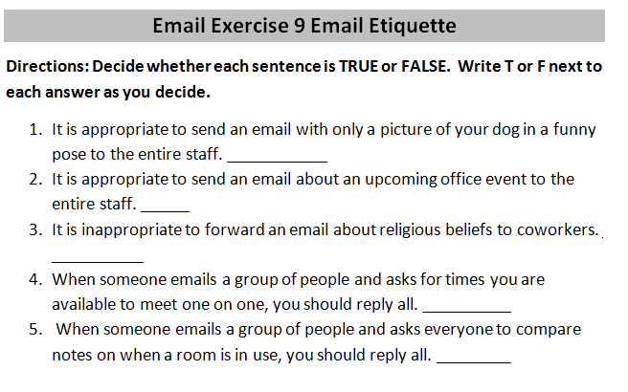
Hand out Email Exercise 9: Email Etiquette
They are true or false questions
Review the answers when students finish
- F
- T
- T
- F
- T

Questions for Email SWAT
- What button do you press if you want to write a new email? (Compose)
- Where can you tell how many unread emails you have? (Number in parenthesis next to Inbox)
- What is the space in email called where you can find emails you have received? (Inbox)
- What is the name of someone who you send an email to/name of the person who received an email? (Recipient)
- When an email in the inbox is unread, what format is the text in? (Bold)
- Where do you click if you want to connect a document to an email? (Attach a file)
- What do you click when you want to respond to an email that was sent to you? (Reply)
- What is the part of your email before the @ sign called? (Username)
- Where do you type in the email address of the recipient of your email? (To: )
- Where is the body of the email? (Under the subject line)
- Where do you write the purpose of your email? (Subject)
- SWAT an example of an email address. (steve@gmail.com)
- SWAT an example of a web address. (www.gmail.com)
- Let’s say you received an email about a job posting that you think would be a great fit for a friend of yours. If you want to send that email on to that friend, what button do you press? (Forward)
- You have highlighted an email you wish to delete,which icon do you click? (trash can)
- What piece of information should you NEVER give out? (Password)
- What is another word for junk email? (Spam)
- Where do you click to write a new email? (Compose)
- What should every professional email end with? (Contact)
- What word we learned that means attitude of an email? (Tone)

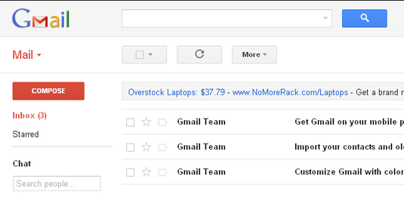
Bold
Reply
Recipient
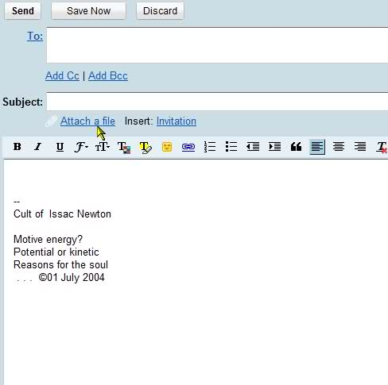
Username
Forward
Steve@gmail.com
Tone
Spam
Contact Information
Password
www.gmail.com
Inbox
Email Exercise 9 Email Etiquette
Directions: Decide whether each sentence is TRUE or FALSE. Write T or F next to each answer as you decide.
- It is appropriate to send an email with only a picture of your dog in a funny pose to the entire staff.
- It is appropriate to send an email about an upcoming office event to the entire staff.
- It is inappropriate to forward an email about religious beliefs to coworkers.
- When someone emails a group of people and asks for times you are available to meet one on one, you should reply all.
- When someone emails a group of people and asks everyone to compare notes on when a room is in use, you should reply all.

Email Exercise 9 Email Etiquette
Directions: Decide whether each sentence is TRUE or FALSE. Write T or F next to each answer as you decide.
- It is appropriate to send an email with only a picture of your dog in a funny pose to the entire staff.
- It is appropriate to send an email about an upcoming office event to the entire staff.
- It is inappropriate to forward an email about religious beliefs to coworkers.
- When someone emails a group of people and asks for times you are available to meet one on one, you should reply all.
- When someone emails a group of people and asks everyone to compare notes on when a room is in use, you should reply all.

