Email: Day 7
Email Safety Day

Objectives Learners will be able to… | Materials
Computer skill: identify unsafe emails  Computer Skill: delete unsafe emails  Literacy skill: reading comprehension | Make Student Copies  - Warm-up Day 7 (Tab 17)  - Email Safety Handout with Tips for Opening Emails-Print Front and Back (Tab 18)  Props, Technology or Other Resources  - Projector  - Computer for every student
Lesson Plan | Vocabulary
Warm-up:  Description: hand out Warm-up Day 7 and have learners complete it  Materials/Prep: copies of Warm-up Day 7  Activity 1: Introduction to Internet Safety  Description: go over tips to avoid issues within Email  Materials/Prep: download Day 7 Email Safety PPT, copies of Email Safety Handout  Activity 2: Deleting Emails  Description: explain the process of how to delete an email, this will also include a discussion of what folders are  Materials/Prep: | - Scam  - Phishing  - Virus  - Worms  - Spam  - Folder

Teacher Directions: Activity 1: Email Safety Introduction -Email Safety Handout
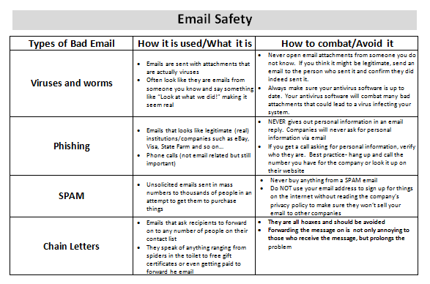
Disclaimer: Oftentimes this conversation can get off track and move in the direction of overall internet safety. If it comes up, remind the class that this is a conversation about EMAIL safety and that internet safety is a much bigger conversation. The best thing you can tell students is that when a website asks for personal information, like credit card info and such, they should check the address bar and if the website starts with “https” it is secure. That “s” makes all the difference.
Step 1: Context
Explain that the wide use of email for communication makes it an attractive market for people trying to sell, steal or simply harm others
IMPORTANT: Explain that we will be discussing ways people will try to get your information via email, but this is not meant to scare, it is meant to keep you aware of potential dangers in order to avoid them
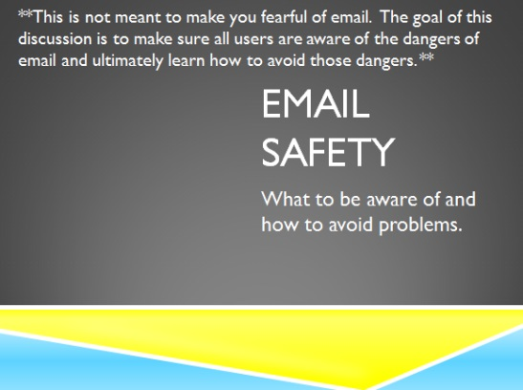
Email is an important aspect of communication in our generation and it cannot be avoided for fear of giving away the wrong information, so we will be discussing tips to

Step 2: Email Safety PowerPoint
Handout Email Safety Handout
Download Email Safety PowerPoint
Answer questions as they come up

Step 3: Examples
Examples start with Slide 10 of the Email Safety PPT
Read through direction slide with learners
There are 3 emails per page, 1 email on each page is a viable email. Slide 12- Email #2, Slide 13- Email #1

Teacher Directions: Activity 2: Deleting Emails
Step 1: Demonstrate
Show students two ways to delete an email, use old emails students have sent, not the emails you sent for practice today
- Click on box next to the email>click on the Trashcan on the bar above the mail in the inbox
- Open an email, see what is inside>Click on the trashcan
Accidentally delete something you did not mean to? Look list below Inbox, scroll down to trash
Open email you meant to keep>click on the Folder Icon “Move To”> Click on Inbox

Step 2: Practice
Learners should “clean out” their inbox of any emails that have been received since the beginning of class

Day 7 Warm-up: Security Questions
Directions: Read the following passage and then pick a security question for Dan to use for his email account.
Dan was born March 4th, 1978 and has six siblings. His mom’s maiden name is Matthews. His first dog was named Sparky and he had him for six years.

Circle the security question Dan should use and write the answer to the question next to it:
- What was the name of your elementary school?
- What town were you born in?
- What is your mother’s maiden name?
- What is your favorite movie?
Answer the following: What is Dan’s DOB: (MM/DD/YYYY)

Day 7 Warm-up: Security Questions
Directions: Read the following passage and then pick a security question for Dan to use for his email account.
Dan was born March 4th, 1978 and has six siblings. His mom’s maiden name is Matthews. His first dog was named Sparky and he had him for six years.

Circle the security question Dan should use and write the answer to the question next to it:
- What was the name of your elementary school?
- What town were you born in?
- What is your mother’s maiden name?
- What is your favorite movie?
Answer the following: What is Dan’s DOB: (MM/DD/YYYY)

Email Safety
Types of Bad Email | How it is used/What it is | How to combat/Avoid it
Viruses and worms | - Emails are sent with attachments that are actually viruses  - Often look like they are emails from someone you know and say something like “Look at what we did!” making it seem real | - Never open email attachments from someone you do not know. If you think it might be legitimate, send an email to the person who sent it and confirm they did indeed sent it.  - Always make sure your antivirus software is up to date. Your antivirus software will combat many bad attachments that could lead to a virus infecting your system.
Phishing | - Emails that looks like legitimate (real) institutions/companies such as eBay, Visa, State Farm and so on…  - Phone calls (not email related but still important) | - NEVER gives out personal information in an email reply. Companies will never ask for personal information via email  - If you get a call asking for personal information, verify who they are. Best practice- hang up and call the number you have for the company or look it up on their website
SPAM | - Unsolicited emails sent in mass numbers to thousands of people in an attempt to get them to purchase things | - Never buy anything from a SPAM email  - Do NOT use your email address to sign up for things on the internet without reading the company’s privacy policy to make sure they won’t sell your email to other companies
Chain Letters | - Emails that ask recipients to forward on to any number of people on their contact list  - They speak of anything ranging from spiders in the toilet to free gift certificates or even getting paid to forward he email | - They are all hoaxes and should be avoided  - Forwarding the message on is not only annoying to those who receive the message, but prolongs the problem

Email Safety: Tips for opening emails
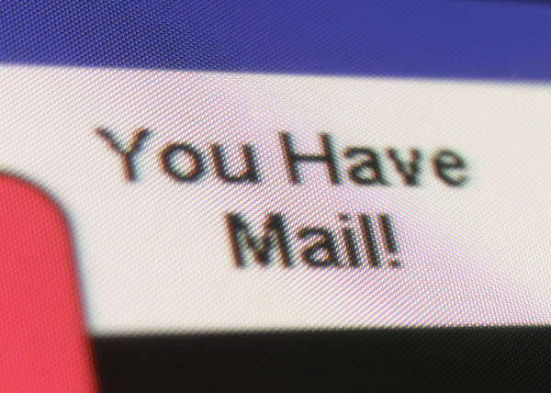
- If you think something seems wrong with an email, delete it IMMEDIATELY
- If you get a window asking you to install something when you open an email, click “No” or simply exit, and then delete the email
- If an email address directs you to a Web site that asks you to install something, click “No” or exit, and then delete the email
- If an email comes from someone you do not know and the subject looks suspicious, delete the email.

