Email: Day 6

Objectives Learners will be able to… | Materials
Computer skill: save a new document  Computer Skill: minimize, expand  Computer skill: attach a document | Make Student Copies  - Story Starters- do not need copies, simply cut each sentence apart from the others (Tab 14)  - Exercise 8: Attach and Email (Tab 15)  - How to Save a File(Tab 16)  Props, Technology or Other Resources  - Projector  - Computer for every student
Lesson Plan | Vocabulary
Warm-up:  Description: Ask learners if they should forward an email to their coworker that is about a dog who rides a skateboard?  Ask learners if they should forward an email to coworkers that is about a funding change the effects the organization you work with?  Ask learners if they should forward an disrespectful joke to their coworkers?  Activity 1: Story Starters  Description: learners will begin typing a story with a specific tone in mind. They will get about 4 minutes to type, and then students will move to the computer next to them, read the story and continue it with their own words. At the end, you will demonstrate how to save the document  Materials/Prep: Story Starters printed and cut into separate strips (might already be done and in the binder), copies of How to Save a File  Activity 2: Attach Emails  Description: teach learners how to attach a document to an email, if you have extra time, go through the steps again. This is a topic that is often quite difficult for students to comprehend  Materials/Prep: copies of Exercise 8: Attach and Email | - Attachment  - Tone  - Save

Teacher Directions: Activity 1: Story Starters and Saving -Story Starters
Step 1: Hand out Activity
Hand out one Story Starter to each student
Keep one for yourself
Demonstrate how to open Microsoft Word and instruct learners to do the same

Step 2: Model Activity
Learners should have their EYES FORWARD AND HANDS OFF OF THEIR COMPUTERS
Read your story starter aloud to the class
Explain that you now need to type in the story starter and think of how you could expand the story
Explain that you only have 4 minutes to type as much as you can
Pretend the 4 minutes are up, and switch over to another computer

Step 3: Ask students what they are supposed to do
Ask students what the steps are to complete this activity?
Ask them how many minutes they get to type?
Ask them if it is a problem if they do not finish what they set out to type? NO
Ask them if they should keep in mind the tone that previous writers have used in the passage: YES

Step 4: Complete the activity
Instruct students to begin the activity
Keep time and remind learners when they have one minute left
Do four rotations
Once the rotations are complete, instruct learners to sit back in their chairs
Ask for volunteers to read their stories.
Ask what the tone is for each story and discuss why.
Step 5: Work through Saving the Document
Explain that now everyone needs to save their document
Go through the steps slowly; making sure everyone is on the same page
NOTE: This skill is not directly relevant to email, so it should not be discussed at length. You can hand out “Saving a Document” to students who desire a reference outside of the class.
File>Save As>My Documents>Name File “Story Starter” (just like giving an email a subject)>Save

Step 6: Minimize Pages
Point out how to minimize the page
Hover your cursor over the buttons on the top right of the page, have students tell you what the buttons do
Click on the buttons and practice using them
Minimize- shrinks the program down to the taskbar
Restore down- shrinks the page within the desktop screen
Maximize- fills the page again
Instruct learners to minimize their document for now

Teacher Directions: Activity 2: Attaching a File

Step 1: Context
Ask if anyone has been asked to email someone else their resume?
Ask if anyone has ever had someone email them pictures?
Explain that oftentimes, these files are sent as attachments

Step 2: What is an attachment
Explain that an attachment is just what it sounds like
Example: You were to send a letter to someone and include another piece of paper, like an application. The first letter is probably something like the body of the email, it explains what the other document is. The other document is an attachment
An attachment is something connected to an email and typically must be downloaded

Step 3: Demonstrate Attaching
Learners should have their EYES FORWARD AND HANDS OFF OF THEIR COMPUTERS
Slowly go through the steps to attach a document
Click on Compose new email>type in an email address (can be fake for now)>Locate Attach a Document>My documents>Story Starters>Open
Point out the bar which shows the document loading
Point out when the document is done loading
Ask if the email is ready to send: NO, you still need a subject and text in the body to explain what the attachment is. If there is no explanation, it could be assumed that this document is dangerous, which is something to be discussed the next day of class.

Step 4: Controlled Practice
Ask students how to return to the inbox: click on Inbox
Ask students how to create a new email: click on Compose
Ask students where you go to attach a file: attach a file
Ask and assist student through the steps of opening and attaching their Story Starter
My documents>Story Starters>Open
Instruct learners to send the attachment to the teacher email address- comp.lit.opendoor@gmail.com
Ask them what text they might include in the body, take suggestions, write an example on the board for them to use

Step 5: Individual Practice- Students send attachment to a partner
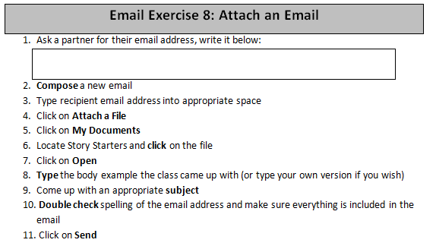
Hand out Exercise 8: Attach and Email
Instruct students to read through the directions, step by step, to send an email attachment to a partner

Step 6: Open Email with attachment
Once students have sent an email with an attachment, go over how to open the attachment
Explain the word download
Ask how one would know if an email had an attachment: look for the paperclip

Story Starters
Directions: Cut each starter apart so that each student only sees one.
It was a dark and stormy night…
The man boarded the plane for Brazil…
The woman walked quickly to her mailbox…
The baby started crying in the middle of the night…
The phone rang just as Bob was headed out of the office…
No one knew who the package was from…
He knew he had seen her before…
The car made a strange sputtering noise…
He jumped into the cold water…
The party began at midnight…
The filing cabinet suddenly tipped over…

Email Exercise 8: Attach an Email
- Ask a partner for their email address, write it below:
- Compose a new email
- Type recipient email address into appropriate space
- Click on Attach a File
- Click on My Documents
- Locate Story Starters and click on the file
- Click on Open
- Type the body example the class came up with (or type your own version if you wish)
- Come up with an appropriate subject
- Double check spelling of the email address and make sure everything is included in the email
- Click on Send

Email Exercise 8: Attach an Email
- Ask a partner for their email address, write it below:
- Compose a new email
- Type recipient email address into appropriate space
- Click on Attach a File
- Click on My Documents
- Locate Story Starters and click on the file
- Click on Open
- Type the body example the class came up with (or type your own version if you wish)
- Come up with an appropriate subject
- Double check spelling of the email address and make sure everything is included in the email
- Click on Send

How to Save a File

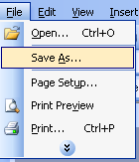
- Click on File
- Click on Save As
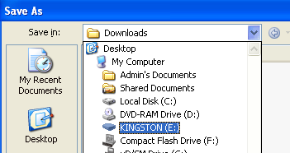
- A box opens, click on the little arrow next to File In

- Click on My Documents
- Type a name for the document into the “File name” line at the bottom of the window, same as determining a Subject for an email
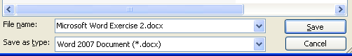

- Once the document has a name, click on Save

