**During Day 11 you will be proctoring the North Star Digital Literacy assessment.**

All the of the computers that learners use need to be registered (per direction on the North Star site) for the assessment,

* This **can take anywhere from 20-40 minutes** depending on the number of students and number of volunteers/coordinators who are setting the assessment up.
* **REGISTER THE COMPUTERS BEFORE CLASS BEGINS**
  + Use the computer sign-in sheet that was filled out Day 1 to determine which computers students are using and pull them out of the COW

**Email: Day 11**

|  |  |
| --- | --- |
| **Objectives** *Learners will be able to…* | **Materials** |
| ***Computer skill:*** *send to multiple participants*  ***Computer Skill:*** *North Star Digital Literacy Assessment*  ***Computer skill:*** *attach a picture from Google* | **Make Student Copies**   * **Email Exercise 11: Review (Tab 23)** * **Email Exercise 12: Multiple Recipients (Tab 24)**   **Props, Technology or Other Resources**   * Projector * Computer for every student * **North Star How-To** |
|  | |
| **Lesson Plan** | Vocabulary |
| **Activity 1: Review**  Description: learners need to complete Email Exercise 11:  Materials/Prep: copies of **Email Exercise 11: Review**  **Activity 2: North Star Digital Literacy Assessment**  Description: learners will take the Email North Star Digital Literacy Assessment  Materials/Prep:  **teacher can use North Star How-to** to set-up tests, project Page 4 (screen shot) to explain assessment  **Activity 3: Activity 11**  Description: once learners finish their assessment, they will work on Email Exercise 12 which reviews sending to multiple addresses and attaching pictures  Materials/Prep: copies of **Email Exercise 12: Multiple Recipients** |  |

**Teacher Directions: Activity 1: Review -Email Exercise 11: Review**

Step 1: Set-up

Explain that learners are going to complete an activity that reviews many of the things we have talked about in class

Learners will have to read each direction and complete what is asked

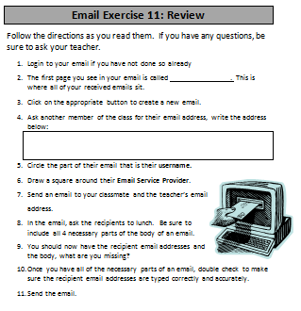 **Explain** that this is the time to ask questions if learners are confused about anything

Step 2: Complete Activity

**Hand out Email Exercise 11: Review**

**Instruct** learners to begin and tell them to work on their own. They should only speak to other students when the directions instruct them to ask for an email address

One step requires that students send an email to the teacher’s email address and one other email address, this is a check to make sure their emails get through

**Teacher Directions: Activity 2: North Star Digital Literacy Assessment**

Step 1:

Take this time to explain the **Email** North Star Digital Literacy Assessment and its purpose:

**This can be read verbatim to the students:** The North Star Digital Literacy Assessment has set the standards of what it means to be knowledgeable about different aspects of the computer. The purpose of this assessment is to provide learners with a standard with which everyone learns the computer to ensure that they will be successful outside of the classroom. If you pass the assessment with an 85% or higher, you will receive a certificate that proves your competency at the unit you were tested on. These certificates can also be presented to employers as proof of your computer skills when you apply for a job.

If you do not know the answer to a question, you are given the option to simply answer “I do not know” or you can take a guess. You are encouraged to guess on this assessment.

Step 2: How the assessment works

**This can be read verbatim to the students:** When it is time to begin, students will open the assessment titled **Windows**. The assessment begins with a test of the speakers. If you hear the piano playing, you will use your mouse to click the “Next” button.

**Explain** that if that student does not hear the piano playing, they can look above their keyboard at and they will see three buttons on the right. These are the volume buttons, one to turn down volume, turn it up, and turn it off.

Next, North Star will go through an orientation of how the assessment works. Each question asked in the assessment will be a function of the program, so your answer to the question will be performing that function. **BE CAREFUL not** to simply click when the page comes up because the assessment will read that as your answer and you cannot go back.

**IMPORTANT:** The **Email Assessment** contains the most typing of any assessment, so **explain** that learners need to double check their spelling before they finish a question

Step 3: Test Page Layout

**Teacher should pull up the Screen Shot page (next page) and review it with the students.**

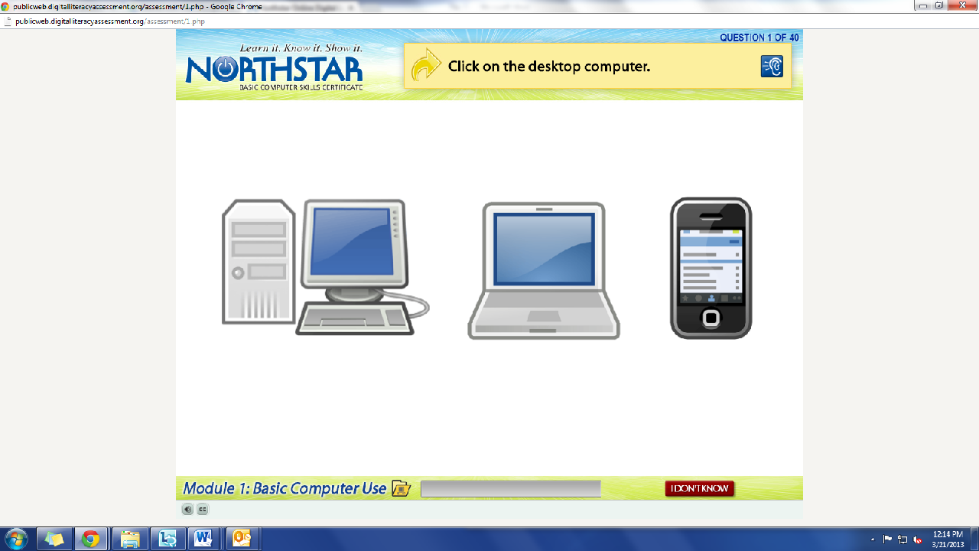

The Email Assessment has quite a bit of typing, so be sure to type exactly what the question tells you to type. For these questions, there will be a green arrow that says “Next” next to the I don’t know button, click this when you are done with the question.

What is the question begin asked?

How do we answer it? We click on the answer.

You **must listen carefully** to the question being asked so that you know how to answer it.

If you miss the question when it is read, you can either read it on the top of the page, or click the on the blue ear and it will read the question again.

If you do not know and do not want to guess, but once you click it, it will ask you if you are sure you want to skip the question, you have to answer “Yes” to move on. You are, however, encouraged to guess.

Step 4: Learner Code of Conduct

**Read** the **Learner Code of Conduct** to the students:

* Learner must listen carefully to all instructions given by proctor
* Learner must treat others with courtesy and respect during assessment process
  + This means no talking to each other during the assessment, if you have a question ask the proctor. If a learner finishes early, they must remain quiet until everyone is finished
* Learner should ask questions prior to the assessment if they are uncertain about the certification process
* Learner is responsible for his or her certificate: if the certificate is lost, s/he will have to retake the assessment
* Learner should inform the proctor if he or she believes that assessment conditions affected his or her results

**Ask** if there are any questions

Explain that the questions will be read aloud to them, so students need to be sure they are listening carefully. If they miss the question, is it also written at the top of the page.

Step 5: Take **Email Assessment**

If there are no questions, learners should scroll down the testing page and click on the **Email Assessment**

*If students are frazzled during the test because they missed the reading of the question, there is a blue square in the top right corner with an ear in it. When it is clicked the question is read again*

Step 6: After the assessment

Once the assessment is completed, hand out **Email Exercise 12** and instruct learners to complete it

**Teacher Directions: Activity 3: Extra Time?**

Step 1: do you have extra time?

If all learners complete the assessment and the handout, take time to go over the assessment

**Ask** learners what they thought of it? What did they know? What were they confused by?

Ask if there was anything they felt they were not specifically prepared for

Step 2: Mavis Beacon

If there is a significant amount of time left, learners should go on to Mavis Beacon and practice their typing

**North Star How-To**

**Teacher A- Generating Codes:**

1. Go to [https://www.digitalliteracyassessment.org/admin](https://www.digitalliteracyassessment.org/admin/login.php)

2. **Login information**:

3. PLEASE SEE YOUR SITE COORDINATOR FOR NORTH STAR LOGIN INFORMATION!

4. Select your name from the drop-down menu

5. Click Submit

6. Click on **Generate User Codes**

7. Simply type in students’ names and a click enter

8. The code next to their name will be used to register their computer

**Teacher B- Registering each computer:**

1. Turn on student computers

**2.** Go to digitaliteracyassessment.org/assessment/proctored

3. Username: SEE YOUR SITE COORDINATOR

4. PIN: **SEE YOUR SITE COORDINATOR**

5. Type in student’s name and then enter the code you got from Part 1

6. Click Confirm and Start

7. Minimize the page

8. Instruct students not to close out of any programs you have opened on their computer

**Note:** As you spend more time in the classroom you get to know the students who show up early and who show up late. Register the students who usually show up early as soon as you arrive, that way they can begin typing as soon as they get to class.

**Email Exercise 11: Review**

Follow the directions as you read them. If you have any questions, be sure to ask your teacher.

1. Login to your email if you have not done so already
2. The first page you see in your email is called . This is where all of your received emails sit.
3. Click on the appropriate button to create a new email.
4. Ask another member of the class for their email address, write the address below:

|  |
| --- |
|  |

1. Circle the part of their email that is their **username.**
2. C:\Users\knorman\AppData\Local\Microsoft\Windows\Temporary Internet Files\Content.IE5\WEHY53O3\MC900390724[1].wmfDraw a square around their **Email Service Provider**.
3. Send an email to your classmate and the teacher’s email address.
4. In the email, ask the recipients to lunch. Be sure to include all 4 necessary parts of the body of an email.
5. You should now have the recipient email addresses and the body, what are you missing?
6. Once you have all of the necessary parts of an email, double check to make sure the recipient email addresses are typed correctly and accurately.
7. Send the email.

**Email Exercise 12: Multiple Recipients**

**Part 1:**

1. Write down two of your classmates email addresses in the table below:

|  |
| --- |
|  |
|  |

1. Send them an email **asking ONE** of the following questions:
   1. Where is your favorite place in the world?
   2. How are you feeling today?
   3. Who is your favorite actor/actress?
   4. If you could visit any country, which one would you choose?
2. Before sending, what three things must every email include?

|  |
| --- |
| 1. |
| 2. |
| 3. |

**Part 2:**

1. Open the email you have received from a fellow classmate.
2. Click on **reply**
3. Type a response to the question asked in the email you were sent.
4. From whom was the email sent?

|  |
| --- |
|  |

1. **Open** another tab within your email page. 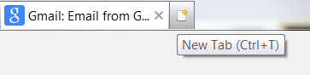
2. **Type** “google.com” into the address bar.
3. **Click** on Images
4. **Type** a picture that represents a response to the question that was asked in the email.
   1. **For example:** If someone asked you how you are feeling, you could send them this picture if you are feeling sad:
5. **Right click** on the picture
6. **Click** on Save Picture As in the dropdown menu
7. **Save** the picture to your **USB Drive**
8. **Name** the picture so that it is easy to locate later on
9. What is the name of the drive that you save the picture to within My Computer?

|  |
| --- |
|  |

1. **Click** on the gmail tab to return to your email
   1. Do **NOT** click on the “x” that appears on the tab icon
2. **Click** on Attach a File
3. **Locate** the picture that you recently saved
4. **Click** on the file (picture)
5. **Click** on Open
6. **Check** to make sure the document loads
7. **Send** the email with the attachment