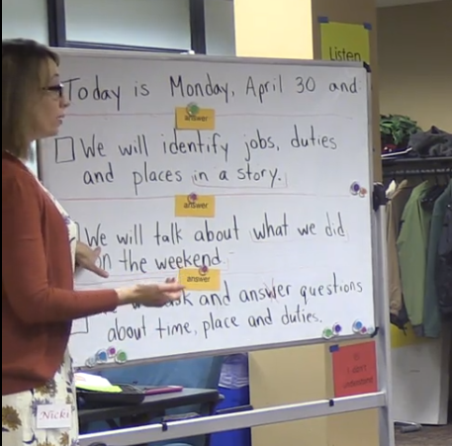
CCRS in the ABE Classroom: Low Beginning ESL
Section 1: Beginning to 16:03
Section 1 Focus: Routines
- What routines were used in this section of the video? What were the components of these routines?

- In her interview, Nicki shares that one of the benefits of routines is that they preserve cognitive space in the students’ minds for the actual instruction. What are some other benefits of routines? What are students in this class able to accomplish because they are comfortable with the existing routines?

- Nicki says that the routines shown in this section of the video took several months to establish. What do you think that process looked like? How do you imagine that she initially introduced the routines and supported the students through their development?

- Nicki developed the “ask and answer questions” routine in order to help her students meet the Reading and Language standards CCR1 (RI/RL.1.1) and CCR1k (L.K.1.D) using a “low stakes” approach. What is a simple low stakes routine that you could put in place that would help to build the students’ ability to reach one of your target standards?

- How do the routines that Nicki uses in this section allow learners to take ownership of their learning?

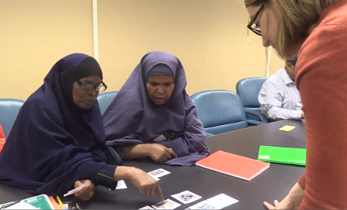
CCRS in the ABE Classroom: Low Beginning ESL
Section 2: 16:04-34:28
Section 2 Focus: Developing Literacy Skills
- In order for learners to move up to the next ESL level, they need a foundational understanding of grammar and the language to talk about it. How does the lesson help learners develop their grammar understanding and metalanguage?

- How does Nicki use scaffolding throughout this section of the lesson to prepare students to interact with a challenging text?

- One of the CCRS shifts is building content knowledge. What content knowledge are students building during this section of the lesson?

- How could you use some of the scaffolding techniques you observed in the video to prepare your own learners to interact with complex texts?

- When working with CCRS, literacy and critical thinking skills are equally important. What receptive, interactive, and productive literacy and critical thinking skills are students using in this section of the video?

- In this video, the learners are familiar with the question words what, where, when, who. How do you imagine that Nicki introduced these question words to her learners? How could you introduce them to your own learners?

CCRS in the ABE Classroom: Low Beginning ESL
Section 3: 34:29-End
Section 3 Focus: Analyzing Text
- Do the students experience productive struggle in this section of the video? How do you know?

- How does Nicki’s use of wait time when asking questions and before providing answers increase the rigor for the students and make this section of the lesson more student-centered?

- How does the highlighting activity in this section of the video build the students’ 1) understanding of the text 2) grammar knowledge and skills 3)ability to cite evidence 4) ability to answer text dependent questions?

- Close reading is heavily emphasized in the CCRS. How do the activities in this lesson prepare beginning level students to closely read a text?

- As Nicki stated, the types of activities shown in this video take a long time. What are the benefits of investing a large amount of class time in building the skills in this lesson? See the question above on interactive/receptive/productive skills.

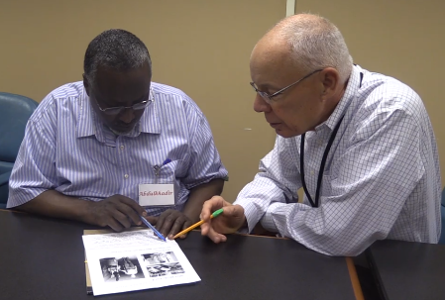
CCRS in the ABE Classroom: Low Beginning ESL
Whole Video Overview and Follow Up Tasks
- The video highlighted routines, literacy instruction, and close reading of a complex text. What other themes and takeaways did you discover while watching the video? Which are the most relevant for you and your teaching practice?

- Throughout the video, where do you see examples of the three key shifts?
  - Complexity: Regular practice with complex texts and their academic language

  - Evidence: Reading, writing, and speaking grounded in evidence from texts, both literary and informational

  - Knowledge: Building knowledge through content-rich nonfiction

- How will the skills and knowledge that the learners are developing throughout this lesson will prepare them for moving up to the next level? Look at Level B in your blue book (CCR Standards for Adult Education) and discuss.

- What are you inspired to try in your own teaching practice after watching this video? How will you make it a regular part of your classroom instruction? How do you think that your learners will respond?

- Select one new activity or teaching practice from the video, and try it out in your classroom. Be prepared to report back on the learners’ response, successes, and challenges. Also be prepared to discuss how you will continue to integrate the CCR Standards into your instruction moving forward.

