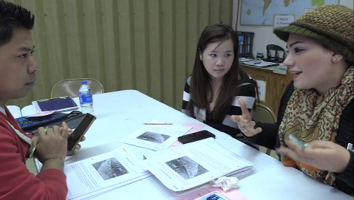
CCRS in the ABE Classroom: Intermediate ESL
Section 1: Beginning-21:59
Section 1 Focus: Preparing for Close Reading
- Identify 1-3 CCRS Reading and/or Speaking & Listening Anchors that are emphasized in this section of the video. How does Jessica integrate them into her lesson?

- One of the CCRS shifts is text complexity. How does Jessica evaluate the complexity of the text that is used in this lesson? What other factors does she consider when choosing the text?

- Which text features does Jessica address during this section of the video? How does she address them?

- In her interview, Jessica says that teachers can’t ignore the impact that vocabulary development has on English language learners. During this section of the lesson, how does she provide support for learners to strengthen their vocabulary? For example, how does she use context and alphabetics to understand the unfamiliar vocabulary item, “march” in this text?

- What choices/tools do students have to show evidence of learning? For example, what are their options for demonstrating the meaning of a word or sentence? What practices of strong readers does Jessica encourage them to use while figuring out the meaning of new words?

- The pink handout “Vocabulary Talk” offers sentence frames for discussion around vocabulary. How do these frames support learning and language development? How could sentence frames be used to prepare your own learners to interact with complex texts?

- During this section of the video, when is Jessica teaching the reader, and when is she teaching the reading?

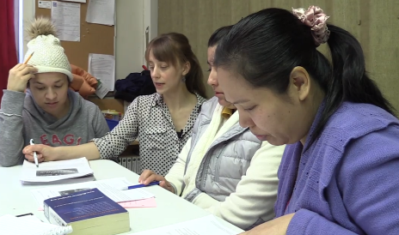
CCRS in the ABE Classroom: Intermediate ESL
Section 2: 22:00-38:07
Section 2 Focus: Productive Struggle
- One of the CCRS shifts is text complexity. How do the learners use the pink “Vocabulary Talk” sheet to check each other’s understanding of the vocabulary in the text? How does this support their use of academic language?

- A goal of increasing text complexity is for learner to read independently and proficiently. How does Jessica reinforce self-monitoring of comprehension in this section of the video?

- How does Jessica define “productive struggle” in this section of the video? Why is it important for language and reading skills development?

- In her interview, Jessica says that teachers need to learn when to “sit on their hands.” How does Jessica encourage and support productive struggle during this section of the video?

- How does Jessica use intentional questioning to build the learners’ understanding of the text? What are some examples of questions that she asks? How do they build upon one another?

- When working with CCRS, literacy and critical thinking skills are equally important. What receptive, interactive, and productive literacy and critical thinking skills are students using in this section of the video?

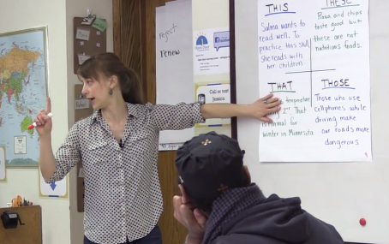
CCRS in the ABE Classroom: Intermediate ESL
Section 3: 38:08-end
Section 3 Focus: Citing Evidence
- This section of the video begins with explicit grammar instruction. How did the text drive the grammar lesson? Was this an effective way to integrate grammar into a reading lesson? Why or why not?

- Jessica facilitates multiple readings of the text throughout the lesson. How does this strategy develop learners’ close reading skills during this section of the video?

- How does Jessica use text annotations in this section of the lesson to help learners identify evidence and assist in reading comprehension?

- Citing evidence is closely emphasized in the CCRS. How does the use of sentence frames in this section of the video support the learners’ ability to present careful analyses and defend their claims?

- How does Jessica “bundle” different strands of standards, thereby encouraging academic conversations as well as reading during this section of the video? Could you use this approach in your own instruction?

- What has Jessica’s experience been as she’s shifted away from an exclusive lifeskills focus to one that is based on more academically rigorous instruction with nonfiction texts? How does her current approach still enable her to meet her learners’ lifeskills needs?

CCRS in the ABE Classroom: Low Beginning ESL
Whole Video Overview and Follow Up Tasks
- The video highlighted preparing for close reading, productive struggle, and citing evidence. What other themes and takeaways did you discover while watching the video? Which are the most relevant for you and your teaching practice?

- Throughout the video, where do you see examples of the three key shifts?
  - Complexity: Regular practice with complex texts and their academic language

  - Evidence: Reading, writing, and speaking grounded in evidence from texts, both literary and informational

  - Knowledge: Building knowledge through content-rich nonfiction

- How will the skills and knowledge that the learners are developing throughout this lesson will prepare them for moving up to the next level? Look at Level D in your blue book (CCR Standards for Adult Education) and discuss.

- What are you inspired to try in your own teaching practice after watching this video? How will you make it a regular part of your classroom instruction? How do you think that your learners will respond?

- Select one new activity or teaching practice from the video, and try it out in your classroom. Be prepared to report back on the learners’ response, successes, and challenges. Also be prepared to discuss how you will continue to integrate the CCR Standards into your instruction moving forward.

