100 Questions
for the
Naturalization Test
Civics (History and Government)

* If you are 65 years old or older and have been a legal permanent resident of the United States for 20 or more years, you may study just the questions that have been marked with an asterisk.

AMERICAN GOVERNMENT
A: Principles of American Democracy
1. What is the supreme law of the land?
- the Constitution

2. What does the Constitution do?
- sets up the government

3. The idea of self-government is in the first three words of the Constitution. What are these words?
- We the People 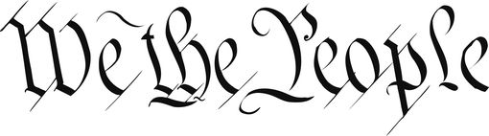

4. What is an amendment?
- a change (to the Constitution)

5. What do we call the first ten amendments to the Constitution?
- the Bill of Rights 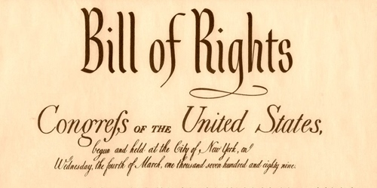

6. What is one right or freedom from the First Amendment?*
- speech

7. How many amendments does the Constitution have?
- twenty-seven (27)

8. What did the Declaration of Independence do?
- declared our independence (from Great Britain)

9. What are two rights in the Declaration of Independence?
- life
- liberty

10. What is freedom of religion?
- You can practice any religion, or not practice a religion.

11. What is the economic system in the United States?*
- capitalist economy

12. What is the “rule of law”?
- Everyone must follow the law.

B: System of Government
13. Name one branch or part of the government.*
President
(Executive)
- President
- (Congress)
the courts
(Judicial)

Congress
(Legislative)

14. What stops one branch of government from becoming too powerful?
- checks and balances

15. Who is in charge of the executive branch?
- the President

16. Who makes federal laws?
- Congress

17. What are the two parts of the U.S. Congress?*
- the Senate and House (of Representatives)

18. How many U.S. Senators are there?
- one hundred (100)

19. We elect a U.S. Senator for how many years?
- six (6)
20. Who is one of your state’s U.S. Senators now?*
Tina Smith Amy Klobuchar
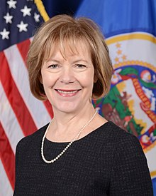

21. The House of Representatives has how many voting members?
- four hundred thirty-five (435)

22. We elect a U.S. Representative for how many years?
- two (2)

23. Name your U.S. Representative.

  - Betty McCollum Keith Ellison
(St. Paul D-5) (Minneapolis D-4)

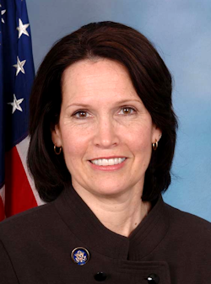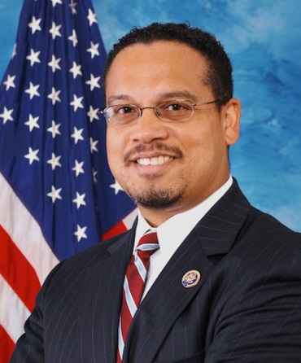
24. Who does a U.S. Senator represent?
- all people of the state

25. Why do some states have more Representatives than other states?
- (because) they have more people

26. We elect a President for how many years?
- four (4)

27. In what month do we vote for President?*
- November

28. What is the name of the President of the United States now?*
- (Donald) Trump
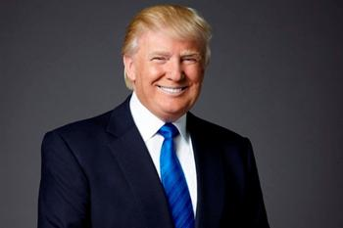
29. What is the name of the Vice President of the United States now?
- (Mike) Pence
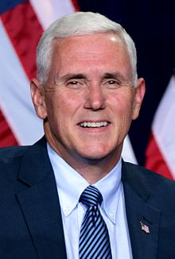
30. If the President can no longer serve, who becomes President?
- the Vice President

31. If both the President and the Vice President can no longer serve, who becomes President?
- the Speaker of the House

32. Who is the Commander in Chief of the military?
- the President

33. Who signs bills to become laws?
- the President

34. Who vetoes bills?
- the President

35. What does the President’s Cabinet do?
- advises the President

36. What are two Cabinet-level positions?
- Secretary of Defense
- Secretary of State

37. What does the judicial branch do?
- explains laws

38. What is the highest court in the United States?
- the Supreme Court

39. How many justices are on the Supreme Court? nine (9) 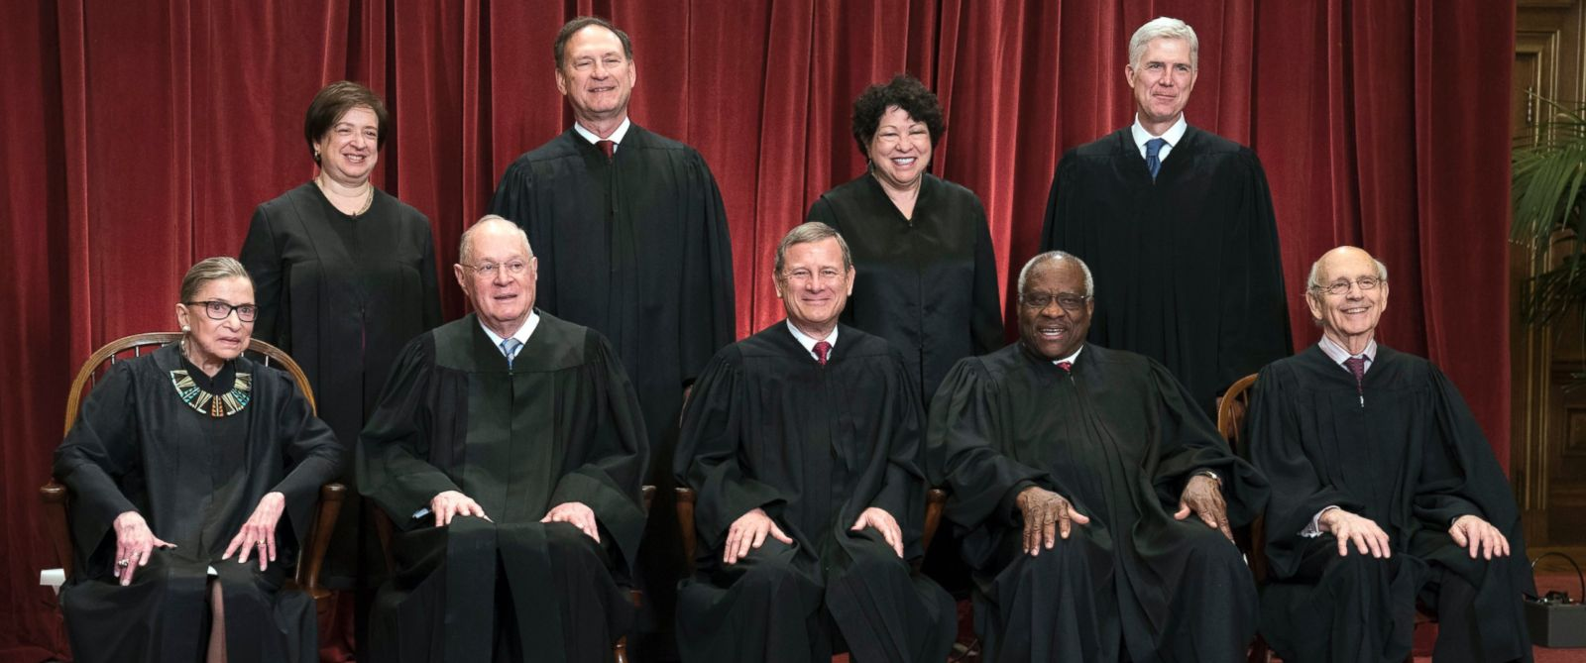

40. Who is the Chief Justice of the United States now?
- John Roberts 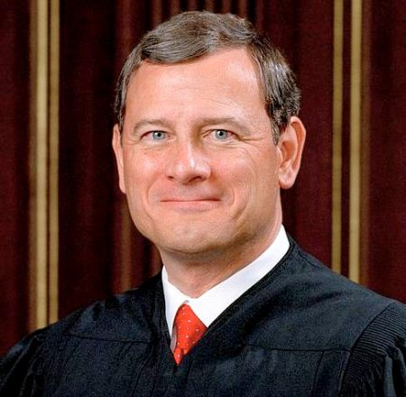

41. Under our Constitution, some powers belong to the federal government. What is one power of the federal government?
- to print money

42. Under our Constitution, some powers belong to the states. What is one power of the states?
- give a driver’s license 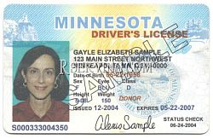
43. Who is the Governor of your state now?
- Mark Dayton 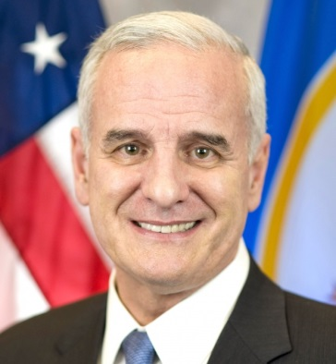

44. What is the capital of your state?*
- St. Paul 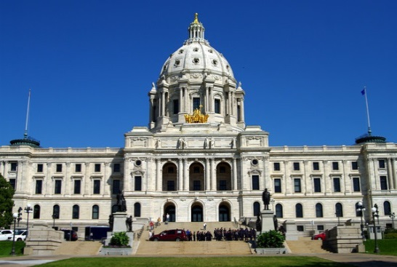

45. What are the two major political parties in the United States?*
- Democratic and Republican

46. What is the political party of the President now?
- Republican

47. What is the name of the Speaker of the House of Representatives now?
- (Paul) Ryan 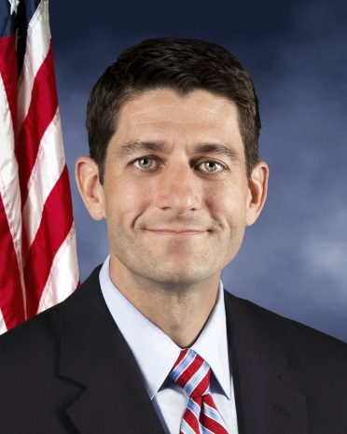

C: Rights and Responsibilities
48. There are four amendments to the Constitution about who can vote. Describe one of them.
- Citizens eighteen (18) and older (can vote)

49. What is one responsibility that is only for United States citizens?*
- vote in a federal election

50. Name one right only for United States citizens.
- vote in a federal election
51. What are two rights of everyone living in the United States?
- freedom of speech
- freedom of religion

52. What do we show loyalty to when we say the Pledge of Allegiance?
- the United States
- the flag
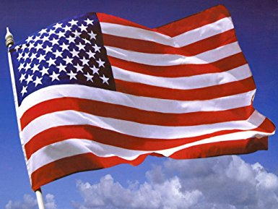

53. What is one promise you make when you become a United States citizen?
- obey the laws of the United States

54. How old do citizens have to be to vote for President?*
- eighteen (18) and older
55. What are two ways that Americans can participate in their democracy?
- vote
- run for office

56. When is the last day you can send in federal income tax forms?*
- April 15

57. When must all men register for the Selective Service?
- between eighteen (18) and twenty-six (26)

AMERICAN HISTORY
A: Colonial Period and Independence
58. What is one reason colonists came to America?
- (religious) freedom

59. Who lived in America before the Europeans arrived?
- American Indians

60. What group of people was taken to America and sold as slaves?
- people from Africa

61. Why did the colonists fight the British?
- because of high taxes

62. Who wrote the Declaration of Independence?
- (Thomas) Jefferson 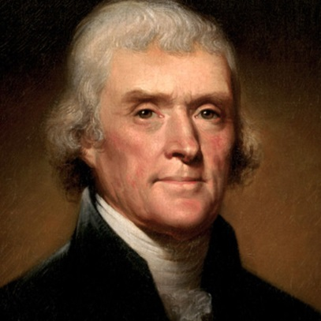

63. When was the Declaration of Independence adopted?
- July 4, 1776

64. There were 13 original states. Name three.
- New Hampshire
- New York
- New Jersey

65. What happened at the Constitutional Convention?
- The Constitution was written.

66. When was the Constitution written?
- 1787

67. The Federalist Papers supported the passage of the U.S. Constitution. Name one of the writers.
- (John) Jay

68. What is one thing Benjamin Franklin is famous for?
- U.S. diplomat 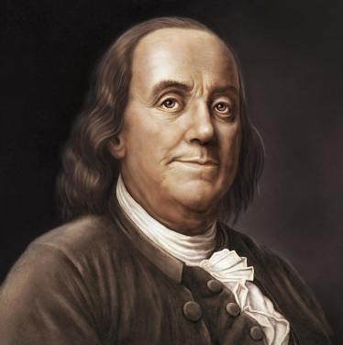
69. Who is the “Father of Our Country”?
- (George) Washington 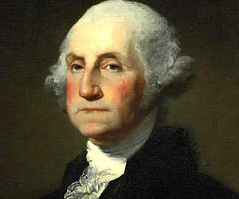

70. Who was the first President?*
- (George) Washington

B: 1800s
71. What territory did the United States buy from France in 1803?
- Louisiana (Territory)

72. Name one war fought by the United States in the 1800s.
- Civil War

73. Name the U.S. war between the North and the South.
- Civil War
74. Name one problem that led to the Civil War.
- slavery

75. What was one important thing that Abraham Lincoln did?*
- freed the slaves (Emancipation Proclamation) 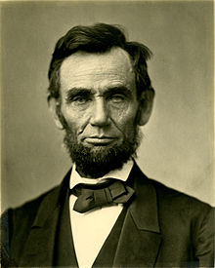
76. What did the Emancipation Proclamation do?
- freed the slaves

77. What did Susan B. Anthony do?
- fought for women’s rights
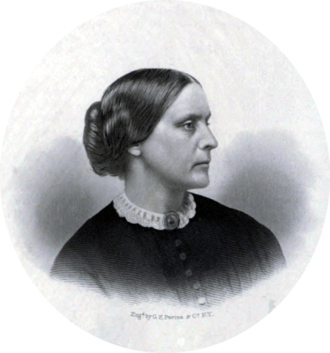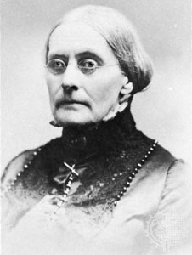
C: Recent American History
78. Name one war fought by the United States in the 1900s.*
- World War I

79. Who was President during World War I?
- (Woodrow) Wilson 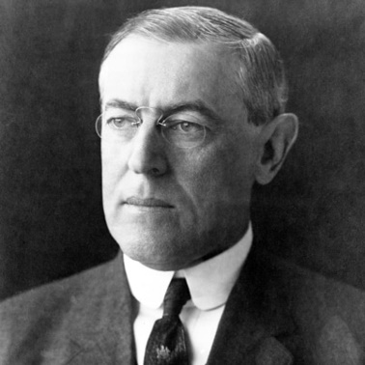

80. Who was President during the Great Depression and World War II?
- (Franklin) Roosevelt 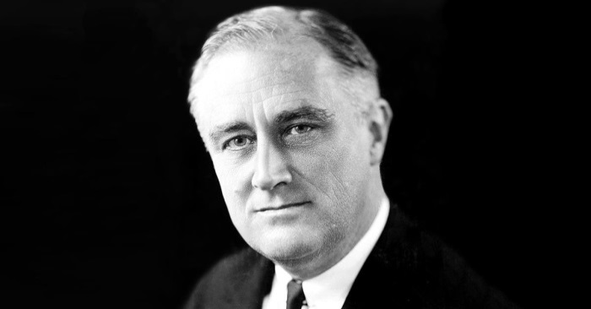

81. Who did the United States fight in World War II?
- Japan, Germany, and Italy
82. Before he was President, Eisenhower was a general. What war was he in?
- World War II 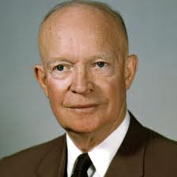

83. During the Cold War, what was the main concern of the United States?
- Communism

84. What movement tried to end racial discrimination?
- civil rights (movement)

85. What did Martin Luther King, Jr. do?*
- fought for civil rights 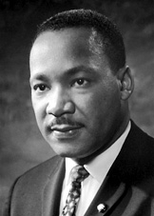
86. What major event happened on September 11, 2001, in the United States?
- Terrorists attacked the United States.

87. Name one American Indian tribe in the United States.
- Hopi

Cherokee
Navajo
Sioux
Chippewa
Choctaw
Pueblo
Apache
Iroquois
Creek
Blackfeet
Seminole

Cheyenne
Arawak
Shawnee
Mohegan
Huron

Oneida
Lakota
Crow
Teton
Inuit

INTEGRATED CIVICS
A: Geography
88. Name one of the two longest rivers in the United States.
- Missouri (River)
- Mississippi (River)

89. What ocean is on the West Coast of the United States?
- Pacific (Ocean)

90. What ocean is on the East Coast of the United States?
- Atlantic (Ocean)

91. Name one U.S. territory.
- Puerto Rico
- Guam

92. Name one state that borders Canada.
- Minnesota 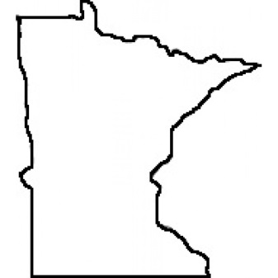
- (Alaska)

93. Name one state that borders Mexico.
- California
94. What is the capital of the United States?*
- Washington, D.C.

95. Where is the Statue of Liberty?*
- New York (Harbor)
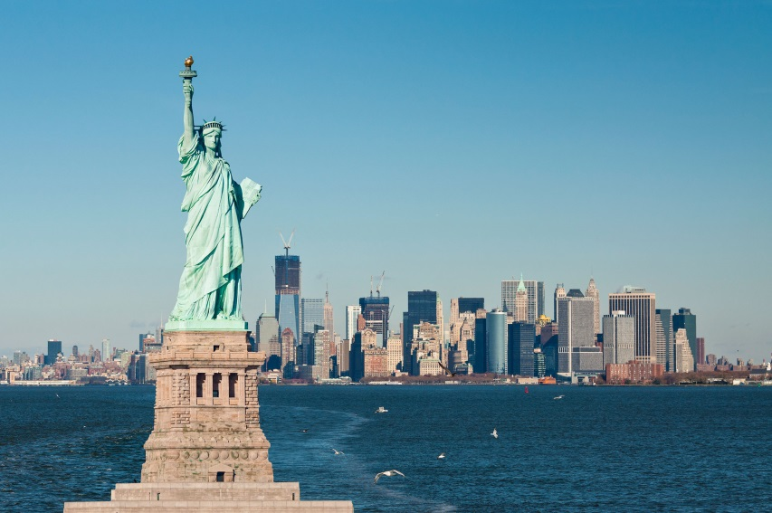
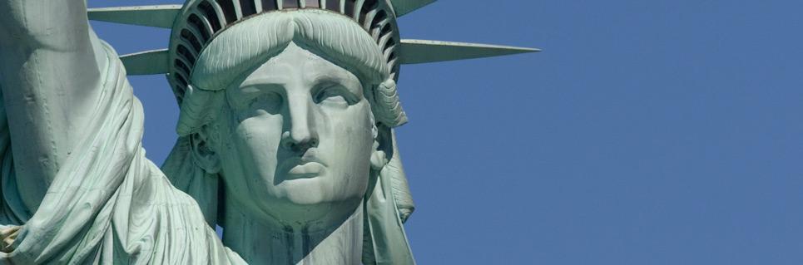
B: Symbols
96. Why does the flag have 13 stripes?
- because there were 13 original colonies

97. Why does the flag have 50 stars?*
- because there are 50 states
98. What is the name of the national anthem?
- The Star-Spangled Banner

C: Holidays
99. When do we celebrate Independence Day?*
- July 4

100. Name two national U.S. holidays.
- New Year’s Day
- Thanksgiving

100 Questions for the Naturalization Test

